Identify if there are characteristics that might signify revolutions (major leaps) in musical evolution from these data? What artists represent revolutionaries (influencers of major change) in your network?

问题e的解决方案：

注：各年发歌数分布图（所有流派）Graph1

PS 这张图可能可以放在前面/第7题讲历史事件对歌曲数的变化？

比如 二战 08年后歌曲出现明显下降？

部分流派发歌数Graph2

这段主要是Vocal和Jazz相似的分析

From Graph1 & Graph2, we can identify that different genres take their major leap at different times. For example, Pop/Rock became popular in 1960s, while Vocal and Jazz reach the peak in 1950s. What’s more, the curve of Vocal and Jazz are of similar type. In consideration of Pearson correlation coefficient, Jazz is similar to Vocal. In addition, many active vocal singers in the 1950s have close links with Jazz. For example, Ella Fitzgerald (ID:184502) was called Queen of Jazz, while Frank Sinatra (ID:792507) was regarded as an idol by many jazz singers.

分析什么因素的变化使得Vocal在50年代流行起来/发生变革

From Graph2, it is clear that Vocal took its major leap around 1950. According to Graph3, the attribute acousticness started dropping, which means the spread of microphone and the improvement of recording technology, when Vocal became popular. Considering the characteristic of Vocal, refers to the singer who takes his own singing talent and singing skills as the selling point, the change of acousticness offers Vocal singers  much room to exercise their talent in developing a softer, more personal and more subtle style. In return, Vocal came into fashion.

经过popularity加权后的图Graph3

找出代表性歌手

已修改

From Graph4, there were many representatives from the 1930s to 1960s. From Graph New, we can identify that Frank Sinatra has a great impact on those Vocal artists. During his peak period, he not only made a great success, but also influenced the development of Vocal. Therefore, Frank Sinatra represented the revolution in the network.

然后从下面几个里面找出他们对Vocal内部影响力比较大的数据+作图！792507 79016 184502 813392 411761 189644

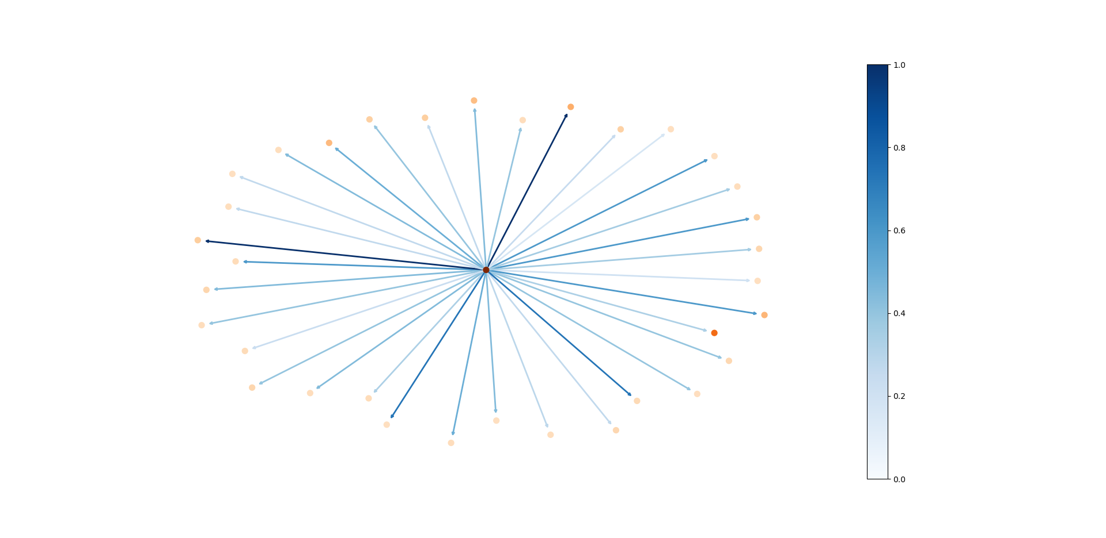

Graph new

Graph4

从各个流派在不同时期发布的歌曲数目，可以大致看出，各个流派在不同时期的活跃程度。如果某个流派在某一时期内的歌曲数量明显增加，我们可以认为该流派在这一时期发生了major leap，从图2中可以看出在50-60年代，Vocal和Jazz得到发生了蓬勃发展，同时也可看出二者的发展曲线非常相似。在50-60年代活跃的Vocal歌手中，较为著名的有被称为Queen of Jazz的Ella Fitzgerald（id184502），以及被许多爵士乐视作偶像的Frank Sinatra（id792507），也足以看出Vocal和Jazz的相似度较高，同时两个流派间的影响也较大。

再结合Vocal的音乐特征随时间变化的特点，不难发现，在Vocal系开始流行的时期，acousticness开始显著下降。结合历史，不难发现，在50-60年代随着麦克风的普及&录音技术的改进，正好让现场表演型歌手得到了更多发挥空间，发展一种更柔软、个人化和细腻的风格，使得Vocal系快速发展。

从图3中可以看出，Vocal流派的代表性歌手在30-70年代都不乏有代表性且高产出的歌手，他们（此处结合影响力进行分析）影响了Vocal系内的其他歌手，故他们代表了influencers of major change

Analyze the influence processes of musical evolution that occurred over time in one

genre. Can your team identify indicators that reveal the dynamic influencers, and explain how the genre(s) or artist(s) changed over time?

问题f的解决方案：这题确实不知道怎么写了

Graph5 Frank Sinatra年均变化

From Graph4, we can identify that Frank Sinatra(ID:79016) is the representative of Vocal. According to Graph5, the liveness and speechiness became lower in the 1950s to 1960s. And most of his songs were published in this period. Therefore, the level of liveness and speechiness that might be the indicator that reveal a singer’s number of publications.What’s more, there was a high  correlation between energy, valence, and instrumentalness, which reveal the artist’s style. Therefore, we can identify that, in the 1950s to 1960s, Frank Sinatra’s spent more time on recording and his style became more active.

改过的

From Graph5, we also find that Frank Sinatra’s characteristic changed a lot after 1973. The liveness, energy, acousticness, and speechiness reached the peak. Because in 1973, Sinatra came out of his short-lived retirement. And he initially developed problems with his vocal cords during the comeback due to a prolonged period without singing. Therefore, his style changed greatly. From the correlation between his songs before and after that, we can identify the problem even made him look like a new person. Therefore, the characteristics mentioned above can be indicators that reveal the dynamic influencers.

document

Write a one-page document to the ICM Society about the value of using your approach to understanding the influence of music through networks. Considering the two problem data sets were limited to only some genres, and subsequently to those artists common to both data sets, how would your work or solutions change with more or richer data? Recommend further study of music and its effect on culture.

The ICM Society, an interdisciplinary and diverse group from the fields of music, history, social science, technology, and mathematics, looks forward to your final report.

**Document**

Our team develop a model to understand the influence of music. This model is based on a directed network. The weight of edge shows the importance of influence. Through the network, we can identify how the genres and artists affect each other, how genres develop. What’s more, we also invent a method to measure the similarity between songs, artists, or genres. This has contribute to understand if the influence really affect the follower.

Up to now, through the analysis on the given data set, Our model has got some satisfactory results. In terms of influence, the influence of mainstream artists on other artists is more consistent with the actual situation. It also reflects the influence of time dimension and the difference of influence between different genres and the same genre. What’s more, we even get influence of the artists themselves. In terms of similarity, by extracting the main features, we find some pairs of artists that influence each other and become more similar to each other. In addition, we also find some genres similar to each other, like Vocal and R & B, Pop/Rock and Avant-Garde. After analyzing the historical facts, the accuracy of our model has been confirmed.

In the future, we will apply the model to the analysis of current music trends. Considering that our model is based on the data set from 1921 to 2020, many genres have not been considered in the model. Therefore, before applying to the current analysis, we need to make some adjustments to our model, like considering the impact of the development of the Internet and so on. We hope that after the adjustment, the model can predict the development trend of pop music in the next 10 years and provide development suggestions for some artists.

Thank you for reading our report. Your idea and suggestion are highly appreciated.

到目前为止，通过在给定数据集上的分析，我们的模型已经能够得到一些比较满意的结果。在影响力方面，主流艺术家对其他艺术家的影响与实际情况较为符合，影响力体现了时间维度的影响，不同流派与同一流派间的影响的差异，同时还得到了艺术家本身的影响力。在相似度方面，通过提取出主要特征，我们发现在这一评价指标下，不少艺术家之间相互影响并且相似度逐渐增大。此外，我们还发现了不少彼此相似的流派比如：Vocal和R&B，以及Pop/Rock和Avant-Garde。在结合历史事实分析后，我们的模型的准确性得到了肯定。

未来，我们决定把模型应用到当前的音乐流行趋势分析上。考虑到我们的模型是通过1921-2020年的数据集得出来的，且不少流派尚未被考虑到模型中。因此在应用到当下的分析之前，需要对我们的模型进行一些调整，考虑互联网发展带来的影响等。我们希望在调整过后，模型能够预测未来 10年的流行音乐发展趋势，为一些创作者提供发展建议等。

感谢您能阅读完我们的报告，我们期待您的宝贵意见。