Date: September 2026
Abstract
Building a Hybrid Enterprise Operations Lab for Threat Detection and Infrastructure Monitoring
Comprehensive SOC / NOC Project Documentation
Author: Lakindu Ranasinghe

Contents
1. Overview 3
2. Executive Summary 3
3. Project Objectives 4
4. Scope 4
In-Scope: 4
Out-of-Scope: 4
5. Architecture / How It Works 4
6. Tools & Technologies Used 5
7. Setup & Installation Guide 6
Step 1: Network Preparation 6
Step 2: Core Server Deployment 6
Step 3: Endpoint Agent Installation 6
Step 4: Monitoring Configuration 6
8. Workflow / Day-to-Day Operations 6
9. Challenges Faced & How They Were Solved 6
10. Lessons Learned & Best Practices 7
11. Future Improvements / Roadmap 7
12. Glossary 7
13. Appendix 8
14. Info Needed 8

Overview

This project is a fully functional, hybrid NOC + SOC lab that reflects how real enterprises monitor both infrastructure, health and security posture from a single operations environment. It combines centralized SIEM-based threat detection with performance/uptime monitoring, all running on a segmented network built with enterprise-grade firewall routing.

The lab simulates real attack scenarios - reconnaissance, brute force, privilege escalation, and web application attacks - and validates that the detection stack actually catches them, with incident handling modeled on NIST SP 800-61 Rev 2 and detections mapped to the MITRE ATT&CK framework.

2. Executive Summary

This project establishes a fully functional, hybrid Operations Center environment that combines both Network Operations Center (NOC) and Security Operations Center (SOC) capabilities. Built as a comprehensive training and simulation lab, it demonstrates the ability to monitor IT infrastructure health while simultaneously detecting, analyzing, and responding to cyber security threats. The environment is designed to reflect real-world enterprise setups, complete with secure network segmentation and centralized logging.
At its core, this project solves the dual challenge of visibility and security. By integrating advanced firewall routing, endpoint threat detection, and continuous performance monitoring, the lab provides complete oversight over both physical and virtual network assets. This allows administrators to quickly identify when a server goes offline or when an unauthorized user attempts to breach the network.
Throughout this project, various attack scenarios were simulated to validate the system's defenses. These ranged from internal unauthorized access attempts to external web application attacks. The successful detection and documentation of these events demonstrate the lab's effectiveness and its alignment with professional incident handling frameworks like NIST SP 800-61 Rev 2.

3. Project Objectives
This project was built to address the following key objectives:
- Establish a realistic, segmented network environment using enterprise-grade routing and firewall rules.

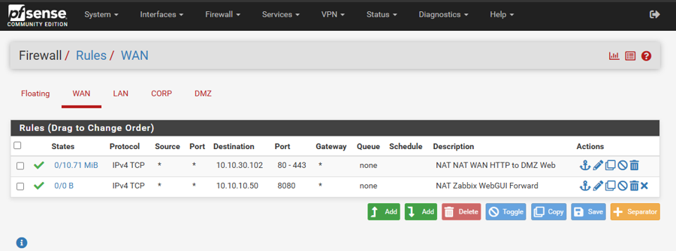

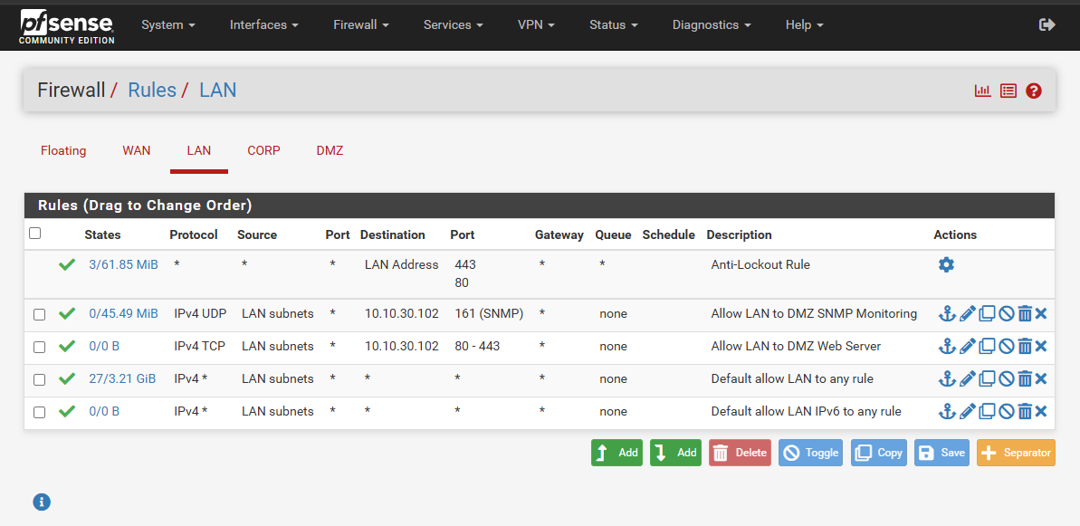

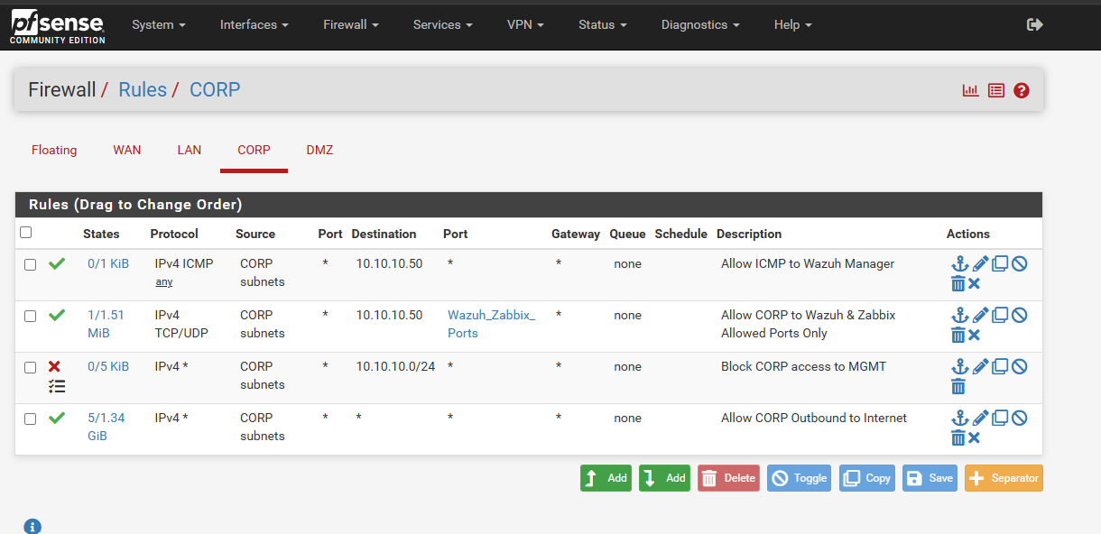

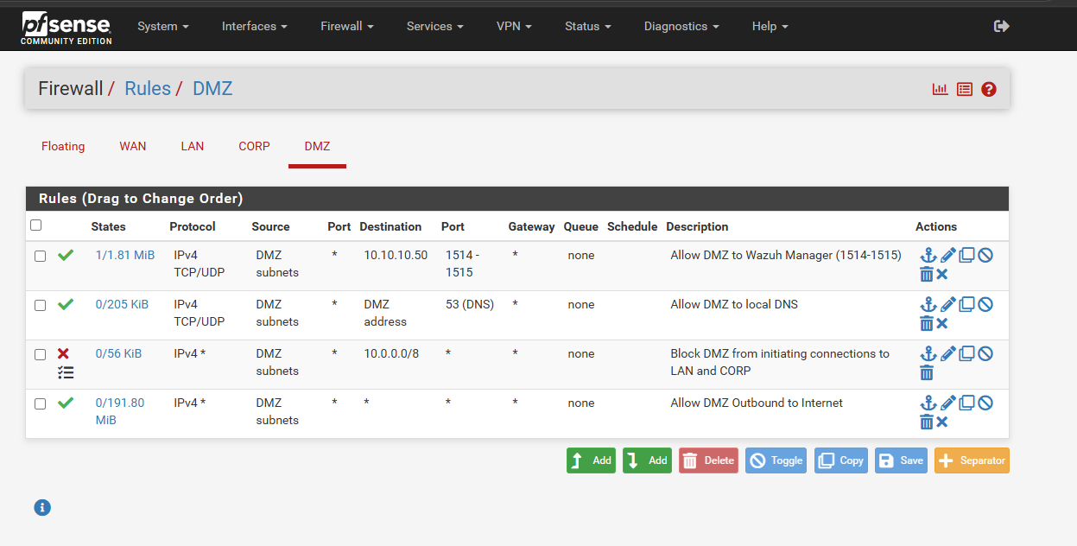

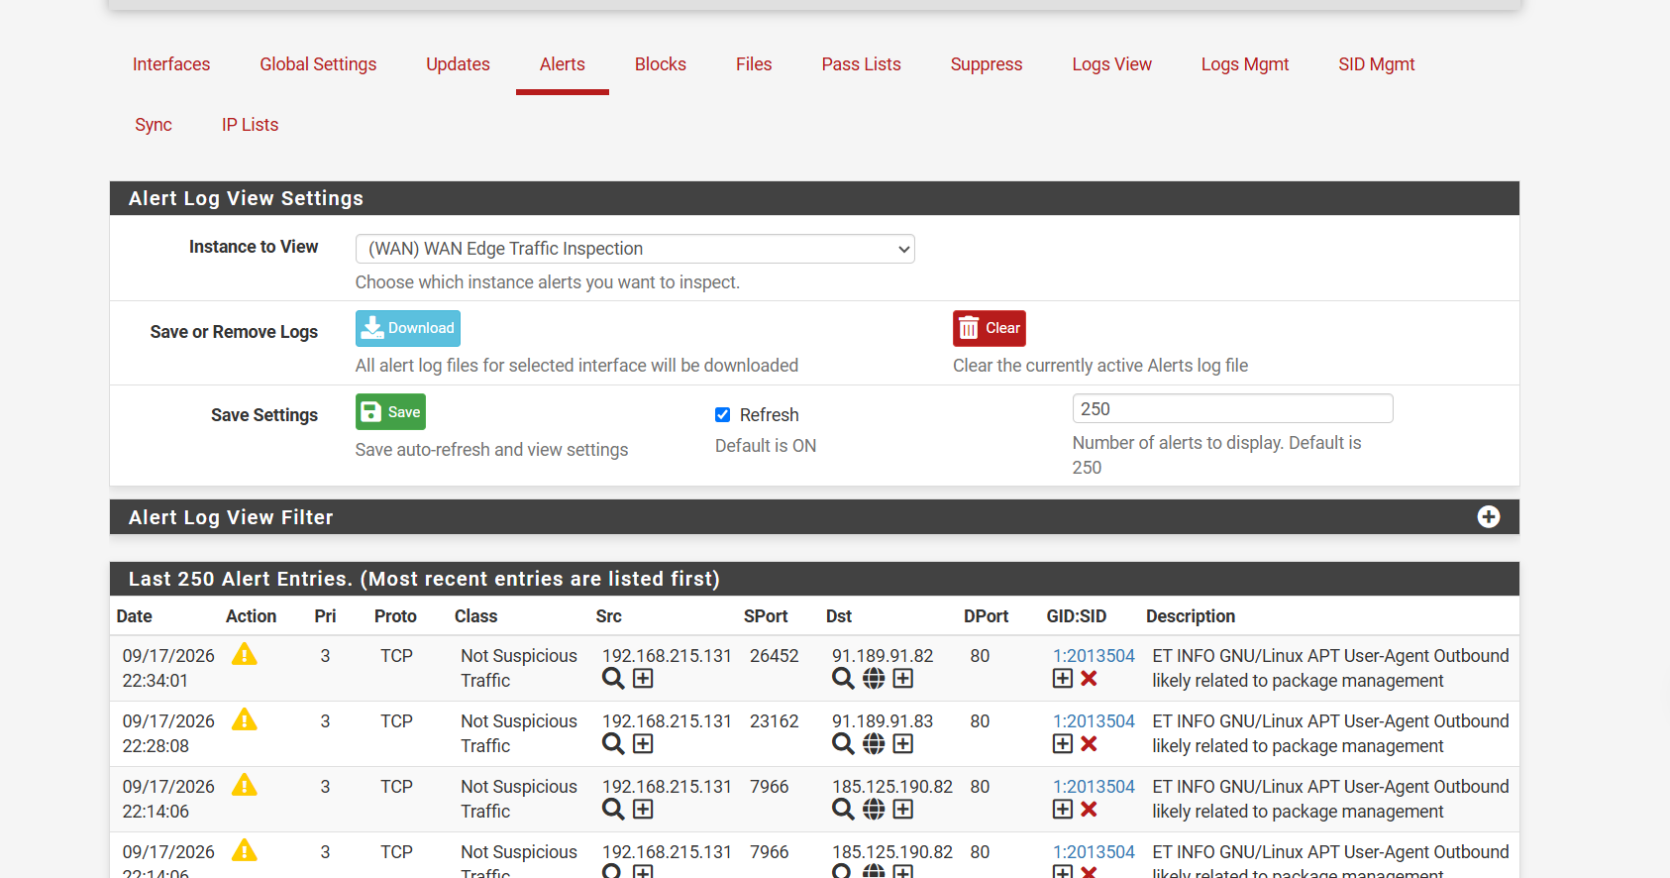

- Deploy a centralized monitoring solution (NOC) to track server uptime, network performance, and resource availability.
- Implement a Security Information and Event Management (SIEM) system (SOC) to collect and analyze security logs from multiple endpoints.
- Validate threat detection capabilities by executing simulated attacks mapped to the MITRE ATT&CK framework.
- Develop troubleshooting skills by resolving integration and configuration issues across various platforms and operating systems.

4. Scope

In-Scope:
- Deployment and configuration of pfSense, Wazuh, Zabbix, and target endpoints (Windows 10, Ubuntu Server).
- Implementation of network segmentation (LAN, DMZ, CORP).
- Configuration of data ingestion from endpoints (Sysmon, Linux auth logs, Nginx access logs).
- Simulation of specific threat vectors (Reconnaissance, Privilege Escalation, Web Attacks, Brute Force).
- Creation of alert filters and dashboards.

Out-of-Scope:
- Automated incident remediation (SOAR capabilities).
- High availability/failover clustering for the management servers.
- Full production deployment into a live corporate environment.

5. Architecture / How It Works
The network architecture is designed like a secure office building with different access zones. The pfSense firewall acts as the security guard at the front door and the hallways, ensuring traffic only flows where it is allowed. The network is divided into three main areas:
- Management LAN (10.10.10.x): The 'control room'. This houses the main server (Ubuntu running Docker at 10.10.10.50), which runs both the Wazuh SIEM (security monitor) and Zabbix (health monitor).
- Corporate Network (10.10.20.x): The 'employee workspace'. This contains a simulated employee workstation running Windows 10 (win10-client at 10.10.20.10).
- DMZ (Demilitarized Zone - 10.10.30.x): The 'public lobby'. This houses public-facing services like our web server (dmz-web01 at 10.10.30.102).

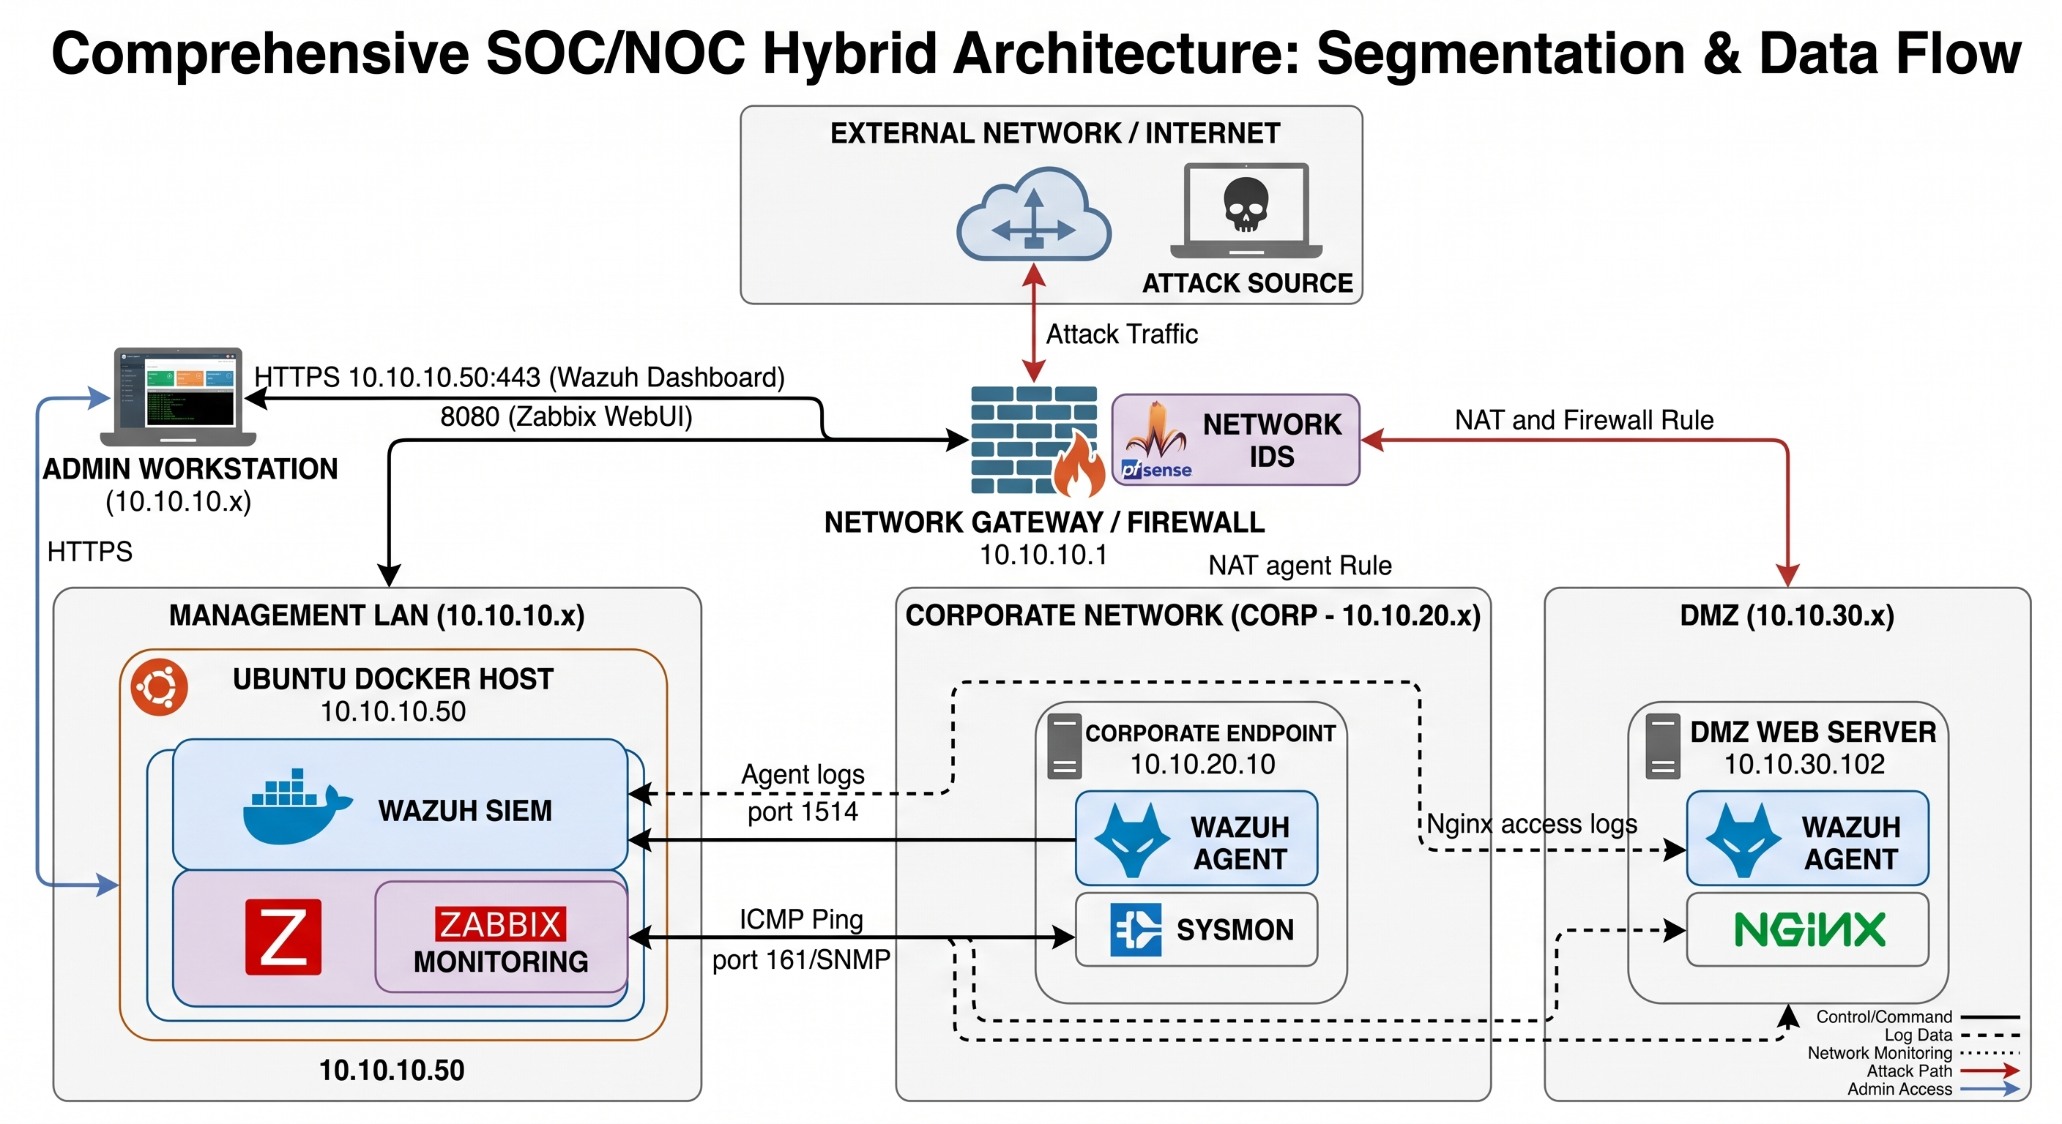

Small programs called 'agents' are installed on the Windows and DMZ servers. These agents act like security cameras and health sensors, constantly sending data back to the control room. If a server stops responding (caught by Zabbix) or if someone tries to break in (caught by Wazuh), an alert is generated.

6. Tools & Technologies Used
Tool / Platform | Function / Role | Reason for Selection
pfSense | Network routing, segmentation, and firewall boundary enforcement. | Industry-standard open-source firewall providing robust VLAN capabilities.
Suricata | Intrusion Detection System (IDS) at the network perimeter. | Provides deep packet inspection to catch malicious traffic before it hits the endpoints.
Wazuh | SOC platform for log analysis, file integrity monitoring, and endpoint detection and response (EDR). | Comprehensive, open-source SIEM that seamlessly maps alerts to the MITRE ATT&CK framework.
Zabbix | NOC platform for infrastructure and performance monitoring. | Highly scalable, supports both agent-based and agentless (SNMP/ICMP) monitoring.
Docker & Compose | Containerization platform to host Wazuh and Zabbix. | Ensures consistent, reliable deployment of complex backend systems on a single host.
Sysmon | Advanced Windows endpoint telemetry. | Provides granular visibility into process creation and network connections on the Windows client.
Kali Linux | Offensive security testing platform. | Used to simulate real-world attacks (SQLi, XSS, Privilege Escalation) to validate defenses.

7. Setup & Installation Guide

Step 1: Network Preparation
- Install pfSense and configure three separate network interfaces (LAN, CORP, DMZ).
- Assign IP subnets to each interface and create firewall rules to allow management traffic from LAN to CORP/DMZ.

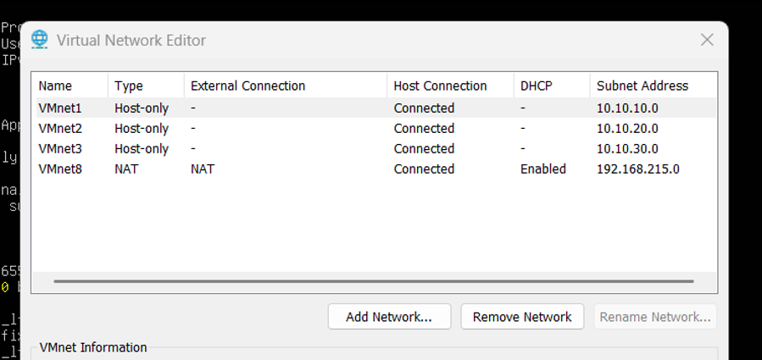

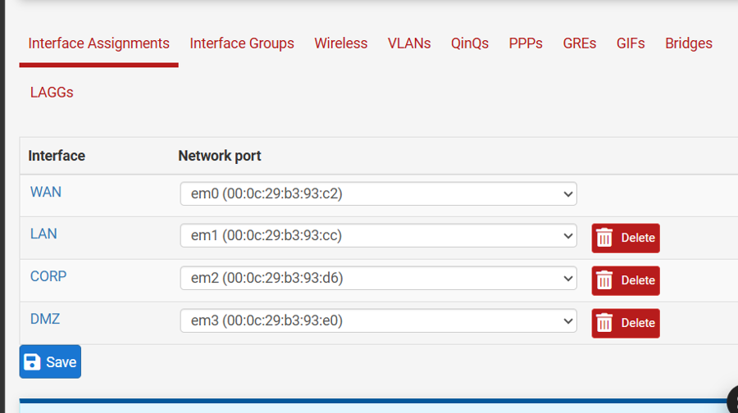

Step 2: Core Server Deployment
- Install Ubuntu Server on the LAN segment (IP: 10.10.10.50).
- Install Docker and Docker Compose.
- Deploy the Wazuh Manager/Indexer stack and Zabbix Server using their respective docker-compose.yml files.

Step 3: Endpoint Agent Installation
- Deploy a Windows 10 VM on the CORP network and an Ubuntu Server on the DMZ.
- Install the Wazuh Agent on both endpoints and connect them to the manager.
- Install Sysmon on the Windows 10 VM to enhance log generation.

Step 4: Monitoring Configuration
- In Zabbix, add pfSense and the DMZ server using SNMP templates.
- Add the Windows 10 client using an ICMP Ping template.
- Enable 'File and Printer Sharing (Echo Request - ICMPv4-In)' on the Windows Firewall to allow Zabbix pings.

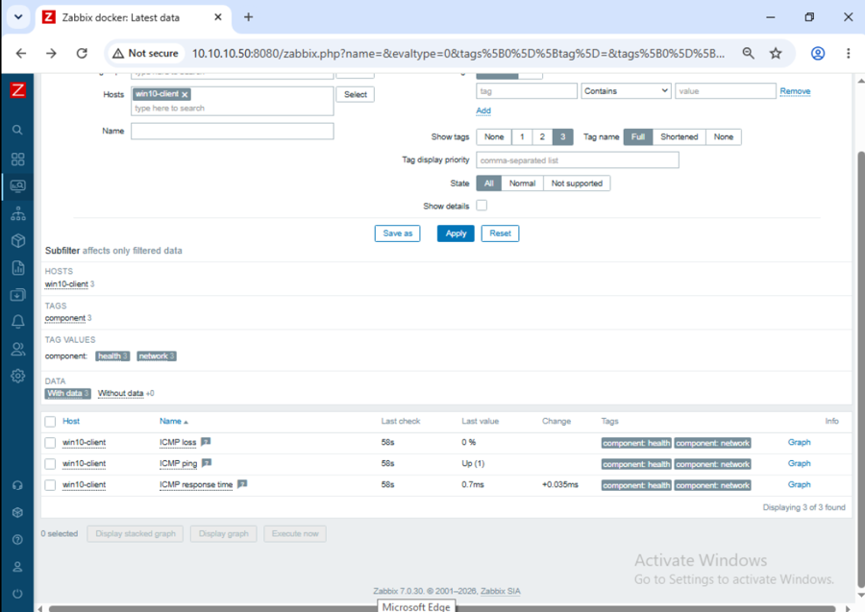

8. Workflow / Day-to-Day Operations
The daily operation of this hybrid NOC/SOC environment involves:
- NOC Monitoring (Zabbix): Dashboards are reviewed to ensure all hosts show green availability statuses. Graphs for network interface traffic and ping response times are monitored for anomalies.

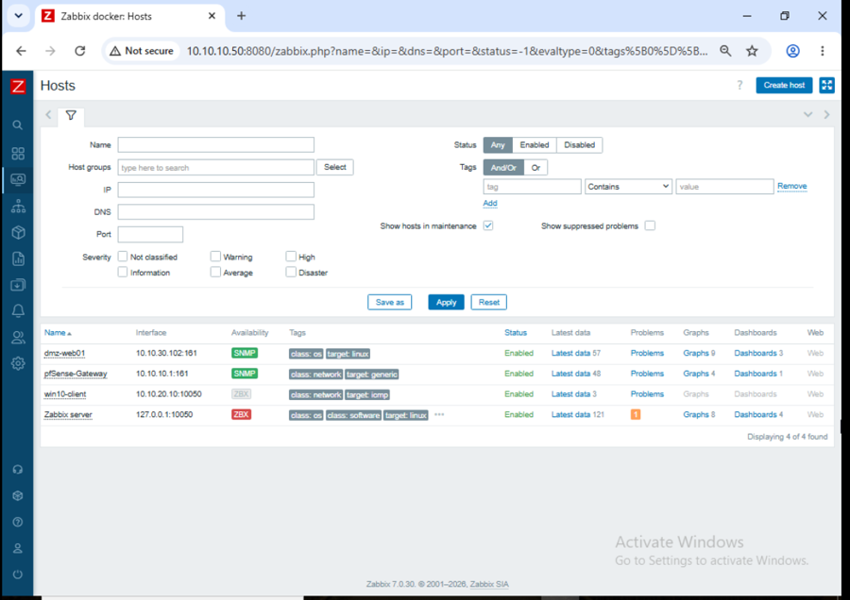

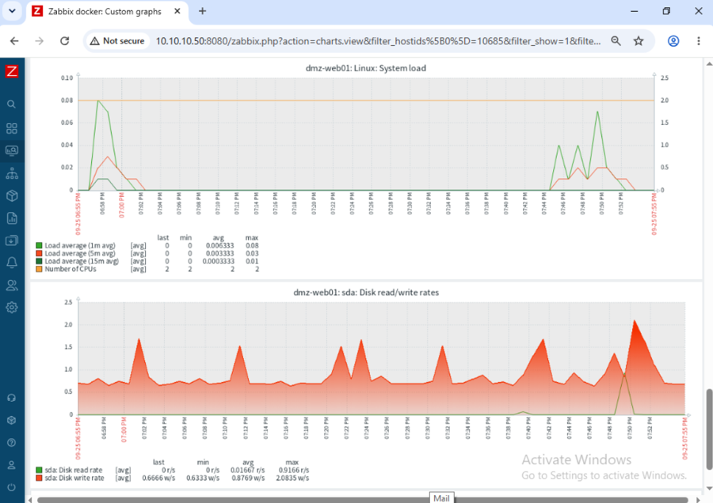
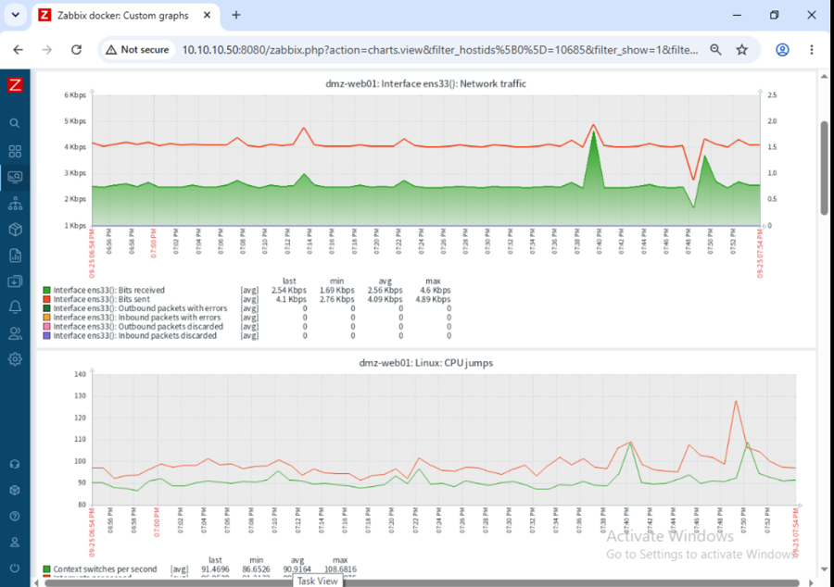

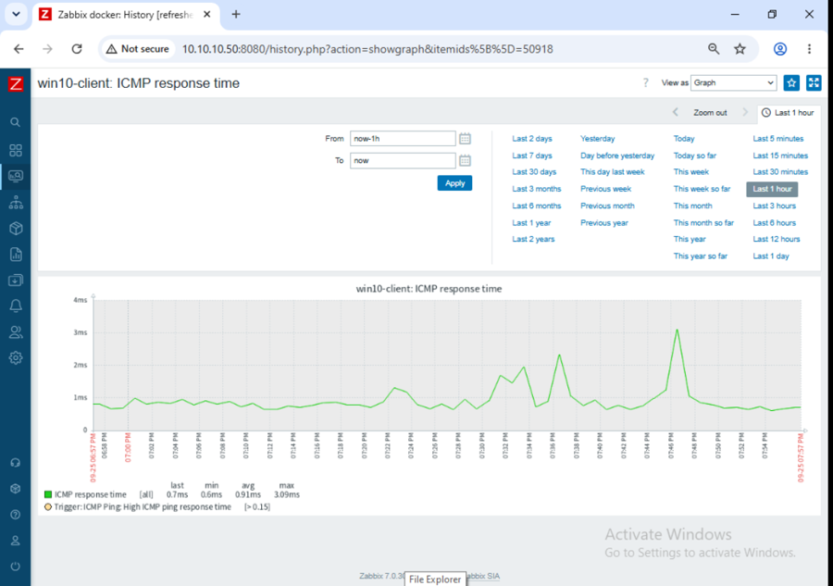
- SOC Monitoring (Wazuh): The SIEM dashboard is actively monitored for security alerts. Events are categorized by severity. Medium (Level 7-11) events are logged for review, while High (Level 12-14) and Critical (Level 15+) events trigger immediate incident response procedures.

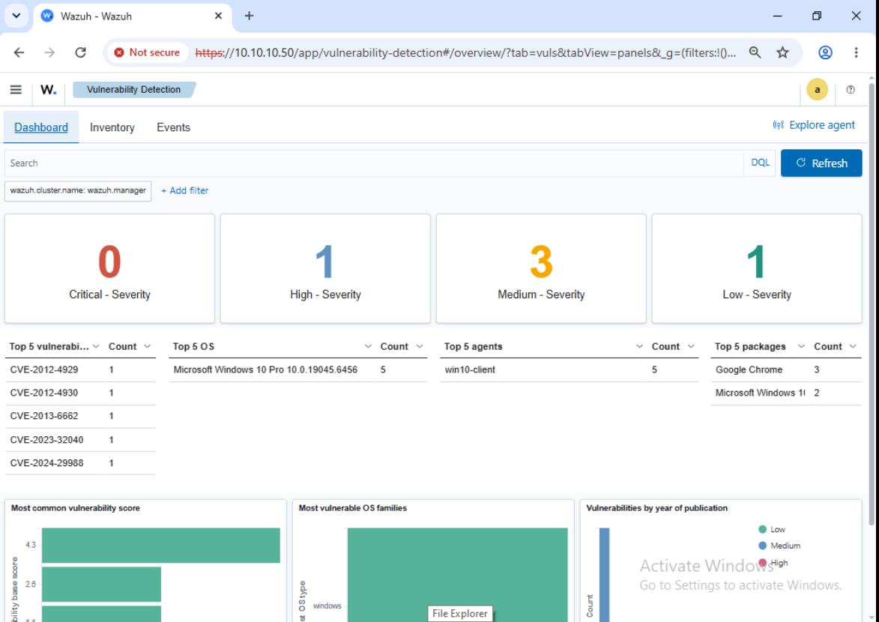

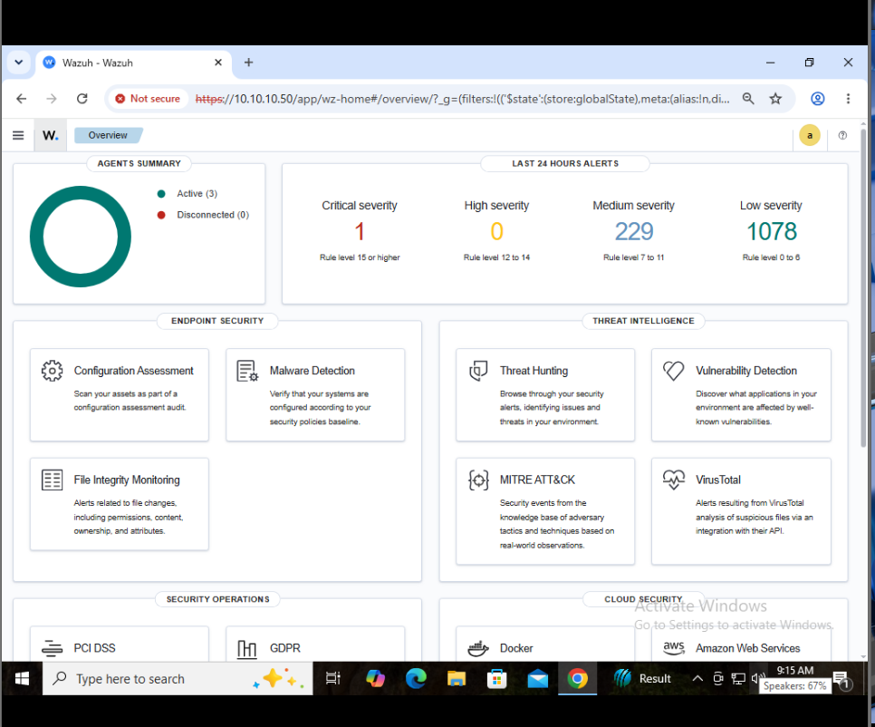

- Incident Handling: Following NIST SP 800-61 Rev 2 guidelines, when a threat (such as an OWASP web attack or sudo privilege escalation) is detected, the team identifies the source IP, contains the threat (e.g., via pfSense firewall block), eradicates the vulnerability, and documents the incident.

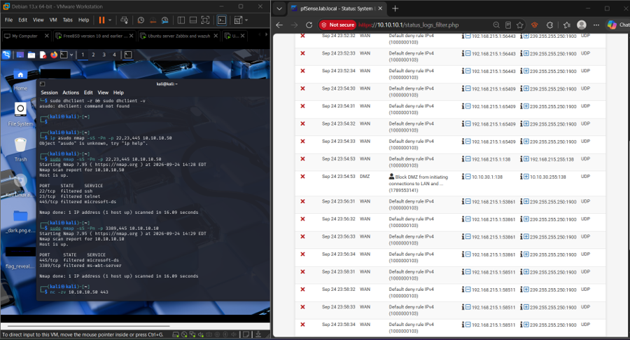
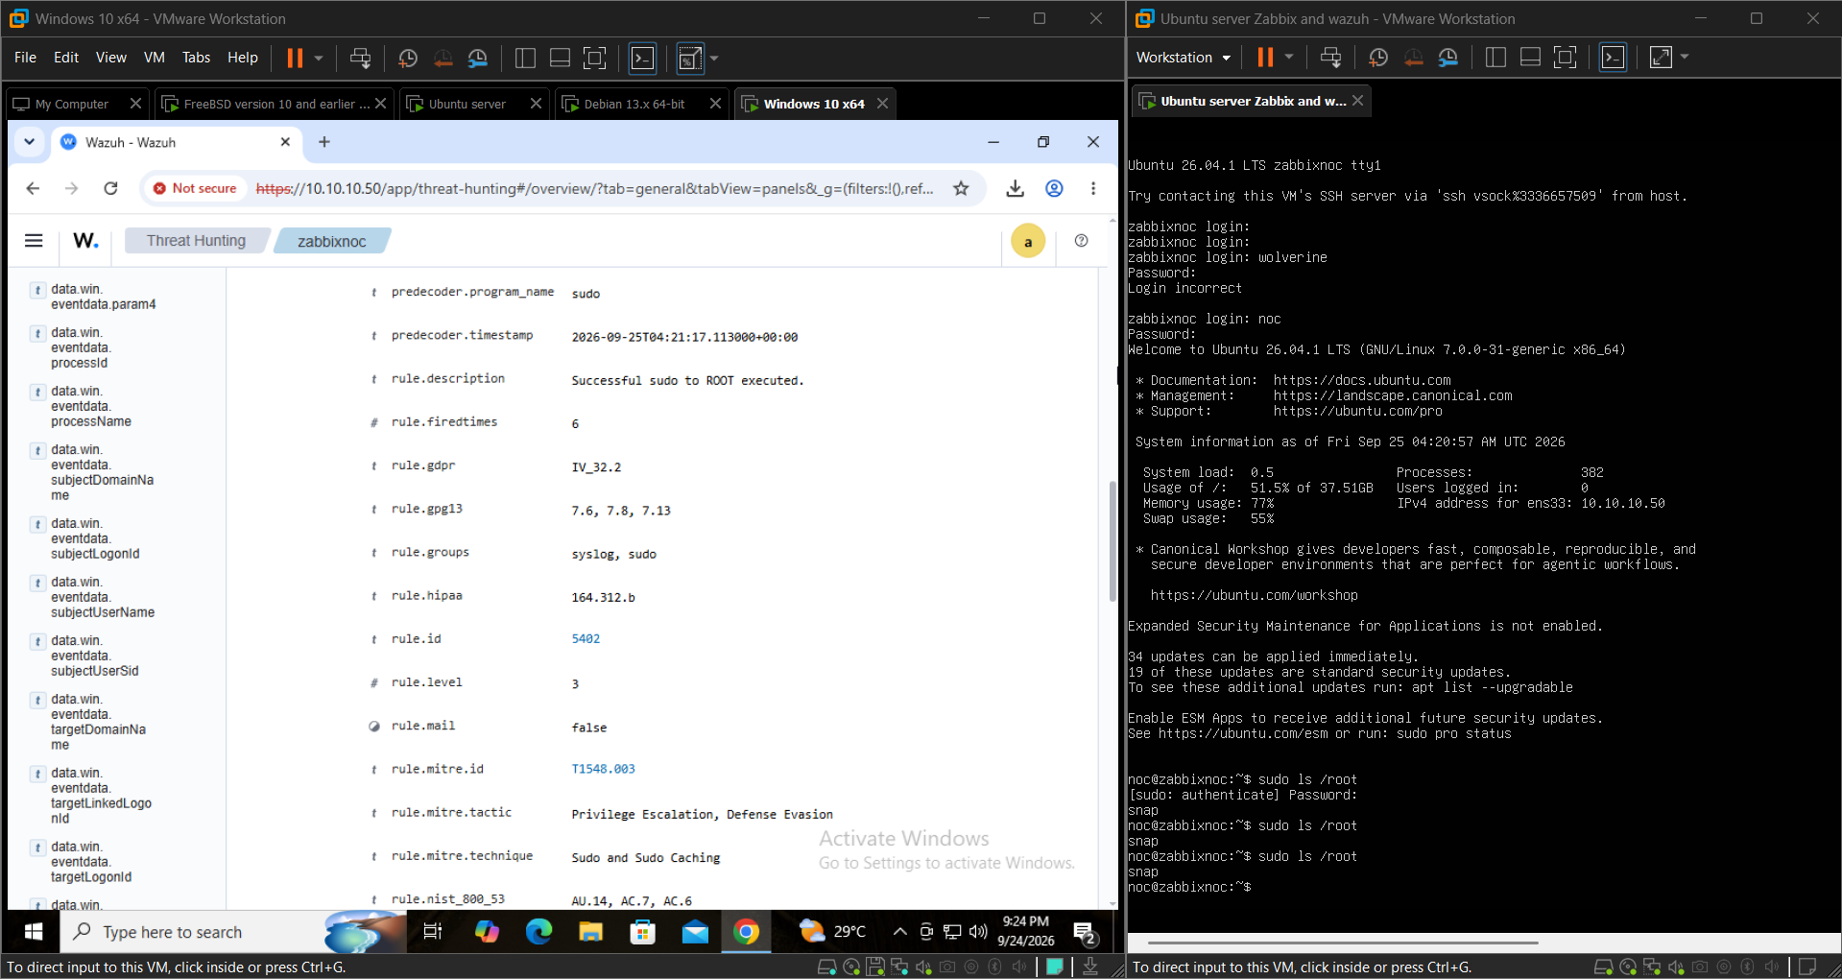

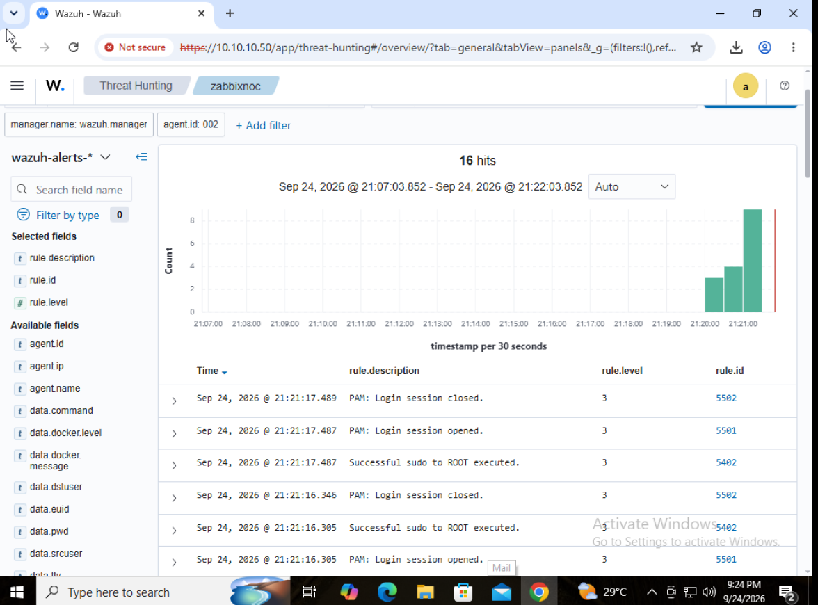

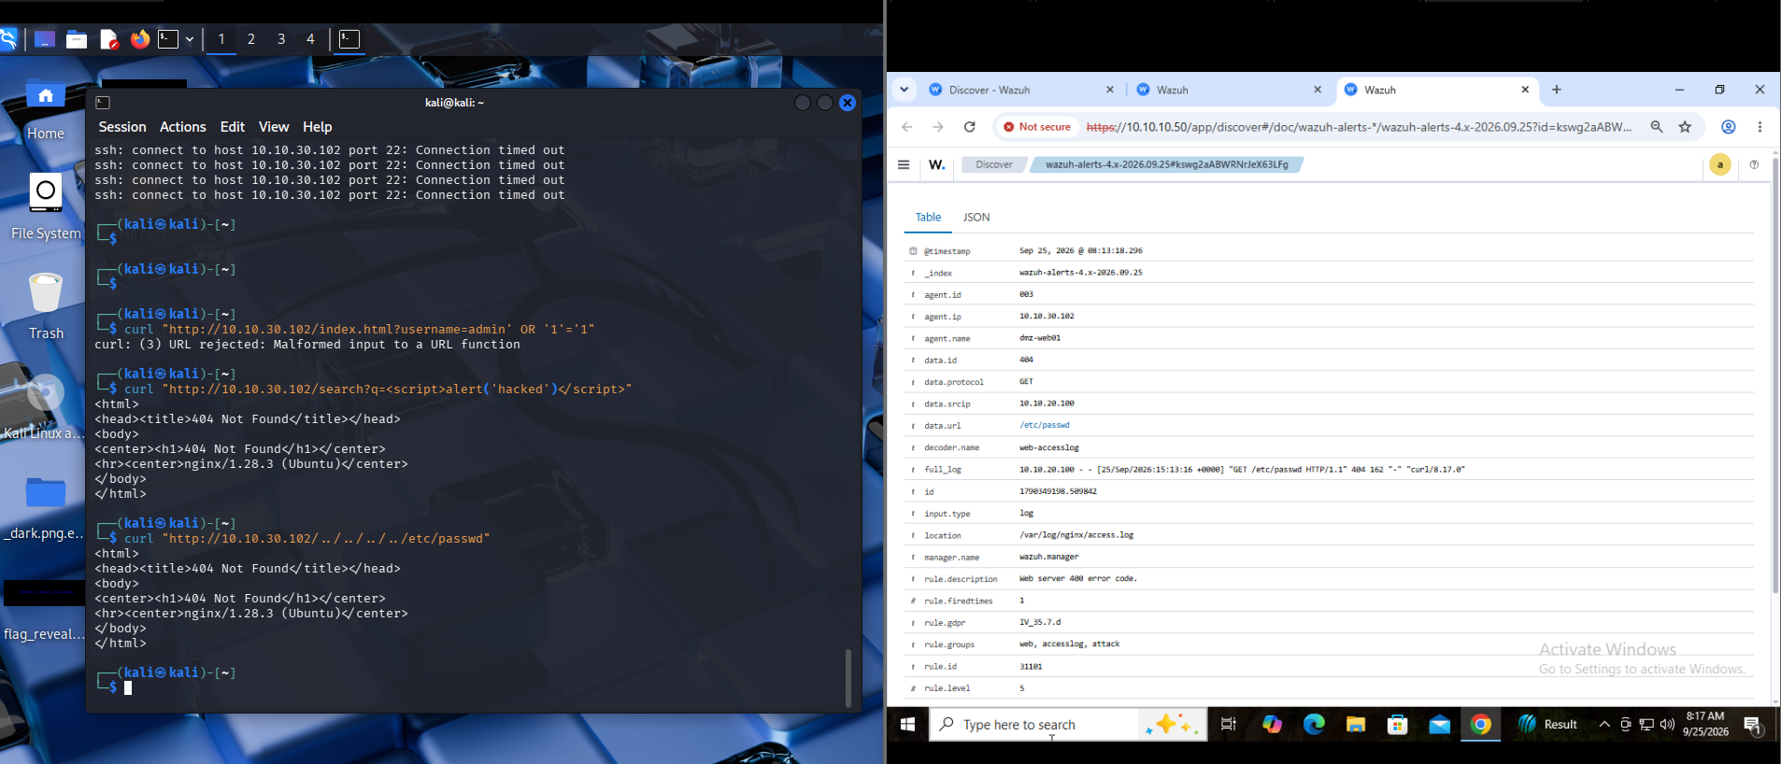

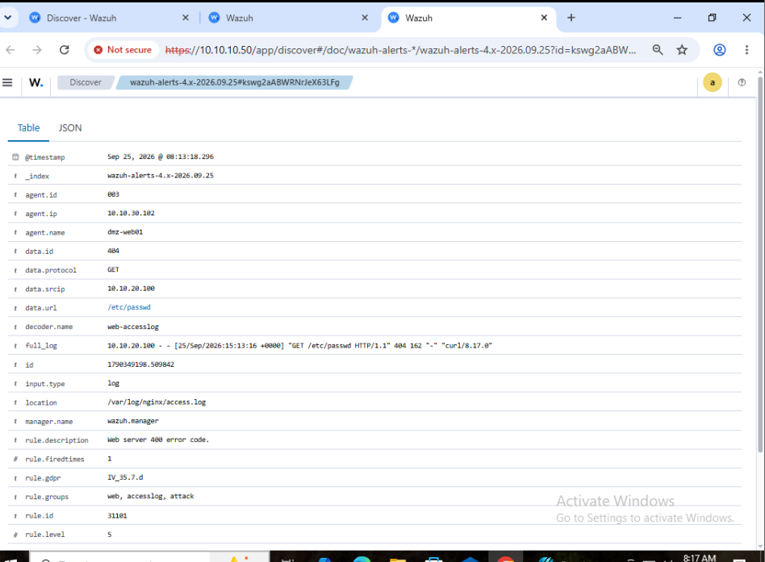

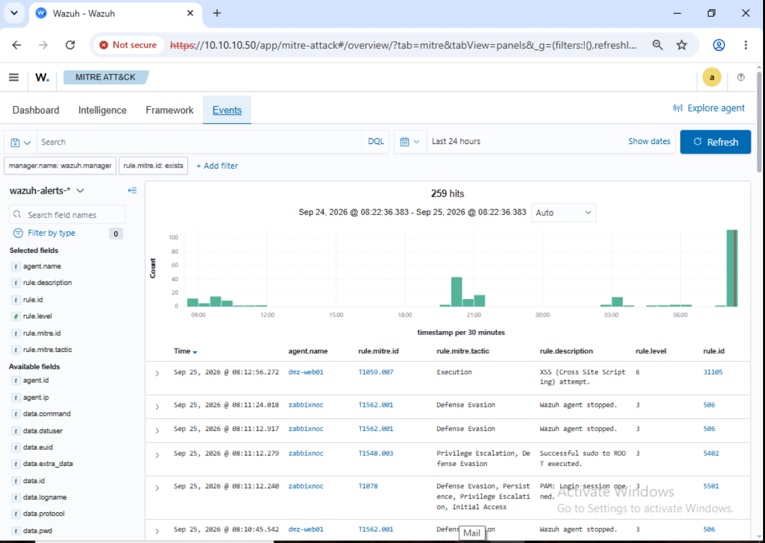

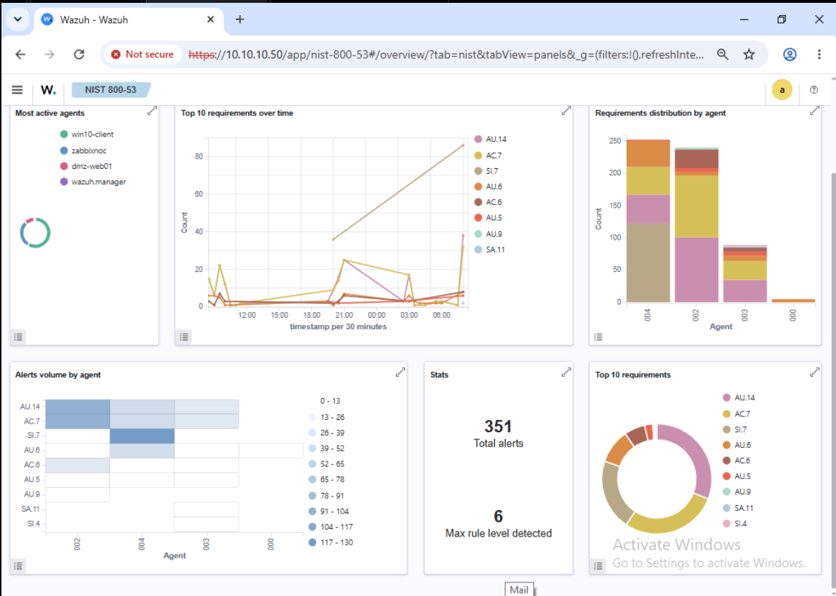

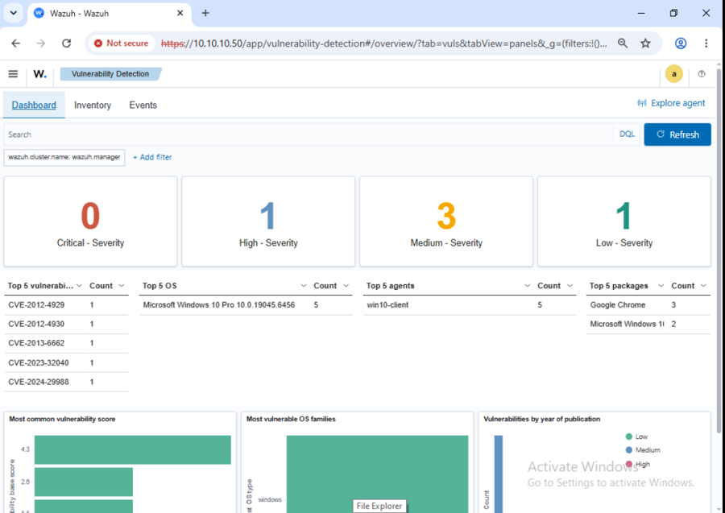

9. Challenges Faced & How They Were Solved
Challenge / Issue | Root Cause | Solution Applied
Wazuh OpenSearch 'Internal Server Error' (Null Pointer Exception) | The dashboard DQL search bar requires specific uppercase boolean operators (OR) and exact field matching for nested JSON objects. | Bypassed DQL syntax errors by using the built-in UI 'Add Filter' tool (filtering by 'rule.level >= 3').
Missing Alerts in Wazuh Dashboard (Empty Results) | Timezone clock drift (UTC in container vs Local Time in browser) and hard-pinned agent filters hiding recent events. | Cleared pinned filters, expanded time range to 'Last 24 hours', and used the raw 'Discover' tab. Verified backend ingestion directly via alerts.json.
Zabbix reporting 'Unavailable by ICMP ping' for Windows 10 Client | Built-in Windows Defender Firewall drops incoming ICMP (ping) requests by default, causing the health check to fail. | Ran a PowerShell command to enable the 'File and Printer Sharing (Echo Request - ICMPv4-In)' firewall rule.

10. Lessons Learned & Best Practices
- Log Verification: Always verify log ingestion at the backend (e.g., checking alerts.json in Wazuh) before assuming the dashboard UI is broken.
- Syntax Matters: When querying databases, precise syntax and understanding field mappings are critical to prevent interface crashes.
- Default Firewall Rules: Operating systems often have strict default firewalls (like Windows blocking ICMP) that can interfere with standard monitoring protocols.

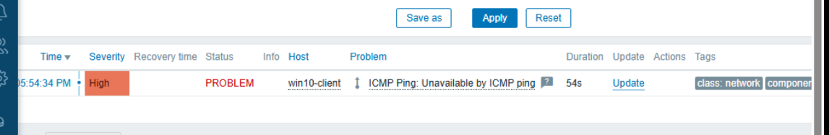

11. Future Improvements / Roadmap
- Implementation of automated Active Response in Wazuh to block attacking IPs automatically.
- Integration of a vulnerable web application (like OWASP Juice Shop) on the DMZ to test more complex web attack vectors.
- Configuration of email or Slack integrations to alert administrators of critical Zabbix or Wazuh events in real-time.

12. Glossary
NOC (Network Operations Center): A centralized location where IT administrators manage, control, and monitor network health and performance.
SOC (Security Operations Center): A centralized function where a team continuously monitors and analyzes an organization's security posture.
SIEM (Security Information and Event Management): Software that gathers and analyzes activity from resources across an IT infrastructure.
VLAN (Virtual Local Area Network): A custom network created from one or more existing LANs.
MITRE ATT&CK: A globally-accessible knowledge base of adversary tactics and techniques.
ICMP (Internet Control Message Protocol): A network layer protocol used to diagnose communication issues (e.g., 'ping').
SNMP (Simple Network Management Protocol): An Internet Standard protocol for collecting information about managed network devices.

13. Appendix
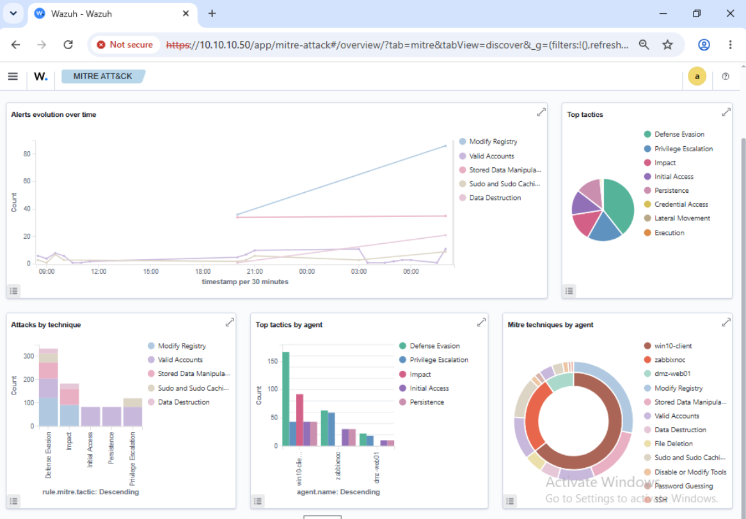

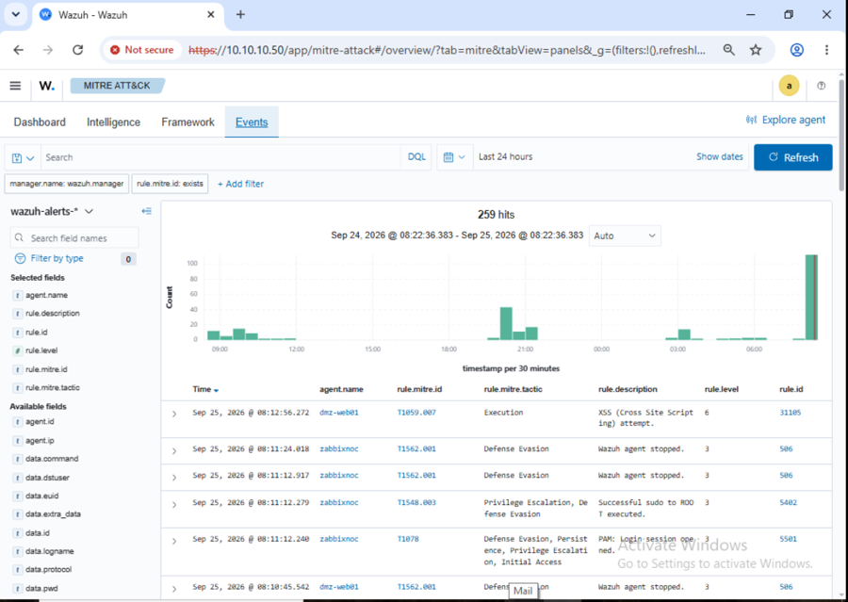
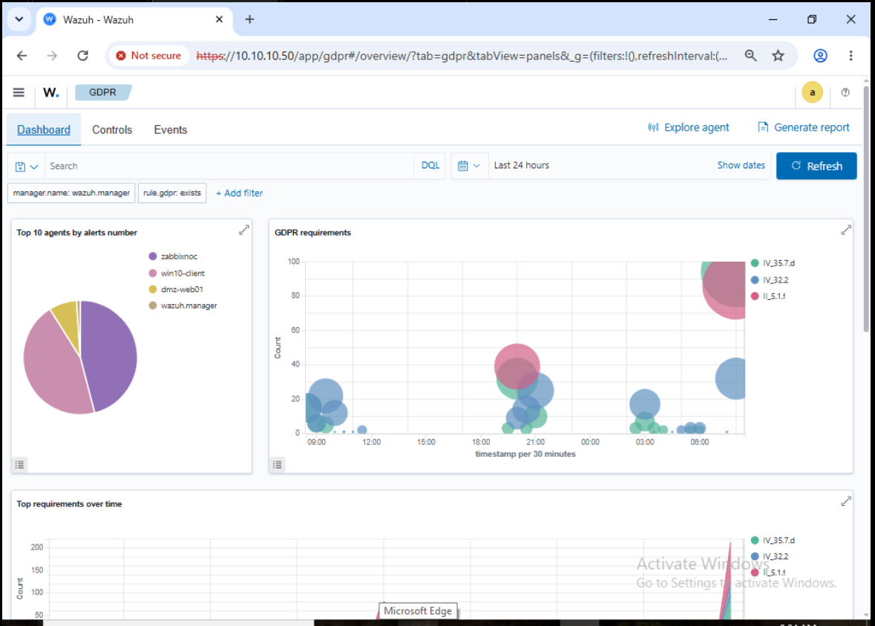
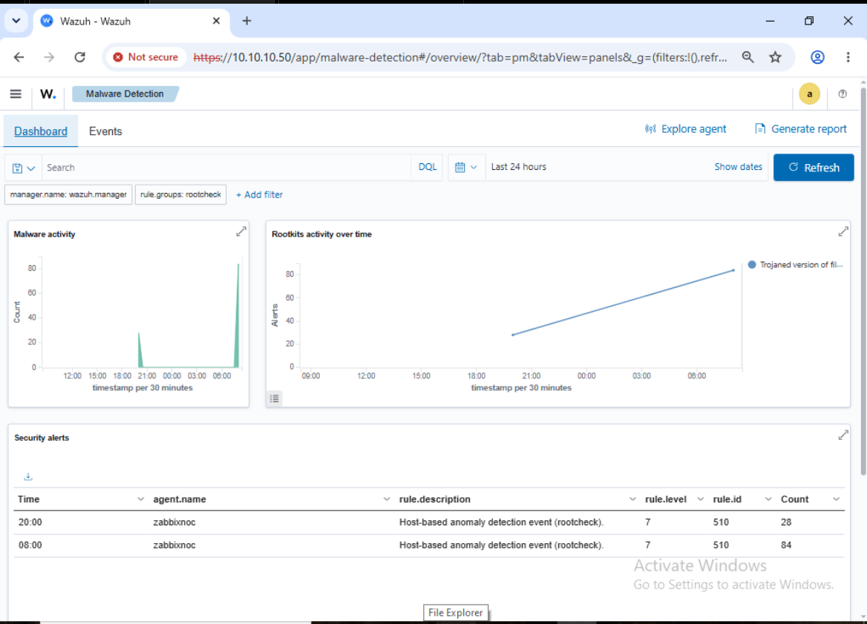

14. Info Needed
The following details were not explicitly detailed during the troubleshooting sessions and may need to be filled in manually to complete the documentation:
- Specific hardware specifications (CPU, RAM, Storage) allocated to each VM/Container.
- Exact Suricata IDS configuration steps and rule sets deployed.
- Details on specific NIST SP 800-61 Rev 2 incident response playbooks customized for this lab.

