

Course title: Computer Networking

Course code: CSE405

Semester: summer 2021

Section: 01

**Project report**

**Project title: Design a full-fledged network for an organization with multiple subnets.**

Submitted by

**Name: Abdullah al nayeem**

**Id: 2018-1-60-086**

**Department: Computer Science & Engineering**

Submitted to

Md Anisur Rahman

Associate Professor

**Department of Computer Science & Engineering**

**Date of Submission: 20.09.2021**

**Problem Statement:** INTERNATIONAL APEX University, is an enterprise like East West University, owns a large number of computers, with a complex network infrastructure. Apart from wired internet access to all the classrooms, labs, employee PCs, library and other administrative and academic wings, the university also provides wireless internet access for everyone. On top of that the university runs a number of complex networked systems to support several of its business process like admissions, advising, results, eTender, library management, accounts and so on. This complex network infrastructure is subnetted and switching/routing mechanisms are in practice.

**Used Tools:**

* Packet Tracer Software (version 7.2.1)
* Switches
* PC-PT
* Routers
* Laptop
* Server-PT For Web
* Server-PT For DNS
* Server-PT For DHCP
* WRT300N For Wireless Router
* Connectors

**Project Diagram:**

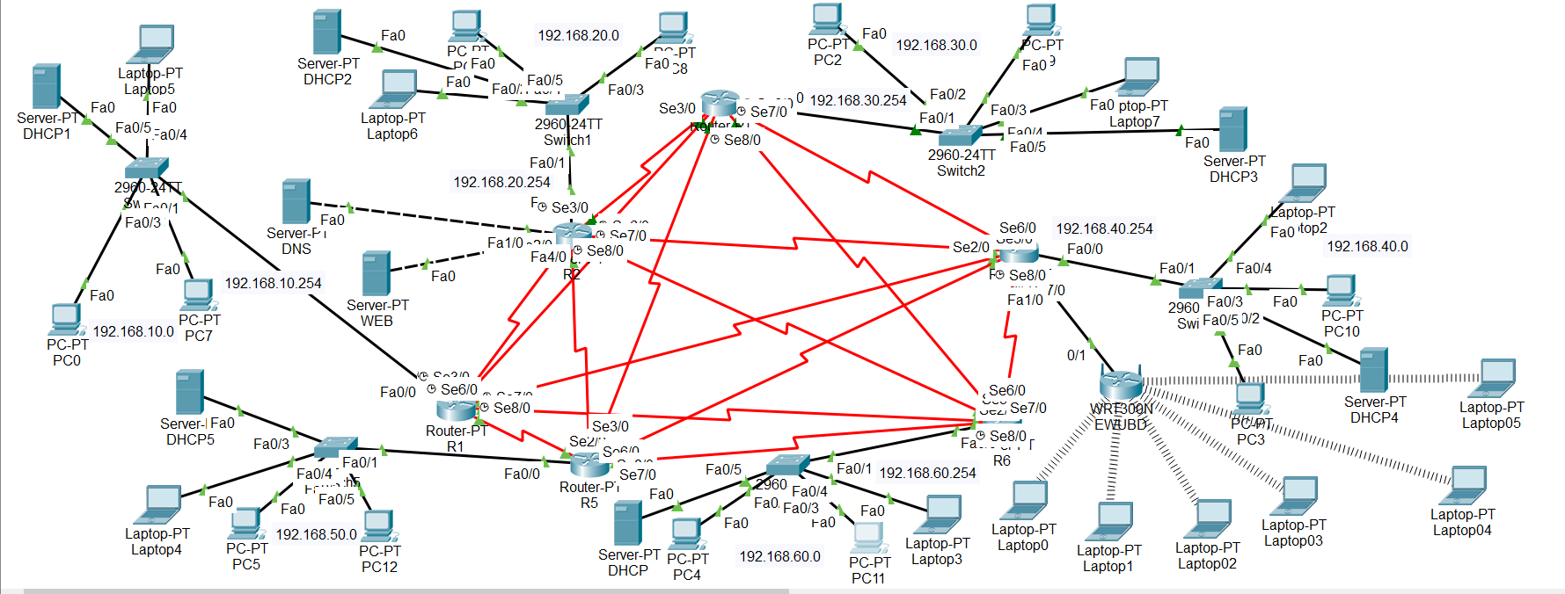

**Tool Set-Up Details:**

* **Routers:** In this project, am mainly use six PT Router.
* **Switches:** Switch-2960(Total 6 switch) uses in this project. This switch has total 24 Fast Ethernet port and two Gigabit Ethernet port.
* **DHCP server:** In this project uses six DHCP server. And I have assign ip address for the each DHCP server. I also add the gateway IP and the DNS server IP.

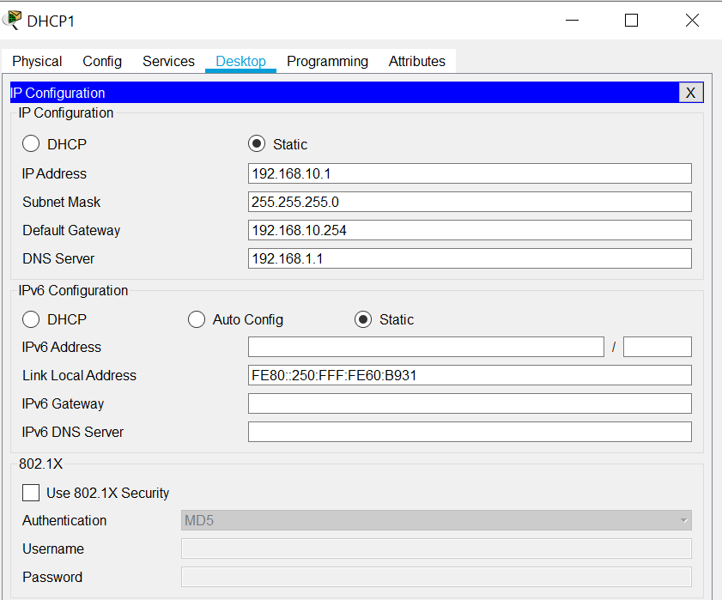

I have created pool for different networks. For example in case of serverpool

network(IP:192.168.10.0) the default gateway will be 192.168.10.254.

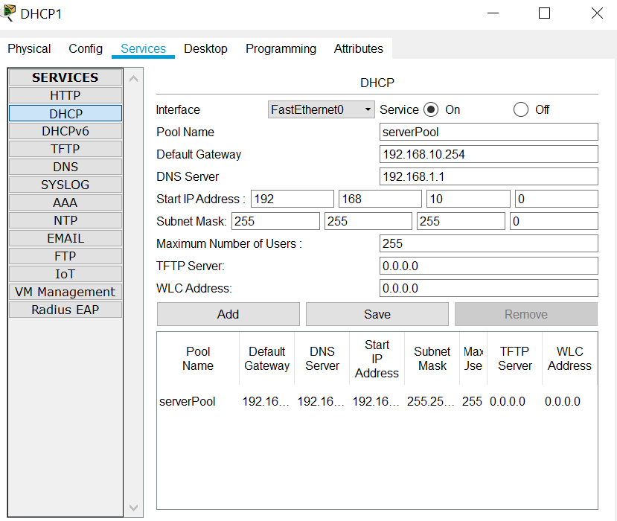

* 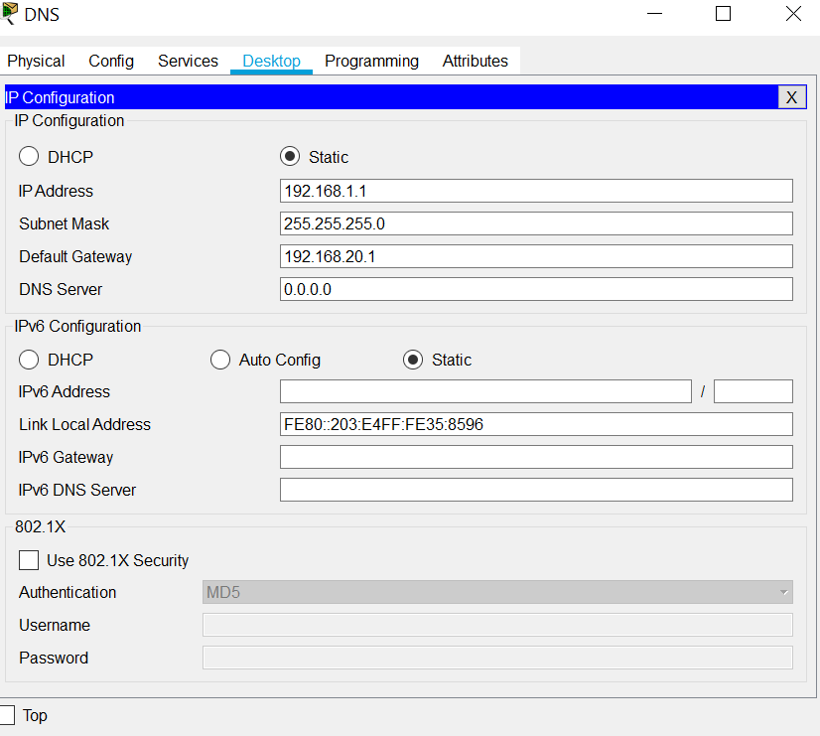**DNS server:** Here uses only one DNS Server. And I have set the IP for DNS server and also added the Default Gateway IP.
* **WEB Server:** Here uses only one WEB server.

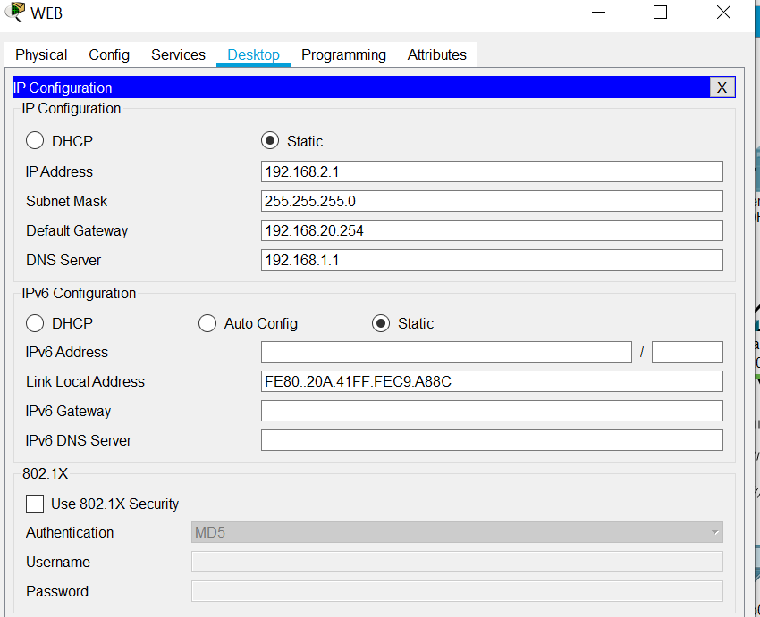

**Wireless Networking:** For wireless networking i have used a wireless router. The IP address of this network is 192.168.0.1. I have set the IP address of my wireless router as 192.168.0.2.

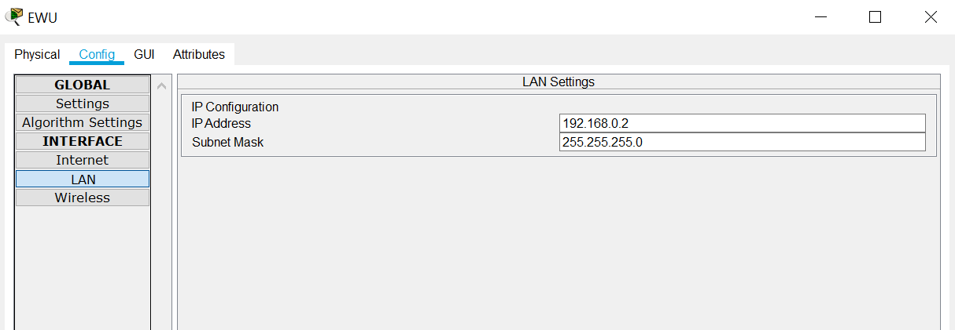

**Sample output:** Here is the some sample output to understand whether the pc are connected or not,

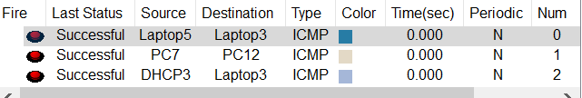

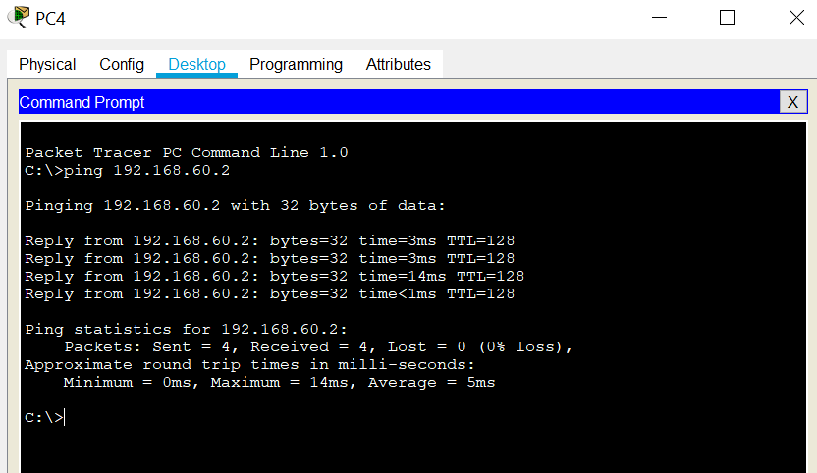

**Conclusion:** This design can connect a lot of devices together. It is easy to operate. But There are also some limitations. The webpage is not fully complete. Wireless Router area Nodes can’t find Web Page(Ewu). But I have learned lot of things while designing the network.