**East West University**

**Assignment**

Course Code & Title: CSE442 Microprocessor & Microcontroller

Section: 02

Subject: LAB 3

Student Name: Abdullah al nayeem

Student ID: 2018-1-60-086

**8-Bit Multiplication of 8086 microprocessors:**

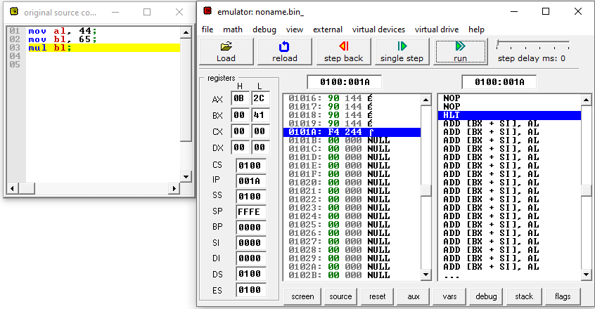

**16-Bit Multiplication of 8086 microprocessors:**

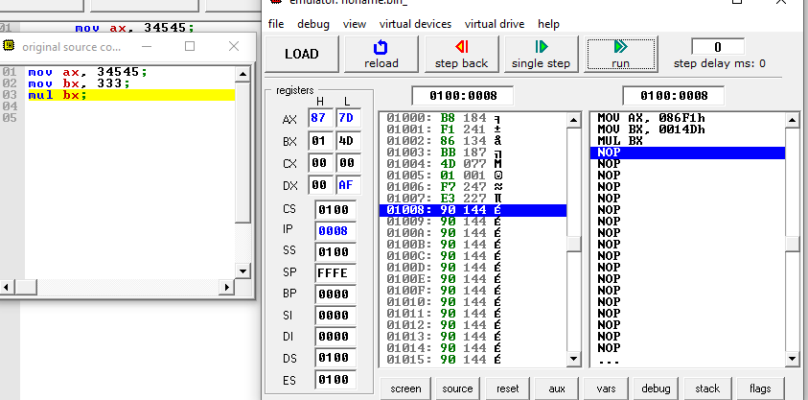

**Signed multiplication of the 886 multiprocessors:**

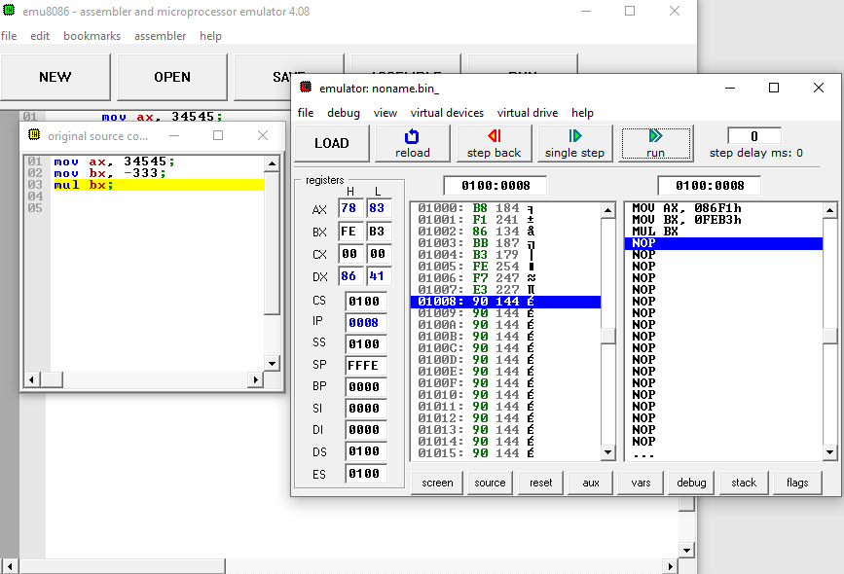

**8-Bit Division of 8086 microprocessors:**

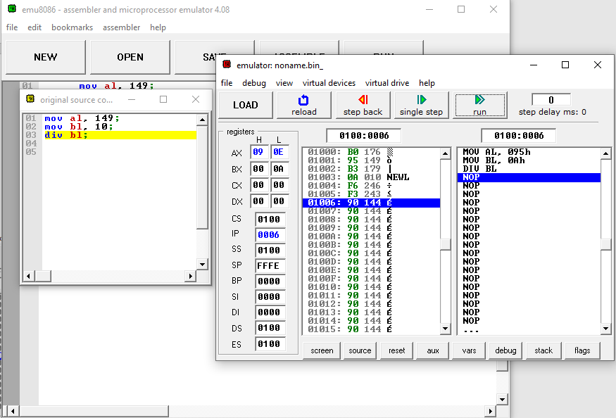

**16-Bit Division of 8086 microprocessors:**



**And Operation on 8086 Microprocessors:**

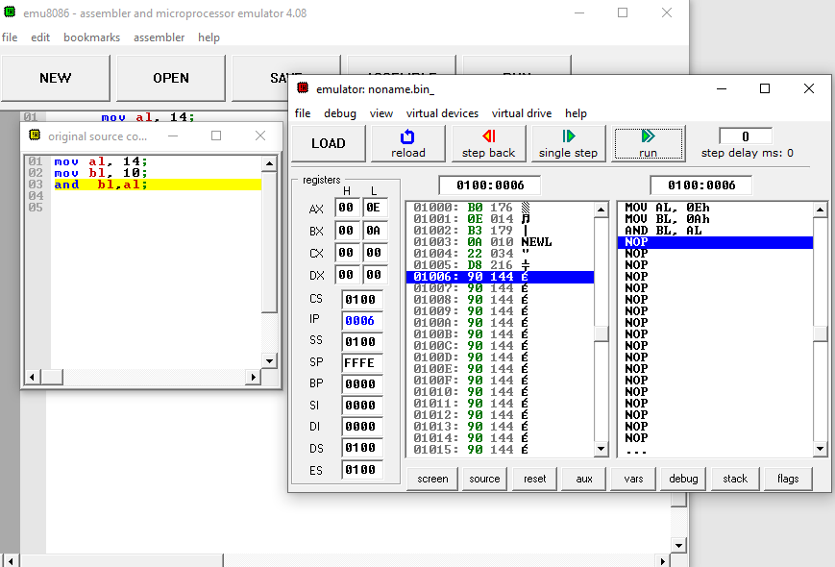

**OR operation of 8086 Microprocessors:**

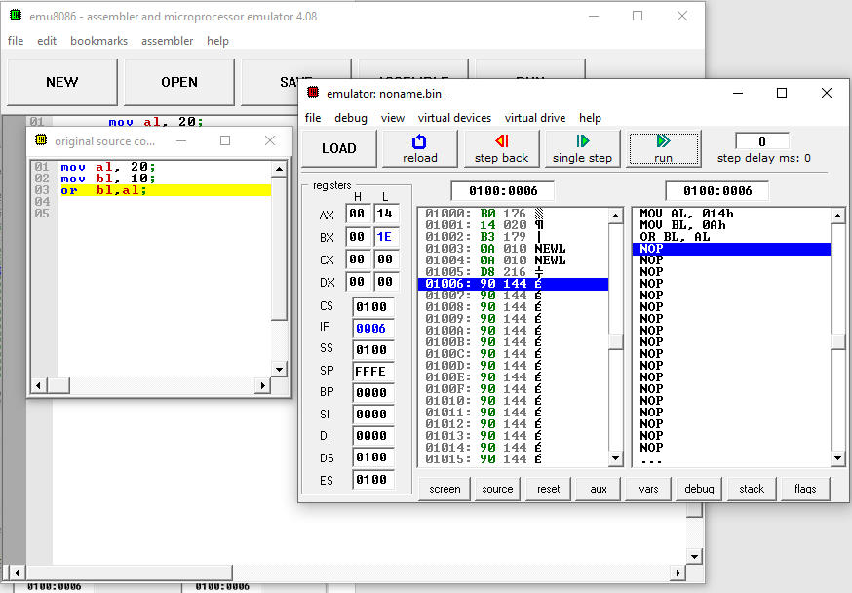

**Not operation on 8086 Microprocessors:**

