

Detailed Level Design Document

**On**

Online Forum



VNR Vignana Jyothi Institute of Engineering & Technology Bachupally, Nizampet (S.O), Hyderabad–90

***Submitted By***

***Group Details:***

**A.ROHITH - 19071A05C4**

**A.SURYA THEJA – 19071A05C5**

**MD.SHOIEB IQBAL – 19071A05F2**

**M.AKHIL REDDY – 19071A05F3**

**T.C.KEVIN SUCHETAN – 19071A05H8**

Contents

Revision History 6

1 Document Overview 7

1.1 Purpose 7

1.2 Audience 7

1.3 Detailed-Design Process 8

2 Detailed-Level Design 9

2.1 UML Class Diagram 9

2.2 State Diagram 10

2.4 Component Diagram 11

3 Sequence Diagrams 12

3.1 Create User 12

3.2 User login 12

3.3 Search/ Post Query 13

4 Activity Diagram 14

4.1 User Login 14

4.2 Login Activity 15

4.3 Search/ Post Query : 16

# Revision History

|  |  |  |  |  |
| --- | --- | --- | --- | --- |
| Revision | Date | Author | Section | Comments/Changes |
| 1.0.0 | 1 April 04 | All | All | Initial Revision. |
|  |  |  |  |  |

# Document Overview

## Purpose

The purpose of this document is to specify the detailed-level design for the Online Forum. This document will act as a map for the implementation of the system. It also provides descriptions for the major components of the Online Forum system. Sequence diagrams are used to ensure that the design is capable of carrying out the functional requirements of the system.

## Audience

This detailed-level design is intended to be used by members of the development team that will implement the functionality of the Online Forum. This document will also be used to communicate the detailed-level design and design considerations to the ITS staff members.

* + - A. Rohith , Development Team
    - A. Surya Theja, Development Team
    - Md. Shoeib Iqbal, Development Team
    - M. Akhil Reddy, Development Team
    - T.C. Kevin Suchetan, Development Team

## Detailed-Design Process

Once the high-level design has been completed, we focused on developing a detailed-level design. First a general UML module diagram for the server-side system was generated. Then the team discussed what design patterns could be used to enhance the general design. Then the team decided that factory, strategy and command design patterns were appropriate for use indifferent portions of the general design. A more thorough version of the design was generated including the chosen design patterns. Then the team went through each class in the design and decided upon major functions and attributes. Various parameterized objects were added for intersystem communication.

Finally, the team used sequence diagrams to verify that the design is capable of satisfying each use case, as specified in the Software Requirements Specification. The process of generating sequence diagrams led to discovery of design flaws and modifications to the design were made as needed.

# Detailed-Level Design

## UML Class Diagram

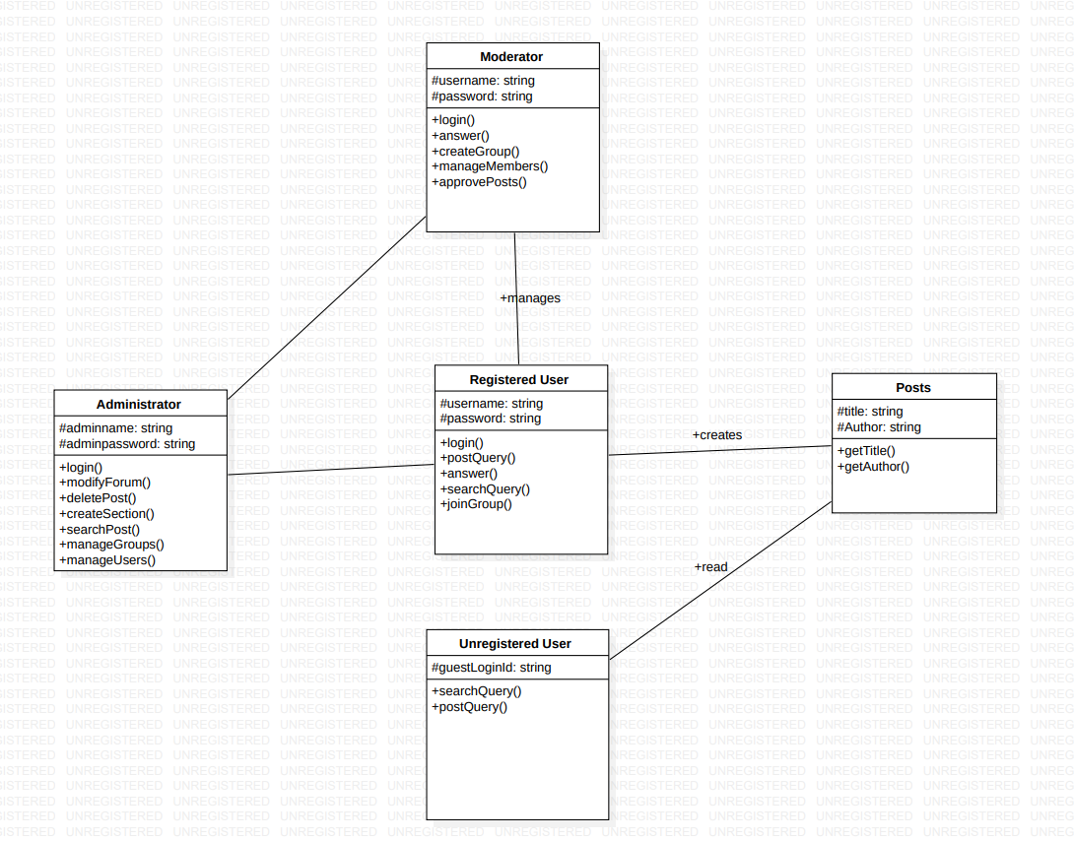

**Administrator:**

The administrator often makes decisions regarding web hosting, which is a service

that makes the forums accessible to visitors through the web.

**Moderator:**

A forum moderator oversees the communication activity of an Internet forum.

He monitors the interchange of contributors and makes decisions regarding

Content and the direction of threads.

**Posts:**

Posts are the queries posted by the registered user so that others registered users can also view them.

**Unregistered User:**

The users who are not registered are unregistered users .They can only read the posts without modifying them.

**Registered User:**

The users who are registered to the website are registered users.They can create posts, and interact with other users.

## State Diagram

User login through login window redirects to home page if he is registered user ,then he can access post, answer search and delete post functionalities .

* 1. **Deployment diagram**

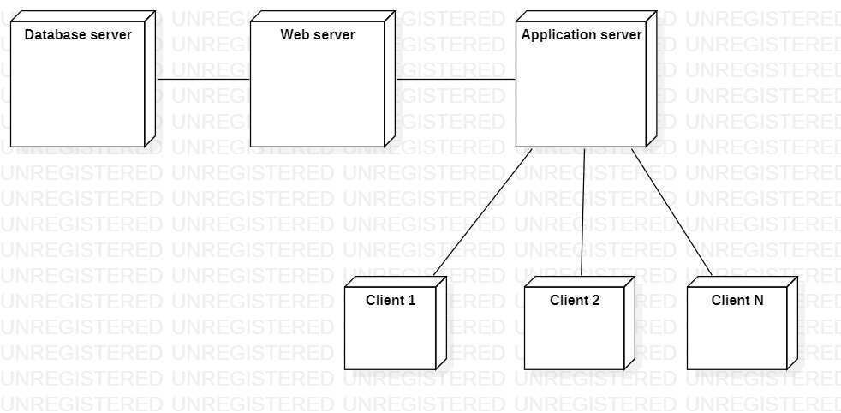

The deployment diagram describes the physical deployment of information generated by the software program from database to client.

## Component Diagram

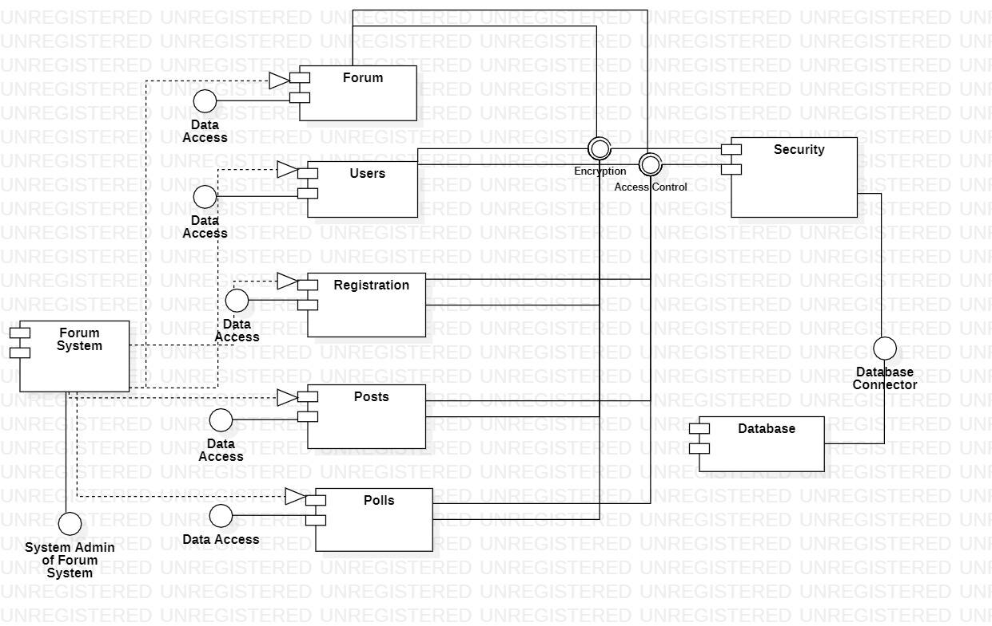

This is a component diagram of online forum which shows components, ports and relationships between the Registrations, Forums, Posts, Polls and users.

# Sequence Diagrams

## Create User

## User login

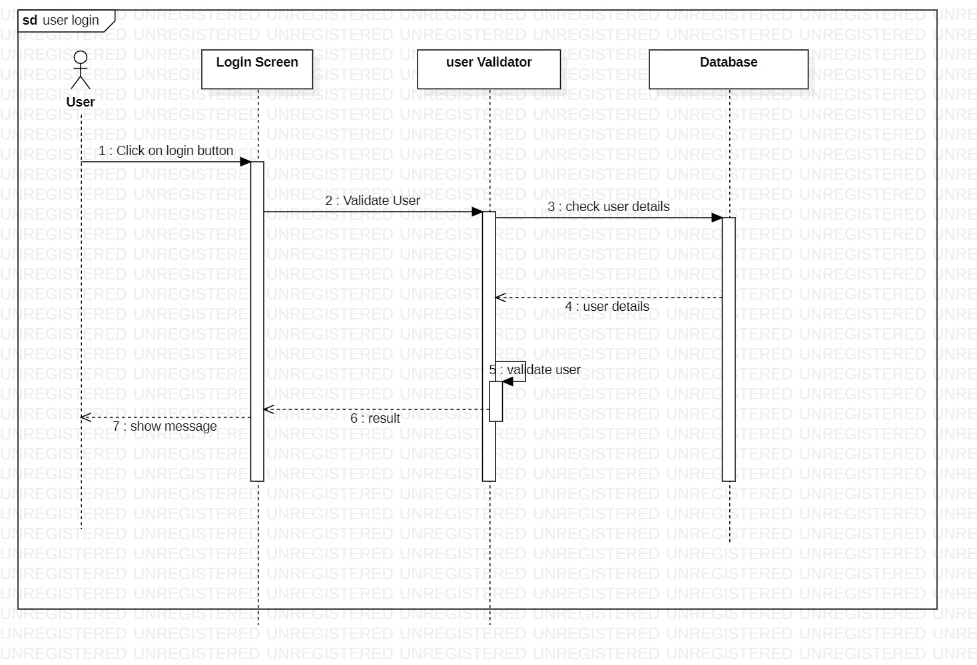

## 

## Search/ Post Query

## 

## Activity Diagram

## 4.1 User Login

## 

## 4.2 Login Activity

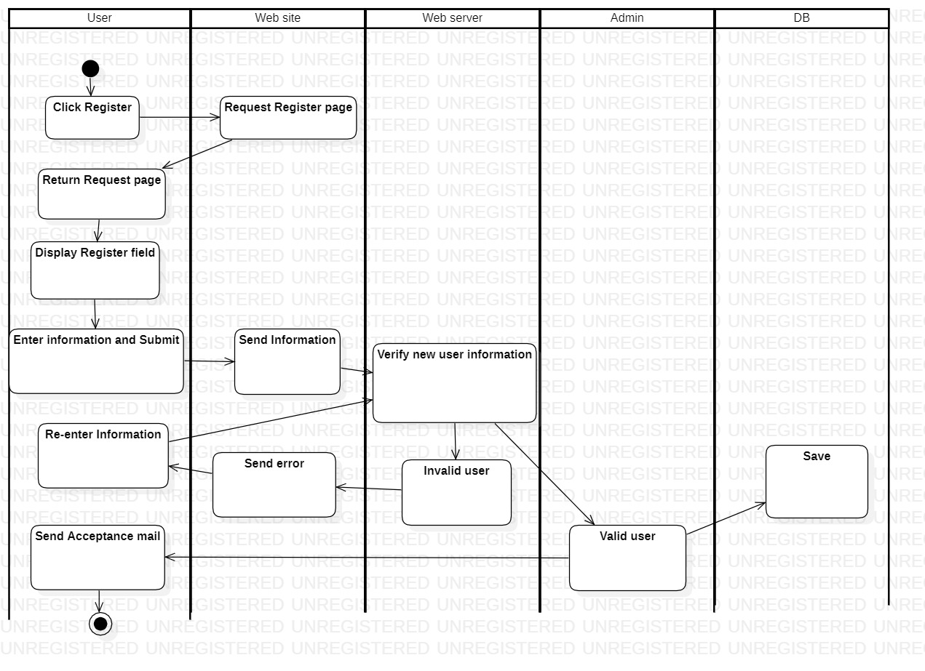

## 4.3 Search/ Post Query :

