ADHD Statistics 2026 — Complete Figures & Data Extract
Source: psychology.com/adhd-statistics/ — "ADHD Statistics 2026" by S. Fontane Pennock (Sept 13, 2026; last full review Sept 16, 2026). Sourced from CDC, HRSA, NIMH, original prescription analyses and peer-reviewed population studies. Extract compiled October 2026.

1. The Ten Headline Numbers (2026)
Measure | Figure | Source / note
U.S. children (3–17) with current ADHD, 2024 | 11.7% — ~7.1 million children | HRSA National Survey of Children's Health, 2026
U.S. adults with current diagnosed ADHD, 2023 | 6.0% — ~15.5 million people | CDC adult survey, 2024
Adults with current ADHD first diagnosed in adulthood | 55.9% | CDC, 2024
Children with current ADHD having ≥1 other mental/behavioral/developmental disorder, 2022 | 77.9% | Danielson et al., 2024
Children with current ADHD receiving neither medication nor behavioral treatment, 2022 | 30.1% | Danielson et al., 2024
Adult stimulant users with ADHD unable to fill a prescription in prior year | 71.5% | CDC, 2023 survey (Staley et al., 2024)
Increase in ADHD medication fills, 2019 → 2023 | +23.8% | Huskamp et al., 2025 (IQVIA data)
Global persistent adult ADHD prevalence, 2020 | 2.58% — 139.84 million adults | Song et al., 2021
Annual excess societal cost of adult ADHD in the U.S., 2018 | $122.8 billion (ages 18–64) | Schein et al., 2022
Sustained untreated remission in MTA childhood ADHD cohort | 9.1% | Sibley et al., 2022

2. How Common Is ADHD — U.S. Prevalence
Measure | Figure | Source / note
Children ever diagnosed with ADHD, 2022 (NSCH) | 11.4% — 7.1M children aged 3–17 | Danielson et al., 2024, NSCH 2022
Children with current ADHD, 2022 (NSCH) | 10.5% — 6.5M children aged 3–17 | Danielson et al., 2024, NSCH 2022
Children with current ADHD, 2024 (NSCH) | 11.7% — 7.1M children aged 3–17 | Robinson et al., HRSA, 2026
Historical current adult prevalence (ages 18–44) | 4.4% | NIMH, NCS-R 2001–2003
Historical lifetime adult prevalence (ages 18–44) | 8.1% | NIMH, NCS-R 2001–2003
Historical lifetime adolescent prevalence (ages 13–18) | 8.7% | NIMH, NCS-A 2001–2004
Adults with current diagnosed ADHD, 2023 | 6.0% — ~15.5M | CDC, 2024

2.1 Global Prevalence Estimates
Measure | Figure | Source / note
Children & adolescents (pooled, studies 1978–2005) | 5.29% | Polanczyk et al., 2007
Children aged 3–12 (pooled, through 2020) | 7.6% | Salari et al., 2023
Adolescents aged 12–18 (pooled, through 2020) | 5.6% | Salari et al., 2023
Persistent adult ADHD (childhood onset required), 2020 | 2.58% — 139.84M adults | Song et al., 2021
Symptomatic adult ADHD (regardless of childhood onset), 2020 | 6.76% — 366.33M adults | Song et al., 2021

3. ADHD in Children — Conditions & Severity (2022 NSCH)
Measure | Figure | Source / note
Any co-occurring mental/behavioral/developmental disorder | 77.9% | Danielson et al., 2024
Moderate or severe ADHD (parent-rated) | 58.1% | Danielson et al., 2024
Co-occurring anxiety | 39.1% | Danielson et al., 2024
Behavioral or conduct problems | 44.1% | Danielson et al., 2024
Co-occurring learning disability | 36.5% | Danielson et al., 2024
Co-occurring autism | 14.4% | Danielson et al., 2024
At least two co-occurring disorders | 51.0% | Danielson et al., 2024
Severity distribution (parents of children with current ADHD, 2022): Mild 41.9% · Moderate 45.3% · Severe 12.8% — Danielson et al., 2024, NSCH 2022.
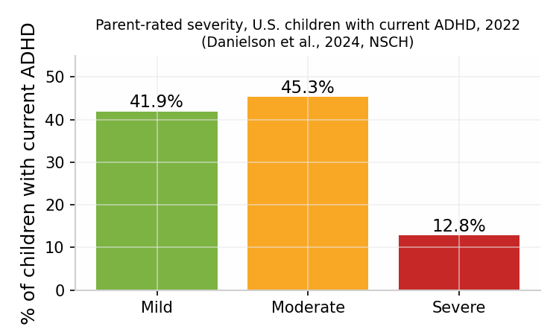

4. Who Is Diagnosed — Sex, Race, Insurance, Geography
Measure | Figure | Source / note
Boys / girls with current ADHD, 2024 NSCH (ages 3–17) | 14.5% / 8.8% | HRSA, 2026
Boys / girls ever diagnosed, 2020–2022 NHIS (ages 5–17) | 14.5% / 8.0% | Reuben & Elgaddal, NCHS, 2024
Non-Hispanic White children ever diagnosed (5–17) | 13.4% | Reuben & Elgaddal, NCHS, 2024
Non-Hispanic Black children ever diagnosed (5–17) | 10.8% | Reuben & Elgaddal, NCHS, 2024
Hispanic children ever diagnosed (5–17) | 8.9% | Reuben & Elgaddal, NCHS, 2024
Ever diagnosed by insurance: public / private / none | 14.4% / 9.7% / 6.3% | Reuben & Elgaddal, NCHS, 2024
State range, ever-diagnosed (ages 3–17) | 6% to 17% | CDC pooled 2020–2023 estimates, July 8, 2026
Age at first recorded ADHD care, females / males (Stockholm 2011–2021) | 23.5 / 19.6 years (mean) | Skoglund et al., 2024
Historical current ADHD, men / women (NCS-R 2001–2003) | 5.4% / 3.2% | NIMH

5. Impact — School, Work, Health and Cost
Measure | Figure | Source / note
Annual excess societal cost of adult ADHD (U.S., 2018) | $122.8 billion (ages 18–64) | Schein et al., 2022 (funded by Otsuka)
Modeled excess cost per adult with ADHD per year | $14,092 | Schein et al., 2022
— Unemployment component | $66.8B (largest component) | Schein et al., 2022
— Productivity loss component | $28.8B | Schein et al., 2022
— Healthcare services component | $14.3B | Schein et al., 2022
Later-than-expected school graduation (Sweden, ADHD vs peers) | 12.5% / 3.8% | Jangmo et al., 2019
Mortality rate ratio (Danish cohort through 2013) | 2.07 (5.85 vs 2.21 deaths per 10,000 person-years; accidents most common cause) | Dalsgaard et al., 2015, The Lancet
Lower crash odds during medicated months, men / women | 38% / 42% | Chang et al., 2017, JAMA Psychiatry
Mortality hazard ratio after medication initiation | 0.79 (within 3 months; ages 6–64, Sweden) | Li et al., 2024, JAMA
Unmet need for any healthcare, children with / without ADHD (2024) | 8.3% / 3.2% | Robinson et al., HRSA, 2026
Parents reporting healthcare costs sometimes/never reasonable, with / without ADHD | 31.7% / 26.9% | Robinson et al., HRSA, 2026 (2024 NSCH)
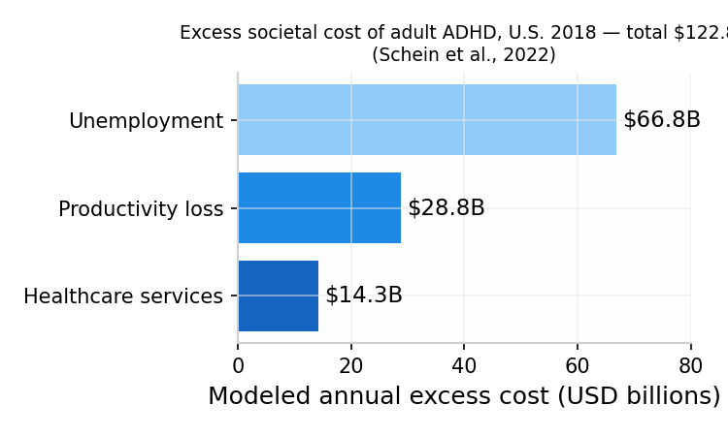

6. Treatment, Medication and the Stimulant Shortage
Measure | Figure | Source / note
Adult stimulant users unable to fill a prescription (prior year) | 71.5% | CDC 2023 survey — Staley et al., MMWR 2024
Children with current ADHD taking medication (2022) | 53.6% | Danielson et al., 2024, NSCH 2022
Children receiving ADHD behavioral treatment (prior year) | 44.4% | Danielson et al., 2024
Children receiving neither measured treatment | 30.1% | Danielson et al., 2024
Children receiving both medication + behavioral treatment | 28.2% | Danielson et al., 2024
Medication only / behavioral treatment only | 25.5% / 16.2% | Danielson et al., 2024
Adults using stimulants in prior year (2023) | 33.4% | Staley et al., CDC MMWR 2024
Adults receiving neither medication nor counseling (prior 12 months) | 36.5% | Staley et al., 2024
Adults prescribed ADHD medication / receiving both (12 months) | 50.4% / 35.2% | Staley et al., 2024
Children using telehealth in 2024, with / without ADHD | 31.6% / 11.6% | Robinson et al., HRSA, 2026
State range for any ADHD treatment among children with ADHD | 58% to 80% | CDC pooled 2020–2023, July 8, 2026

6.1 Medication Effect Sizes (2018 Network Meta-Analysis — Cortese et al.)
Group — drug | Effect vs placebo | Source / note
Children/adolescents — methylphenidate | −0.78 SMD | Cortese et al., 2018, Lancet Psychiatry
Adults — amphetamines | −0.79 SMD | Cortese et al., 2018
Adults — atomoxetine (nonstimulant) | −0.45 SMD | Cortese et al., 2018
SMD = standardized mean difference on clinician-rated symptoms at ~12 weeks; not a "% improved" figure.

7. Trends 2019–2026
Measure | Figure | Source / note
ADHD medication fills, 2019 / 2023 | 72,849,441 / 90,183,437 (+23.8%) | Huskamp et al., 2025, IQVIA
Fill growth: nonstimulants / stimulants, 2019–2023 | +60.1% / +20.4% | Huskamp et al., 2025
Stimulant-fill growth, adults 31+ | +44.1% | Huskamp et al., 2025
Stimulant fills change, ages 0–18 | −6.5% | Huskamp et al., 2025
Current child ADHD, 2019 / 2023 | 8.8% / 10.5% | Katz et al., 2026 (NSCH trend analysis)
Child medication receipt, 2016 / 2023 | 62.5% / 53.0% | Katz et al., 2026
Any child ADHD treatment, 2016 / 2023 | 76.9% / 70.8% | Katz et al., 2026
Diagnosed ADHD patients prescribed stimulants (Epic), 2013 / 2022 | 61% / 64% | Russell et al., Epic Research, 2023
New diagnosis incidence ages 30–49, 2020 / 2022 | 0.34% / 0.64% | Russell et al., Epic Research, 2023
Women 20–24 with stimulant fill, 2020→2021 | +19.2% | Danielson et al., CDC MMWR, 2023
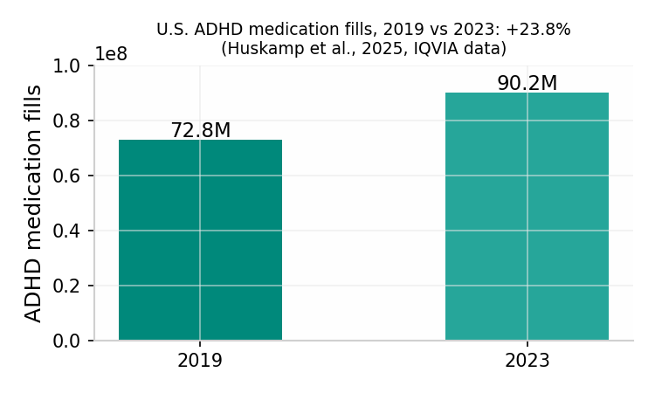
Shortage timeline: FDA/DEA joint stimulant-shortage update August 1, 2023 (FDA). The 71.5% access figure documents that period and does not establish 2026 availability.

8. Adult ADHD and Late Diagnosis
Measure | Figure | Source / note
Adults first diagnosed at age ≥18 | 55.9% | CDC 2023 survey, 2024
Adults who ever used ADHD telehealth | 46.0% | Staley et al., 2024
Telehealth for prescriptions / counseling since March 2020 | 30.5% / 30.8% | Staley et al., 2024
Sustained remission (MTA cohort, 558 participants) | 9.1% | Sibley et al., 2022, Am J Psychiatry
Fluctuating remission/recurrence course (MTA) | 63.8% (~60% of initial remitters later recurred) | Sibley et al., 2022

8.1 Past-Year Co-Occurring Disorders in Adults with ADHD (NCS-R 2001–2003)
Disorder category | Share of adults with current ADHD | Source
Any anxiety disorder | 47.1% | Kessler et al., 2006
Any mood disorder | 38.3% | Kessler et al., 2006
Any substance disorder | 15.2% | Kessler et al., 2006

9. Important Caveats from the Source Page
- Diagnosis-based counts depend on recognition and access to assessment; symptom surveys can identify difficulties never recorded in healthcare.
- Survey definitions differ (ever vs current; NSCH vs NHIS age ranges), so percentages across sections are not directly comparable.
- Prescription fills are dispensing events, not people; one patient can contribute multiple fills, and some medications have non-ADHD uses.
- Global adult estimates differ on whether childhood onset is required (2.58% persistent vs 6.76% symptomatic).
- Relative measures (mortality ratios, crash odds) describe group comparisons and cannot predict an individual's future.
- The 71.5% stimulant-shortage figure covers the year before the 2023 survey; it cannot establish product availability on September 16, 2026.

Citation: Fontane Pennock, S. (2026, September 13). ADHD Statistics 2026. Psychology.com. https://psychology.com/adhd-statistics/

