**NAME : AMMAD KHAN**

**REGISTRATION NO. : 2212105**

**SECTION : BCS/BS 1A.**

**DATED : 11-01-2023**

**Blood bank management system**

**“Project Snapshots”**

**1.Registration Form:**

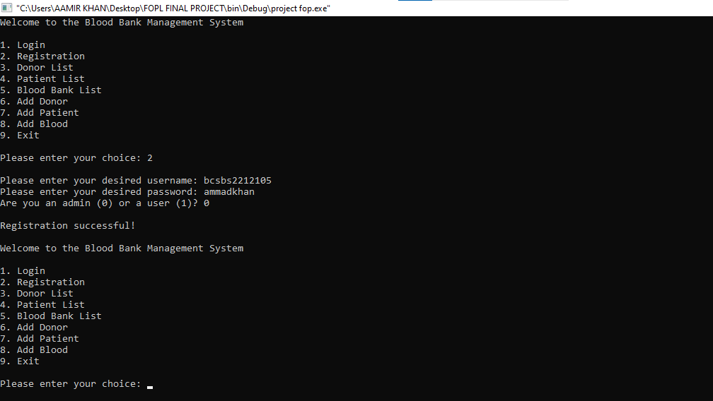

**2.Login**

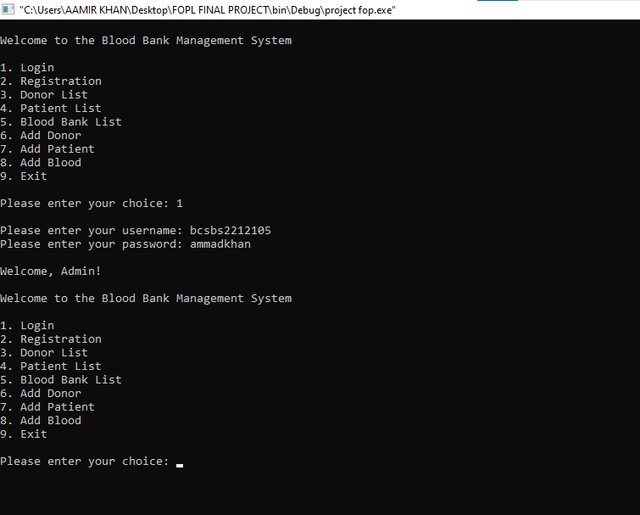

**3.Add Patient:**

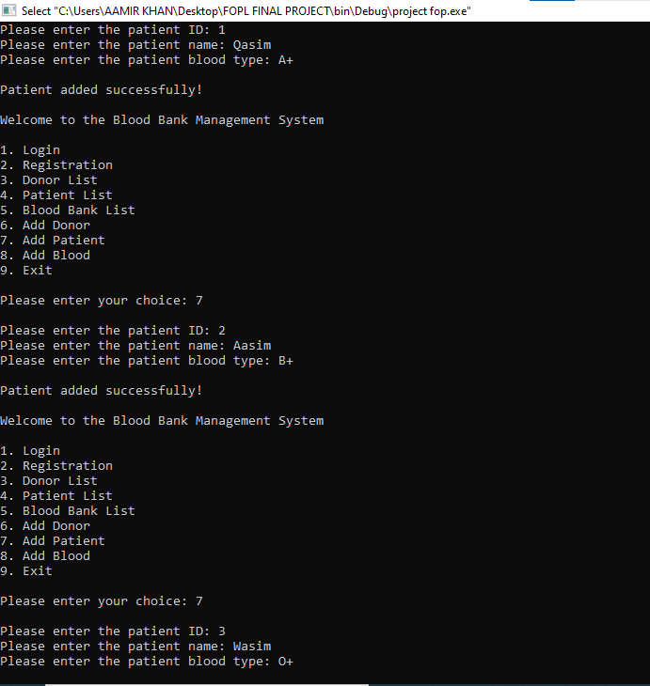

**4.Patient List:**

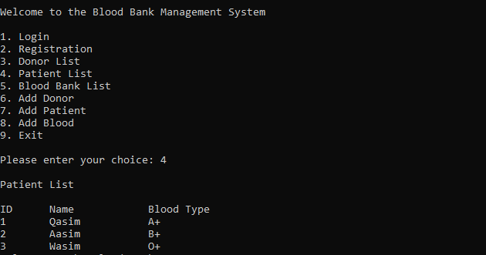

**5.Add Donor:**

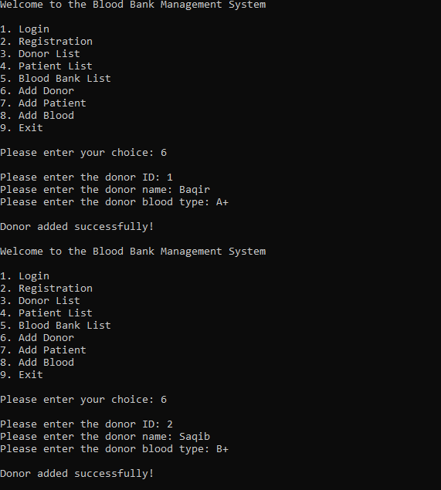

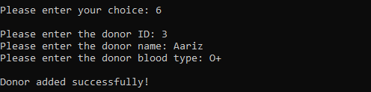

**6.Donor List:**

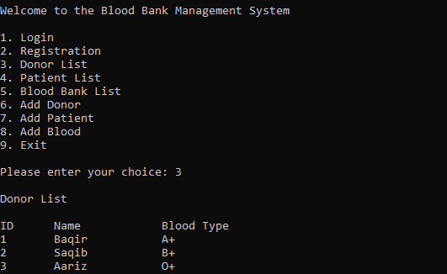

**7.Add Blood (1):**

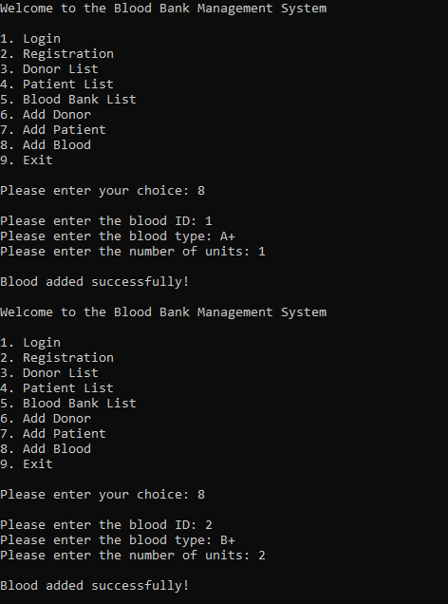

**7.Add Blood (2):**

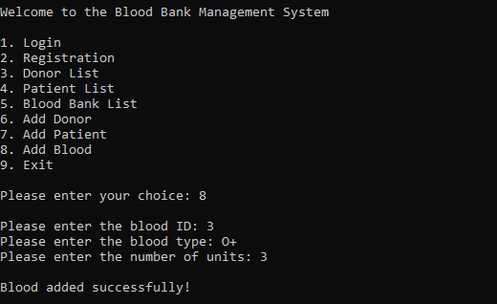

**8.Blodd Bank List & Exit:**

