**proSection 1: Metadata**

*to be filled by the student*

**1.1. Project Information** to be filled by the student

|  |  |
| --- | --- |
| Title com . **پوشاک**  (poshaak.com) | |
| Section: L-2 | Instructor: Prof. Umer Tariq |

**1.2. Student(s) Information**

|  |  |
| --- | --- |
| Name: Muhammad Anas | ID: 08458 |
| Section: L-2 | Batch: 2026 |

|  |  |
| --- | --- |
| Name: Sher Ali | ID: 08505 |
| Section: L-2 | Batch: 2026 |

|  |  |
| --- | --- |
| Name: Muhammad Mustafa | ID: 08323 |
| Section: L-2 | Batch: 2026 |

**Submission guideline:** Save your project proposal as a pdf file and rename as Project Proposal_L1_ProposedTitle where L1 is to be replaced with your section

**Section 2: The Project**

*to be filled by the student*

**2.1. Project Description:** *Please provide a brief introduction of the project including its scope.*

It is a E-Commerce store that deals in kids garments and being a big store it requires a data management system which will cater their needs as follows :

1. **Product Catalog**: The project will feature an extensive product catalog containing a wide range of kids' garments, including clothing for infants, toddlers, and older children. The catalog will encompass various categories such as casual wear, formal wear, seasonal attire, and accessories. review ratings on the products, filter search results for particular color, brand etc and will offer a feature to add their desired items to their cart. Which will require product search screen.
2. **User Accounts:** Users will have option to +sign up using their ids for special bonuses. Add items to their cart, and order items. This will require sign up/ login screen.
3. **Admin Accounts:**  The management can manage the stocks, update them, put some items on discounts also review orders, supply and receive the stocks.
4. **User Cart:** This includes interim items that the user selects and save in their cart. Subsequently they can proceed towards billing or delete the item.
5. **Billing:** This will prompt the user for billing options available and then further inquire them about their payment details (COD).
6. **Search and Filtering:** Users will have access to advanced search and filtering options, making it easy to find specific garments based on criteria such as size, color, price range, and brand.

**2.2 Functional Requirements**

*This section describes each function/feature provided by your system. These functions are logically grouped into modules based on their purposes. The users in your system must be categorized such as admin, customer or administrator etc. These users will be accessing the database with the level of access that they are authorized with.*

Sample functional Requirements:

**Module 1: Registrations**

• Function 1: Register an account

The system lets users register an account on the website as a admin and as a customer.

– Function 1a: Register as a admin The register form prompts the user to enter their details i.e. Name, Email, Password. The form is submitted and an unveriﬁed admin account is created. The user receives a link on their email address which completes account veriﬁcation.

– Function 1b: Register as a customer The register form prompts the user to enter their details i.e. Name, Email, Password. The form is submitted and an unveriﬁed customer account is created. The user receives a link on their email address which completes account veriﬁcation.

**Module 2: Buying and Selling**

**Admins:**

• Function 1: Only admin type users can upload item(s) to sell .A registered admin can upload an item to sell through the application. The system prompts the admin for item photos, item category and item details and the item is added to the item inventory.

**Users:**

• Function 1: Add item to cart. A certain button on the item page prompts the system to add the item to the user’s cart. All consequent item(s) added without checkout, are added to the same cart unless cleared.

• Function 2: View an item: Users can select an item to view its details whereby they can spectate the product ‘s Name, description including size, color, category etc.

• Function 3: Clear item from cart .The system allows the user to remove a previously added item from the cart. If cart is empty, the checkout link is no longer accessible.

• Function 4: After the cart is finalized, the customer will moved to another billing screen where they will be prompted to fill the payment details and then will be assigned a order ID .

• Function 5: Users can apply filters based on size, category or color etc to get their desired product(s).

**2.3. Planned Schedule:** *Kindly list the start/end dates and the timeline for the achievement of any intermediate milestones and the expected contribution to be made by the participant(s).*

*Initial ERD Screens attached with project proporsal*

*Final ERD by Week 9*

*PYQT6 code by week 10*

*Projct finalization by week 12*

**2.4. Technology Stack:** *If you are utilizing any language or database besides PyQt and SQL Server, please complete this section; otherwise, leave it blank. Specify the programming language and database management system intended for constructing this application, as well as the application type (Desktop, Web, or Mobile).*

**2.5. Screens:** *Provide images of all application screens, showcasing clear input and corresponding outputs. Ensure each image includes a concise caption explaining user action and expected/observed output. You can create these screens using Qt Designer.*

*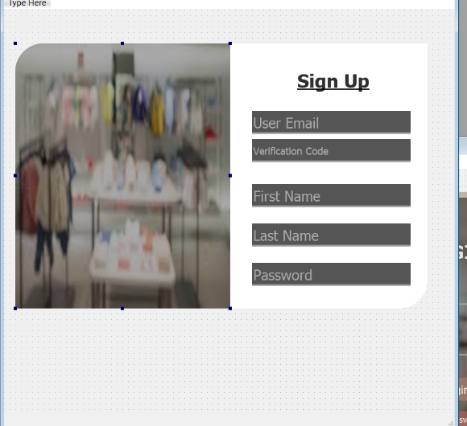 A customer can sign up using this screen, and will receive a verification code on his email. However, if an email with certain verification code is entered then a new admin can sign up.*

*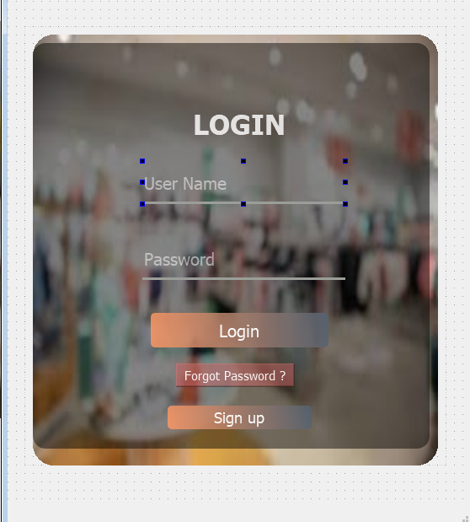 When a customer logins with their credentials then the database looks for their account, if it exists then they can successfully login else it will generate an error. Similarly an admin can login with their own credentials to get more access on the database.*

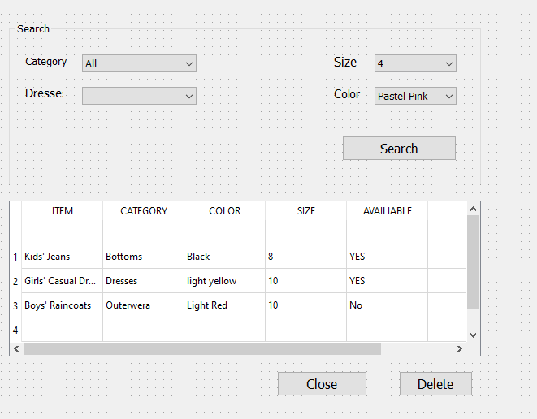

*This is the layout for user where user can view the items available in the store and can apply relevant filters to get nearer to there desired item.*

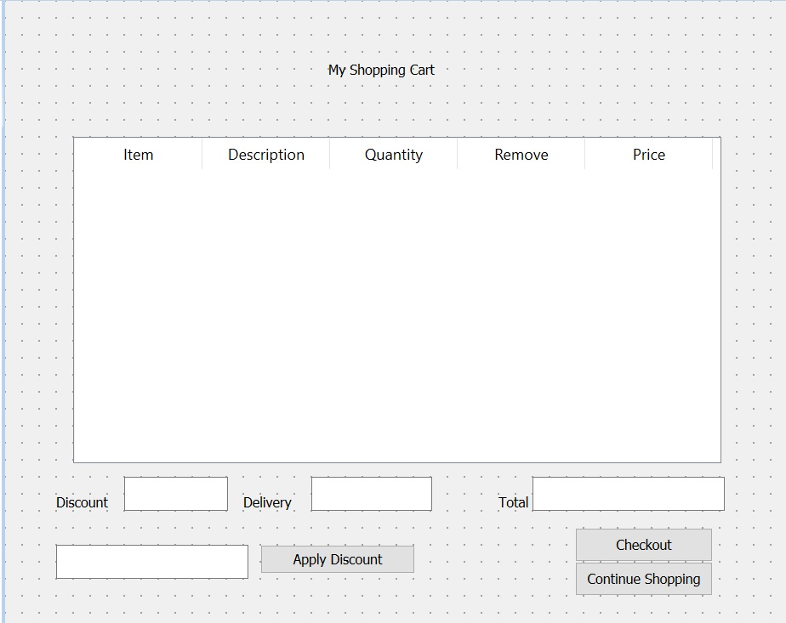

*Shopping Cart for which the user will be able to add their desired items in the cart. The cart will become empty after the user clicks Checkout and will take the user to Billing screen below .*

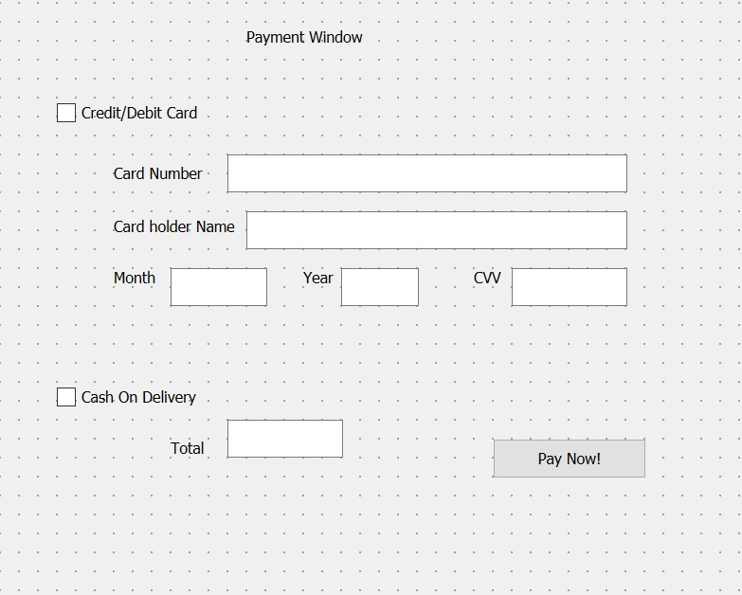

*Billing Screen where the user will be prompted with information and details for making payment to their desired items.It will open after shopping cart.*

**2.5. ERD:** *Please incorporate an initial ERD for your project, ensuring clear highlighting of primary keys and accurate depiction of table relationships. Avoid manual ERD creation; utilize tools like DBdesigner for this purpose.*

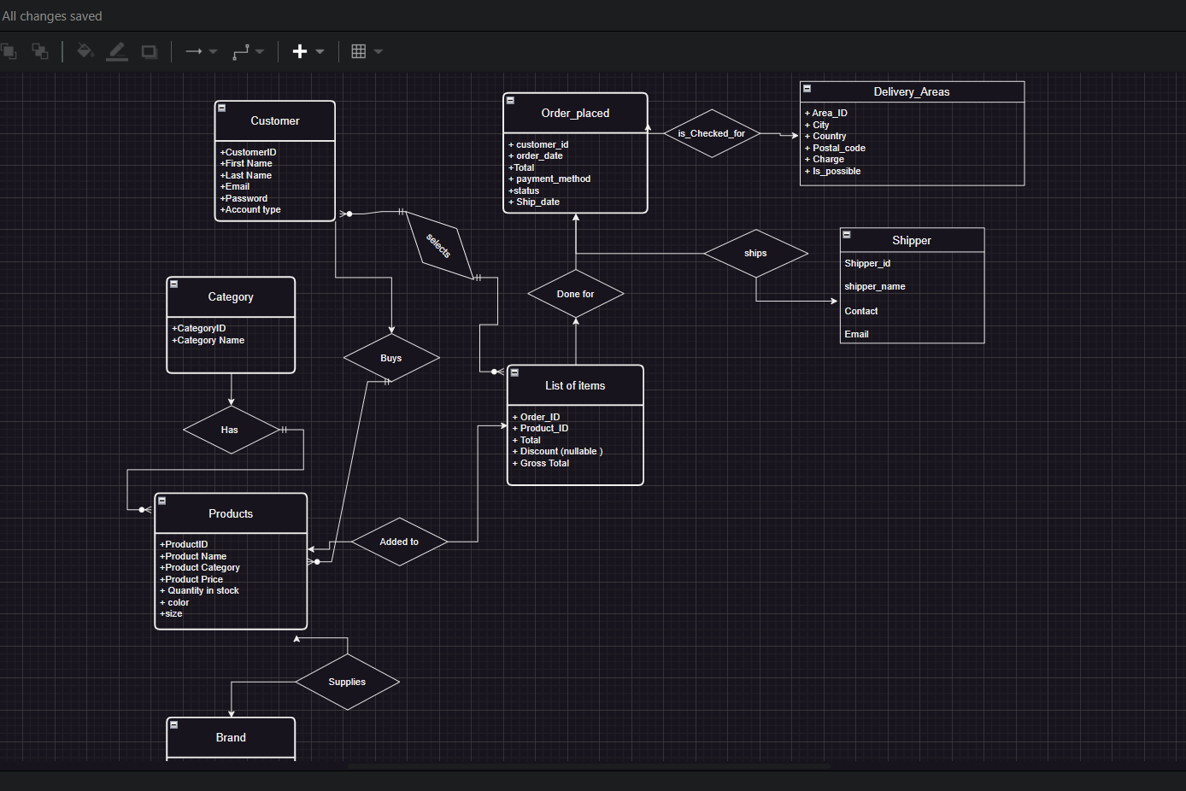

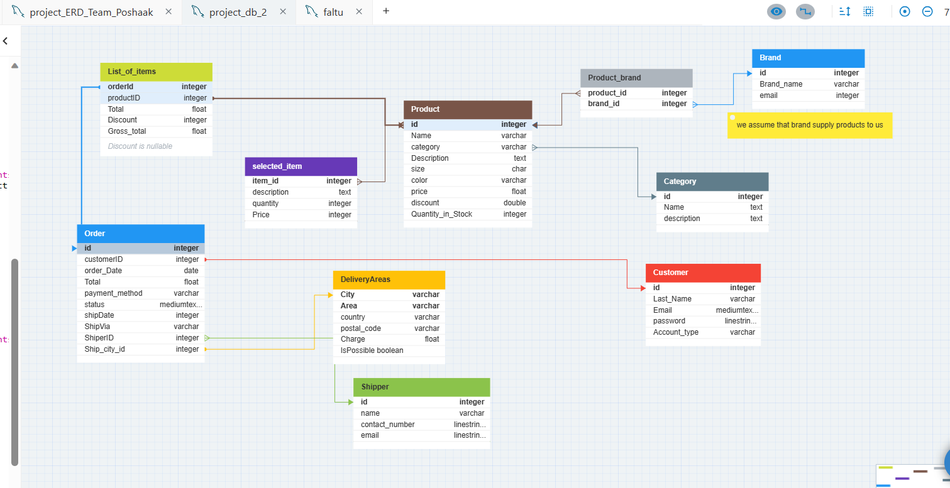

Explanation of above tables :

* **User** can choose items available in stocks and after their selection add them to their cart.
* **List_of_items** user will be prompted with the description of all the items with prices and discount applied (if any) , therefore the user can click on proceed and the order will be placed Details of which can be further seen in the order table .
* **Category,** category refers to the filters the user can apply to search their desired item including color, size, and particular apparel i.e. shirt, pant etc.
* **Products** refer to the overall items available in the store, containing the details of price, size, color etc.
* **Order**  this is the last step when the user places the order, therefore the order will be prompted to the admin whereon the admin will assign a shipper according to the place to be shipped and the payment method. As this is an online store so we assume that most payments will be either as Cash on delivery or online payments which user will be prompted while ordering.
* **Selected_item:** user can select and view any item’s description from the products.
* **Customer:**  this table will contain all the details of customer. Moreover, the customer HAS to create an account to proceed with shopping.