

Advanced Backend Development
Assignment 2
Name:
Muhammad Saad Khan
SAP ID:
70153904
Semester:
6-I
Repo Link:
CLICK ME!

Question 1: List Operations
Write functions to remove duplicate integers, find the average of a list, and multiply every list element by a scalar.
Solution (question1.py):
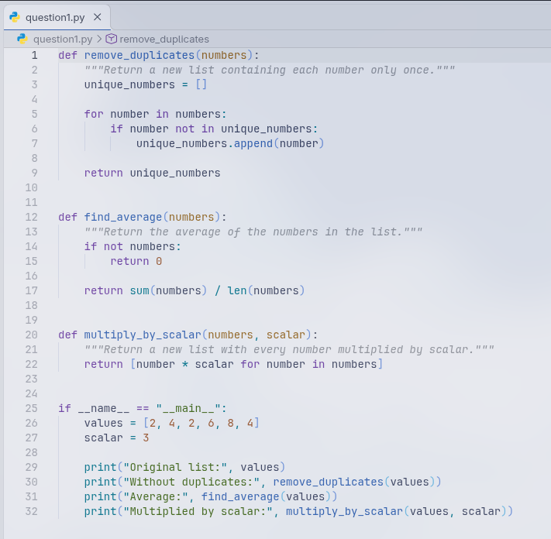
Output:
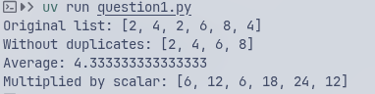

Question 2: Store Inventory
Use loops to print each inventory item with its quantity and calculate the total inventory value using quantity multiplied by price.
Solution (question2.py):
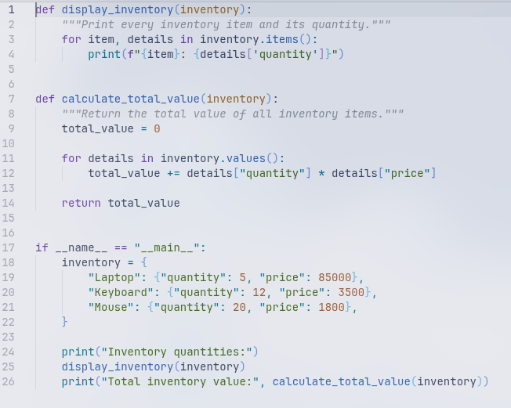
Output:
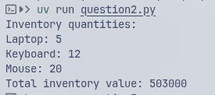

Question 3: Library System
Construct a Library class with methods to add, remove, search, and display books stored as a list of strings.
Solution (question3.py):
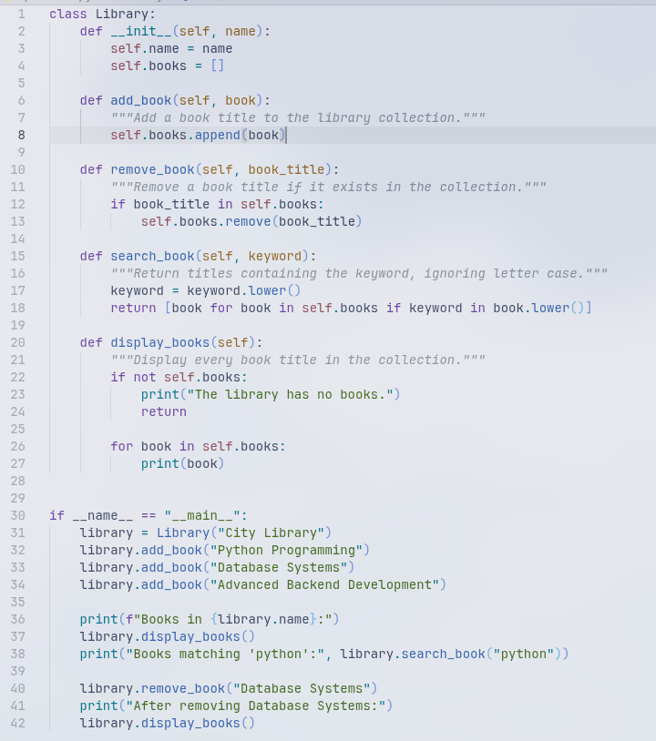

Output;
