TechFix

Database Report Repair Workflow Management System



Group Members:
70153904 Muhammad Saad Khan
70152951 Muhammad Shahrose Rafique
70152488 Junaid Ahmad
70149352 Mohsin Qureshi
Subject:

Database Management System

Degree:

BS-IET (5-I)

Table of Contents
1. Introduction
2. Domain Selection
3. Problem Statement
4. Novelty
5. Entity Relationship Diagram (ERD)
  - 5.1 Enhanced ERD — Role Specialization
  - 5.2 Status Lifecycle State Machine
6. Entity Specifications
  - 6.1 organizations
  - 6.2 employees
  - 6.3 customers
  - 6.4 devices
  - 6.5 repair_jobs
  - 6.6 inventory_usage
7. Constraints Summary
  - Foreign Key Relationships
8. DBMS Features Used
  - 8.1 SQL Queries
  - 8.2 JOINs
  - 8.3 Stored Procedures
  - 8.4 Functions
  - 8.5 Triggers
  - 8.6 Nested Subqueries
  - 8.7 Indexes
  - 8.8 ENUM Data Types
  - 8.9 Transactions
  - 8.10 Error Handling
9. Stored Procedure / Function Catalog
  - 9.1 Function
  - 9.2 Organization & Employee Setup
  - 9.3 Authentication
  - 9.4 Create Records
  - 9.5 Update Records
  - 9.6 Read Records
  - 9.7 Usage Matrix
10. Trigger Details
11. Use-Case Diagram
  - Use-Case Summary
12. Sample Query Results
  - 12.1 Parts Total Function
  - 12.2 Trigger Auto-Calculation
  - 12.3 Customer Full Profile
13. Seed Data Walkthrough
14. Conclusion

1. Introduction
TechFix is a digital repair workflow management system designed for small-to-medium electronics repair shops. The system replaces paper-based job cards and verbal handoffs with a centralized database-driven platform that tracks the complete lifecycle of a repair job from device check-in to final delivery and cost settlement.

This report documents the complete database design and implementation of TechFix using MySQL 8.0. The database serves as the single source of truth, housing all business logic within stored procedures, functions, and triggers. The application layer (Node.js/Express) strictly validates inputs and calls database routines it never executes raw DML, ensuring data integrity and consistency at the database level.

2. Domain Selection
The electronics repair industry was selected as the project domain for the following reasons:

- Real-world relevance: Local repair shops (mobile, laptop, console repairs) are ubiquitous but largely under-digitized. Most still rely on paper job slips and verbal tracking.
- Rich data relationships: The domain naturally involves multiple interconnected entities customers, devices, repair jobs, employees, inventory parts making it ideal for demonstrating relational database design.
- Clear workflow: Repair jobs follow a well-defined state machine (Pending → Repairing → Ready → Delivered/Cancelled), providing a natural fit for enforcing business rules through DBMS constraints and triggers.
- Multi-tenant requirement: Each repair shop operates independently, requiring org-scoped data isolation a common real-world pattern.

3. Problem Statement
Local electronics repair shops face several operational challenges:

- Lost or misplaced job cards Paper-based tracking lacks reliability and audit history.
- Unclear job status Customers and technicians have no real-time visibility into where a repair stands.
- Inaccurate cost calculations Final costs are often computed manually, leading to errors or disputes.
- No parts tracking There is no systematic record of which parts were used in which repair, making it difficult to calculate profitability.
- No centralized customer history Repeat customers have no consolidated device or repair history, forcing staff to rely on memory.

TechFix addresses these problems by providing a structured, role-aware database system that manages customers, devices, repair jobs, and inventory usage within a fully isolated organizational scope.

4. Novelty
TechFix introduces several innovative design choices that distinguish it from conventional repair management systems:

Novel Feature | Description
All business logic in stored procedures | Every INSERT, UPDATE, and DELETE operation is wrapped in a stored procedure. The backend never executes raw DML it only calls procedures. This ensures consistent validation and prevents data corruption regardless of the client application.
Trigger-based auto cost calculation | When a job is marked Delivered, a BEFORE UPDATE trigger automatically computes the final_cost by summing all parts logged against that job via the fn_parts_total function. No manual entry required.
Idempotent customer creation | If a customer with the same email already exists, the procedure returns the existing record instead of throwing a duplicate error making the system resilient to duplicate submissions.
Org-scoped multi-tenancy | Every table references an organization_id (directly or through FK chains). All write procedures validate that the employee and the target record belong to the same organization before allowing any mutation.
No-password customer self-service | Customers authenticate using only their email (no password), providing a frictionless portal for checking their own repair status without exposing other customers' data.
ENUM-based role specialization | Employees are classified as Owner or Employee via an ENUM discriminator column, implementing a disjoint total specialization without requiring separate subclass tables.

5. Entity Relationship Diagram (ERD)
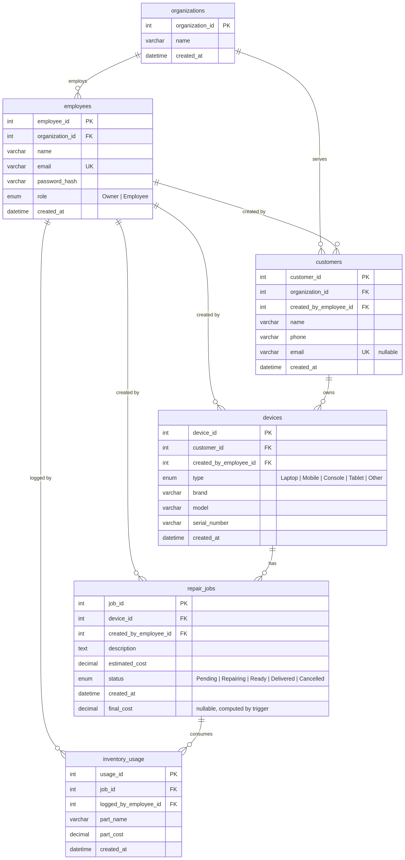

5.1 Enhanced ERD Role Specialization
The employees table implements a disjoint (total) specialization via the role ENUM column. Every employee is exactly one of Owner or Employee. This is a single-table specialization (no subclass tables) with an ENUM discriminator:

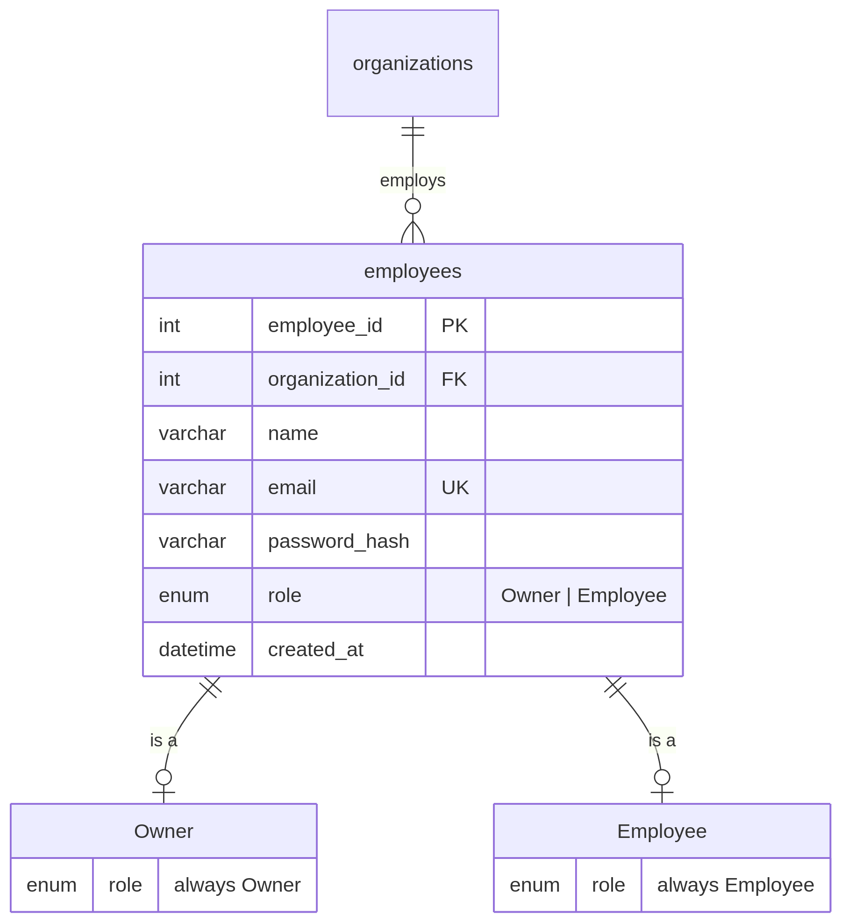

Enforcement:
- The role ENUM restricts values at the column level
- sp_create_owner sets role = 'Owner'
- sp_create_employee sets role = 'Employee'

5.2 Status Lifecycle State Machine
Repair jobs follow a strict state machine enforced by stored procedures:
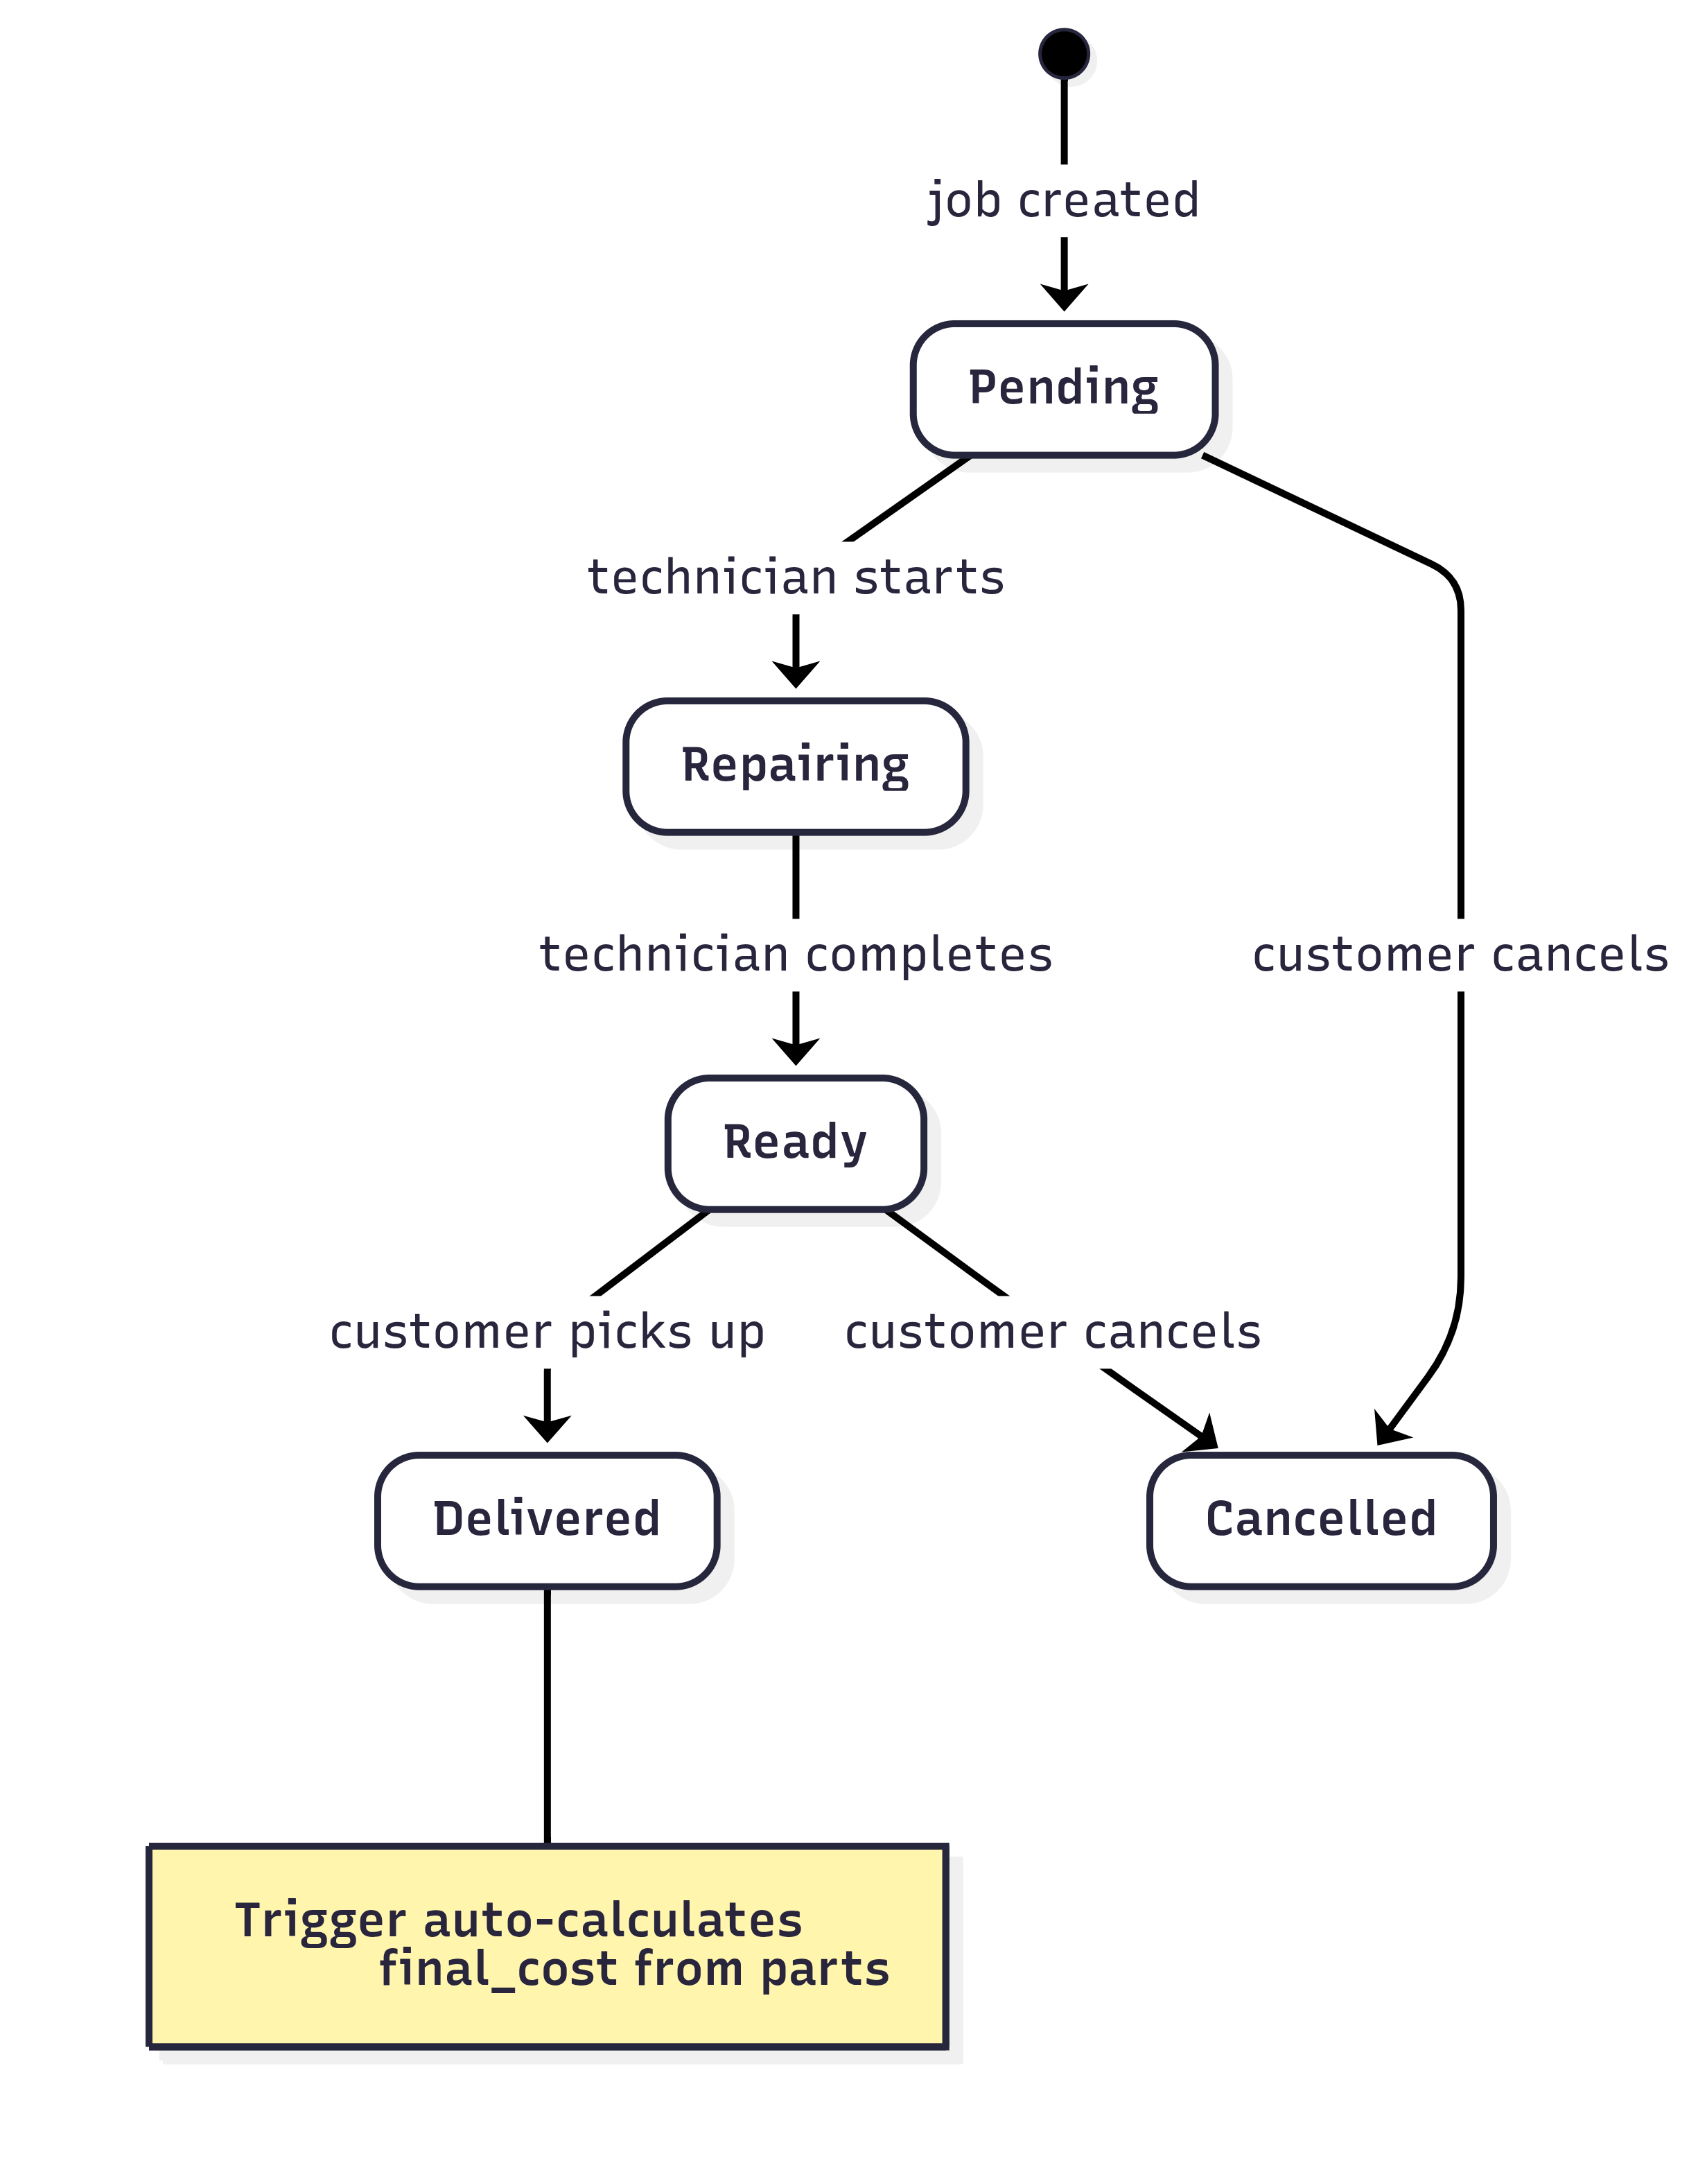

Rules:
- Only customers can cancel a job (via sp_cancel_repair_job_by_customer), and only from Pending status.
- Employees cannot transition a job to Cancelled that is customer-only.
- Delivered and Cancelled are terminal states no further updates are allowed.
- The trigger tr_repair_jobs_delivered_cost fires on transition to Delivered to auto-set final_cost.

6. Entity Specifications

6.1 organizations

Column | Type | Constraints | Notes
organization_id | INT | PK AUTO_INCREMENT | Surrogate key
name | VARCHAR(100) | NOT NULL | Organization display name
created_at | DATETIME | NOT NULL DEFAULT CURRENT_TIMESTAMP | Auto-set on insert

6.2 employees

Column | Type | Constraints | Notes
employee_id | INT | PK AUTO_INCREMENT | Surrogate key
organization_id | INT | NOT NULL, FK → organizations | Org membership
name | VARCHAR(100) | NOT NULL | Display name
email | VARCHAR(100) | NOT NULL, UNIQUE | Login identifier
password_hash | VARCHAR(255) | NOT NULL | SHA2-256 hash
role | ENUM('Owner','Employee') | NOT NULL DEFAULT 'Employee' | Role discriminator
created_at | DATETIME | NOT NULL DEFAULT CURRENT_TIMESTAMP | Auto-set on insert

6.3 customers

Column | Type | Constraints | Notes
customer_id | INT | PK AUTO_INCREMENT | Surrogate key
organization_id | INT | NOT NULL, FK → organizations | Org scope
created_by_employee_id | INT | NOT NULL, FK → employees | Who registered the customer
name | VARCHAR(100) | NOT NULL | Customer display name
phone | VARCHAR(20) | NOT NULL | Contact number
email | VARCHAR(100) | NULL, UNIQUE | Nullable login optional
created_at | DATETIME | NOT NULL DEFAULT CURRENT_TIMESTAMP | Auto-set on insert

6.4 devices

Column | Type | Constraints | Notes
device_id | INT | PK AUTO_INCREMENT | Surrogate key
customer_id | INT | NOT NULL, FK → customers | Device owner
created_by_employee_id | INT | NOT NULL, FK → employees | Who registered the device
type | ENUM('Laptop','Mobile','Console','Tablet','Other') | NOT NULL | Device category
brand | VARCHAR(50) | NOT NULL | Manufacturer
model | VARCHAR(50) | NOT NULL | Model name/number
serial_number | VARCHAR(100) | NOT NULL | Device S/N
created_at | DATETIME | NOT NULL DEFAULT CURRENT_TIMESTAMP | Auto-set on insert

6.5 repair_jobs

Column | Type | Constraints | Notes
job_id | INT | PK AUTO_INCREMENT | Surrogate key
device_id | INT | NOT NULL, FK → devices | Device being repaired
created_by_employee_id | INT | NOT NULL, FK → employees | Who created the job
description | TEXT | NOT NULL | Issue description
estimated_cost | DECIMAL(10,2) | NOT NULL DEFAULT 0.00 | Initial estimate
status | ENUM('Pending','Repairing','Ready','Delivered','Cancelled') | NOT NULL DEFAULT 'Pending' | Lifecycle state
created_at | DATETIME | NOT NULL DEFAULT CURRENT_TIMESTAMP | Auto-set on insert
final_cost | DECIMAL(10,2) | NULL | Computed by trigger on Delivered

6.6 inventory_usage

Column | Type | Constraints | Notes
usage_id | INT | PK AUTO_INCREMENT | Surrogate key
job_id | INT | NOT NULL, FK → repair_jobs | Job that used the part
logged_by_employee_id | INT | NOT NULL, FK → employees | Who logged the part
part_name | VARCHAR(100) | NOT NULL | Part description
part_cost | DECIMAL(10,2) | NOT NULL DEFAULT 0.00 | Cost of the part
created_at | DATETIME | NOT NULL DEFAULT CURRENT_TIMESTAMP | Auto-set on insert

7. Constraints Summary

Constraint Type | Details
Primary Keys | Each table has an INT AUTO_INCREMENT PK: organization_id, employee_id, customer_id, device_id, job_id, usage_id
Foreign Keys | 10 FK relationships enforcing referential integrity. Every child record references a valid parent.
ON DELETE CASCADE | Organization → Employees, Organization → Customers, Customer → Devices, Device → Repair Jobs, Repair Job → Inventory Usage
ON DELETE RESTRICT | Employee → Customers/Devices/RepairJobs/InventoryUsage employees who created records cannot be deleted (preserves audit trail)
UNIQUE | employees.email, customers.email
NOT NULL | All business-critical columns are NOT NULL (15+ columns across 6 tables)
DEFAULT | created_at defaults to CURRENT_TIMESTAMP on all tables; estimated_cost defaults to 0.00; part_cost defaults to 0.00; status defaults to 'Pending'; role defaults to 'Employee'
ENUM Domains | role (Owner, Employee), device.type (Laptop, Mobile, Console, Tablet, Other), repair_jobs.status (Pending, Repairing, Ready, Delivered, Cancelled)
CHECK via SIGNAL | Stored procedures enforce business rules using SIGNAL SQLSTATE '45000' e.g., terminal state protection, org-scope validation, status transition validation
Trigger Constraint | tr_repair_jobs_delivered_cost enforces that final_cost is always computed from actual parts, never manually set

Foreign Key Relationships

FK | Child Table | Parent Table | ON DELETE
fk_employees_org | employees | organizations | CASCADE
fk_customers_org | customers | organizations | CASCADE
fk_customers_employee | customers | employees | RESTRICT
fk_devices_customer | devices | customers | CASCADE
fk_devices_employee | devices | employees | RESTRICT
fk_repair_jobs_device | repair_jobs | devices | CASCADE
fk_repair_jobs_employee | repair_jobs | employees | RESTRICT
fk_inventory_usage_job | inventory_usage | repair_jobs | CASCADE
fk_inventory_usage_employee | inventory_usage | employees | RESTRICT

8. DBMS Features Used
TechFix leverages a wide range of MySQL DBMS features:

8.1 SQL Queries
All four fundamental SQL operations are used:
- SELECT Read procedures fetch data with filtering, sorting, and joins
- INSERT Create procedures insert new records
- UPDATE Status transition and description update procedures
- DELETE Not directly exposed (all mutation goes through procedures)

8.2 JOINs
Multiple JOIN types across stored procedures and the view:

JOIN Type | Example | Location
INNER JOIN | JOIN devices d ON d.device_id = r.device_id | All read procedures
LEFT JOIN | LEFT JOIN employees e ON e.employee_id = u.logged_by_employee_id | sp_get_customer_full_*
Multi-table JOIN | 4-table JOIN chain employees → customers → devices → repair_jobs | sp_log_inventory_usage
4-table JOIN chain | employees → customers → devices → repair_jobs | Org-scope validation in sp_log_inventory_usage

8.3 Stored Procedures (12 total)
All business logic is encapsulated in stored procedures:
- Setup: sp_create_owner, sp_create_employee
- Auth: sp_employee_login, sp_customer_login
- Create: sp_create_customer, sp_create_device, sp_create_repair_job, sp_log_inventory_usage
- Update: sp_update_repair_job_status, sp_update_repair_job_description, sp_cancel_repair_job_by_customer
- Read: sp_get_repair_jobs, sp_get_customer_full_for_employee, sp_get_customer_full_for_customer

8.4 Functions
CREATE FUNCTION fn_parts_total(p_job_id INT) RETURNS DECIMAL(10,2)
DETERMINISTIC
BEGIN
SELECT IFNULL(SUM(part_cost), 0.00) INTO v_total
FROM inventory_usage WHERE job_id = p_job_id;
RETURN v_total;
END
Used by the trigger to auto-compute final cost. Uses SUM() aggregate with IFNULL for null safety.

8.5 Triggers
CREATE TRIGGER tr_repair_jobs_delivered_cost
BEFORE UPDATE ON repair_jobs
FOR EACH ROW
BEGIN
IF NEW.status = 'Delivered' AND OLD.status <> 'Delivered' THEN
SET NEW.final_cost = fn_parts_total(NEW.job_id);
END IF;
END
Fires automatically when a job transitions to Delivered, computing final cost from logged parts.

8.6 Nested Subqueries
Used extensively for validation in stored procedures via EXISTS:
IF NOT EXISTS (
SELECT 1 FROM employees e
JOIN customers c ON c.organization_id = e.organization_id
JOIN devices d ON d.customer_id = c.customer_id
WHERE e.employee_id = p_employee_id AND d.device_id = p_device_id
) THEN
SIGNAL SQLSTATE '45000' SET MESSAGE_TEXT = 'Not in same organization.';
END IF;
These subqueries validate org-scope across 3–4 table joins before allowing any mutation.

8.7 Indexes
- Primary Key indexes (auto-generated on all 6 tables)
- Unique indexes: uq_employees_email, uq_customers_email
- Foreign Key indexes: All 9 FK columns are indexed automatically by InnoDB

8.8 ENUM Data Types
Three ENUMs enforce domain values at the column level:
- employees.role: 'Owner', 'Employee'
- devices.type: 'Laptop', 'Mobile', 'Console', 'Tablet', 'Other'
- repair_jobs.status: 'Pending', 'Repairing', 'Ready', 'Delivered', 'Cancelled'

8.9 Transactions
sp_create_owner uses explicit transactions to atomically create both the organization and the owner employee:
START TRANSACTION;
INSERT INTO organizations ...;
INSERT INTO employees ...;
COMMIT;
With an EXIT HANDLER FOR SQLEXCEPTION that rolls back on any failure.

8.10 Error Handling
All stored procedures validate inputs and use SIGNAL SQLSTATE '45000' to raise structured errors that the backend can catch and return as HTTP responses.

9. Stored Procedure / Function Catalog

9.1 Function

Name | Returns | Purpose
fn_parts_total(p_job_id) | DECIMAL(10,2) | Sums all part_cost for a given job. Used by the Delivered trigger. Deterministic.

9.2 Organization & Employee Setup

Procedure | Parameters | Purpose
sp_create_owner | p_org_name, p_owner_name, p_owner_email, p_password_hash | Transactional: creates org + owner employee in one call. Sets role = 'Owner'.
sp_create_employee | p_org_id, p_name, p_email, p_password_hash | Creates an employee under an existing org. Sets role = 'Employee'.

9.3 Authentication

Procedure | Parameters | Purpose
sp_employee_login | p_email, p_password_hash | Validates credentials. Returns employee row. Signals 'Invalid credentials.' on mismatch. Case-insensitive collation.
sp_customer_login | p_email | No-password login. Returns customer row. Signals 'Customer not found.' if email doesn't exist.

9.4 Create Records

Procedure | Parameters | Purpose
sp_create_customer | p_org_id, p_employee_id, p_name, p_phone, p_email | Creates customer. Rejects if email already exists in any org.
sp_create_device | p_employee_id, p_customer_id, p_type, p_brand, p_model, p_serial_number | Creates device. Validates employee + customer are in same org via JOIN.
sp_create_repair_job | p_employee_id, p_device_id, p_description, p_estimated_cost, p_status | Creates a repair job. Validates org scope. Normalizes status to Pending if null.
sp_log_inventory_usage | p_employee_id, p_job_id, p_part_name, p_part_cost | Logs part usage. Validates org scope through 4-table JOIN chain.

9.5 Update Records

Procedure | Parameters | Purpose
sp_update_repair_job_status | p_employee_id, p_job_id, p_status | Employee-side status transition. Rejects Cancelled (customer-only). Rejects terminal states.
sp_update_repair_job_description | p_employee_id, p_job_id, p_description | Updates job description. Rejects updates on cancelled jobs. Validates org scope.
sp_cancel_repair_job_by_customer | p_customer_id, p_job_id | Customer-side cancellation. Only allows cancellation from Pending status.

9.6 Read Records

Procedure | Parameters | Purpose
sp_get_repair_jobs | p_employee_id, p_status, p_org_id | Multi-role: when p_org_id provided (manager view) returns all org jobs; when null (technician view) returns only own jobs. Optional status filter.
sp_get_customer_full_for_employee | p_employee_id, p_customer_id | Returns 4 result sets: customer info, devices, repair jobs, inventory usage. Validates same-org scope.
sp_get_customer_full_for_customer | p_email | Self-service view returning 4 result sets. No-password access.

9.7 Usage Matrix (Procedure → Table)

Procedure | organizations | employees | customers | devices | repair_jobs | inventory_usage
sp_create_owner | INSERT | INSERT
sp_create_employee |  | INSERT
sp_employee_login |  | SELECT
sp_customer_login |  |  | SELECT
sp_create_customer |  |  | INSERT
sp_create_device |  |  |  | INSERT
sp_create_repair_job |  |  |  |  | INSERT
sp_log_inventory_usage |  |  |  |  |  | INSERT
sp_update_repair_job_status |  |  |  |  | UPDATE
sp_update_repair_job_description |  |  |  |  | UPDATE
sp_cancel_repair_job_by_customer |  |  |  |  | UPDATE
sp_get_repair_jobs |  |  | SELECT | SELECT | SELECT
sp_get_customer_full_for_employee |  | SELECT | SELECT | SELECT | SELECT | SELECT
sp_get_customer_full_for_customer |  | SELECT | SELECT | SELECT | SELECT | SELECT

10. Trigger Details

tr_repair_jobs_delivered_cost
- Timing: BEFORE UPDATE on repair_jobs
- Fires when: Status changes to 'Delivered' (from anything else)
- Action: Sets NEW.final_cost = fn_parts_total(NEW.job_id)
- Edge case: If no parts were logged, fn_parts_total returns 0.00

Execution Flow:
sp_update_repair_job_status(status='Delivered')
→ BEFORE UPDATE trigger fires
→ fn_parts_total(job_id) SUMs inventory_usage.part_cost
→ SET final_cost = the sum
→ UPDATE completes with final_cost populated

11. Use-Case Diagram
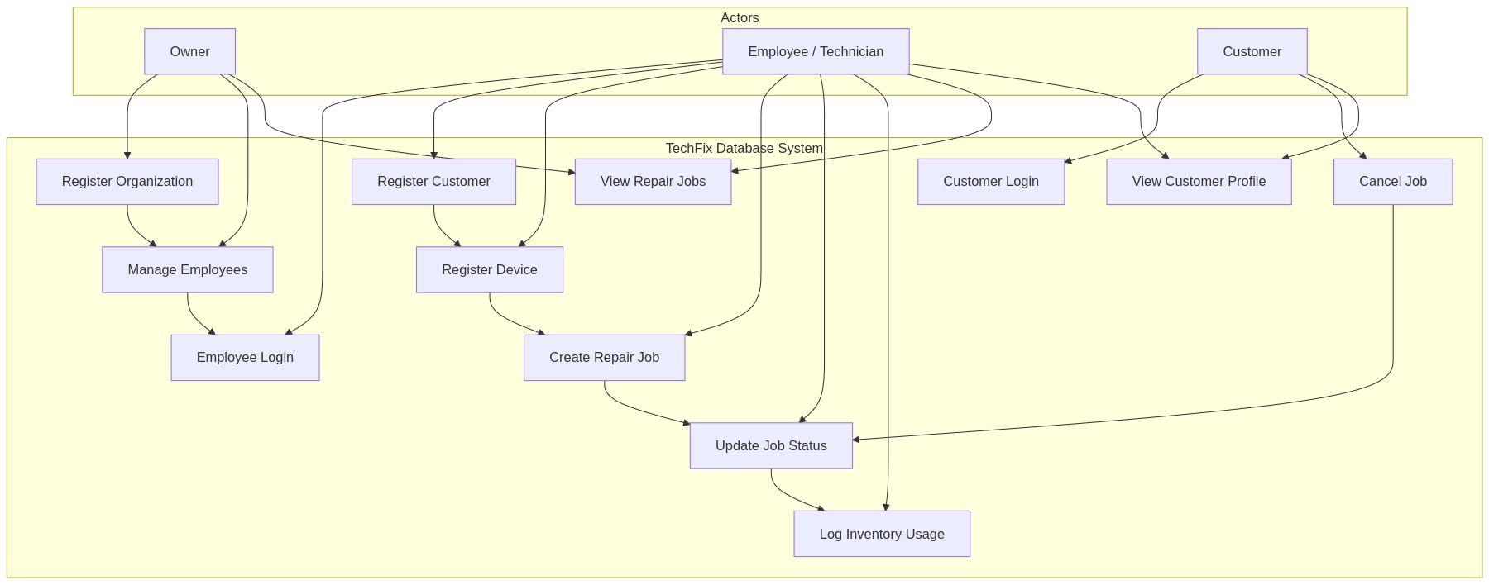

Use-Case Summary

Use Case | Actor | Description
Register Organization | Owner | Creates a new repair shop with the initial Owner account
Manage Employees | Owner | Adds or removes employee technicians under the organization
Employee Login | Employee | Authenticates via email and password
Customer Login | Customer | Self-service login using email only (no password)
Register Customer | Employee | Registers a walk-in customer under the organization
Register Device | Employee | Registers a customer's device with type, brand, model, serial
Create Repair Job | Employee | Creates a repair job for a device with description and estimate
Update Job Status | Employee | Transitions job through Pending → Repairing → Ready → Delivered
Log Inventory Usage | Employee | Logs parts used during a repair against a specific job
Cancel Job | Customer | Cancels a pending job (customer-only action)
View Repair Jobs | Owner, Employee | Views jobs filtered by status; Owner sees all, Employee sees own
View Customer Profile | Employee, Customer | Full customer view with devices, jobs, and inventory usage

12. Sample Query Results

12.1 Parts Total Function
Query:
SELECT fn_parts_total(3) AS total_parts_cost;

Result:

total_parts_cost
800.00

Job 3 (Sony Console, HDMI repair) had one part (HDMI port) costing 800.00.

12.2 Trigger Auto-Calculation
When job 9 is marked Delivered:

-- Before: final_cost is NULL
SELECT job_id, status, final_cost FROM repair_jobs WHERE job_id = 9;
-- CALL sp_update_repair_job_status(emp_id, 9, 'Delivered')
-- After: final_cost is auto-set to 1200.00 (Wi-Fi card cost)
SELECT job_id, status, final_cost FROM repair_jobs WHERE job_id = 9;
Before:

job_id | status | final_cost
9 | Ready | NULL

After:

job_id | status | final_cost
9 | Delivered | 1200.00

12.3 Customer Full Profile
CALL sp_get_customer_full_for_customer('bilal@example.com');

Returns 4 result sets:

Set 1 Customer Info:

customer_id | name | phone | email
2 | Bilal Ahmed | 03019876543 | bilal@example.com

Set 2 Devices:

device_id | type | brand | model
1 | Laptop | Dell | Inspiron 15
2 | Mobile | Samsung | Galaxy S20
3 | Console | Sony | PS4
4 | Laptop | HP | Pavilion

Set 3 Repair Jobs:

job_id | device_id | status | estimated_cost | final_cost
2 | 2 | Repairing | 8000.00 | NULL
4 | 4 | Pending | 3500.00 | NULL
10 | 2 | Repairing | 2500.00 | NULL

Set 4 Inventory Usage:

usage_id | job_id | part_name | part_cost | employee_name
1 | 1 | Battery | 1500.00 | Bilal Hussain
2 | 2 | Display | 4500.00 | Bilal Hussain

13. Seed Data Walkthrough
File: techfix_seed.sql

Organization
- TechFix Lahore single org with organization_id = 1

Employees (Org 1)

Name | Email | Role
Owner Admin | owner@techfix.com | Owner
Bilal Hussain | bilal.tech@techfix.com | Employee
Hira Khan | hira.tech@techfix.com | Employee
Usman Ali | usman.tech@techfix.com | Employee

Customers (Org 1)

Name | Phone | Email | Created By
Ayesha Malik | 03001234567 | ayesha@example.com | Bilal
Bilal Ahmed | 03019876543 | bilal@example.com | Hira
Sara Iqbal | 03331234567 | sara@example.com | Hira
Junaid Ahmad | 03121234567 | junaid@example.com | Usman
Mohsin Qureshi | 03211234567 | mohsin@example.com | Usman

Devices (8 total)

Customer | Type | Brand | Model
Bilal Ahmed | Laptop | Dell | Inspiron 15
Bilal Ahmed | Mobile | Samsung | Galaxy S20
Bilal Ahmed | Console | Sony | PS4
Bilal Ahmed | Laptop | HP | Pavilion
Sara Iqbal | Mobile | Apple | iPhone 12
Junaid Ahmad | Laptop | Lenovo | ThinkPad X1
Mohsin Qureshi | Tablet | Apple | iPad Air
Mohsin Qureshi | Mobile | Xiaomi | Mi 11

Repair Jobs (10 total)

Created By | Device | Description | Est. Cost | Status
Bilal | Dell Laptop | Battery drains quickly | 4500 | Pending
Bilal | Samsung Mobile | Screen flicker issue | 8000 | Repairing
Bilal | Sony Console | HDMI port not working | 6000 | Ready → Delivered
Bilal | HP Laptop | Keyboard keys stuck | 3500 | Pending
Hira | iPhone 12 | Camera not focusing | 5000 | Repairing
Hira | Lenovo Laptop | Overheating during use | 7000 | Pending
Hira | iPad Air | Touch not responding | 6500 | Ready → Delivered
Bilal | Xiaomi Mobile | Charging port loose | 3000 | Pending
Bilal | Dell Laptop | Wi-Fi disconnects | 4000 | Ready → Delivered
Bilal | Samsung Mobile | Speaker distortion | 2500 | Repairing

Inventory Usage (7 entries)
3 jobs are transitioned to Delivered to demonstrate the trigger computing final_cost:
- Job 3 (Sony Console, HDMI) → Delivered, final_cost = 800 (HDMI port)
- Job 7 (iPad Air, Touch) → Delivered, final_cost = 2800 (Touch panel)
- Job 9 (Dell Laptop, Wi-Fi) → Delivered, final_cost = 1200 (Wi-Fi card)

14. Conclusion
TechFix demonstrates a complete, production-oriented database design for the repair workflow management domain using MySQL 8.0. The project achieves the following:

Database Design:
- A normalized 3NF schema with 6 entities, 9 foreign key relationships, and full referential integrity
- ENUM-based domain constraints on roles, device types, and job statuses
- Proper indexing with primary, unique, and foreign key indexes

DBMS Features Utilized:
- 12 stored procedures encapsulating all business logic
- 1 stored function for aggregate computation
- 1 BEFORE UPDATE trigger for automated cost calculation
- 1 view joining all 6 tables for consolidated active job reporting
- Nested subqueries with EXISTS for org-scope validation
- Multi-table JOINs (INNER, LEFT, 4-table and 6-table chains)
- Transactions with rollback handling
- Structured error handling via SIGNAL

Business Requirements Met:
- Complete repair job lifecycle management with enforced state transitions
- Multi-tenant data isolation (organization-scoped)
- Role-based access (Owner, Employee, Customer)
- Automated cost calculation eliminating manual errors
- Customer self-service portal with no-password login
- Audit trail via employee attribution on all records

The database serves as the authoritative data layer, with all business rules enforced at the database level ensuring data integrity and consistency regardless of the client application consuming the API.

