MEMBERSHIP APPLICATION FORM

|  |
| --- |
| **PERSONAL DETAILS** |
| Name: Adrian Joen O. Rapsing |
| Address: 93 Bonifacio St. Zone IV Luisiana, Laguna |
| Mobile Number: 09975634081 |
| Email Address: rapsingaj06@gmail.com |

|  |
| --- |
| **COMPANY DETAILS** |
| Business Name: JAK Photography and Productions |
| Business Address: 93 Bonifacio St. Brgy. Zone IV, Luisiana, Laguna |
| Contact Number: 09975634081 |
| Email Address: [orangestidios@gmail.com](mailto:orangestidios@gmail.com) |
| Years in Business: 3yrs |
| Business Classification (kindly put a check): |
| □ Coordinator □ Catering □ Event Venue □ Decor/Florist  ✓  Photographer |
| □ Videographer □ Host □ Makeup Artist □ Cake & Pastries  □ Light & Sounds |
| □ Souvenirs/Invitations |

Please attach the following requirements for further assessment.

DTI/SEC Certificate

BIR Certification of Registration Business/Mayor’s Permit

Brgy. Certificate Valid ID

Updated Photo (white background) Screenshot of Registration Fee (₱100.00)

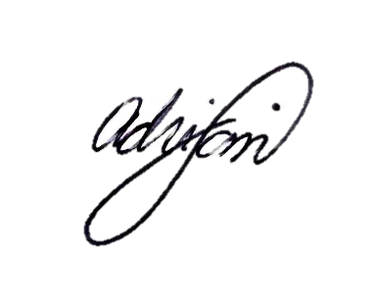Gcash Number: 09380070884

**Supplier**

Signature over printed name