|  |
| --- |
|  |

|  |
| --- |
| **GitHub** |
| Console Commands and Operation |
|  |
| In this paper showing the different commands that can be used in the console and the effect it has on our repositories |
|  |
| **Matias Sosa** |
| **3/18/2014** |
|  |

Contents

Commit 2

Branch 2

Checkout 3

Merge 3

Rebase 4

Operator ^ 6

Operator ~ 7

Reset 8

Revert 9

Cherry-pick 9

Rebase 10

Ament 13

Tag 13

Describe 14

Clone 15

Fake Teamwork 16

Fetch 17

Fetch with parameters 17

Pull 18

Pull with parameters 19

Push 20

Push with parameters 20

Push in different destination 21

Commands

Below are the different commands and their usefulness.

# Commit

This command saves a change we have made in our local repository.

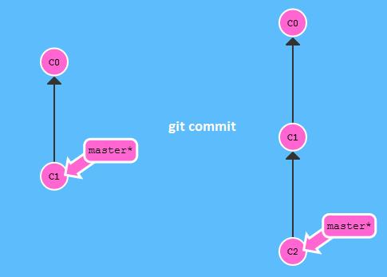

# Branch

Create a new branch in the local repository.

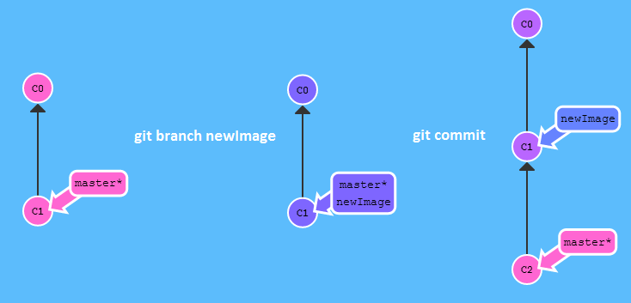

# Checkout

Change our position in the local repository. In this way we can go positioning ourselves in different places. The (*) represents our current position.

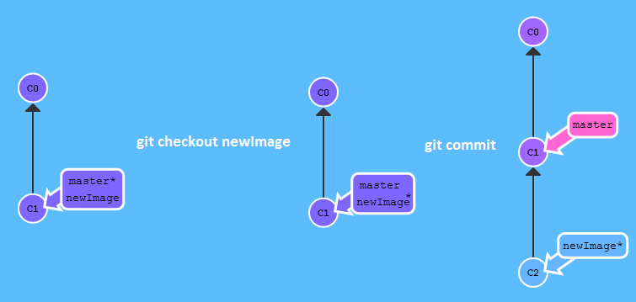

# Merge

Merge two branches having a common father in the local repository.

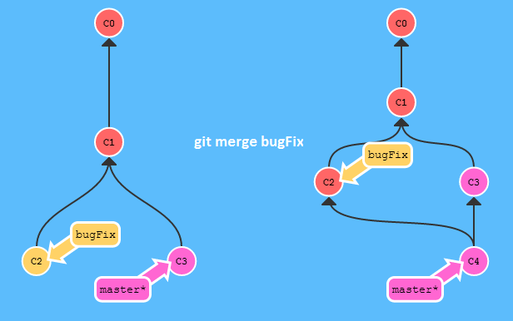

To leave the two branches in the same state:

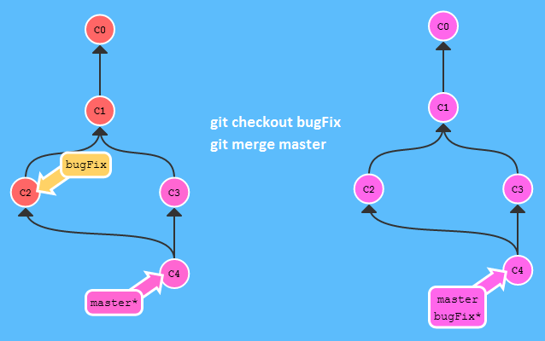

# Rebase

Merge the commits involved and leaves them sequentially.

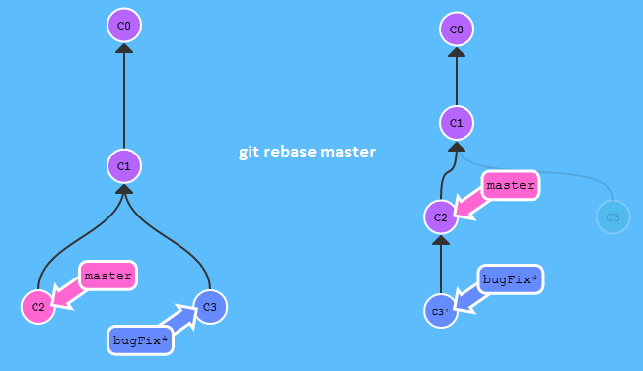

To leave the two branches in the same state:

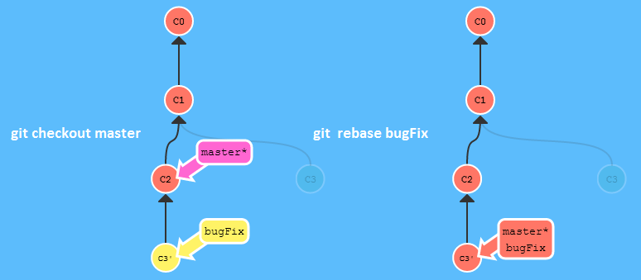

HEAD element

To continue with the commands, we must first know the HEAD element, HEAD always points to the last selection, now look at an example:

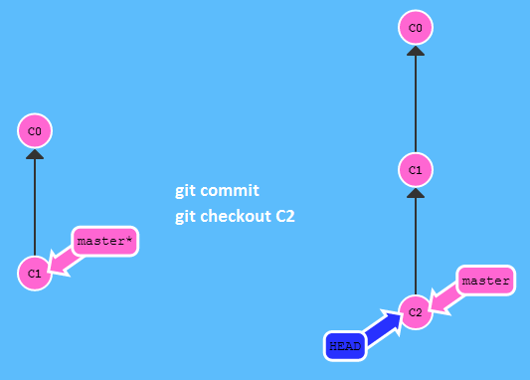

Other example:

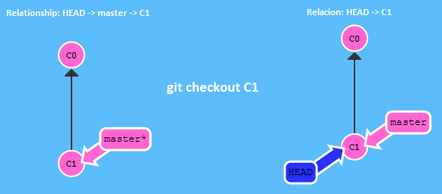

Operators

With these operators we can make direct positions to use in commands.

# Operator ^

This operator allows us to move up a level, the father commit.

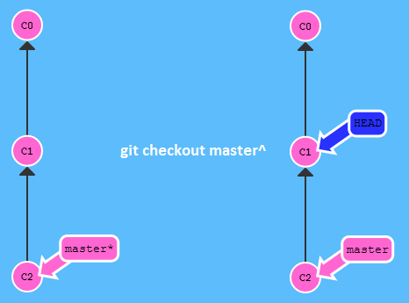

Other example:

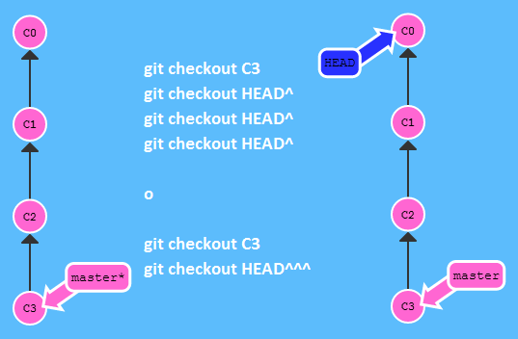

# Operator ~

With this operator also you upload levels but the amount that you indicate.

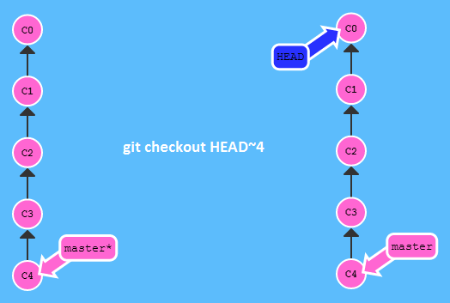

**Forcing a branch**

This command change the index position of a branch.

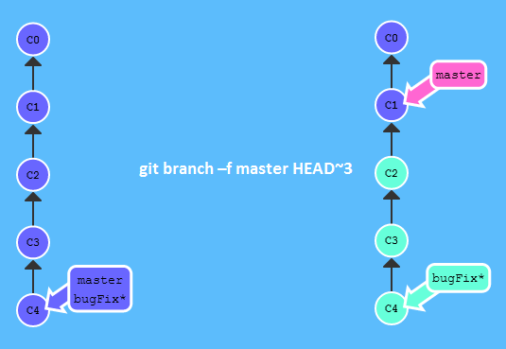

# Reset

It allows us to reverse a commit in the local repository.

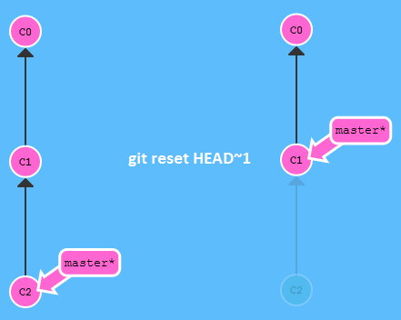

# Revert

It allows us to revert a commit, as a result created a new one to then take it to the remote repository.

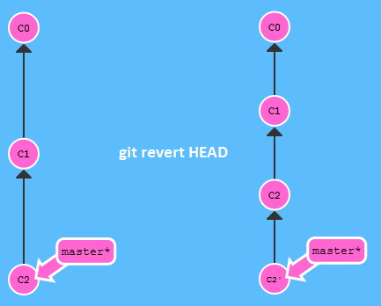

# Cherry-pick

Choose the list of commits that need to perform a merge.

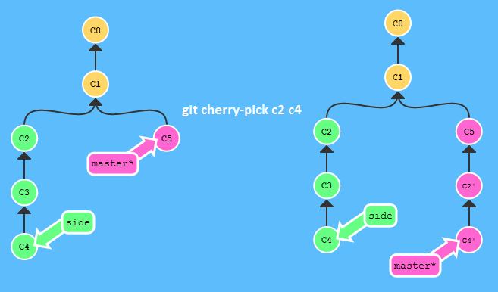

# Rebase

It allows us to arrange, the commits, on one line.

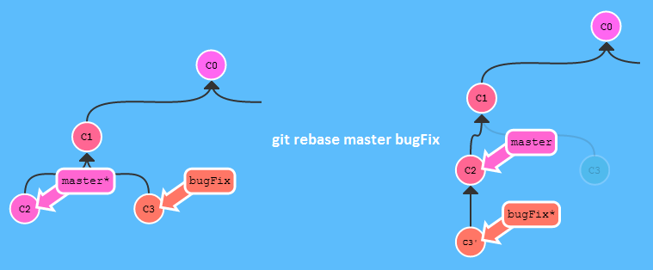

Situations

Perform a "rebase", change the order and choose who applies a merge and create a branch like with cherry-pick, this is used when not to "commits" apply merge with cherry-pick or reorder commits:

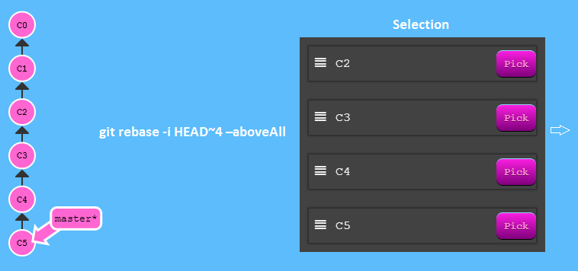

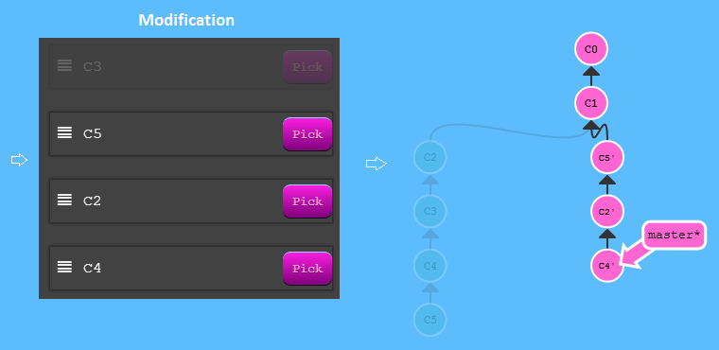

Update branch before loading changes:

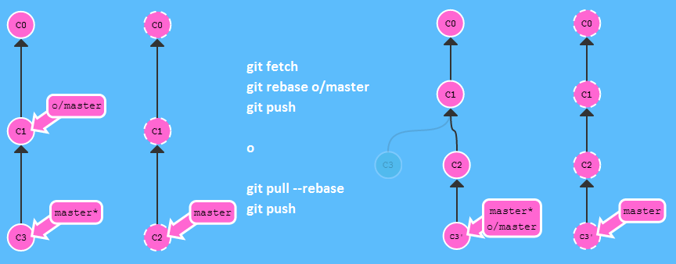

Merge the new changes to the remote branch:

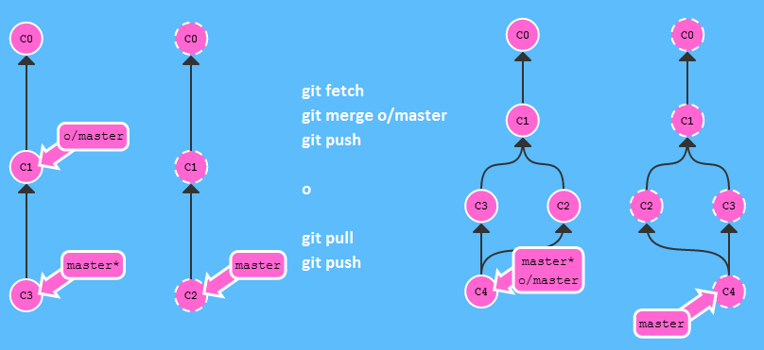

Create a follower branch of the remote repository:

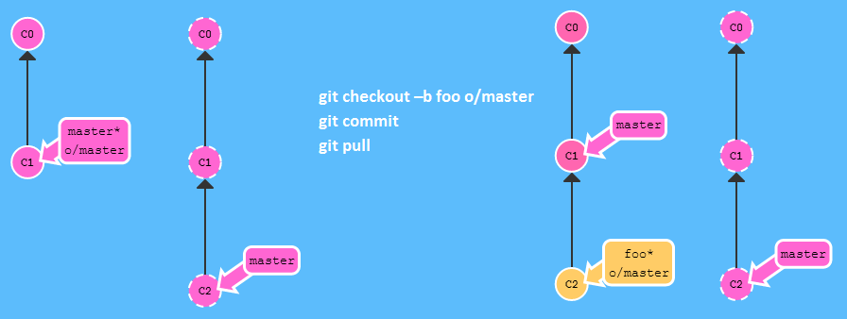

Other way:

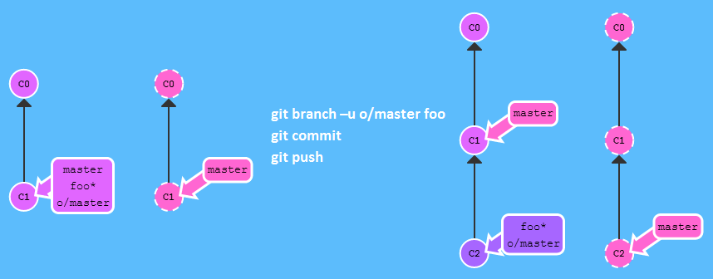

# Ament

Make changes to the last commit generating new one and so do not need to create a complete new commit.

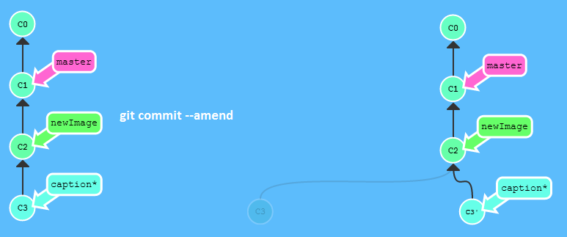

# Tag

It is used to create permanent points.

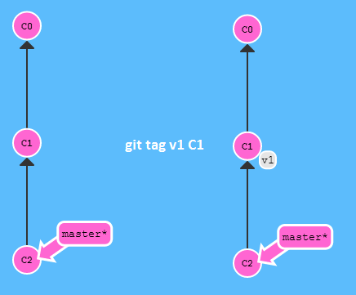

# Describe

It allows us to find the last tag, the number of commits and your name.

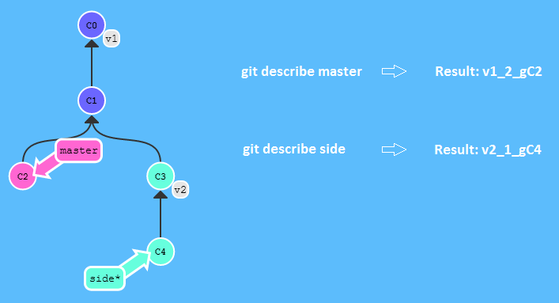

Back in the commits

Back in the commits, the other branch, using operators.

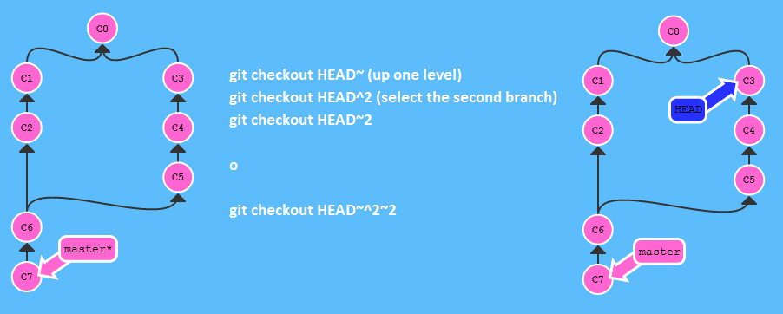

# Clone

It allows us to clone a remote repository.

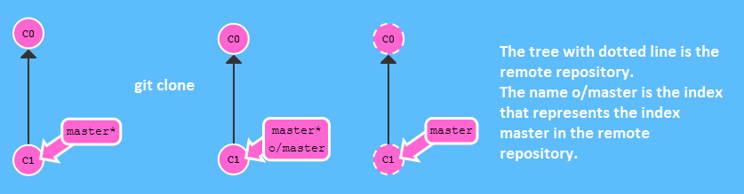

In practice does not have the name "o/master" has the name "origin".

Example:

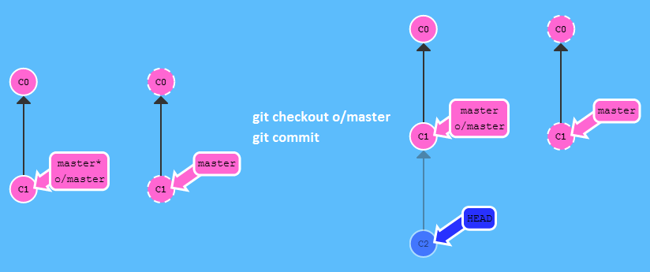

# Fake Teamwork

We can simulate the state of the repository was updated.

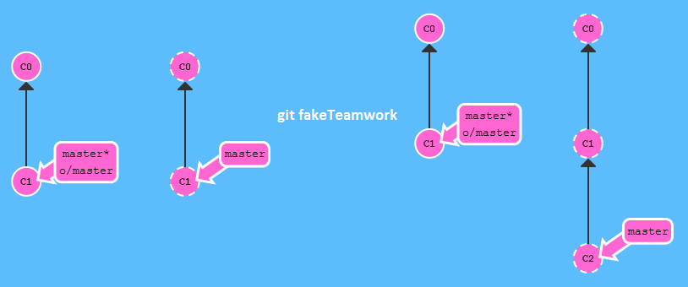

Another example updating three commits of the foo branch:

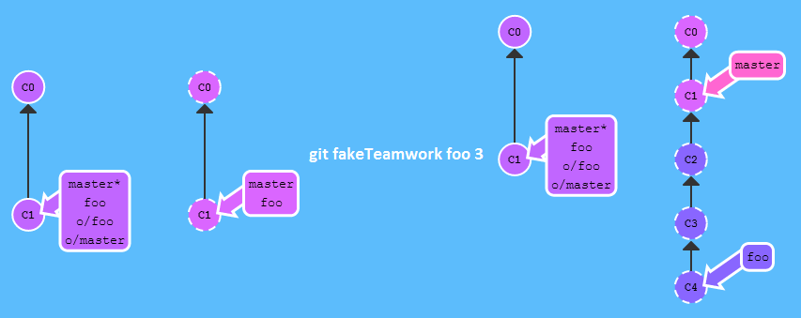

# Fetch

It allows us to retrieve data from the remote repository, but does not change anything about the local state.

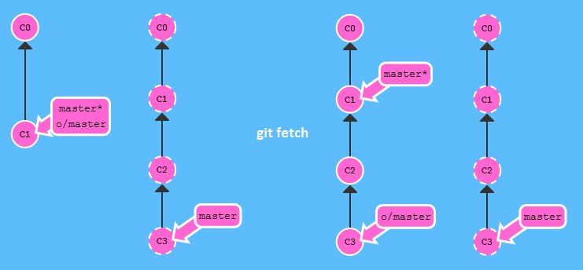

## Fetch with parameters

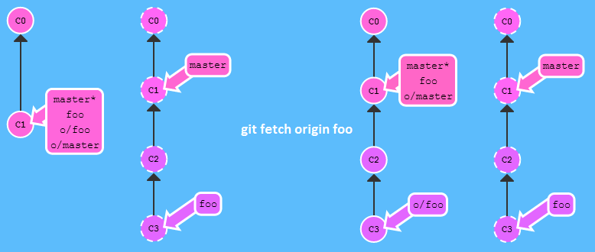

Other example:

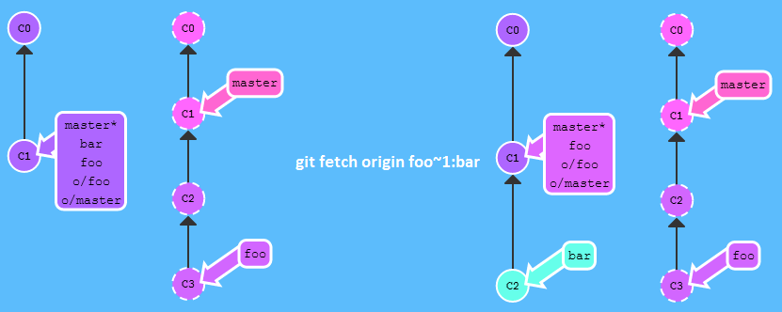

# Pull

It allows us to retrieve data from the remote repository and updates the local state.

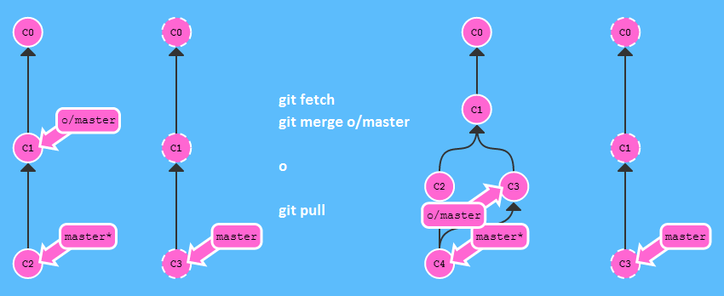

## Pull with parameters

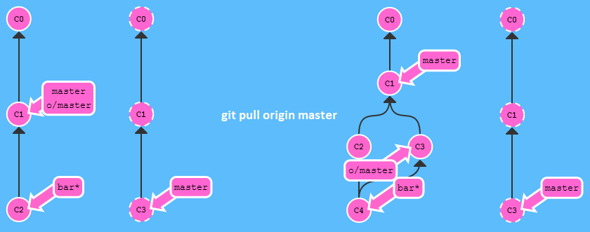

Other Example:

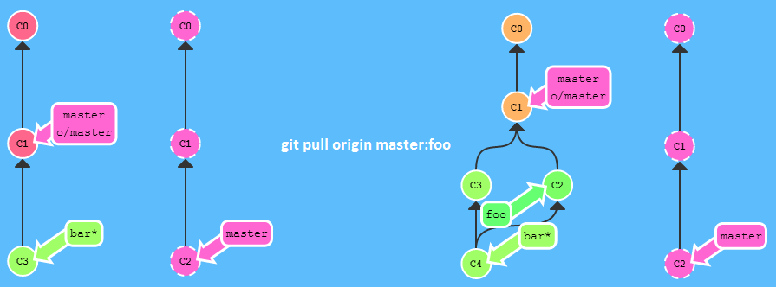

# Push

Upload the local changes to the remote repository, publishes local work.

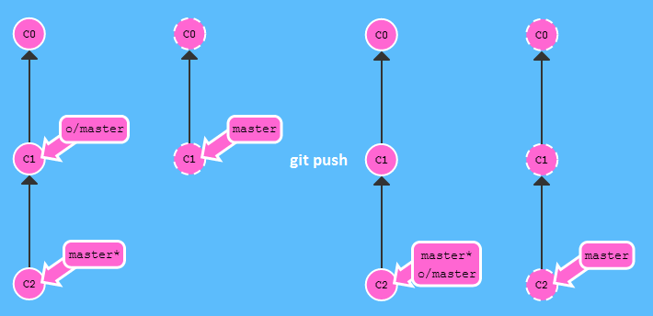

## Push with parameters

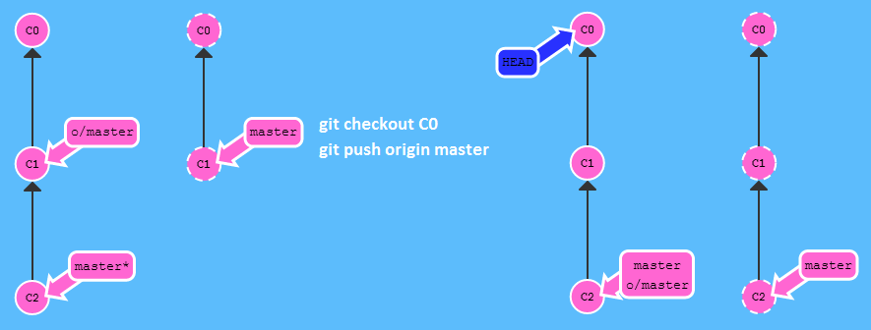

If you do not use parameters we obtain the following result:

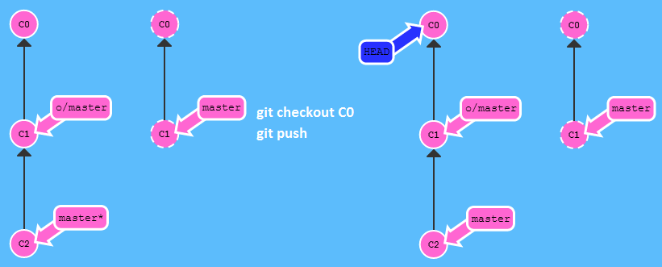

## Push in different destination

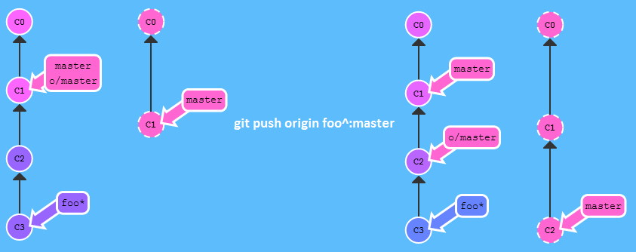

Other example:

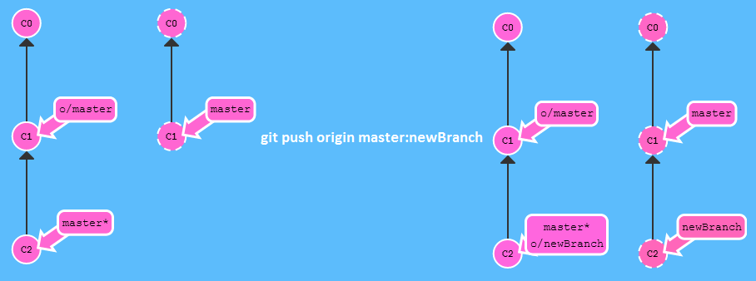

Example with empty argument:

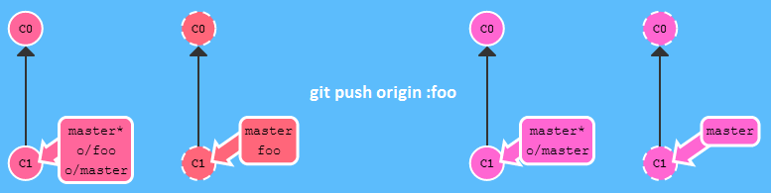

Other example:

