Trying Rmarkdown

Ben Best

August 1, 2014

## Introduction

The Ocean Health Index (Halpern et al., 2012; Selig et al., 2013) derives most of its pressures from Halpern et al. (2008).

## Food Provision: Fisheries

Amount of sustainable wild-caught seafood compared to the max sustainable

$$x_{FIS}=(\prod_{g=1}^{6}{S}S_{i,g}^{C_{i,g}})^{\frac{1}{∑C_{i,g}}}$$

Variables:

* $SS$: stock status score, based on B/Bmsy and an underharvest penalty adjustment
* $C$: total catch
* $i$: OHI reporting region
* $g$: level of taxonomic grouping (ISSCAAP)

## Default Rmarkdown

This is an R Markdown document. Markdown is a simple formatting syntax for authoring HTML, PDF, and MS Word documents. For more details on using R Markdown see <http://rmarkdown.rstudio.com>.

When you click the **Knit** button a document will be generated that includes both content as well as the output of any embedded R code chunks within the document. You can embed an R code chunk like this:

summary(cars)

## speed dist   
## Min. : 4.0 Min. : 2   
## 1st Qu.:12.0 1st Qu.: 26   
## Median :15.0 Median : 36   
## Mean :15.4 Mean : 43   
## 3rd Qu.:19.0 3rd Qu.: 56   
## Max. :25.0 Max. :120

You can also embed plots, for example:

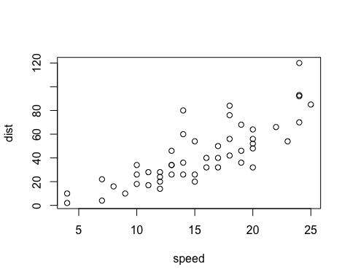

Scatterplot of cars.

Note that the echo = FALSE parameter was added to the code chunk to prevent printing of the R code that generated the plot.

## Github Markdown

To get github friendly Markdown document for cleanly tracking changes to document in Github, put the following output first:

output:  
 md_document:  
 variant: "markdown_github"

NOTE: You need to run this **LAST** though, since knitting other formats wipes out the test_files directory. To return to the Knit button having other options (HTML, PDF, Word), move this output type below the first option.

## References

Halpern, B. S., Longo, C., Hardy, D., McLeod, K. L., Samhouri, J. F., Katona, S. K., … Zeller, D. (2012). An index to assess the health and benefits of the global ocean. *Nature*. doi:[10.1038/nature11397](http://dx.doi.org/10.1038/nature11397)

Halpern, B. S., Walbridge, S., Selkoe, K. A., Kappel, C. V., Micheli, F., D’Agrosa, C., … Watson, R. (2008). A Global Map of Human Impact on Marine Ecosystems. *Science*, *319*(5865), 948–952. doi:[10.1126/science.1149345](http://dx.doi.org/10.1126/science.1149345)

Selig, E. R., Longo, C., Halpern, B. S., Best, B. D., Hardy, D., Elfes, C. T., … Katona, S. K. (2013). Assessing Global Marine Biodiversity Status within a Coupled Socio-Ecological Perspective. *PLoS ONE*, *8*(4), e60284. doi:[10.1371/journal.pone.0060284](http://dx.doi.org/10.1371/journal.pone.0060284)