Trying Rmarkdown

Ben Best

August 1, 2014

## Introduction

The Ocean Health Index (Halpern et al., 2012; Selig et al., 2013) derives most of its pressures from Halpern et al. (2008)...

## Food Provision: Fisheries

Amount of sustainable wild-caught seafood compared to the max sustainable

$$x_{FIS}=(\prod_{g=1}^{6}{S}S_{i,g}^{C_{i,g}})^{\frac{1}{∑C_{i,g}}}$$

Variables:

* $SS$: stock status score, based on B/Bmsy and an underharvest penalty adjustment
* $C$: total catch
* $i$: OHI reporting region
* $g$: level of taxonomic grouping (ISSCAAP)

## Results

Hats off to the top scoring region of **Heard and McDonald Islands** with a score of 90.29! The top 10 scoring regions (of 221 globally) are largely comprised of unpopulated islands (see Table 1).

|  |  |
| --- | --- |
| Region | Score |
| Heard and McDonald Islands | 90.29 |
| Ile Europa | 89.48 |
| Bassas da India | 88.17 |
| Howland Island and Baker Island | 85.89 |
| Juan de Nova Island | 83.84 |
| Glorioso Islands | 83.79 |
| Kerguelen Islands | 82.84 |
| Northern Saint-Martin | 82.58 |
| Nauru | 82.18 |
| Seychelles | 81.93 |

Top 10 scoring regions.

The global average of 68 consists of food provision scores being lowest (Mariculture = 26; Fisheries = 40), but Artisanal Fishing Opportunities highest (98) (see Figure 1).

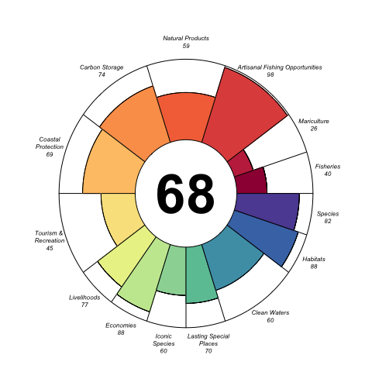

Global average across Oceean Health Index goals.

Note that the echo = FALSE parameter was added to the code chunk to prevent printing of the R code that generated the plot.

## Github Markdown

To get github friendly Markdown document for cleanly tracking changes to document in Github, put the following output first:

output:  
 md_document:  
 variant: "markdown_github"

NOTE: You need to run this **LAST** though, since knitting other formats wipes out the test_files directory. To return to the Knit button having other options (HTML, PDF, Word), move this output type below the first option.

## References

Halpern, B. S., Longo, C., Hardy, D., McLeod, K. L., Samhouri, J. F., Katona, S. K., … Zeller, D. (2012). An index to assess the health and benefits of the global ocean. *Nature*. doi:[10.1038/nature11397](http://dx.doi.org/10.1038/nature11397)

Halpern, B. S., Walbridge, S., Selkoe, K. A., Kappel, C. V., Micheli, F., D’Agrosa, C., … Watson, R. (2008). A Global Map of Human Impact on Marine Ecosystems. *Science*, *319*(5865), 948–952. doi:[10.1126/science.1149345](http://dx.doi.org/10.1126/science.1149345)

Selig, E. R., Longo, C., Halpern, B. S., Best, B. D., Hardy, D., Elfes, C. T., … Katona, S. K. (2013). Assessing Global Marine Biodiversity Status within a Coupled Socio-Ecological Perspective. *PLoS ONE*, *8*(4), e60284. doi:[10.1371/journal.pone.0060284](http://dx.doi.org/10.1371/journal.pone.0060284)