~

LK8000 version 7.2
What's new and what has changed since v7.0

© 2020 The LK8000 Development Team
December 2020

TABLE OF CONTENT

Overlay Configuration 3
Bottom Bar Mode 4
Airspace/Waypoint Data Management 5
Airspace Management 7
Airspace Group Acknowledge 7
Airspace Class Notam 8
FIR (flight information regions) 8
Automatic Radio selection B> 9
Airfield ICAO-Code Search 10
New Multiselect Elements 10
Flarm Target 10
Own position 11
Oracle 11
Team 11
FLARM Radio Frequency 11
Airfield Additional Frequencies 11
New Terminal Send Button 12
New Lowercase Keyboard 12
New UTF8 Map Symbols 13
Task selection on loading CUP files 14
En-/Disable Multimap5 FLARM Radar 14
Multi Contests 15
New Contest rules 15
New System option “Draw XC Triangle” 17
New X> target 18
New FAI Assistant 19
FLARM IGC File readout 21
System Menu 23 - Map Scale 23
New LX Navigation driver for EOS, ERA, LX10k and ColibriX devices 24
NANO III driver enhancements 26

Overlay Configuration

Overlay configuration has been simplified. For each overlay, at System menu 13 Map Overlay, the user can choose:
OFF: Overlay is not visible.
Default: Overlay value will be displayed as in version 5.
Custom with any of the available infobox values.

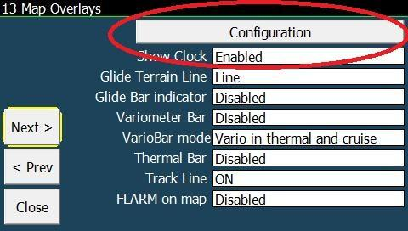
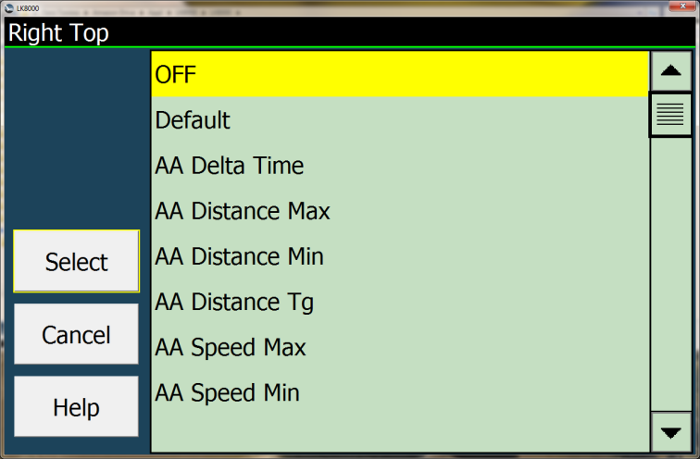

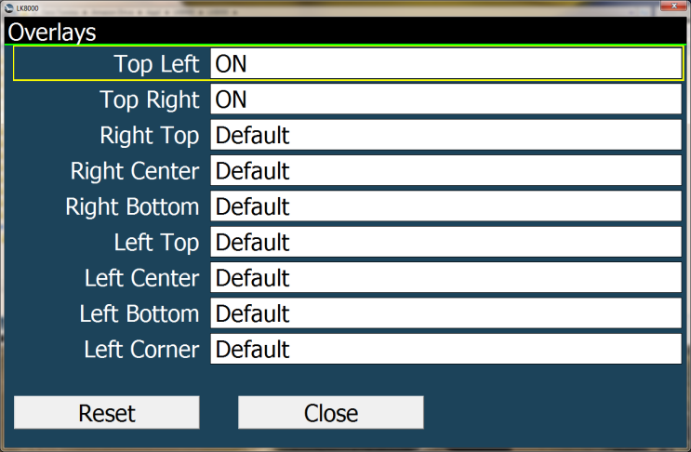

Bottom Bar Mode

There is an additional bottom bar mode available at System menu page 10 Interface. The modes are now :
MANUAL: The Bottom bar will only change manually
AUTO THERMALLING : The Bottom bar will change automatically to TMR0 each time the flying mode is detected as “thermalling” and will switch back to the previous mode when thermalling is finished.
FULL AUTO : The Bottom bar will change automatically to TMR0 , CRU7 and FIN8 stripe respectively when flying mode is detected as “thermalling” , “cruise” and “final glide”

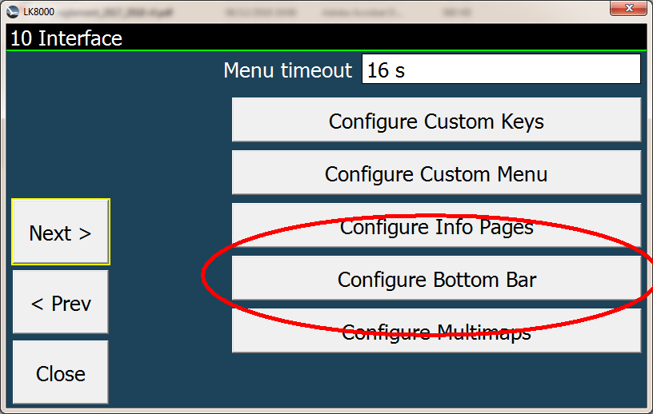
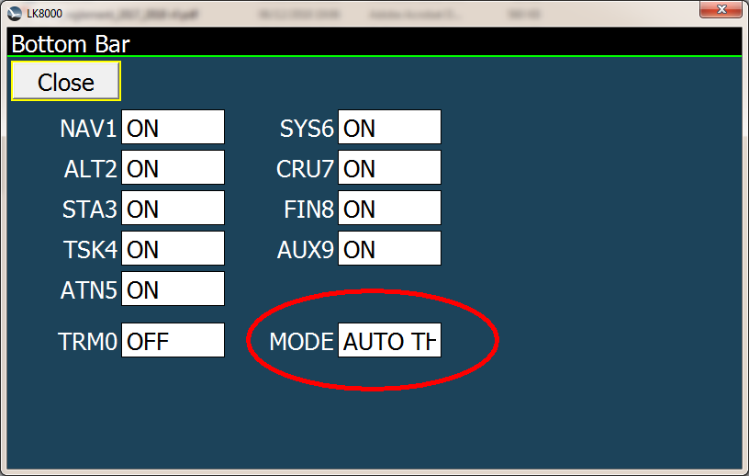

Airspace/Waypoint Data Management

Some flying regions (e.g. the alps) need more than 2 country data sets. Airspace and waypoint data are typically arranged by country. Now you can set up to nine different airspace/waypoint files. On system setup page 1 there are now two buttons which lead to the new setup for waypoint and airspace data.
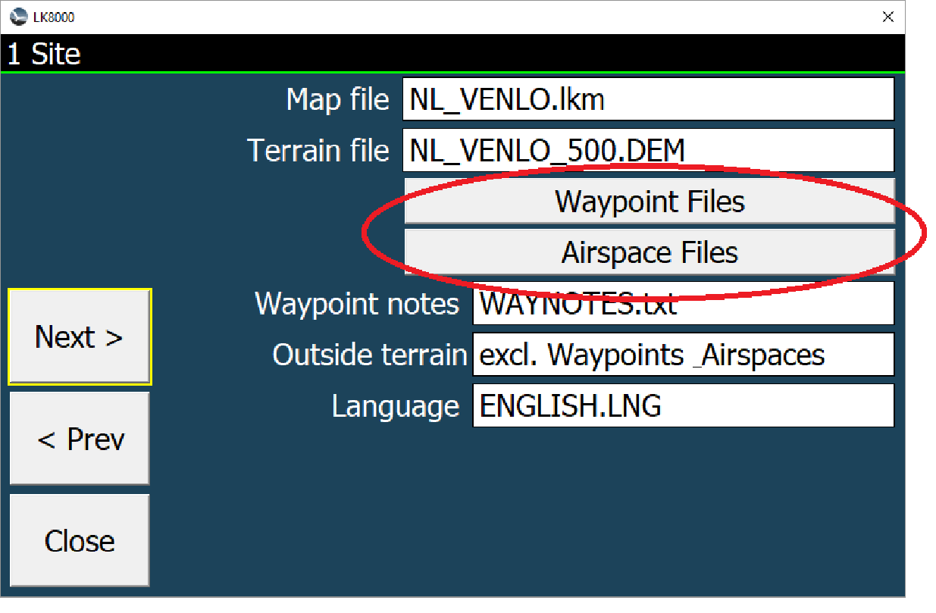
Here we see a typical setup for the alps, where multiple countries are included.

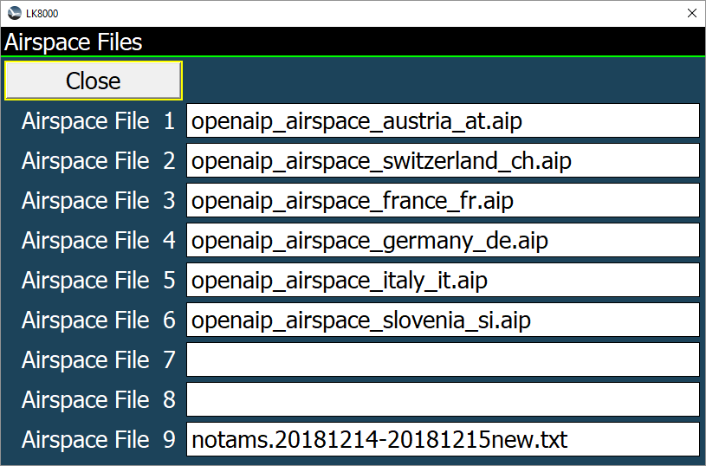
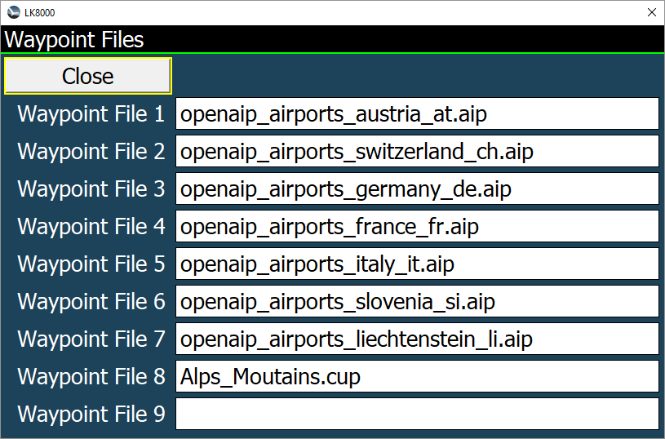

It is obvious that this setup will load more than needed airspace data for a particular flying region (e.g. Italian, German or French non alpine regions). These superficial airspace data tend to slow down the program performance. To prevent this, a new filter (“Outside terrain” at system setup page 1) can be switched on which excludes airspaces out of terrain from calculations.

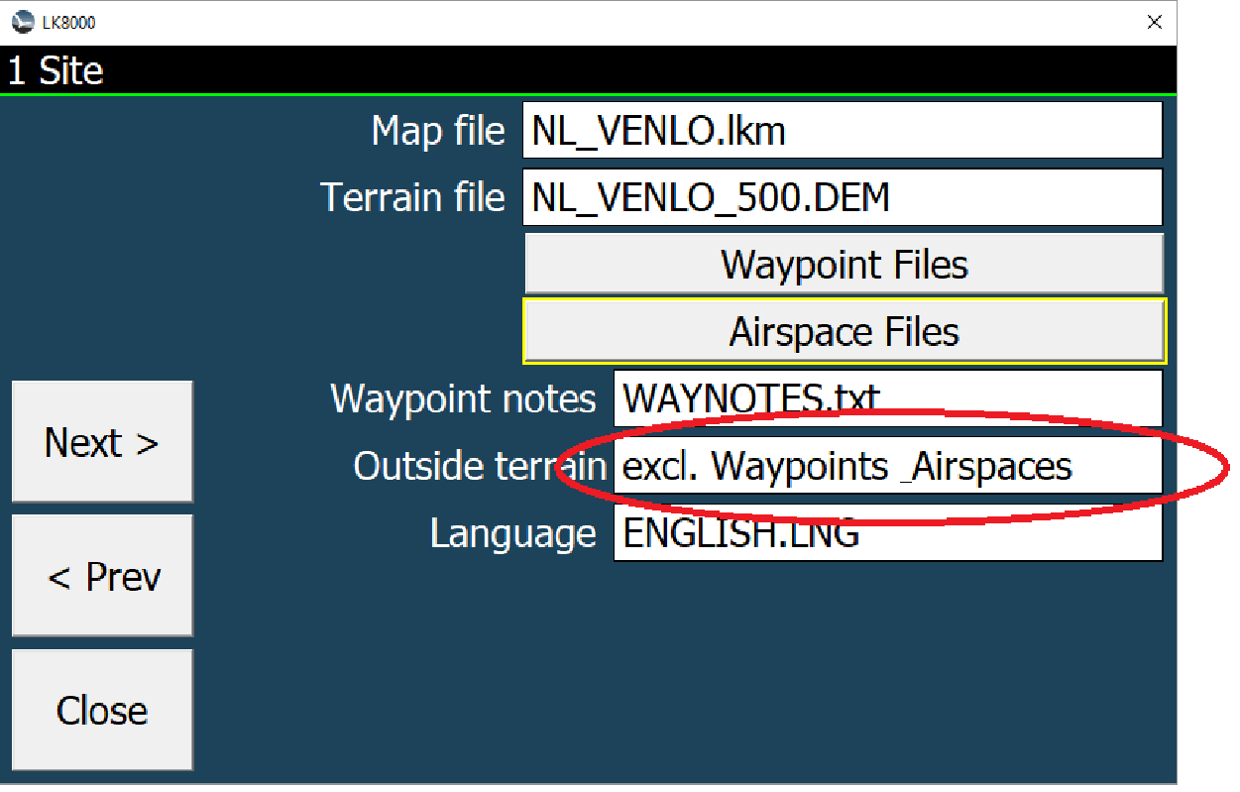

With the option “excl. Waypoints Airspaces” all waypoints and airspaces outside the loaded terrain regions will be excluded from calculations and vanish from the map as can be seed in the left picture. Full inclusion i.e. “incl. Waypoints Airspaces” is shown in the right picture.

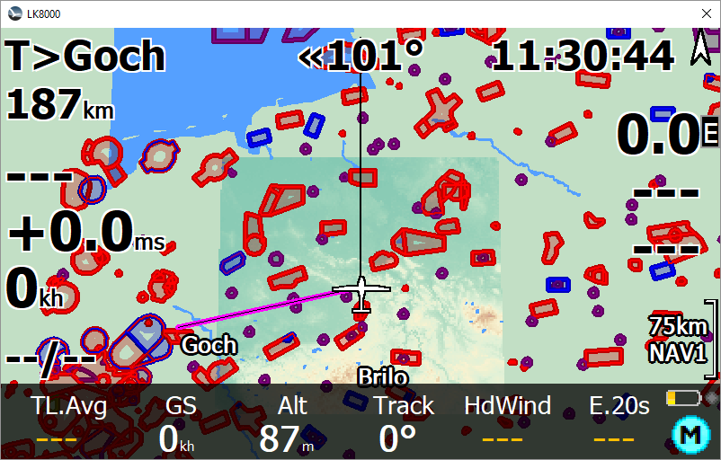
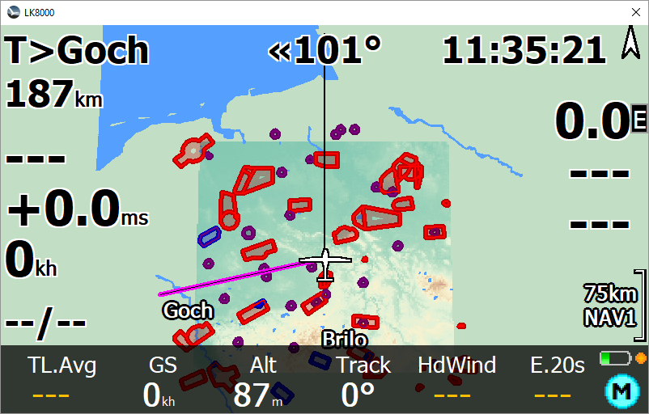

Exclude waypoints & airspaces outside terrain include waypoints & airspaces outside terrain

In detail, the exclude option determines a data area which exceeds the loaded terrain borders by 5%. All waypoints and airspaces touching this region or located within this region will not be sorted out. This guarantees valid airspace data and navigation also at the terrain region borders.

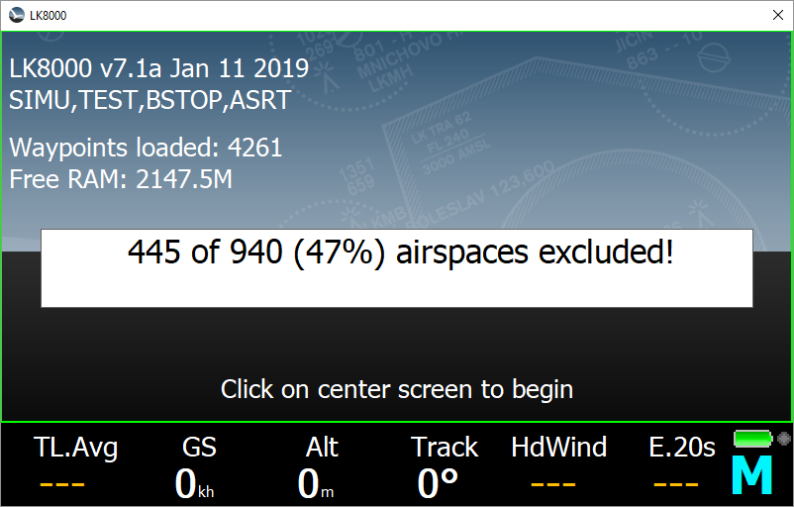
During startup the amount of excluded airspaces is shown.

Airspace Management

On menu NAV 3/3 a new “Airspace Lookup” button can be found. It opens the airspace management dialog as in system config page 2.
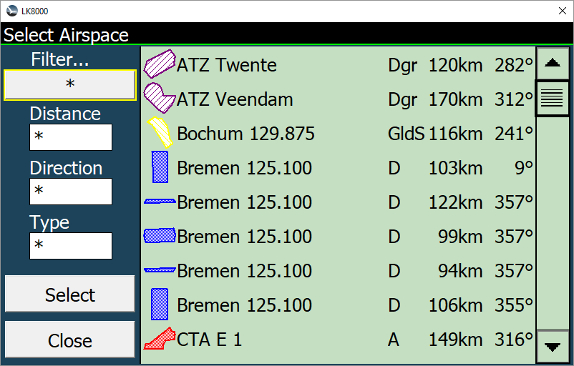
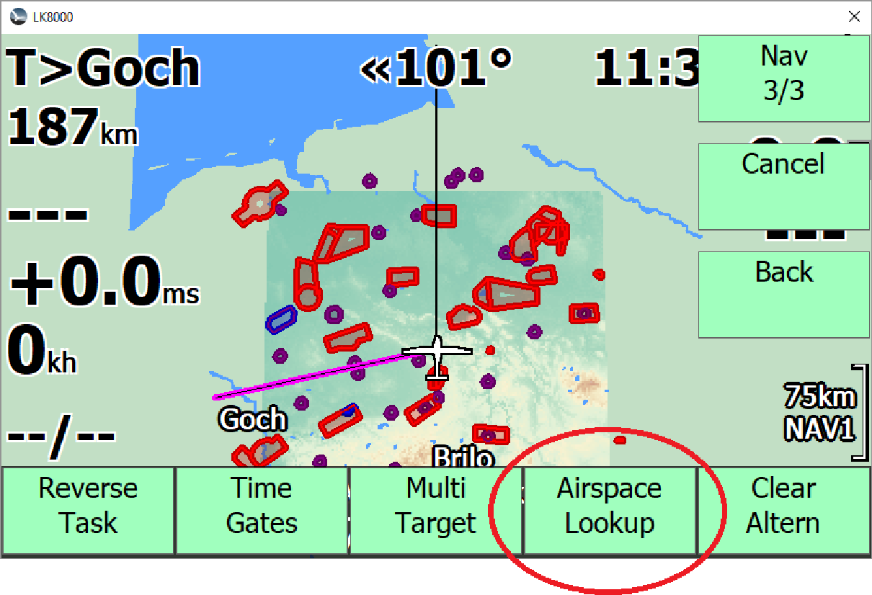

In the airspace management dialog the shape of an airspace is shown as pictorial for a quicker identification. For a quick activation/deactivation of an airspace simple click on its pictorial line. Please note the “Group Acknowledge” works for activation/deactivation of airspaces here as well.
If you want to get more information about a particular airspace select it and press the [Select] button.

Airspace Group Acknowledge

Complex airspaces can be defined as a group of airspaces with a common name and class and their member airspaces can be handled in parallel if you enable “Group acknowledge”. This can be achieved by press button [Warnings] in system setup page 2 and set in the “Warnings” sub menu “Group Ack” to on.
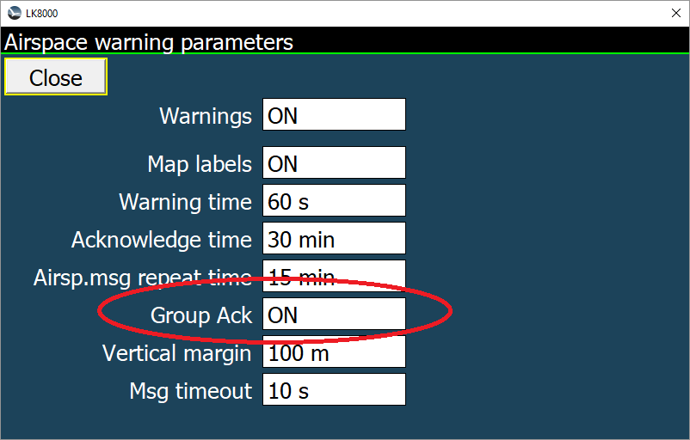
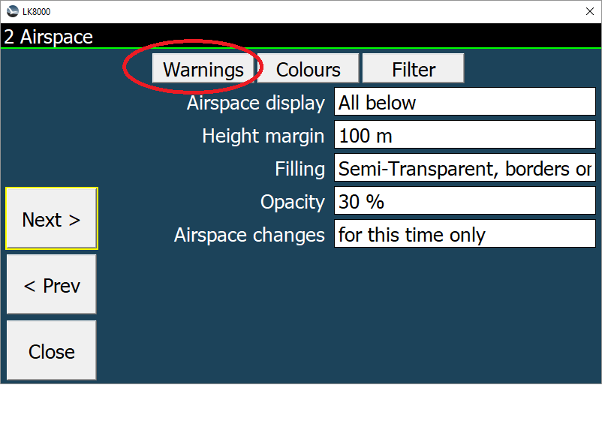

Airspace Class Notam

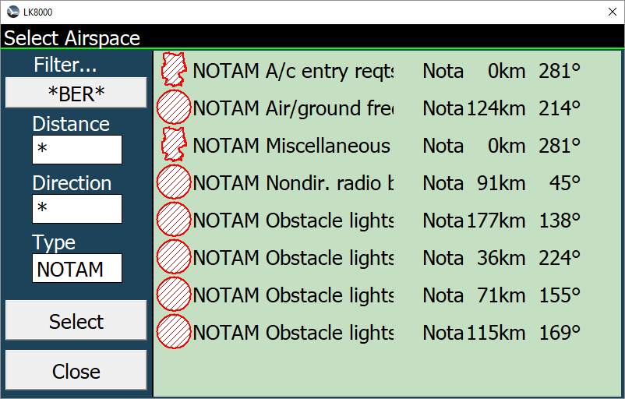
A new airspace class “Notam” is now available. This is used for temporary airspaces announced by NOTAMs (Notice to Airmen). A good source of daily updated NOTAM airspace information is:
https://notaminfo.com/
After free registration at that website you can download a user defined NOTAM airspace file compatible for LK8000. Most NOTAM airspaces have additional textual information, which can be seen in the airspace details page, after clicking [Details]. Please be aware that the filter searches in the complete airspace text.

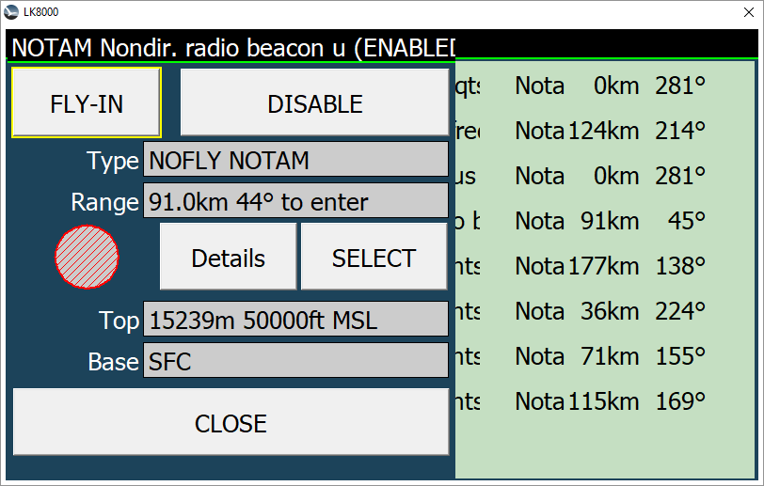
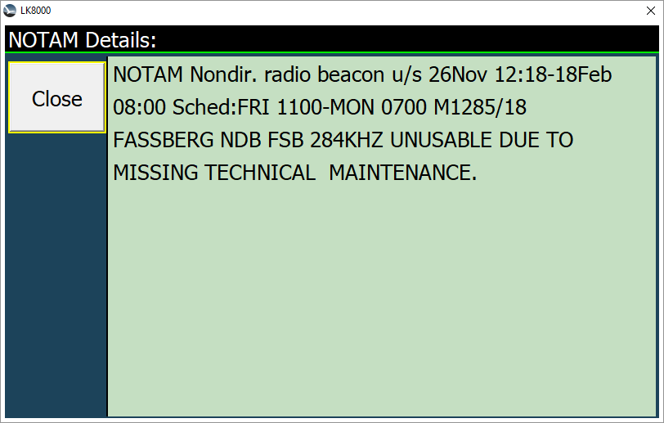

Additional [Details] button Additional airspace details text
If the [Details] button does not appear, there is no additional information in the file except the airspace name in the title of the dialog.

FIR (flight information regions)
Some airspace files include FIRs, these data useful to get the correct frequency (channel) and callsign of the FIS (flight information service), but tend to clutter the map display.
For such cases defining an airspace with an upper limit of 0m MSL will exclude this airspace from drawing on the map and from the airspace warning system but allow selecting it with the multiselect function in order to set the radio frequency.

Automatic Radio selection B>
Similar to the Best Alternate automatic selection it is possible to automatically set the radio to the best alternate airfield frequency, to do so simply click on the most left position of the airfield selector in the radio dialog, to disable it press it again. This works for the primary and standby frequency as well.
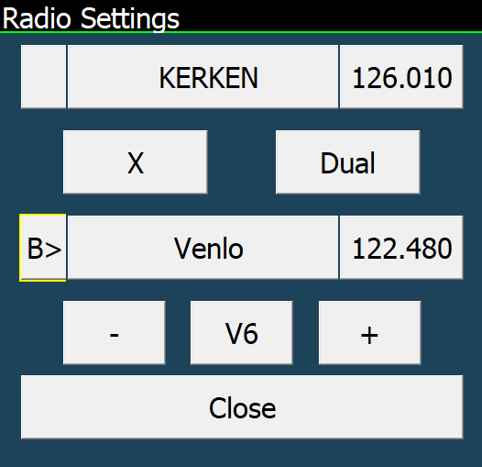
Caution:
Even if this is a useful feature, please keep in mind that this works even if the radio dialog is closed, so on a cross country flight you will automatically be forwarded to the next airfield but may not recognize that.

Airfield ICAO-Code Search
If the airfield ICAO code is specified in the waypoint files (like in OpenAIP Files, provided by LKMaps) the search function can be used for it too. In right picture “EDH” shows all airfields with ICAO code containing EDH. So if you are aware of the ICAO-Code, searching it can be much quicker. The ICAO-Code is now shown in round brackets after the airfield name.

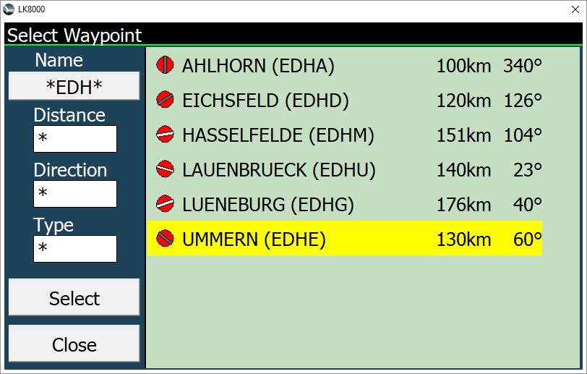
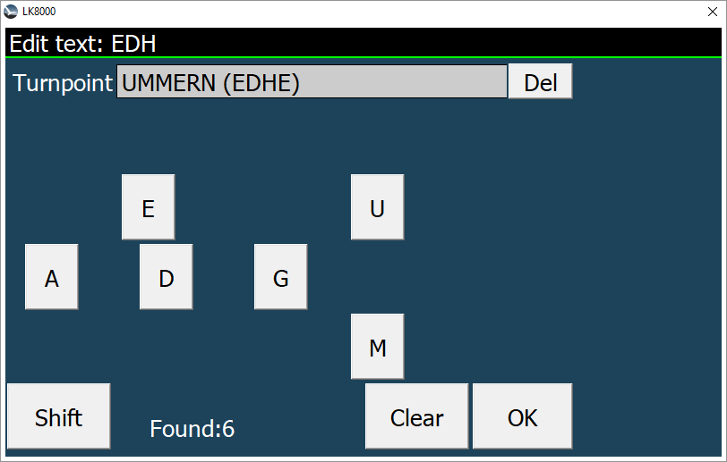

New Multiselect Elements

The Multiselect Dialog has now four more elements:
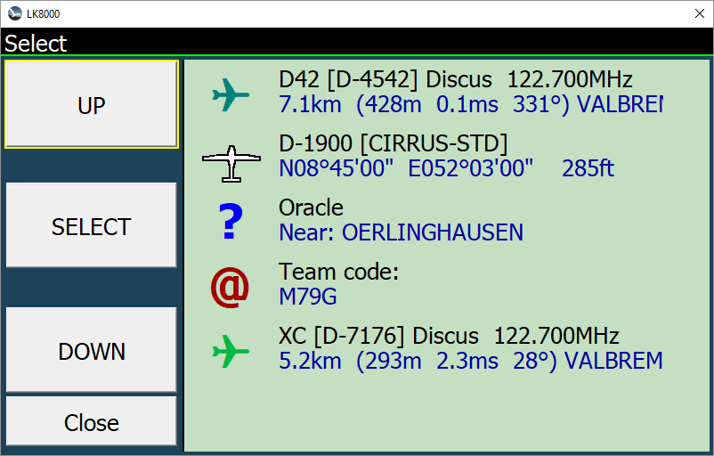
Flarm Target
Own position
Oracle
Team

Flarm Target

If a FLARM target was selected it appears with some additional information in the multiselect dialog. If the target is additionally registered at FlarmNet we get further Information (registration, home airfield etc.). Like on the maps, the symbol color of the FLARM target indicates the climb rate (green=climbing, blue = sinking).
By touching the entry the Flarm Object dialog opens. This might be helpful to navigate to a climbing Flarm target, meeting a friend or establish a radio contact.

If you touch your own aircraft position you get three additional elements such as:

Own position

Here you can read your own GPS position as well as your defined glider type, registration, polar (e.g. verify the polar you're flying with), current height MSL in ft. If you touch this entry again you enter the “Basic settings” dialog for your aircraft.

Oracle

Here you get textual information about your current position. This is very helpful for transmitting your position via radio (e.g. ATC). To receive even more precise information touch this entry again and the oracle provides more information.

Team

If you have defined the same team reference point as your teammate, you can tell him your current position just by sending him the shown code. If you touch this entry you can enter his code in order to find his position. This is very useful in team flights (lead and follow) in the case you lost visible contact. It is much easier and more fail-safe than communicating a GPS position.

FLARM Radio Frequency
In case you have a connected radio and a Flarm Object has defined an air/air frequency you can set this on the radio just by pressing the frequency button.
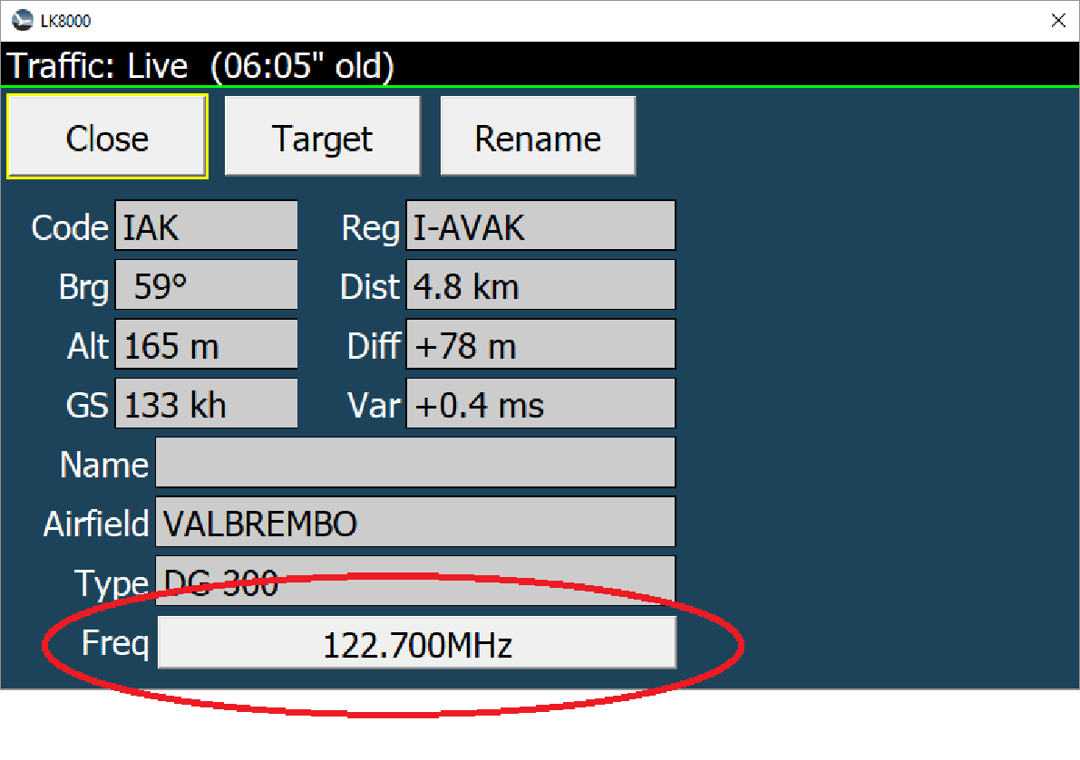

Airfield Additional Frequencies
On large airfields/airports more than just one radio frequency may be in use. In this case the other frequencies can be written in/red from the airfield comments of the waypoint data. If you have a connected radio, you can set the frequency of choice just by pressing the appropriate comment line.
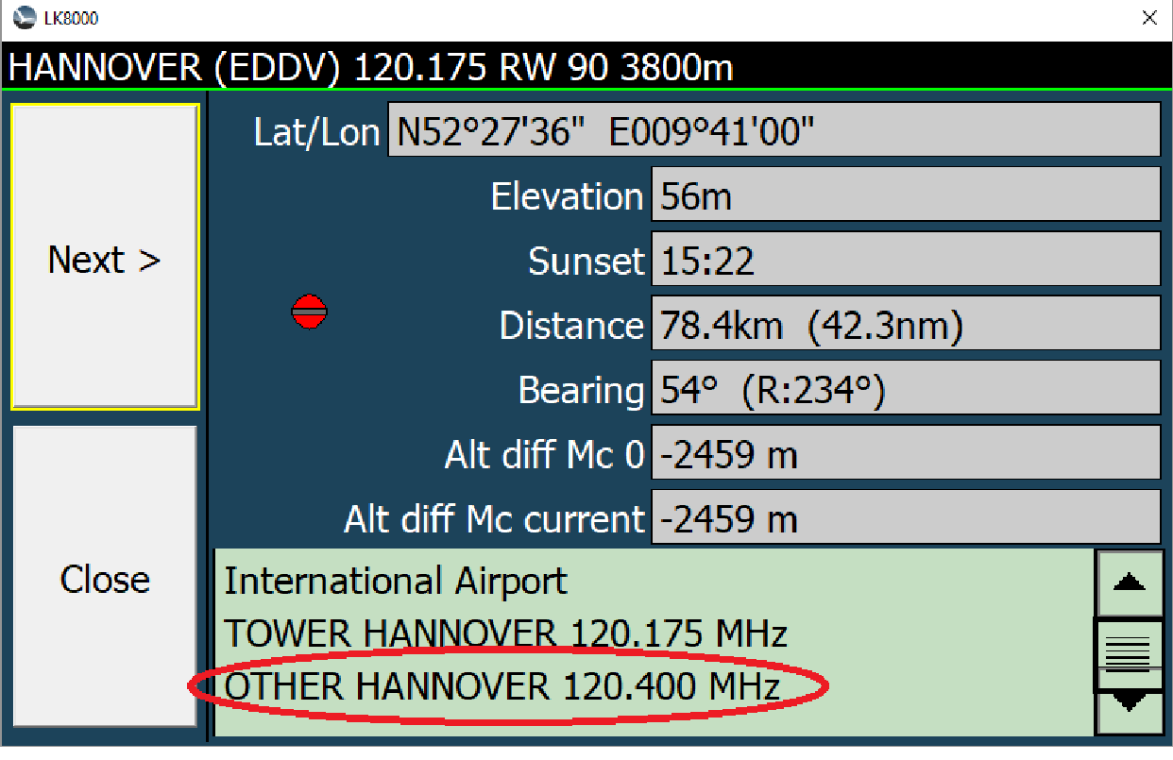

New Terminal Send Button
For debugging purposes the terminal window in the device setup has now also the “Send” feature. This allows testing on connected devices in both communication directions.
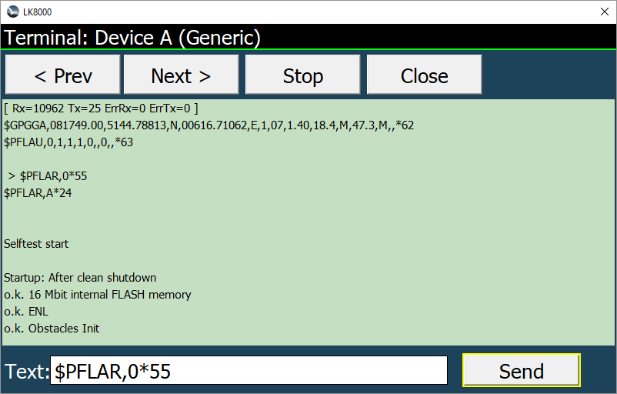
If the entered text is a NMEA-string (starting with $) the checksum is added automatically.

New Lowercase Keyboard
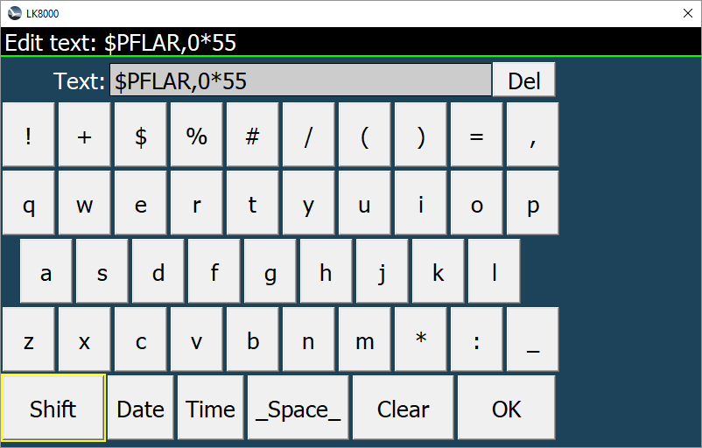
Now it is possible to enter lower case characters and special characters using the [Shift] button in all text editable fields.

New UTF8 Map Symbols
On system setup page 12 “Fonts” you can choose an alternate map symbols display mode “UTF8”. It is based on scalable UTF8 text symbols. Especially at higher display resolutions the symbol presentation might be better than with the standard bitmap symbols.
Please note that UTF8 symbols might not be supported by all devices. If in doubt use the “Bitmap” option.
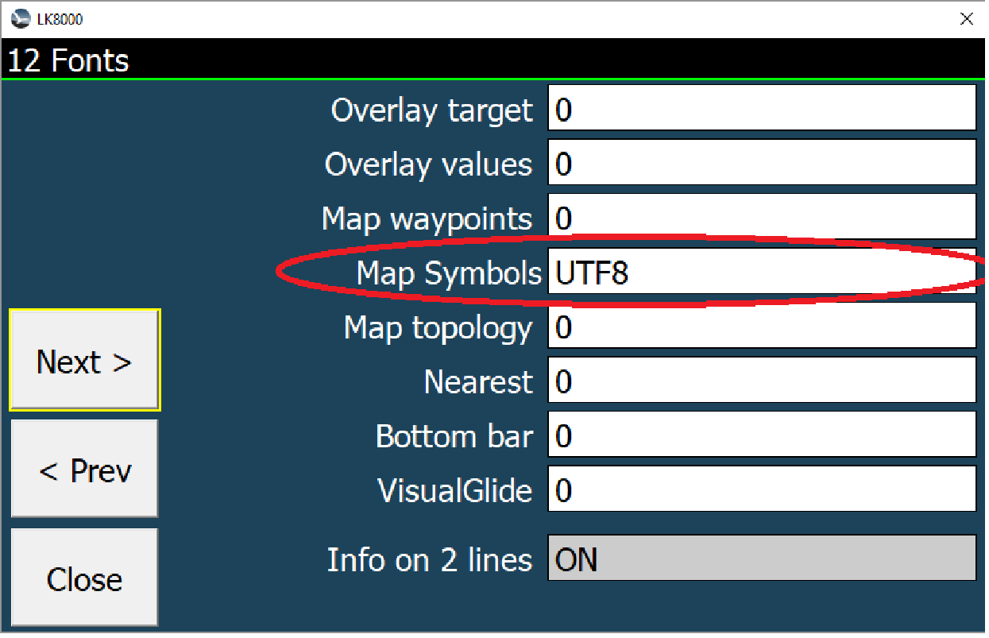

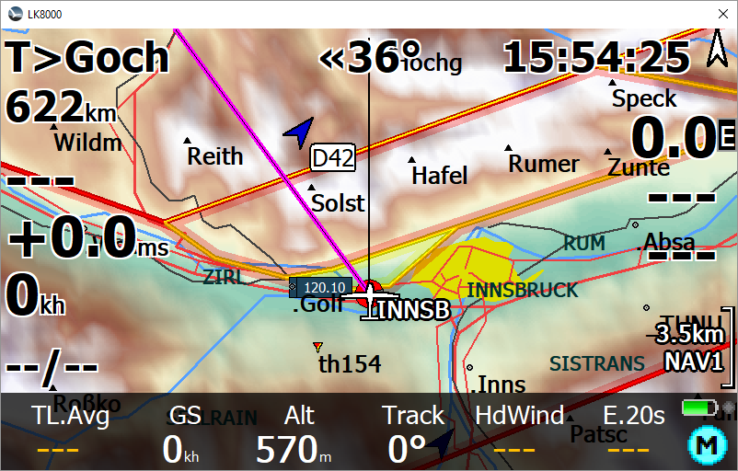
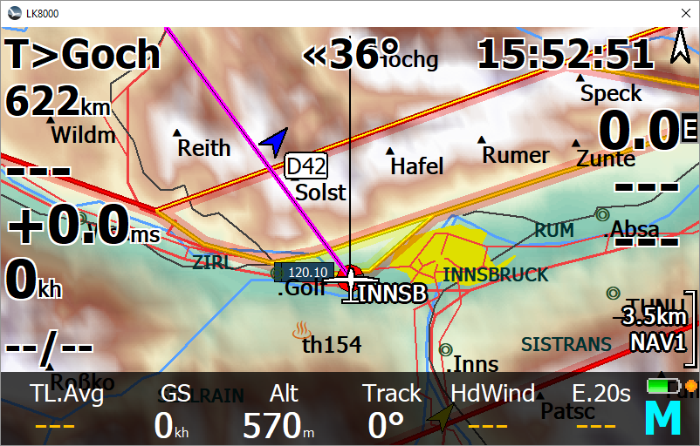
UTF8 Symbols Bitmap Symbols
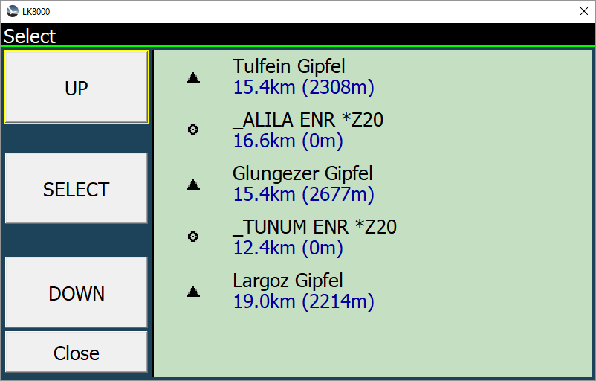
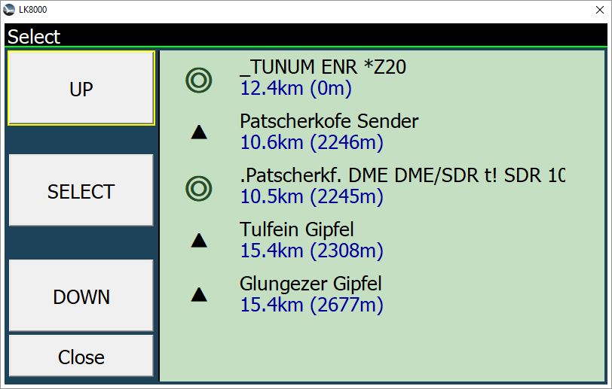

Task selection on loading CUP files
If there is a CUP-task-file loaded within with more than one task defined a task select dialog opens. (In former versions only the first task found was loaded.)
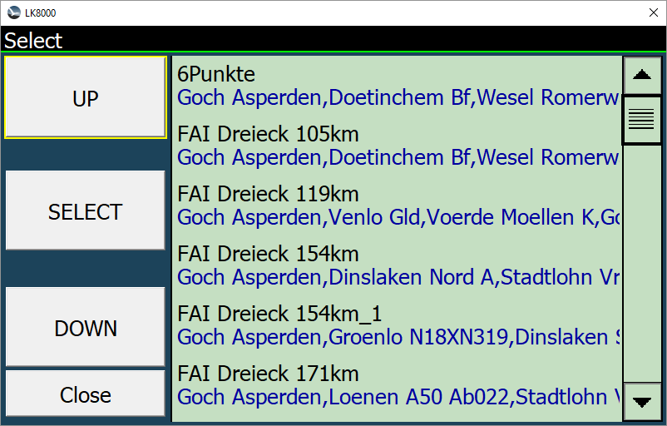

En-/Disable Multimap5 FLARM Radar
Multimap5 (Flarm Radar) can now be manually en-/disabled as well.
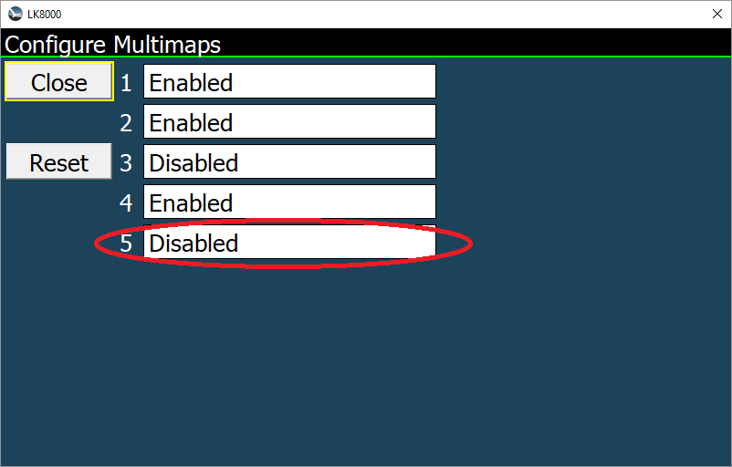
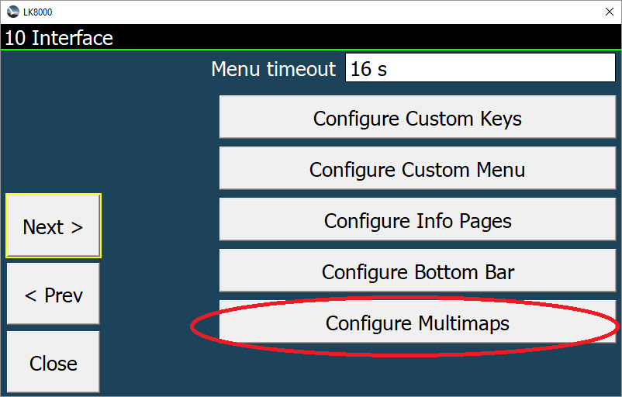

Multi Contests

New Contest rules

Now LK8000 also supports PG/HG most popular cross country online contests along with the Online Contest (OLC) which continues to be the default one. The new feature is available on System menu 22. Options are:
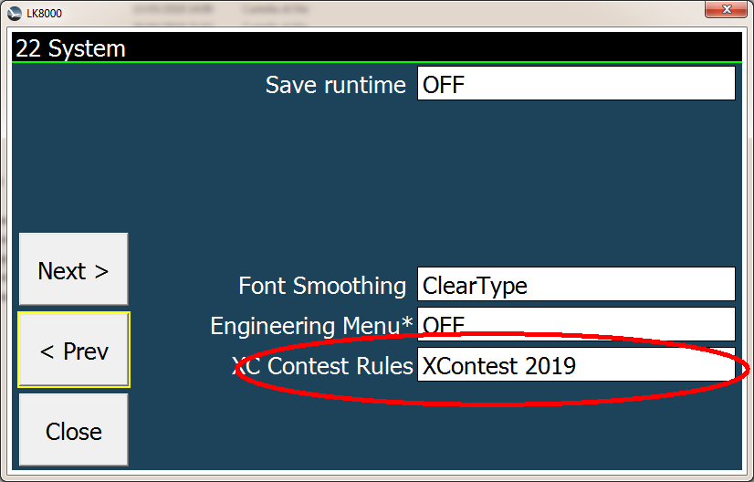
- OFF
- Only FAI assistant
- OLC (Default)
- XContest 2018
- XContest 2019
- French CDF ligue
- Leonardo XC
- UK National League

If OFF is selected no contest data will be evaluated and also the FAI Assistant (highly related to contest algorithms) will not be available. This option is particularly interesting during competitions (or other cases) for reducing CPU usage and consequently increasing battery lifetime.

The Only FAI assistant option will not score any contest and contest data will not be available in infoboxes. In this case only the triangle solvers needed by the FAI Assistant functionality will run.

If OLC is selected (Default option) you will have the same information and behavior of version 7.0.

If an XC contest is selected (XContest, CDF, LeonardoXC …) 12 new infoboxes values will be available with results and data calculated according to that rule:

XC FREE Flight distance [FRE Dis]: Free distance over 3 turnpoints.
XC FREE Flight score [FRE Scr]: Score of Free flight with 3 turnpoints.
XC FREE Triangle distance [TRI Dis]: Triangle distance which does not conform to FAI triangle specification.
XC FREE Triangle score [TRI Scr]: Score of FREE Triangle (NOT FAI).
XC FAI Triangle distance [FAI Dis]: Triangle distance conforms to the FAI definition (the shortest leg of the triangle must be at least 28% of the total triangle).
XC FAI Triangle score [FAI Scr]: Score of FAI Triangle.
XC best distance [XC Dis]: Distance of the best scored contest (FAI Triangle, FREE Triangle, FREE Flight).
XC best score [XC Scr]: Best score of all contests (FAI Triangle, FREE Triangle, FREE Flight).
XC Triangle closure distance [XC C]: Distance to close the best scored contest triangle (FAI or FREE) in km
XC Triangle closure % [XC C%]: Distance to close the best scored contest triangle (FAI or FREE) in percentage
XC Triangle predicted distance [XC Dis*]: Distance to close the best scored contest triangle (FAI or FREE) in km
XC mean speed [XC Spd] Cross country mean speed calculated on three turn points

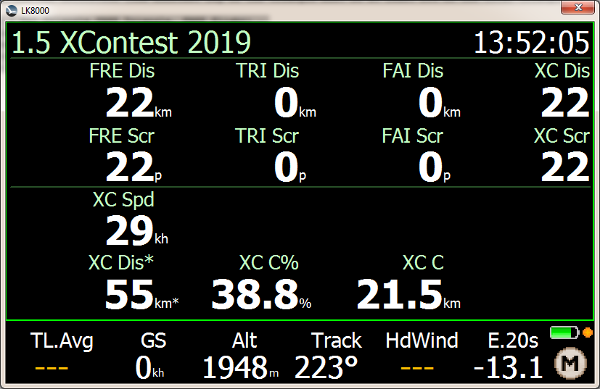
These infoboxes can be used in any configurable field (Overlay or Bottombar) and are also directly available on Contest Page 1.5 that will also indicate the current rule used for calculation.

New System option “Draw XC Triangle”
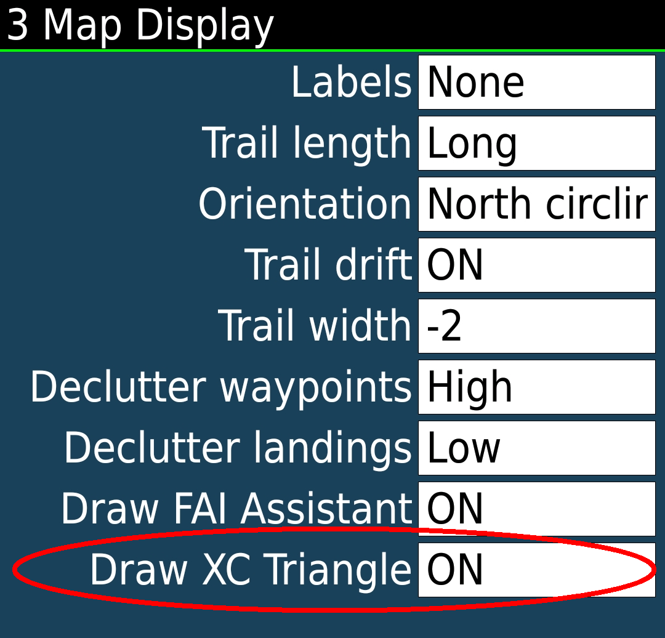
A new System option is available on System menu n. 3 “Map Display”. This option, related to the new Contest feature described in the previous paragraph, can also be activated/deactivated as a “Runtime Option” on Display 2/3 menu ( Draw XC ).

When activated (ON) the current “best” cross-county predicted triangle (according to the Contest rules defined on System menu 22) is displayed on the main map.
“Best” always means the triangle that, if closed, will score more points.
Under OLC rules this is always the current predicted FAI triangle. Under PG/HG XC rules it can be either a FAI or a FLAT (not FAI) triangle.
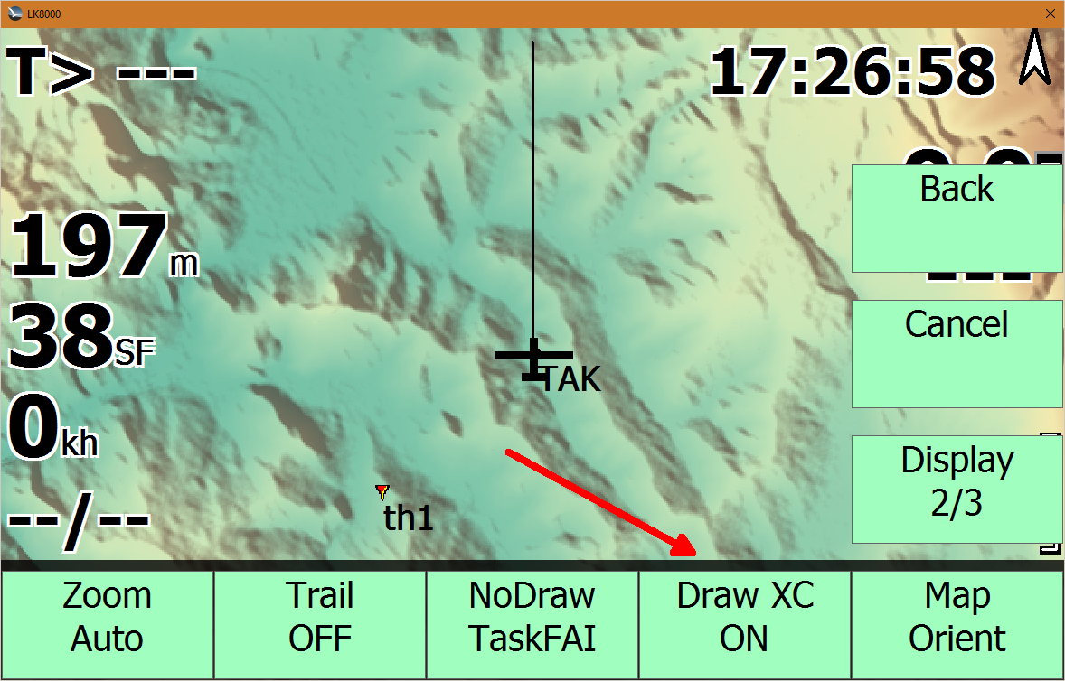

The triangle is displayed in three different colours according to its status:
- Orange – The triangle is not valid yet and will score zero points. For example, this means, under XContest 2019 rules, that the closing distance is more than 20% of its total perimeter (or under OLC rules that the closing distance is more than 1000 meters).
- Green. The triangle is Valid and will score according to current rules.
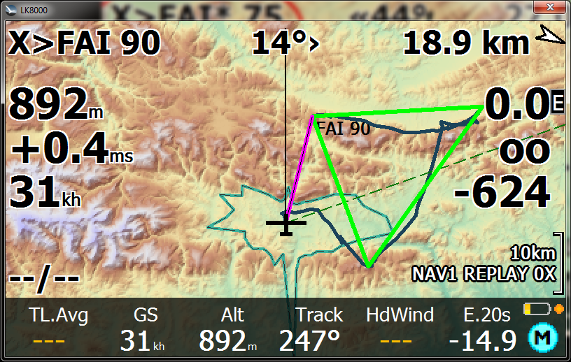
- Red- The triangle is Closed. For example, this means, under XContest 2019 rules, that the closing distance is less than 5% or its total perimeter.

The transition radii of these status are also display on the map with the same colors of “Draw XC” functionality. A green circle indicates the area to reach for having a valid triangle meanwhile a red circle indicates the area to reach for having a closed triangle. For contests rules where there is no distinction between Valid and Closed status (OLC, LeonardoXC ...) only the closed status is displayed.

New X> target
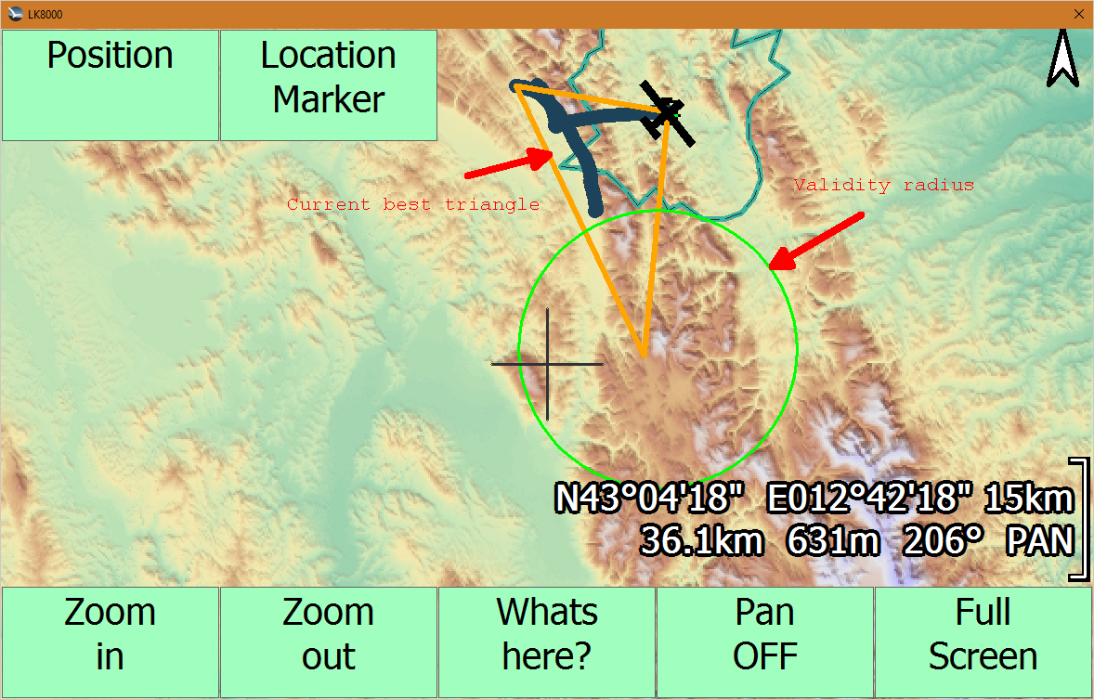
When a contest rule is active in System menu 22 there will also be a new target (the X> target) to use in the LK8000 multitarget functionality.
The X target is, in any moment of the flight, the best point where to close the best scored triangle in that moment. The name of the target is for example FAI*70 o TRI 80 or TRI*80 or FAI!90.
FAI means FAI Triangle. TRI means free (or named Flat under some rules) triangle.

The asterisk (*) indicates a predicted not yet valid triangle (for example under XContest 2019 rules a triangle with a closing distance > 20% and under CDF rules a triangle with a closing distance > 5%) and the number is the total predicted length of the triangle if closed. An exclamation mark (!) indicates a closed triangle. No symbol indicates a valid triangle. The current triangle is also drawn on the map with the same colors of the New Runtime option “Draw XC” feature.

A green arc on the indicated track indicates the sector to enter to have a VALID triangle and a red arc to have a CLOSED triangle.

New FAI Assistant

We now have a new algorithm for the FAI Assistant and there is no more need for the pilot to enter the type of start (old start on turnpoint or start on leg) as was necessary before. The best possible triangle, to be promoted into a FAI one, is always detected automatically.
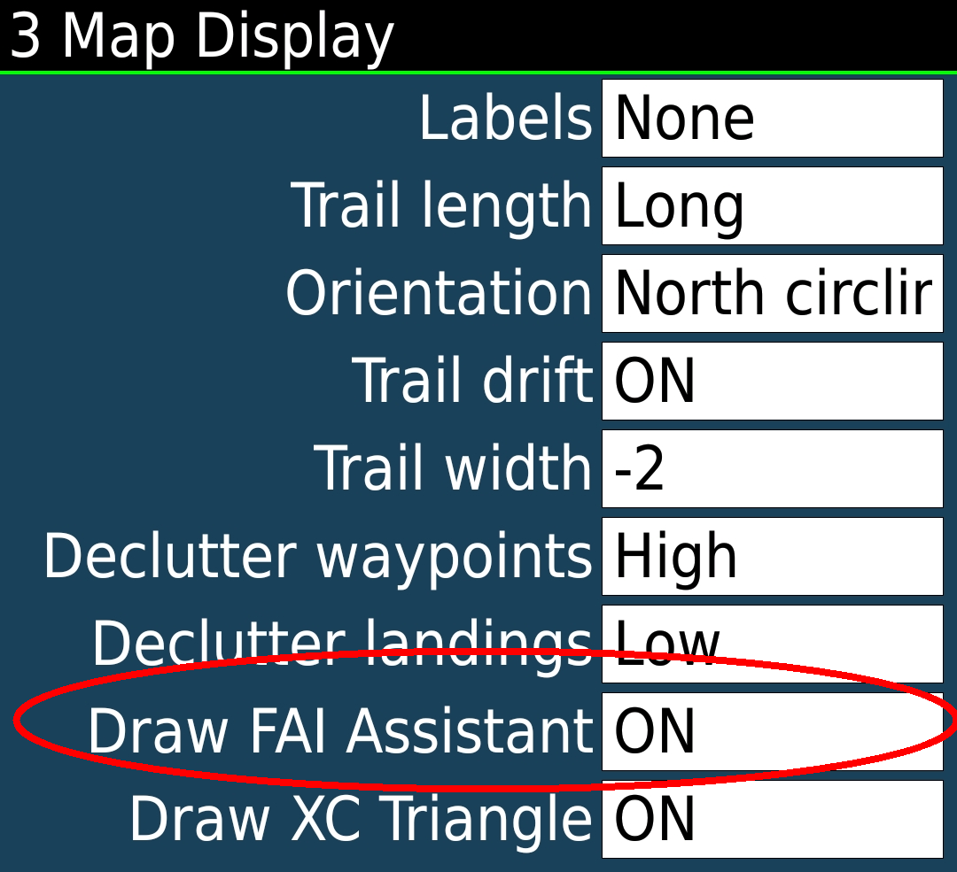
To get this functionality make sure you have activated the FAI Assistant (or any of the Contest rules other than OFF) in System menu 22. Moreover, to be able to see the sectors on the main map activate the “Draw FAI Assistant” option on System menu 3.

The yellow sector indicates the sector on the first leg of the triangle and a cyan sector the one on the second leg. The second sector becomes visible only when you are in the proximity of reaching the first one.
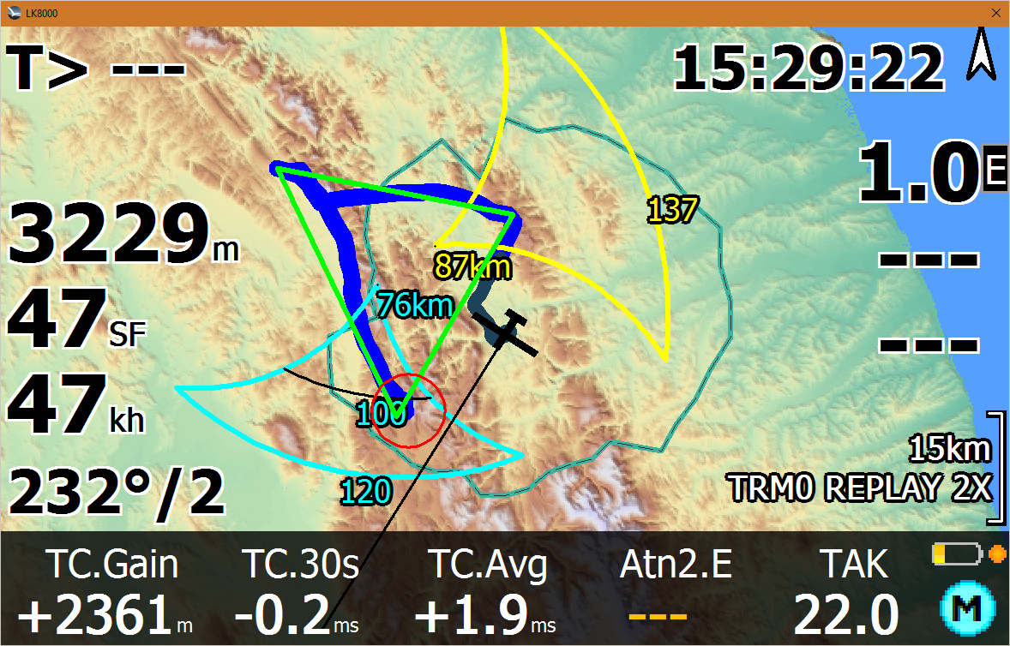

On the main map only the relevant sectors are visible. The main sector to follow is , in most situations, the yellow one. Once you have reached that sector and you are happy with the achieved distance you can easily use the targeting function above to close your triangle.
In the analysis page ( Menu->Info->Analysis->Contest->Fai Assistant ) you have similar information but with more details. :
D : Distance achieved so far on the FAI triangle ( = D*-B)
D* : Total/Predicted distance of the FAI triangle
C : Current distance to the best point where to close the triangle
B : Best achieved distance to the best point where to close the triangle
S : Current Mean speed
T : Time
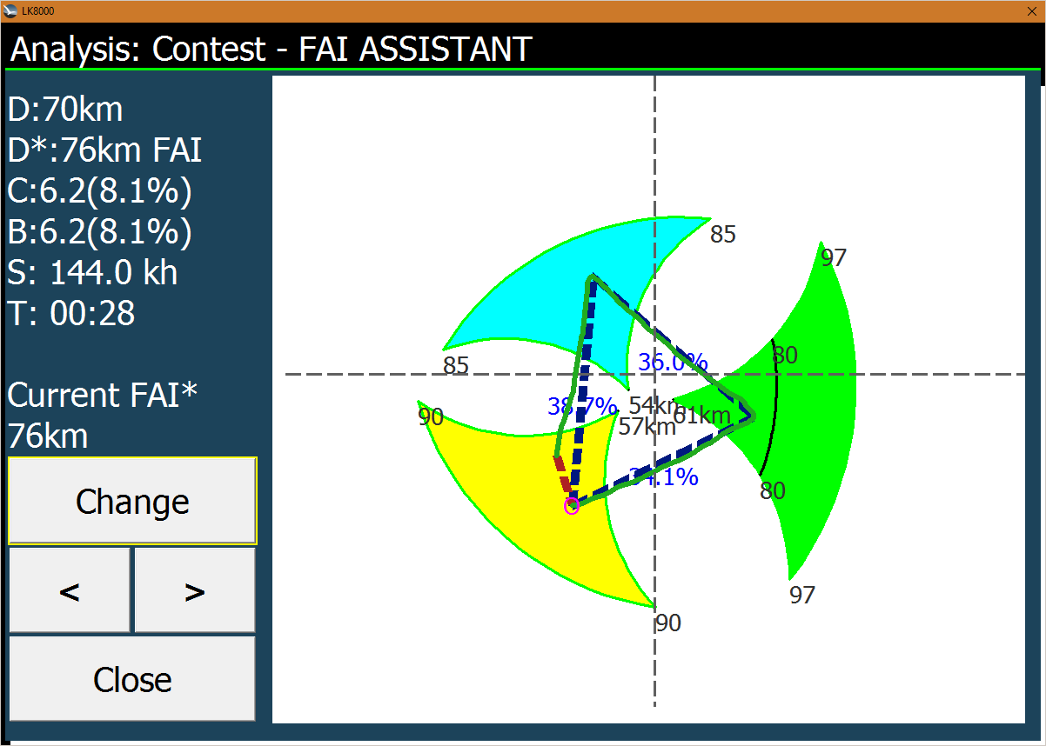
At the end you also have the current predicted FAI triangle. This can be drastically smaller of the triangle the FAI Assistant is using because the FAI Assistant will always use the biggest possible triangle.

FLARM IGC File readout
If a FLARM device is connected it is now possible to read the IGC Files out of the device and store it in the _Logger directory. Therefore a new device FLARM was added as device driver. If a FLARM device is connected and detected, a new [Conf.]. button appears. Pressing this button lead to a Flarm Configuration page:

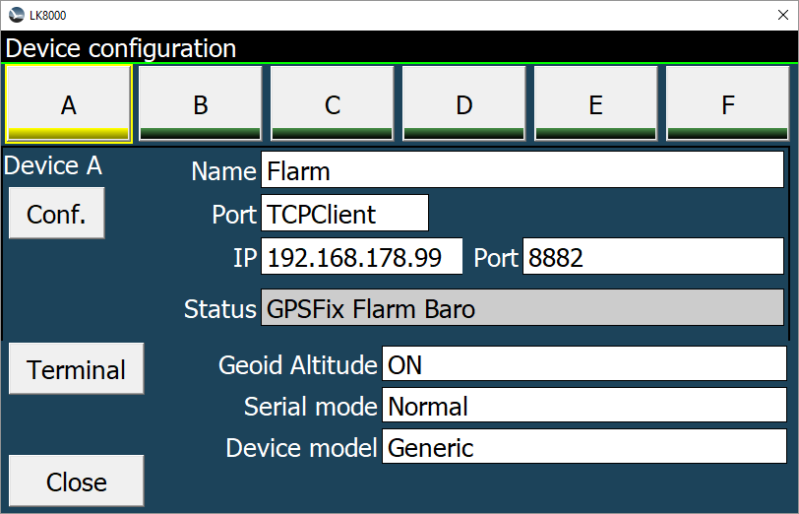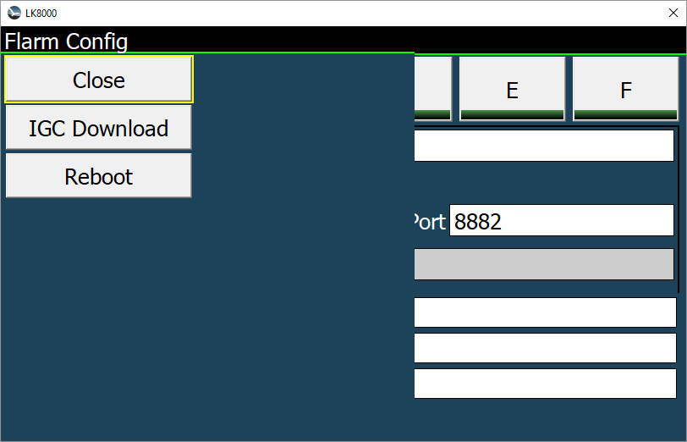

The [IGC Download] button leads to the IGC Download Dialog. When this dialog open it reads the list of logged files from the device.
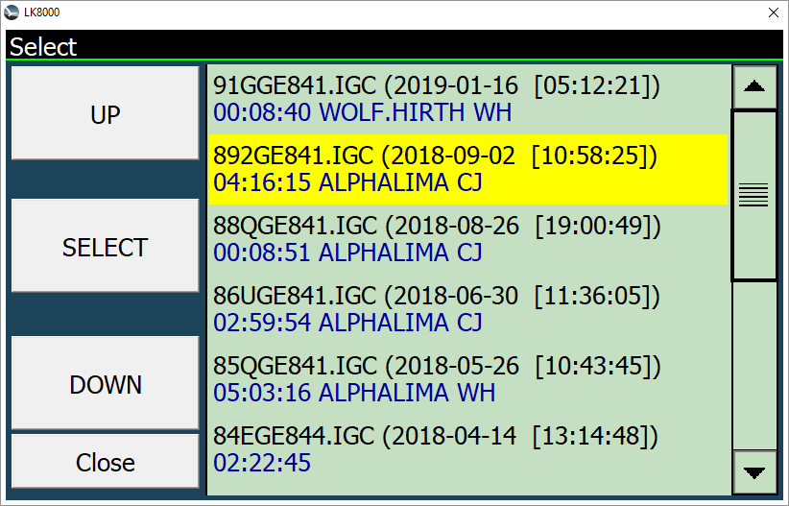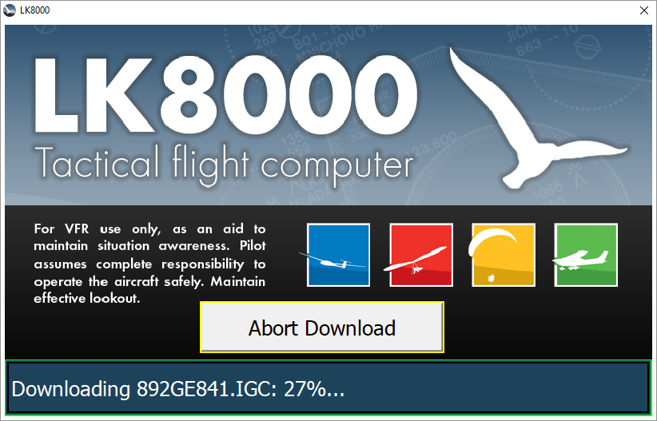
If a file is selected and confirmed the download starts. Please be patient, a download may take some time. The progress is shown in the bottom status line as a percentage vale.

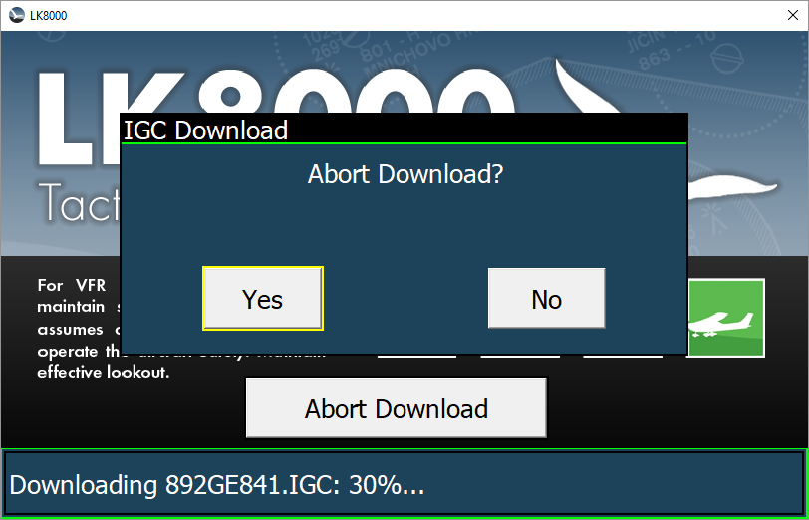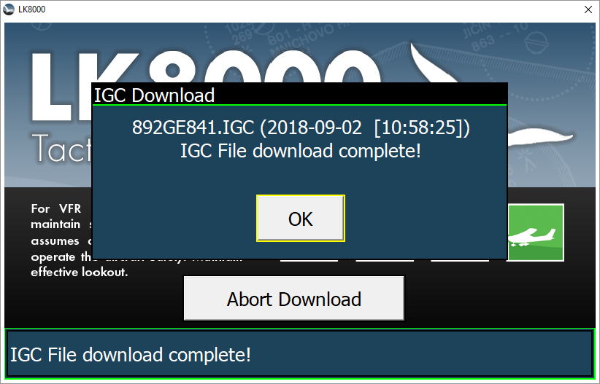

The IGC File download can be interrupted at any time by pressing the [Abort Download] Button. If the download was interrupted, the incomplete File will be deleted.

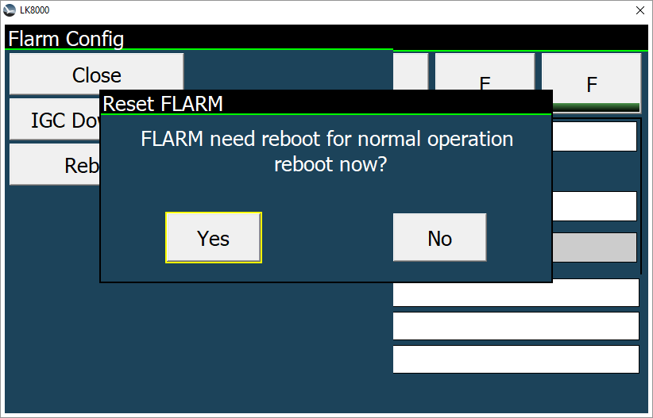

Once the dialog has been opened the Flarm device was set into a binary data transfer mode. In order to return to normal operation a reset of the device must be performed. After leaving the dialog the user can trigger this reset. The reset takes some time before the Flarm returns to normal operation.

System Menu 23 - Map Scale
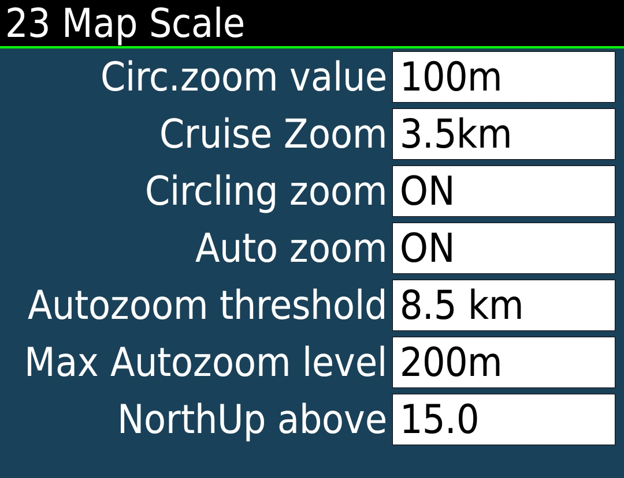
Menu 23 now is dedicated to “Map Scale” for all discipline.

[Cirl.zoom value] Set zoom level for circling. You can change it while circling zoomin in and out manually,and for the rest of the flight that setting will be kept. This is the default if you don't change it.

[Cruise Zoom] Default cruise zoom. Lower values bring more zoom, higher values bring less zoom.

[Circling zoom]If enabled, then the map will zoom in automatically when entering circling mode and zoom out automatically when leaving circling mode.

[Auto zoom] Auto-zoom changes the zoom level during flight so that the map zooms in as the active waypoint is approached.
After passing a waypoint, the map zooms out to the next waypoint.
Manually changing the zoom will disable Auto zoom.

[Autozoom threshold]
When using autozoom , autozoom gets working only if the next waypoint gets closer than this limit.For example if you choose 5km, it means when you're 5km to the next waypoint the autozoom will start working.
It's zoom out to 5km zoom range, and it will keep zoom in as you're approaching the waypoint.
After you reach the waypoint the Cruise zoom is restored. And as soon you reach 5km to the next waypoint the autozoom start working again.

[Max Autozoom level]
When autozoom feature is active it will not zoom beyond this zoom level to limit ma scale.

[NorthUp Above]
When zoom level is greater or equal to this value, map orientation will change to NorthUp. If below this value, the Orientation setting will be used normally.
Setting an high value will result in never using this option.

New LX Navigation driver for EOS, ERA, LX10k and ColibriX devices
LX Navigation series devices do have a new extended command set that is now supported by LK8000 new driver LX EOS/ERA driver.
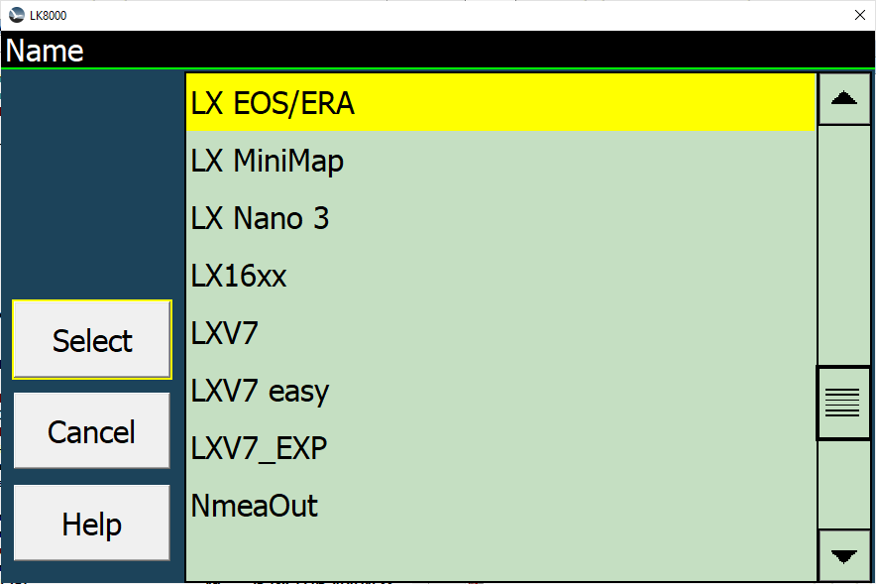
After pressing the [Conf.] Button it is now possible to setup each individual data item for reception and transmission separately in some cases it is also possible to exchange data in both directions (bi-directional).
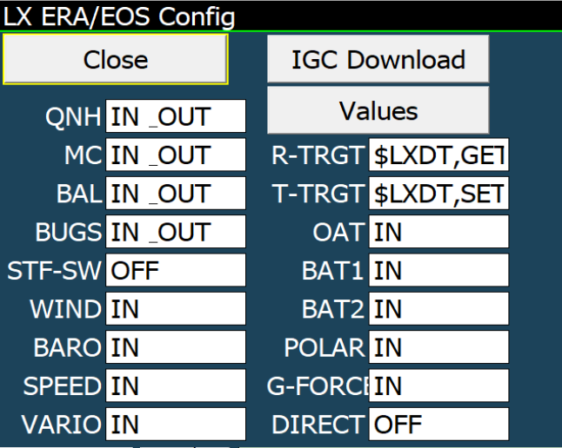

[QNH] en-/disable data exchange and direction of the QNH setting with the device
[MC] en-/disable data exchange and direction of the MacCready setting with the device
[BAL] en-/disable data exchange and direction of the Ballast setting with the device
[STS-SW] en-/disable data exchange and direction of the Vario/Sollfahrt Switch status with the device
[BUGS] en-/disable data exchange and direction of the Bugs wing degradation setting with the device
[WIND] en-/disable data exchange and direction of the calculated wind setting with the device
[BARO] en-/disable data reception of the Barometric altitude from the device.
[SPEED] en-/disable data reception of the Indicated airspeed from the device.
[VARIO] en-/disable data reception of the Variometer values from the device.
[R-TRGT] en-/disable data reception of the Navigation Target from the device (Alternate 2).
[T-TRGT] en-/disable data transmission of the Navigation Target to the device APT page.
[OAT] en-/disable data reception of the Outside Air Temperature from the device.
[BAT1] en-/disable data reception of the Battery 1 voltage from the device.
[BAT2] en-/disable data reception of the Battery 2 voltage from the device.
[POLAR] en-/disable data reception of the Polar coefficients from the device (not recommended).
[G-FORCE] en-/disable data reception of the G-Force and AHRS values from the device.
[DIRECT] not used yet

The target navigation point coming from the device [R-TRGT] will be shown as Alternate2 multi target with a up arrow ^ prefix indicating this is coming from an external device e.g. Logger allowing to check the target of the device all time.

The target navigation point, sent to the device [T-TRGT] will be shown in the Airport display (APT) of the LX Navigation device.

Pressing on the [Values] button will show which data is really delivered by the instrument or sent to it respectively.
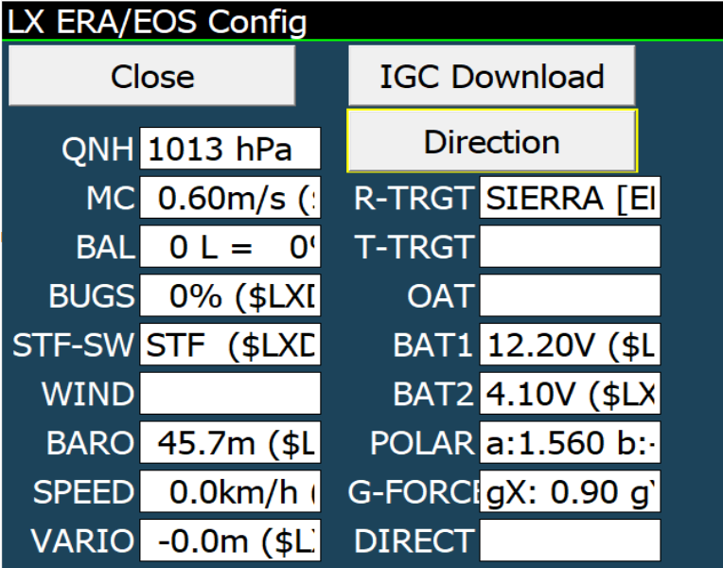
It is also possible to control the radio if connected to th LX Navigation device and [IGC Download] the IGC logger files (similar to the FLARM IGC File readout described before). Pressing on the [Direction] button will return to the data config page.

NANO III driver enhancements

Similar to the LX Navigation driver the NANO III driver has some improvements to setup the individual data exchange points. We recommend to use this driver for all other LXNav devices. This driver gives a much greater flexibility than the to the LX drivers which will be discontinued soon or later

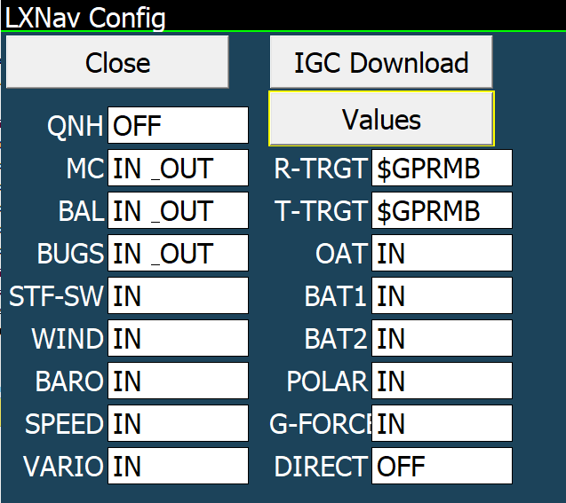
[QNH] en-/disable data exchange and direction of the QNH setting with the device
[MC] en-/disable data exchange and direction of the MacCready setting with the device
[BAL] en-/disable data exchange and direction of the Ballast setting with the device
[STS-SW] en-/disable data exchange and direction of the Vario/Sollfahrt Switch status with the device
[BUGS] en-/disable data exchange and direction of the Bugs wing degradation setting with the device
[WIND] en-/disable data exchange and direction of the calculated wind setting with the device
[BARO] en-/disable data reception of the Barometric altitude from the device.
[SPEED] en-/disable data reception of the Indicated airspeed from the device.
[VARIO] en-/disable data reception of the Variometer values from the device.
[R-TRGT] en-/disable data reception of the Navigation Target from the device (Alternate 2).
[T-TRGT] en-/disable data transmission of the Navigation Target to the device APT page.
[OAT] en-/disable data reception of the Outside Air Temperature from the device.
[BAT1] en-/disable data reception of the Battery 1 voltage from the device.
[BAT2] en-/disable data reception of the Battery 2 voltage from the device.
[POLAR] en-/disable data reception of the Polar coefficients from the device (not recommended).
[G-FORCE] en-/disable data reception of the G-Force and AHRS values from the device.
[DIRECT] en-/disable the direct bypass allowing to declare a task into a logger or FLARM connected to the LXNav device

The target navigation point coming from the device [R-TRGT] will be shown as Alternate2 multi target with a up arrow ^ prefix indicating this is coming from an external device e.g. Logger allowing to check the target of the device all time.

Pressing on the [Values] button will show which data is really delivered by the instrument or sent to it respectively. Pressing on the [Direction] button will return to the data config page.

[IGC Download] allows users to download IGC logger files (similar to the FLARM IGC File readout described before).

