# UFC display debug board

## Operation

The following board is designed to help with debugging control of the LED matrices and the OLED display used on the UFC board.

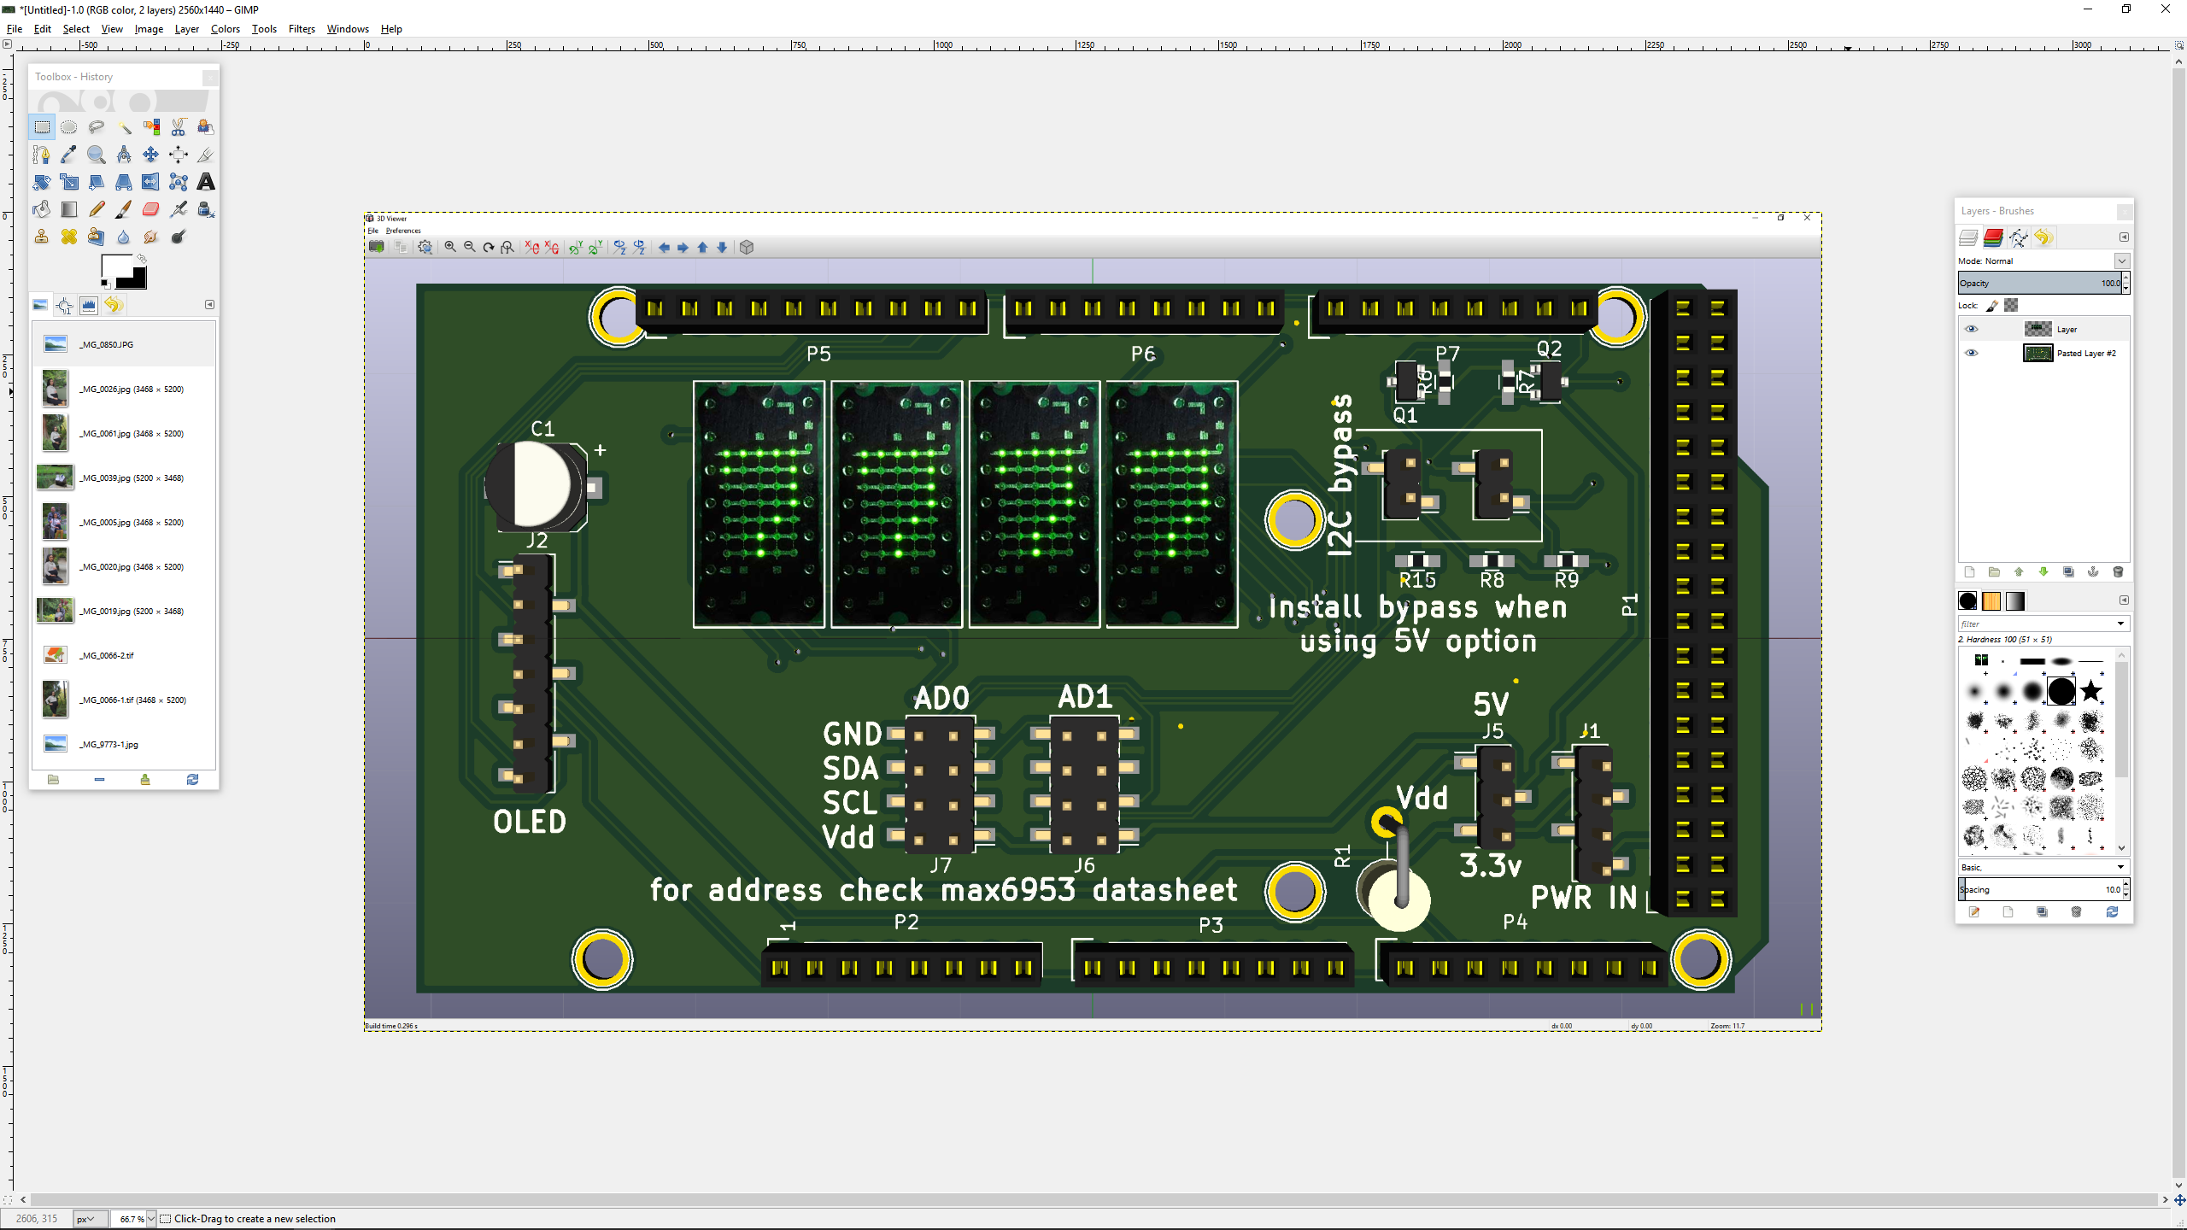

IMPORTANT: Mandatory jumper installation

In order to operate the board, before first power on the jumpers on J5, J6, and J7 MUST be installed accordingly.

## Power options

### 5V option

The board was designed to connect and be powered by the Arduino Mega board, In order to use the Arduino mega board only the 5v option needs to be selected on J5, I2C bypasses need to be installed and the AD0 and AD1 jumpers must be populated. This option has limitations since the matrices can draw up to 0.5A from the power supply.

The OLED display CANNOT be powered this way





Figure 1: 5V/Arduino powered operation

### 3.3v option (preferred)

The best way to power up the board is by using the 3.3v option, for this the PWR in connector MUST be plugged, this connector can also be used to provide a +12v power source for the Arduino.

When using 3.3v the jumpers for I2C bypass should be open (no jumper installed).





Figure 2: preferred mode of operation

## MAX6953 Address selection

In order to use the LED matrices the MAX6953 MUST be addressable, the jumpers on connectors J7 and L6 MUST be populated, and not installing the jumpers will cause undefined behavior.

|  |  |  |  |  |  |  |  |  |
| --- | --- | --- | --- | --- | --- | --- | --- | --- |
| PIN | | Device Address | | | | | | |
| AD0 | AD1 | A6 | A5 | A4 | A3 | A2 | A1 | A0 |
| GND | GND | 1 | 0 | 1 | 0 | 0 | 0 | 0 |
| V+ | GND | 1 | 0 | 1 | 0 | 0 | 0 | 1 |
| SDA | GND | 1 | 0 | 1 | 0 | 0 | 1 | 0 |
| SCL | GND | 1 | 0 | 1 | 0 | 0 | 1 | 1 |
| GND | V+ | 1 | 0 | 1 | 0 | 1 | 0 | 0 |
| V+ | V+ | 1 | 0 | 1 | 0 | 1 | 0 | 1 |
| SDA | V+ | 1 | 0 | 1 | 0 | 1 | 1 | 0 |
| SCL | V+ | 1 | 0 | 1 | 0 | 1 | 1 | 1 |
| GND | SDA | 1 | 0 | 1 | 1 | 0 | 0 | 0 |
| V+ | SDA | 1 | 0 | 1 | 1 | 0 | 0 | 1 |
| SDA | SDA | 1 | 0 | 1 | 1 | 0 | 1 | 0 |
| SCL | SDA | 1 | 0 | 1 | 1 | 0 | 1 | 1 |
| GND | SCL | 1 | 0 | 1 | 1 | 1 | 0 | 0 |
| V+ | SCL | 1 | 0 | 1 | 1 | 1 | 0 | 1 |
| SDA | SCL | 1 | 0 | 1 | 1 | 1 | 1 | 0 |
| SCL | SCL | 1 | 0 | 1 | 1 | 1 | 1 | 1 |

### OLED operation

The only requirement to operate the OLED display is to connect the external power, the OLED display requires 3.3v, this voltage is NOT obtained from the Arduino board.