**Contents**

**Results** 2

**Analysis Visualizations and Graphs** 2

Table 8: Anova results including Robust test of equality of means and Anova effect sizes. The Welch F-statistic and Adjusted omega-squared are used in this analysis because homogeneity of variance violation occurs. 2

Table 9: Games-Howell Post-hoc analysis used because homoscedasticity is violated. 3

**Kruskal-Wallis analysis visualizations and Graphs** 4

**Chi-square analysis visualizations and Graphs** 6

**Goodness of fit test for patient proportions distribution** 6

**Goodness of fit test insuree proportions by expense type per level** 7

**Chi-square test of association between family size and expense type** 9

**Chi-square test of association Detailed** 11

## **Results**

# **Analysis Visualizations and Graphs**

Analysis figures and graphs derived from SPSS are provided for each analysis method. Some of this analysis was done in SAS but this paper is limited to SPSS output.

### Table 8: Anova results including Robust test of equality of means and Anova effect sizes. The Welch F-statistic and Adjusted omega-squared are used in this analysis because homogeneity of variance violation occurs.

|  |  |  |  |  |  |
| --- | --- | --- | --- | --- | --- |
| **ANOVA** | | | | | |
| **Expenses** | | | | | |
|  | Sum of Squares | df | Mean Square | F | Sig. |
| Between Groups | 361549380.965 | 2 | 180774690.482 | 9.747 | <.001 |
| Within Groups | 19102764749.627 | 1030 | 18546373.543 |  |  |
| Total | 19464314130.591 | 1032 |  |  |  |

|  |  |  |  |  |
| --- | --- | --- | --- | --- |
| **Robust Tests of Equality of Means** | | | | |
| **Expenses** | | | | |
|  | Statistica | df1 | df2 | Sig. |
| Welch | 11.655 | 2 | 436.298 | <.001 |
| Brown-Forsythe | 10.756 | 2 | 749.506 | <.001 |
| a. Asymptotically F distributed. | | | | |

|  |  |  |  |  |
| --- | --- | --- | --- | --- |
| **ANOVA Effect Sizesa** | | | | |
|  | | Point Estimate | 95% Confidence Interval | |
| Lower | Upper |
| **Expenses** | Eta-squared | .019 | .005 | .037 |
| Epsilon-squared | .017 | .003 | .035 |
| Omega-squared Fixed-effect | .017 | .003 | .035 |
| Omega-squared Random-effect | .008 | .002 | .018 |
| a. Eta-squared and Epsilon-squared are estimated based on the fixed-effect model. | | | | |

$${Adjusted ω}^{2}=\frac{\left(df_{b}\right)(F-1)}{\left(df_{b}\right)\left(F-1\right)+N_{total}}=\frac{2(11.655-1)}{2\left(11.655-1\right)+1033}=0.0202$$

### Table 9: Games-Howell Post-hoc analysis used because homoscedasticity is violated.

|  |  |  |  |  |  |  |
| --- | --- | --- | --- | --- | --- | --- |
| **Games-Howell Post-hoc Multiple Comparisons** | | | | | | |
| **Dependent Variable: Expenses** | | | | | | |
| Games-Howell | | | | | | |
| (I) Famsize_num | (J) Famsize_num | Mean Difference (I-J) | Std. Error | Sig. | 95% Confidence Interval | |
| Lower Bound | Upper Bound |
| small family size | normal family size | -306.10085 | 292.96456 | .549 | -993.9455 | 381.7438 |
| large family size | -1773.27379* | 382.52129 | <.001 | -2673.7469 | -872.8007 |
| normal family size | small family size | 306.10085 | 292.96456 | .549 | -381.7438 | 993.9455 |
| large family size | -1467.17294* | 352.08662 | <.001 | -2297.1158 | -637.2301 |
| large family size | small family size | 1773.27379* | 382.52129 | <.001 | 872.8007 | 2673.7469 |
| normal family size | 1467.17294* | 352.08662 | <.001 | 637.2301 | 2297.1158 |
| *. The mean difference is significant at the 0.05 level. | | | | | | |

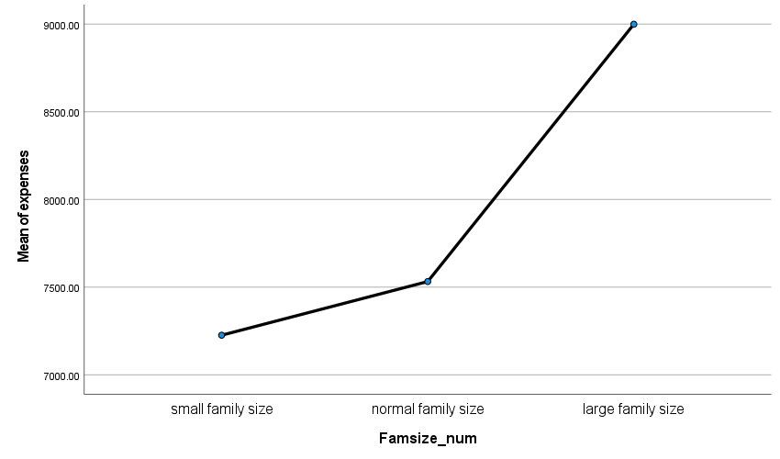

Figure 1: Mean Plots for 3-levels of family sized analyzed using Anova.

## **Kruskal-Wallis analysis visualizations and Graphs**

|  |  |  |  |
| --- | --- | --- | --- |
| **Ranks** | | | |
|  | **Famsize_num** | **N** | **Mean Rank** |
| **Health expenses** | small family size | 458 | 478.71 |
| normal family size | 424 | 521.47 |
| large family size | 151 | 620.60 |
| Total | 1033 |  |

|  |  |
| --- | --- |
| **Test Statisticsa,b** | |
|  | **Health expenses** |
| Kruskal-Wallis H | 25.849 |
| df | 2 |
| Asymp. Sig. | <.001 |
| a. Kruskal Wallis Test | |
| b. Grouping Variable: Famsize_num | |

|  |  |  |  |  |  |
| --- | --- | --- | --- | --- | --- |
| **Pairwise Comparisons of Famsize_num** | | | | | |
| Sample 1-Sample 2 | Test Statistic | Std. Error | Std. Test Statistic | Sig. | Adj. Sig.a |
| small family size-normal family size | -42.760 | 20.107 | -2.127 | .033 | .100 |
| small family size-large family size | -141.895 | 27.997 | -5.068 | <.001 | .000 |
| normal family size-large family size | -99.136 | 28.274 | -3.506 | <.001 | .001 |
| Each row tests the null hypothesis that the Sample 1 and Sample 2 distributions are the same.  Asymptotic significances (2-sided tests) are displayed. The significance level is .017. | | | | | |
| a. Significance values have been adjusted by the Bonferroni correction for multiple tests. | | | | | |

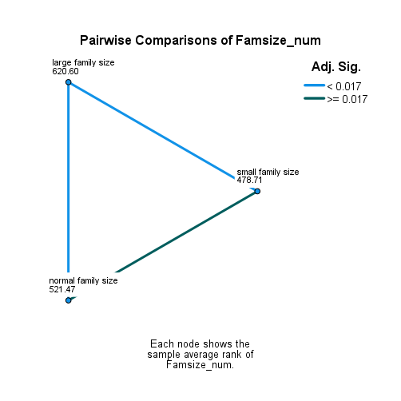

Figure 2: Visual of Dunn's pairwise comparison for family size levels. A significant difference between LFS vs SFS and LFS vs NFS, indicate by the blue lines.

## **Chi-square analysis visualizations and Graphs**

### **Goodness of fit test for patient proportions distribution**

#### Table 10: Chi-square goodness of fit test. (Chi-sq stat (E, U) = 175.37,361.756, p<.001, p<.0001); REJECT null

|  |  |  |  |
| --- | --- | --- | --- |
| **Groups based on family size and health expense-Equal(E)** | | | |
| **Categories** | **Observed N** | **Expected N** | **Residual** |
| SFS_AA | 210 | 172.2 | 37.8 |
| NFS_AA | 190 | 172.2 | 17.8 |
| LFS_AA | 85 | 172.2 | -87.2 |
| SFS_BA | 248 | 172.2 | 75.8 |
| NFS_BA | 234 | 172.2 | 61.8 |
| LFS_BA | 66 | 172.2 | -106.2 |
| Total | 1033 |  |  |
| **Groups based on family size and health expense-Unequal(U) (SAS and Excel)** | | | |
| **Categories** | **Observed N** | **Expected N** | **Residual** |
| SFS_AA | 210 | 154.95 (15%) | 55.05 |
| NFS_AA | 190 | 206.6 (20%) | -16.60 |
| LFS_AA | 85 | 309.9 (30%) | -224.90 |
| SFS_BA | 248 | 206.6 (20%) | 41.40 |
| NFS_BA | 234 | 103.3 (10%) | 130.70 |
| LFS_BA | 66 | 51.65 (5%) | 14.35 |
| Total | 1033 |  |  |

|  |  |  |
| --- | --- | --- |
| **Chi-square Statistics** | | |
|  | **Family size+Spending amount group (Equal)** | **Family size+Spending amount group (Unequal)** |
| Chi-Square | 175.370a | 361.756b |
| df | 5 | 5 |
| Asymp. Sig. | <.001 | <.0001 |
| a. 0 cells (0.0%) have expected frequencies less than 5. The minimum expected cell frequency is 172.2.  b. 0 cells (0.0%) have expected frequencies less than 5. The minimum expected cell frequency is 51.65. **Obtained from SAS and merged with the SPSS table. Long version of project has snippet of SAS output. SAS code will be provided.** | | |

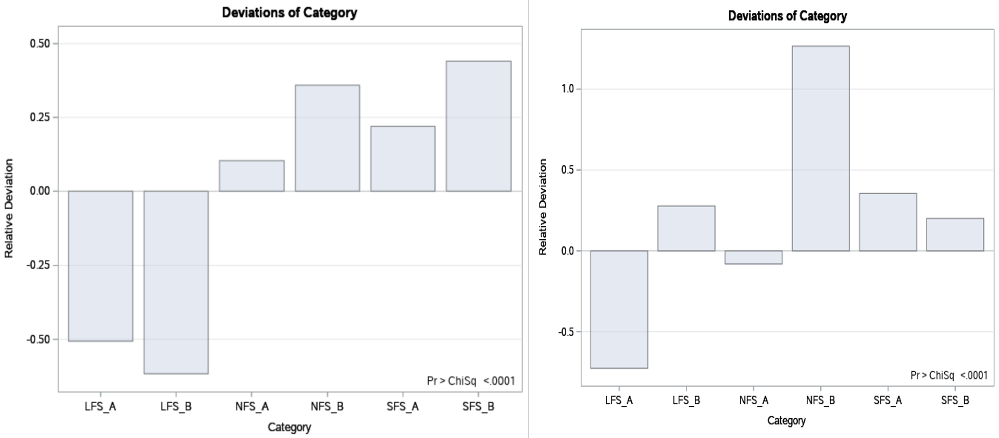

Figure 3: Chi-square goodness of fit test (left = equal proportions hypothesis, right = unequal proportions hypothesis). Unequal proportions hypothesis follows the rule LFSA>NFSA>SFSA & LFSB<NFSB<SFSB. The SAS code provided for this analysis has to be followed exactly as provided to avoid errors.

### **Goodness of fit test insuree proportions by expense type per level**

Test whether within each family size level, health expenses (expense type) will generate unequal proportions of insurees. Does the distribution for the proportions of insurees per health expense type follow an equal proportions hypothesis? Is there anything unique about spending above vs below average that will drive an unequal proportion of patients between the expense type groups, for each level?

#### **SFS level goodness of fit**

##### Table 11: Chi-sq goodness of fit (gof) test for insuree proportions in SFS by expense type. The observed distribution DOES NOT differ significantly from the equal proportions’ distribution (Chi-sq = 3.153, p = 0.076); ACCEPT the null (alpha = 0.017)

|  |  |  |  |
| --- | --- | --- | --- |
| **Expense type code (SFS)** | | | |
| **SFS** | **Observed N** | **Expected N** | **Residual** |
| BA | 248 | 229.0 | 19.0 |
| AA | 210 | 229.0 | -19.0 |
| Total | 458 |  |  |

|  |  |
| --- | --- |
| **Chi-sq Test Statistics (SFS)** | |
|  | **Expense type code (SFS)** |
| Chi-Square | 3.153a |
| df | 1 |
| Asymp. Sig. | .076 |
| a. 0 cells (0.0%) have expected frequencies less than 5. The minimum expected cell frequency is 229.0. | |

#### **NFS level goodness of fit**

##### Table 12: Chi-sq goodness of fit (gof) test for insuree proportions in NFS by expense type. The observed distribution DOES NOT differ significantly from the equal proportions’ distribution (Chi-sq = 4.566, p = 0.033); ACCEPT the null

|  |  |  |  |
| --- | --- | --- | --- |
| **Expense type code (NFS)** | | | |
| **NFS** | **Observed N** | **Expected N** | **Residual** |
| BA | 234 | 212.0 | 22.0 |
| AA | 190 | 212.0 | -22.0 |
| Total | 424 |  |  |

|  |  |
| --- | --- |
| **Chi-sq Test Statistics (NFS)** | |
|  | **Expense type code (NFS)** |
| Chi-Square | 4.566a |
| df | 1 |
| Asymp. Sig. | .033 |
| a. 0 cells (0.0%) have expected frequencies less than 5. The minimum expected cell frequency is 212.0. | |

#### **LFS level goodness of fit**

##### Table 13: Chi-sq goodness of fit (gof) test for insuree proportions in LFS by expense type. The observed distribution DOES NOT differ significantly from the equal proportions’ distribution (Chi-sq = 2.391, p = .122); ACCEPT the null

|  |  |  |  |
| --- | --- | --- | --- |
| **Expense type code (LFS)** | | | |
| **LFS** | **Observed N** | **Expected N** | **Residual** |
| BA | 66 | 75.5 | -9.5 |
| AA | 85 | 75.5 | 9.5 |
| Total | 151 |  |  |

|  |  |
| --- | --- |
| **Chi-sq Test Statistics (LFS)** | |
|  | **Expense type code (LFS)** |
| Chi-Square | 2.391a |
| df | 1 |
| Asymp. Sig. | .122 |
| a. 0 cells (0.0%) have expected frequencies less than 5. The minimum expected cell frequency is 75.5. | |

### **Chi-square test of association between family size and expense type**

#### Table 1: Summary of Chi-square test of association. With respect to the Bonferroni corrected alpha-level, statistically significant association is observed between family size and expense type, in the NFS vs LFS pairwise comparison (alpha = 0.017). Refer to details of these comparisons in the appendix.

|  |  |  |  |  |  |  |  |
| --- | --- | --- | --- | --- | --- | --- | --- |
| Pairwise | Family sizes | Family sizes | Pearson χ2 | p-value | Phi-stat | p-value | Decision |
| 1-SFS v NFS | SFS | NFS | .096 | .757 | .010 | .757 | Independent |
| 2-SFS v LFS | SFS | LFS | 4.956 | .026 | -.090 | .026 | Independent |
| 3- NFS v LFS | NFS | LFS | 5.881 | .015 | -.101 | .015 | Association |

#### **Chi-square Bar Charts**

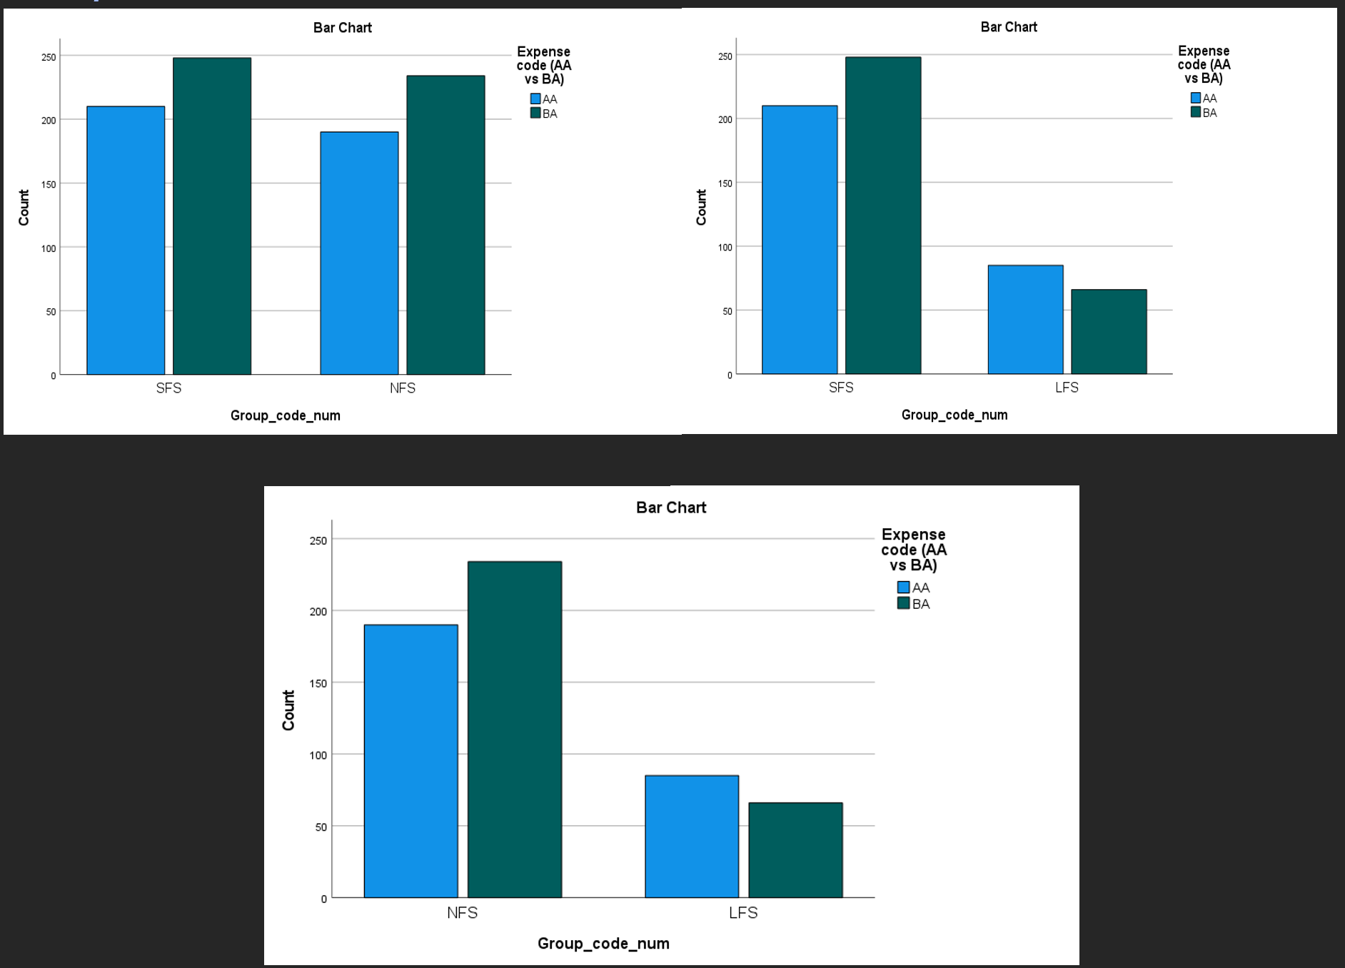

Figure 4: Bar charts of Chi-square pairwise tests of association (left = SFS vs NFS, right = SFS vs LFS, bottom = NFS vs LFS)

# **Chi-square test of association Detailed**

##### **SFS vs NFS pairwise Chi-square association test**

|  |  |  |  |  |  |
| --- | --- | --- | --- | --- | --- |
| **Pairwise family size levels * Expense type (AA vs BA) Crosstabulation** | | | | | |
|  | | | **Dichotomous Expense type (AA vs BA)** | | **Total** |
| AA | BA |
| Family size | SFS | Count | 210 | 248 | 458 |
| Expected Count | 207.7 | 250.3 | 458.0 |
| % within Group_code_num | 45.9% | 54.1% | 100.0% |
| % within Expense code (AA vs BA) | 52.5% | 51.5% | 51.9% |
| % of Total | 23.8% | 28.1% | 51.9% |
| NFS | Count | 190 | 234 | 424 |
| Expected Count | 192.3 | 231.7 | 424.0 |
| % within Group_code_num | 44.8% | 55.2% | 100.0% |
| % within Expense code (AA vs BA) | 47.5% | 48.5% | 48.1% |
| % of Total | 21.5% | 26.5% | 48.1% |
| Total | | Count | 400 | 482 | 882 |
| Expected Count | 400.0 | 482.0 | 882.0 |
| % within Group_code_num | 45.4% | 54.6% | 100.0% |
| % within Expense code (AA vs BA) | 100.0% | 100.0% | 100.0% |
| % of Total | 45.4% | 54.6% | 100.0% |

|  |  |  |  |  |  |
| --- | --- | --- | --- | --- | --- |
| **Chi-Square Association Tests** | | | | | |
| **Statistical test** | **Value** | **df** | **Asymptotic Significance (2-sided)** | **Exact Sig. (2-sided)** | **Exact Sig. (1-sided)** |
| Pearson Chi-Square | .096a | 1 | .757 |  |  |
| Continuity Correctionb | .059 | 1 | .809 |  |  |
| Likelihood Ratio | .096 | 1 | .757 |  |  |
| Fisher's Exact Test |  |  |  | .787 | .404 |
| N of Valid Cases | 882 |  |  |  |  |
| a. 0 cells (0.0%) have expected count less than 5. The minimum expected count is 192.29. | | | | | |
| b. Computed only for a 2x2 table | | | | | |

|  |  |  |  |
| --- | --- | --- | --- |
| **Correlation Measuresc** | | | |
|  | | **Value** | **Approximate Significance** |
| Nominal by Nominal | Phi | .010 | .757 |
| Cramer's V | .010 | .757 |
| N of Valid Cases | | 882 |  |

##### **SFS vs LFS pairwise Chi-square association test**

|  |  |  |  |  |  |
| --- | --- | --- | --- | --- | --- |
| **Pairwise family size levels * Expense type (AA vs BA) Crosstabulation** | | | | | |
|  | | | Expense code (AA vs BA) | | Total |
| AA | BA |
| Family size | SFS | Count | 210 | 248 | 458 |
| Expected Count | 221.9 | 236.1 | 458.0 |
| % within Group_code_num | 45.9% | 54.1% | 100.0% |
| % within Expense code (AA vs BA) | 71.2% | 79.0% | 75.2% |
| % of Total | 34.5% | 40.7% | 75.2% |
| LFS | Count | 85 | 66 | 151 |
| Expected Count | 73.1 | 77.9 | 151.0 |
| % within Group_code_num | 56.3% | 43.7% | 100.0% |
| % within Expense code (AA vs BA) | 28.8% | 21.0% | 24.8% |
| % of Total | 14.0% | 10.8% | 24.8% |
| Total | | Count | 295 | 314 | 609 |
| Expected Count | 295.0 | 314.0 | 609.0 |
| % within Group_code_num | 48.4% | 51.6% | 100.0% |
| % within Expense code (AA vs BA) | 100.0% | 100.0% | 100.0% |
| % of Total | 48.4% | 51.6% | 100.0% |

|  |  |  |  |  |  |
| --- | --- | --- | --- | --- | --- |
| **Chi-Square Association Tests** | | | | | |
|  | **Value** | **df** | **Asymptotic Significance (2-sided)** | **Exact Sig. (2-sided)** | **Exact Sig. (1-sided)** |
| Pearson Chi-Square | 4.956a | 1 | .026 |  |  |
| Continuity Correctionb | 4.546 | 1 | .033 |  |  |
| Likelihood Ratio | 4.961 | 1 | .026 |  |  |
| Fisher's Exact Test |  |  |  | .031 | .016 |
| N of Valid Cases | 609 |  |  |  |  |
| a. 0 cells (0.0%) have expected count less than 5. The minimum expected count is 73.14. | | | | | |
| b. Computed only for a 2x2 table | | | | | |

|  |  |  |  |
| --- | --- | --- | --- |
| **Correlation Measures c** | | | |
|  | | **Value** | **Approximate Significance** |
| Nominal by Nominal | Phi | -.090 | .026 |
| Cramer's V | .090 | .026 |
| N of Valid Cases | | 609 |  |

##### **NFS vs LFS pairwise Chi-square association test**

|  |  |  |  |  |  |
| --- | --- | --- | --- | --- | --- |
| **Pairwise family size levels * Expense type (AA vs BA) Crosstabulation** | | | | | |
|  | | | Expense code (AA vs BA) | | Total |
| AA | BA |
| Group_code_num | NFS | Count | 190 | 234 | 424 |
| Expected Count | 202.8 | 221.2 | 424.0 |
| % within Group_code_num | 44.8% | 55.2% | 100.0% |
| % within Expense code (AA vs BA) | 69.1% | 78.0% | 73.7% |
| % of Total | 33.0% | 40.7% | 73.7% |
| LFS | Count | 85 | 66 | 151 |
| Expected Count | 72.2 | 78.8 | 151.0 |
| % within Group_code_num | 56.3% | 43.7% | 100.0% |
| % within Expense code (AA vs BA) | 30.9% | 22.0% | 26.3% |
| % of Total | 14.8% | 11.5% | 26.3% |
| Total | | Count | 275 | 300 | 575 |
| Expected Count | 275.0 | 300.0 | 575.0 |
| % within Group_code_num | 47.8% | 52.2% | 100.0% |
| % within Expense code (AA vs BA) | 100.0% | 100.0% | 100.0% |
| % of Total | 47.8% | 52.2% | 100.0% |

|  |  |  |  |  |  |
| --- | --- | --- | --- | --- | --- |
| **Chi-Square Association Tests** | | | | | |
|  | **Value** | **df** | **Asymptotic Significance (2-sided)** | **Exact Sig. (2-sided)** | **Exact Sig. (1-sided)** |
| Pearson Chi-Square | 5.881a | 1 | .015 |  |  |
| Continuity Correctionb | 5.430 | 1 | .020 |  |  |
| Likelihood Ratio | 5.884 | 1 | .015 |  |  |
| Fisher's Exact Test |  |  |  | .018 | .010 |
| N of Valid Cases | 575 |  |  |  |  |
| a. 0 cells (0.0%) have expected count less than 5. The minimum expected count is 72.22. | | | | | |
| b. Computed only for a 2x2 table | | | | | |

|  |  |  |  |  |  |  |
| --- | --- | --- | --- | --- | --- | --- |
| **Directional Measures** | | | | | | |
|  | | | Value | Asymptotic Standard Errora | Approximate Tb | Approximate Significance |
| Nominal by Nominal | Uncertainty Coefficient | Symmetric | .008 | .007 | 1.216 | .015c |
| Group_code_num Dependent | .009 | .007 | 1.216 | .015c |
| Expense code (AA vs BA) Dependent | .007 | .006 | 1.216 | .015c |
| a. Not assuming the null hypothesis. | | | | | | |
| b. Using the asymptotic standard error assuming the null hypothesis. | | | | | | |
| c. Likelihood ratio chi-square probability. | | | | | | |

|  |  |  |  |
| --- | --- | --- | --- |
| **Correlation Measures** | | | |
|  | | **Value** | **Approximate Significance** |
| Nominal by Nominal | Phi | -.101 | .015 |
| Cramer's V | .101 | .015 |
| N of Valid Cases | | 575 |  |