Linear Regression Modelling-Machine Learning Primer

Correlation: In linear regression and machine learning, correlation is a test used to determine the best predictor for the dependent variable.

Bivariate normality: Checking to see if both variables are normal.

Linear Regression model: The equation used to fit the data and help in predicting the outcome variable with high predictive precision being the target.

Line of Best fit: Mathematical predictor equation. Aka, the regression line. The line is only as good as the data.

Least-Squares Method: Used to determine the equation of the regression line by error minimization (using the lowest possible residual values).

$$LSM=\sum{Negative residuals+Positive residuals=0}$$

Auto-correlation: Applicable in linear regression is the absence of independence of observations, as a result, absence of independence of residuals.

T-test: Tells whether the coefficients of the regression equation differ from 0 thus helps understand the significance of the magnitude of coefficients.

Anova: Anova in linear regressions produces an F-ratio that tells if the regression model is a statistically significant predictor of the outcome variable from the predictor variable.

Correlation Coefficient: Thought of as the measure of effect size in correlation.

$$Regression variance \%=\frac{\sum{{\left(y_{ip}-\overline{y}\right)}^{2}}}{\sum{{\left(y_{i}-\overline{y}\right)}^{2}}}*100;y_{ip}=predicted FEV_{L},$$

$$y_{i}=sample FEV_{L} value$$

$$Regression variance \%=\frac{\sum{{\left(y_{ip}-2.637\right)}^{2}}}{\sum{{\left(y_{i}-2.637\right)}^{2}}}*100$$

$$Regression variance \%=\frac{366.1053}{489.8586}*100=74.739\%$$

Regression Equation: slope = 0.121 and Y-intercept = 4.388 $$y= .121x- 4.388$$

F-ratio: A measure used to determine the statistical significance of the linear regression model (p < 0.001 is significant).

$F-ratio=\frac{MS_{M}}{MS_{R}}, MS_{M}=SOS_{regression}, MS_{R}=SOS_{residuals}$

Slope: The coefficient of the independent variable in a linear model.

$$m=r*\frac{S_{y}}{S_{x}}$$

Y-Intercept: It is the value of the dependent variable when there is no effect (0 effect) from the independent variable. The value is minimized by picking a good predictor. The variable r below is Pearson’s regression coefficient.

$$Y-intercept= {\overline{X}}_{y}-{r* \overline{X}}_{x}$$

Models and Transformation Decisions

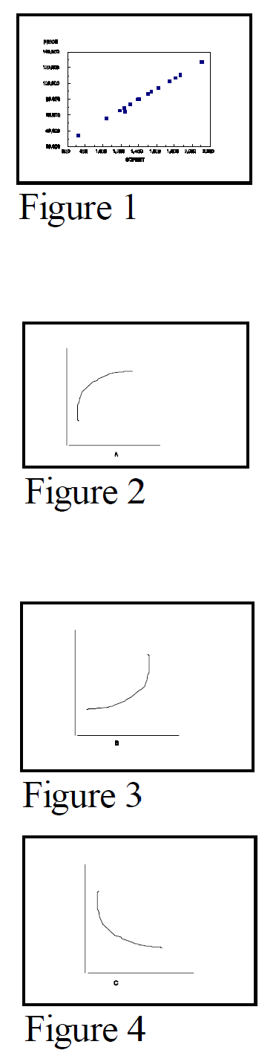

$x$

$$\frac{1}{X} or Exp(-X)$$

$Log\left(x\right) or \sqrt{x}$

$$X^{2} or Exp(X)$$

Dummy variable: Used when coding categorical variables and rule is p-1 dummy variables where p = # of categories.

Data set size: $2*{\left(\frac{p}{n}\right)}^{\frac{1}{2}}>1 , large data set$

Heteroscedasticity: Not identical distributions of error terms or residuals (error variances are NOT identical).

SPEC test (SAS): The null hypothesis posits independence of error terms and homoscedasticity (identical distribution of error terms). A p-value > 0.05 indicates acceptance of the NULL. (Prob>Chi-Sq of ..>0.05 is the desired outcome).

Durbin-Watson Test: A test for first order correlation of error terms. Value ranges from 0 to 4 with 2.0 being the sweet spot; and <2 = positive first order correlation VS >2 = negative first order correlation. The statistic is valid for large data sets.

Shapiro-Wilk: Null = normality hence normality of residuals is achieved with p > 0.01.

Multicollinearity: Correlation of X variables.

Variance Inflation Factor (VIF): Tests for multicollinearity. VIF > 10 indicates multicollinearity.

Outliers: observations that have high impact on the predictive model.

Cook’s distance: A determinant of outliers. Cooks d > |2| should be reviewed.

Other outlier Measures (SAS): DFFITs > $2*{\left(\frac{p}{n}\right)}^{\frac{1}{2}}$ for large data sets. Dfbetas > 1 (small to medium data sets) and > $\frac{2}{√n}$ (large data sets).

Weighted outliers: Assigning weights (ranking outliers) to outliers in trying to reduce their effect.

Order of Assumptions Check (Workflow): Most Severe to Least Severe (subjective)

1. Normality of residuals (S-W)
2. Homoscedasticity and autocorrelation (IID)- (Durbin Watson)
3. Multicollinearity (VIF)
4. Outliers(Cooks d, DFFIT, DFBetas)
5. Test Model Fit

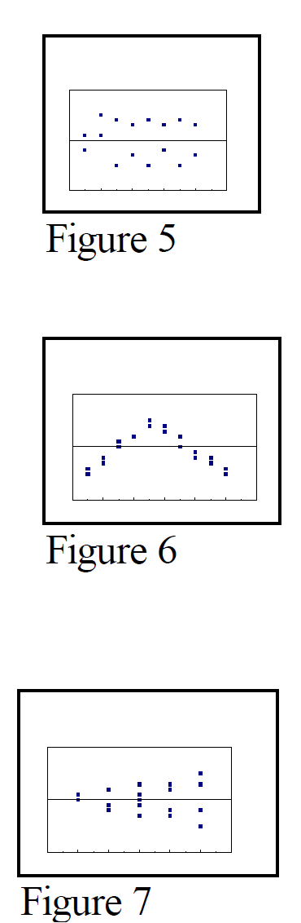

$$Y-→Log(Y)$$

$X-→X^{2}$

$Linear$

Interpreting Linear Regression:

Root MSE (Lower is better)

Type III SS p-value < 0.05 (indicates significance)

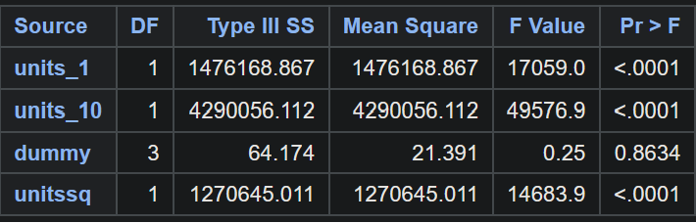  
R-square and Adj R-square(>= 0.7)