Plot of cycle*units_1. Legend: A = 1 obs, B = 2 obs, etc.
cycle |
|
160 +
|
|
|
|
140 +
|
|
|
|
120 +
|
|
| AA A A
| AA A A
100 + A A A A
| A A A A
| A A B
| A AA A
| A A A A
80 + A AAA
| A AA A
| A AA A
| AA A A
| C A
60 + BAA
| AAA A
| BAA
| AC
| BB
40 + CA
| ABA
| BAA
| AC
| ABA
20 + AC
| CA
| AC
| D
| D
0 + A
|
---+------------+------------+------------+------------+------------+------------+------------+------------+------------+--
0 200 400 600 800 1000 1200 1400 1600 1800
units, appliance 1
NOTE: 47 obs had missing values.

Plot of cycle*units_10. Legend: A = 1 obs, B = 2 obs, etc.
cycle |
|
160 +
|
|
|
|
140 +
|
|
|
|
120 +
|
|
|
|
100 +
|
|
| A A A A
| A A AA
80 + A A A A
| A A A A
| AA A A
| BA A
| A B A
60 + A A AA
| A A A A
| A A A A
| A A A A
| BA A
40 + B AA
| A AA A
| B AA
| AAB
| BB
20 + CA
| AC
| C A
| AAB
| AB A
0 + A
|
---+------------+------------+------------+------------+------------+------------+------------+------------+--
0 200 400 600 800 1000 1200 1400 1600
units, appliance 10
NOTE: 67 obs had missing values.

Obs | units_1 | units_2 | units_3 | units_4 | units_5 | units_6 | units_7 | units_8 | units_9 | units_10 | units_11
1 | 1 | 14 | 1 | 1 | 2 | 1 | 1 | 7 | 1 | 33 | 20
2 | 1 | 14 | 1 | 1 | 2 | 1 | 1 | 7 | 1 | 33 | 20
3 | 1 | 14 | 1 | 1 | 2 | 1 | 1 | 7 | 1 | 33 | 20
4 | 1 | 14 | 1 | 1 | 2 | 1 | 1 | 7 | 1 | 33 | 20
5 | 1 | 14 | 1 | 1 | 2 | 1 | 1 | 7 | 1 | 33 | 20

Obs | units_12 | units_13 | units_14 | units_15 | units_16 | units_17 | units_18 | units_19 | units_20
1 | 1 | 8 | 1 | 1 | 1 | 1 | 1 | 1 | 1
2 | 1 | 8 | 1 | 1 | 1 | 1 | 1 | 1 | 1
3 | 1 | 8 | 1 | 1 | 1 | 1 | 1 | 1 | 1
4 | 1 | 8 | 1 | 1 | 1 | 1 | 1 | 1 | 1
5 | 1 | 8 | 1 | 1 | 1 | 1 | 1 | 1 | 1

Obs | units_21 | units_22 | units_23 | units_24 | cycle | i | dummy
1 | 1 | 1 | 1 | 1 | 1 | 1 | 4
2 | 1 | 1 | 1 | 1 | 1 | 2 | 4
3 | 1 | 1 | 1 | 1 | 1 | 3 | 3
4 | 1 | 1 | 1 | 1 | 1 | 4 | 4
5 | 1 | 1 | 1 | 1 | 1 | 5 | 3

Number of Observations Read | 24336
Number of Observations Used | 13884
Number of Observations with Missing Values | 10452

Analysis of Variance
Source | DF | Sum of  Squares | Mean  Square | F Value | Pr > F
Model | 6 | 7962617 | 1327103 | 15336.3 | <.0001
Error | 13877 | 1200823 | 86.53332
Corrected Total | 13883 | 9163440

Root MSE | 9.30233 | R-Square | 0.8690
Dependent Mean | 45.00000 | Adj R-Sq | 0.8689
Coeff Var | 20.67184

Parameter Estimates
Variable | Label | DF | Parameter  Estimate | Standard  Error | t Value | Pr > |t|
Intercept | Intercept | 1 | 14.62883 | 0.19505 | 75.00 | <.0001
units_1 | units, appliance 1 | 1 | 0.19460 | 0.00149 | 130.61 | <.0001
units_10 | units, appliance 10 | 1 | 0.06811 | 0.00030588 | 222.66 | <.0001
S1 |  | 1 | 0.12328 | 0.22439 | 0.55 | 0.5827
S2 |  | 1 | 0.11364 | 0.22404 | 0.51 | 0.6120
S3 |  | 1 | -0.03098 | 0.22633 | -0.14 | 0.8911
unitssq |  | 1 | -0.00021140 | 0.00000174 | -121.18 | <.0001

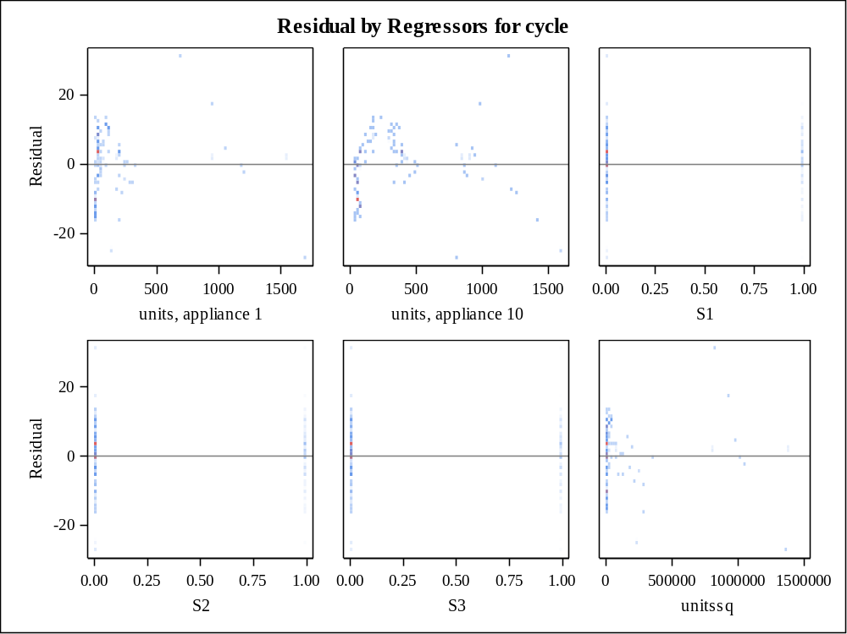

Class Level Information
Class | Levels | Values
dummy | 4 | 1 2 3 4

Number of Observations Read | 24336
Number of Observations Used | 13884

Source | DF | Sum of Squares | Mean Square | F Value | Pr > F
Model | 6 | 7962617.102 | 1327102.850 | 15336.3 | <.0001
Error | 13877 | 1200822.898 | 86.533
Corrected Total | 13883 | 9163440.000

R-Square | Coeff Var | Root MSE | cycle Mean
0.868955 | 20.67184 | 9.302329 | 45.00000

Source | DF | Type I SS | Mean Square | F Value | Pr > F
units_1 | 1 | 3667245.433 | 3667245.433 | 42379.6 | <.0001
units_10 | 1 | 3023491.483 | 3023491.483 | 34940.2 | <.0001
dummy | 3 | 1235.176 | 411.725 | 4.76 | 0.0026
unitssq | 1 | 1270645.011 | 1270645.011 | 14683.9 | <.0001

Source | DF | Type III SS | Mean Square | F Value | Pr > F
units_1 | 1 | 1476168.867 | 1476168.867 | 17059.0 | <.0001
units_10 | 1 | 4290056.112 | 4290056.112 | 49576.9 | <.0001
dummy | 3 | 64.174 | 21.391 | 0.25 | 0.8634
unitssq | 1 | 1270645.011 | 1270645.011 | 14683.9 | <.0001

Parameter | Estimate |  | Standard  Error | t Value | Pr > |t|
Intercept | 14.59784520 | B | 0.19285017 | 75.70 | <.0001
units_1 | 0.19460042 |  | 0.00148994 | 130.61 | <.0001
units_10 | 0.06810782 |  | 0.00030588 | 222.66 | <.0001
dummy 1 | 0.03098042 | B | 0.22633241 | 0.14 | 0.8911
dummy 2 | 0.15426328 | B | 0.22282641 | 0.69 | 0.4888
dummy 3 | 0.14462406 | B | 0.22246924 | 0.65 | 0.5156
dummy 4 | 0.00000000 | B | . | . | .
unitssq | -0.00021140 |  | 0.00000174 | -121.18 | <.0001

Note: | The X'X matrix has been found to be singular, and a generalized inverse was used to solve the normal equations. Terms whose estimates are followed by the letter 'B' are not uniquely estimable.

Number of Observations Read | 24336
Number of Observations Used | 13884
Number of Observations with Missing Values | 10452

Analysis of Variance
Source | DF | Sum of  Squares | Mean  Square | F Value | Pr > F
Model | 6 | 7962617 | 1327103 | 15336.3 | <.0001
Error | 13877 | 1200823 | 86.53332
Corrected Total | 13883 | 9163440

Root MSE | 9.30233 | R-Square | 0.8690
Dependent Mean | 45.00000 | Adj R-Sq | 0.8689
Coeff Var | 20.67184

Parameter Estimates
Variable | Label | DF | Parameter  Estimate | Standard  Error | t Value | Pr > |t|
Intercept | Intercept | 1 | 14.62883 | 0.19505 | 75.00 | <.0001
units_1 | units, appliance 1 | 1 | 0.19460 | 0.00149 | 130.61 | <.0001
units_10 | units, appliance 10 | 1 | 0.06811 | 0.00030588 | 222.66 | <.0001
S1 |  | 1 | 0.12328 | 0.22439 | 0.55 | 0.5827
S2 |  | 1 | 0.11364 | 0.22404 | 0.51 | 0.6120
S3 |  | 1 | -0.03098 | 0.22633 | -0.14 | 0.8911
unitssq |  | 1 | -0.00021140 | 0.00000174 | -121.18 | <.0001

Test of First and Second Moment Specification
DF | Chi-Square | Pr > ChiSq
21 | 2132.30 | <.0001

Durbin-Watson D | 0.005
Number of Observations | 13884
1st Order Autocorrelation | 0.998

Number of Observations Read | 24336
Number of Observations Used | 13884
Number of Observations with Missing Values | 10452

Analysis of Variance
Source | DF | Sum of  Squares | Mean  Square | F Value | Pr > F
Model | 5 | 6691972 | 1338394 | 7515.47 | <.0001
Error | 13878 | 2471468 | 178.08531
Corrected Total | 13883 | 9163440

Root MSE | 13.34486 | R-Square | 0.7303
Dependent Mean | 45.00000 | Adj R-Sq | 0.7302
Coeff Var | 29.65525

Parameter Estimates
Variable | Label | DF | Parameter  Estimate | Standard  Error | t Value | Pr > |t|
Intercept | Intercept | 1 | 24.38749 | 0.25486 | 95.69 | <.0001
units_1 | units, appliance 1 | 1 | 0.01754 | 0.00041798 | 41.96 | <.0001
units_10 | units, appliance 10 | 1 | 0.04868 | 0.00037373 | 130.26 | <.0001
S1 |  | 1 | 0.38196 | 0.32189 | 1.19 | 0.2354
S2 |  | 1 | 0.32451 | 0.32139 | 1.01 | 0.3126
S3 |  | 1 | -0.36487 | 0.32467 | -1.12 | 0.2611

Test of First and Second Moment Specification
DF | Chi-Square | Pr > ChiSq
15 | 2103.97 | <.0001

Durbin-Watson D | 0.003
Number of Observations | 13884
1st Order Autocorrelation | 0.999

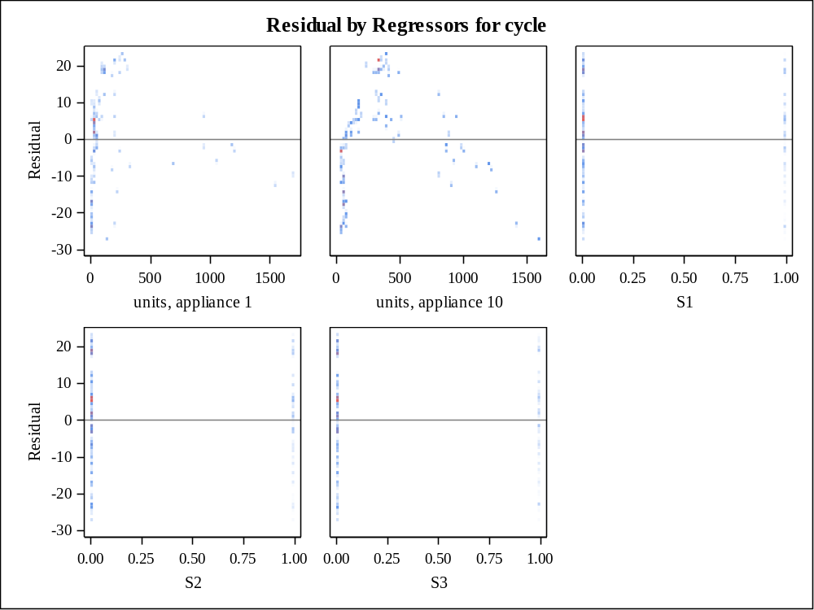

Moments
N | 13884 | Sum Weights | 13884
Mean | 0 | Sum Observations | 0
Std Deviation | 13.3424574 | Variance | 178.02117
Skewness | -0.1634317 | Kurtosis | -0.8057979
Uncorrected SS | 2471467.91 | Corrected SS | 2471467.91
Coeff Variation | . | Std Error Mean | 0.11323444

Basic Statistical Measures
Location |  | Variability
Mean | 0.00000 | Std Deviation | 13.34246
Median | 1.03430 | Variance | 178.02117
Mode | 19.41121 | Range | 51.24361
 |  | Interquartile Range | 18.32073

Tests for Location: Mu0=0
Test | Statistic |  | p Value
Student's t | t | 0 | Pr > |t| | 1.0000
Sign | M | 501 | Pr >= |M| | <.0001
Signed Rank | S | 599268 | Pr >= |S| | 0.2045

Tests for Normality
Test | Statistic |  | p Value
Kolmogorov-Smirnov | D | 0.069015 | Pr > D | <0.0100
Cramer-von Mises | W-Sq | 9.761088 | Pr > W-Sq | <0.0050
Anderson-Darling | A-Sq | 91.96926 | Pr > A-Sq | <0.0050

Quantiles (Definition 5)
Level | Quantile
100% Max | 23.69212
99% | 22.94529
95% | 21.15627
90% | 18.77407
75% Q3 | 8.71270
50% Median | 1.03430
25% Q1 | -9.60803
10% | -20.44802
5% | -23.31105
1% | -26.80467
0% Min | -27.55150

Extreme Observations
Lowest |  | Highest
Value | Obs | Value | Obs
-27.5515 | 12168 | 23.6921 | 11219
-27.5515 | 12165 | 23.6921 | 11223
-27.5515 | 12159 | 23.6921 | 11227
-27.5515 | 12149 | 23.6921 | 11228
-27.5515 | 12148 | 23.6921 | 11230

Missing Values
Missing  Value | Count | Percent Of
Missing  Value | Count | All Obs | Missing Obs
. | 10452 | 42.95 | 100.00

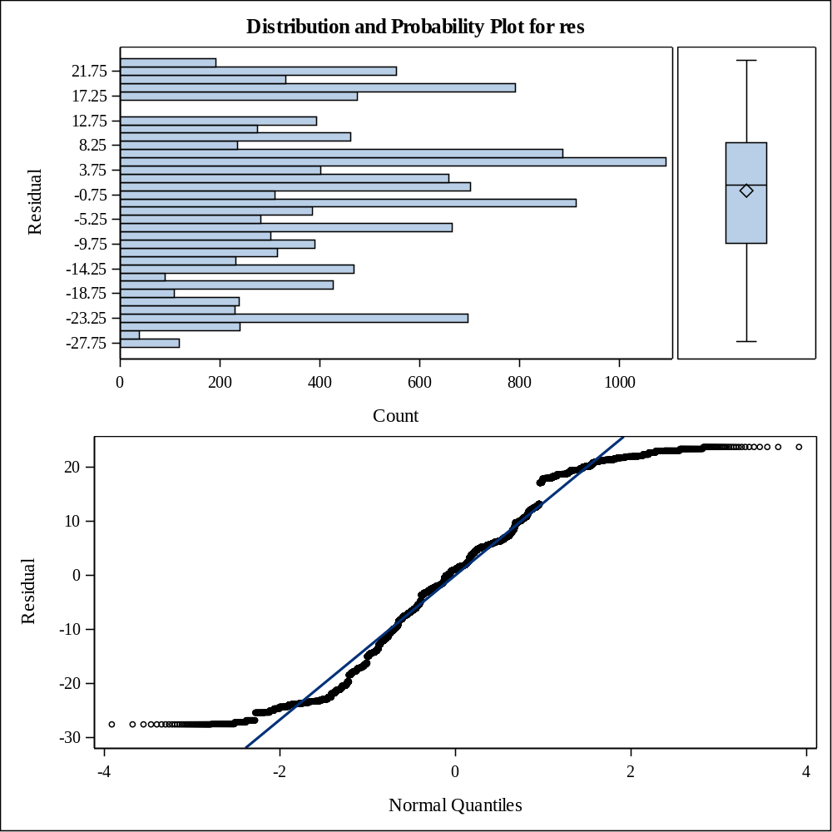

Number of Observations Read | 24336
Number of Observations Used | 13884
Number of Observations with Missing Values | 10452

Analysis of Variance
Source | DF | Sum of  Squares | Mean  Square | F Value | Pr > F
Model | 6 | 7962617 | 1327103 | 15336.3 | <.0001
Error | 13877 | 1200823 | 86.53332
Corrected Total | 13883 | 9163440

Root MSE | 9.30233 | R-Square | 0.8690
Dependent Mean | 45.00000 | Adj R-Sq | 0.8689
Coeff Var | 20.67184

Parameter Estimates
Variable | Label | DF | Parameter  Estimate | Standard  Error | t Value | Pr > |t| | Variance  Inflation
Intercept | Intercept | 1 | 14.62883 | 0.19505 | 75.00 | <.0001 | 0
units_1 | units, appliance 1 | 1 | 0.19460 | 0.00149 | 130.61 | <.0001 | 39.24365
units_10 | units, appliance 10 | 1 | 0.06811 | 0.00030588 | 222.66 | <.0001 | 2.06845
S1 |  | 1 | 0.12328 | 0.22439 | 0.55 | 0.5827 | 1.53721
S2 |  | 1 | 0.11364 | 0.22404 | 0.51 | 0.6120 | 1.53911
S3 |  | 1 | -0.03098 | 0.22633 | -0.14 | 0.8911 | 1.52858
unitssq |  | 1 | -0.00021140 | 0.00000174 | -121.18 | <.0001 | 44.66277

Number of Observations Read | 24336
Number of Observations Used | 13884
Number of Observations with Missing Values | 10452

Analysis of Variance
Source | DF | Sum of  Squares | Mean  Square | F Value | Pr > F
Model | 5 | 6691972 | 1338394 | 7515.47 | <.0001
Error | 13878 | 2471468 | 178.08531
Corrected Total | 13883 | 9163440

Root MSE | 13.34486 | R-Square | 0.7303
Dependent Mean | 45.00000 | Adj R-Sq | 0.7302
Coeff Var | 29.65525

Parameter Estimates
Variable | Label | DF | Parameter  Estimate | Standard  Error | t Value | Pr > |t| | Variance  Inflation
Intercept | Intercept | 1 | 24.38749 | 0.25486 | 95.69 | <.0001 | 0
units_1 | units, appliance 1 | 1 | 0.01754 | 0.00041798 | 41.96 | <.0001 | 1.50076
units_10 | units, appliance 10 | 1 | 0.04868 | 0.00037373 | 130.26 | <.0001 | 1.50042
S1 |  | 1 | 0.38196 | 0.32189 | 1.19 | 0.2354 | 1.53707
S2 |  | 1 | 0.32451 | 0.32139 | 1.01 | 0.3126 | 1.53902
S3 |  | 1 | -0.36487 | 0.32467 | -1.12 | 0.2611 | 1.52835

Coding Coefficients for the Independent Variables
Factor | Subtracted off | Divided by
units_1 | 852.500000 | 852.500000
units_10 | 817.500000 | 788.500000
S1 | 0.500000 | 0.500000
S2 | 0.500000 | 0.500000
S3 | 0.500000 | 0.500000

Response Surface for Variable cycle
Response Mean | 45.000000
Root MSE | 6.828337
R-Square | 0.9294
Coefficient of Variation | 15.1741

Regression | DF | Type I Sum of Squares | R-Square | F Value | Pr > F
Linear | 5 | 6691972 | 0.7303 | 28704.8 | <.0001
Quadratic | 2 | 1542203 | 0.1683 | 16538.0 | <.0001
Crossproduct | 7 | 282606 | 0.0308 | 865.87 | <.0001
Total Model | 14 | 8516781 | 0.9294 | 13047.2 | <.0001

Residual | DF | Sum of Squares | Mean Square | F Value | Pr > F
Lack of Fit | 337 | 646347 | 1917.944289 | 83361.0 | <.0001
Pure Error | 13532 | 311.340050 | 0.023008
Total Error | 13869 | 646659 | 46.626185

Parameter | DF | Estimate | Standard  Error | t Value | Pr > |t| | Parameter Estimate from Coded Data
Intercept | 1 | 10.426663 | 0.179711 | 58.02 | <.0001 | 96.913994
units_1 | 1 | 0.152615 | 0.001669 | 91.45 | <.0001 | 5.634771
units_10 | 1 | 0.109305 | 0.000781 | 140.00 | <.0001 | -50.499639
S1 | 1 | 0.109456 | 0.228729 | 0.48 | 0.6323 | -0.018301
S2 | 1 | -0.085848 | 0.228163 | -0.38 | 0.7067 | 0.148438
S3 | 1 | -0.092516 | 0.230031 | -0.40 | 0.6876 | 0.139578
units_1*units_1 | 1 | -0.000027134 | 0.000000543 | -49.97 | <.0001 | -19.720019
units_10*units_1 | 1 | -0.000123 | 0.000001574 | -77.84 | <.0001 | -82.345980
units_10*units_10 | 1 | -0.000042120 | 0.000000521 | -80.91 | <.0001 | -26.187667
S1*units_1 | 1 | 0.000056880 | 0.000618 | 0.09 | 0.9266 | 0.024245
S1*units_10 | 1 | -0.000238 | 0.000550 | -0.43 | 0.6650 | -0.093824
S1*S1 | 0 | 0 | . | . | . | 0
S2*units_1 | 1 | 0.000421 | 0.000625 | 0.67 | 0.5001 | 0.179556
S2*units_10 | 1 | 0.000028884 | 0.000540 | 0.05 | 0.9573 | 0.011387
S2*S1 | 0 | 0 | . | . | . | 0
S2*S2 | 0 | 0 | . | . | . | 0
S3*units_1 | 1 | 0.000331 | 0.000605 | 0.55 | 0.5841 | 0.141099
S3*units_10 | 1 | 0.000109 | 0.000548 | 0.20 | 0.8417 | 0.043149
S3*S1 | 0 | 0 | . | . | . | 0
S3*S2 | 0 | 0 | . | . | . | 0
S3*S3 | 0 | 0 | . | . | . | 0

Factor | DF | Sum of Squares | Mean Square | F Value | Pr > F | Label
units_1 | 6 | 412056 | 68676 | 1472.91 | <.0001 | units, appliance 1
units_10 | 6 | 2392329 | 398722 | 8551.45 | <.0001 | units, appliance 10
S1 | 3 | 12.597623 | 4.199208 | 0.09 | 0.9655
S2 | 3 | 34.665889 | 11.555296 | 0.25 | 0.8629
S3 | 3 | 32.725221 | 10.908407 | 0.23 | 0.8728

Factor | Critical Value |  | Label
Factor | Coded | Uncoded | Label
units_1 | -0.822992 | 150.899027 | units, appliance 1
units_10 | -0.426962 | 480.840163 | units, appliance 10
S1 | -8.063582E11 | -4.031791E11
S2 | 1.875682E12 | 937841002420
S3 | -2.248342E12 | -1.124171E12
Predicted value at stationary point: -20638607814

Eigenvalues | Eigenvectors
Eigenvalues | units_1 | units_10 | S1 | S2 | S3
18.346324 | 0.734264 | -0.678849 | 0.002221 | 0.003382 | 0.002025
0.000087695 | 0.000270 | 0.001440 | -0.732882 | 0.369616 | 0.571197
0 | 0 | 0 | 0.265510 | -0.617608 | 0.740314
-0.000323 | -0.002730 | 0.003613 | 0.626405 | 0.694213 | 0.354491
-64.253774 | 0.678859 | 0.734267 | 0.000408 | -0.001014 | -0.000992
Stationary point is in a flatness.
Stationary point is a saddle point.

