HTML FILES

DOM

BEngine

UI

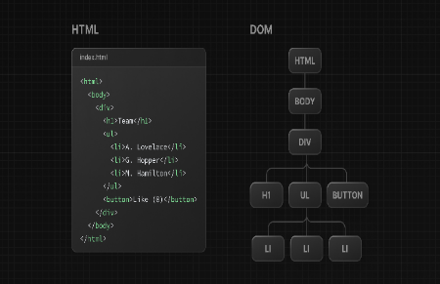

1. The DOM has a tree-like structure with parent and child relationships. DOMs can be manipulated using JS. The HTML code contains the initial page content, and the DOM represents the updated page content changed by JS.
2. What is the core React library? React
3. What is react-dom? DOM specific methods that enable me to use React with DOM

JSX

What is JSX? An extension of JS.