 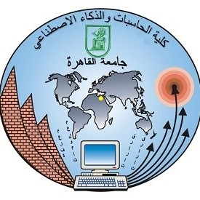

**Systems Modeling and Simulation**

**DS331/DS241**

**Prof. Ayman Ghoneim**

Muhammed Alaa Eddin Mustafa – 20211083

Table of Contents:

* **Problem - 1 Formulation & Objectives**