# Course References

<http://softelec.pagesperso-orange.fr/Projects/RTOS/PICOS18/Tutorial/Projects_RTOS_PICOS18_tutorial_us.htm>

# Install tools

1. Github
   1. Clone <https://github.com/tomipeiov/yazaki_upt_lab_2017.git>
2. IDE
   1. "Quickstart\MPLABX-v3.51-windows-installer.exe"
3. Compiler
   1. " Quickstart\mplabc18-v3.47-windows-eval-installer.exe"

Everything should be installed by default in "c:\Program Files (x86)\Microchip"…leave them all there

# Create project and build all

1. Add OSEK src files
   1. "c:\data\Poli\OSEK Curs\PICOS18_v1_11"
2. Change linker file
   1. 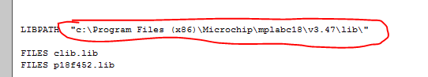
3. Build all