**The Hong Kong Polytechnic University**

**Web Application Design and Development**

**Group Project Proposal**

|  |  |
| --- | --- |
| **Member:** | Chau Siu Fai 14059448d  Kwan Yiu Man 14006209d  Tsang Ka Wing 14059204d  (other 3 members are no information temporary) |

**Organization Background**

[**http://www.changingyounglives.org.hk/chi/movingnotice.php**](http://www.changingyounglives.org.hk/chi/movingnotice.php)

Changing Young Lives Foundation (成長希望基金會) is always serving many protection, education, development and participation programmes in Hong Kong and Mainland.

**Value Proposition**

At first we agree the organization has fine organized different aspects of introduction on the web page.

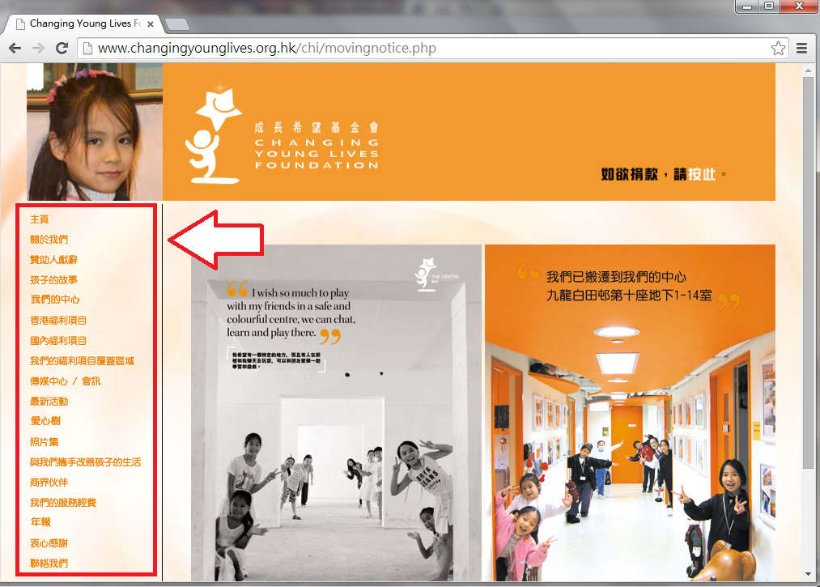

We concentrated one part on their website that we are considering it may be highly potentially to be refined to provide more efficiency and quality of services for their members. On the other hand it should be also able to reduce much communication and confirmation time of their labor.

As below observation, the organization always organize many activities to their serving target. We can reasonably believe, these activities’ appointment would need many manual works to record. Afterward, their staffs would update the documents (pdf) on the web site for the announcement.

We are considering to enhance its electronic based activity list or booking on this part of the website, so that it would improve their services more interactions and directly with their serving targets. It would also able to reduce their labor workloads.

