Software Engineering (COMP3211)

Semester Project

14112105d WONG CHUN KIU

14005194d NG YU HUEN

# Task Specification

ModernDesign Corporation is a large furniture store. It sells furniture made from different countries.

The company manages different furniture by using an advanced stock control system to maintain the furniture record and the stock level.

Recently, ModernDesign plans to acquire ModernDesign Corporation which is a small furniture firm solely sells furniture from China.

ModernDesign uses a class called “FurnitureControl” to manage the furniture records. The system has couple basic methods to support the daily operations.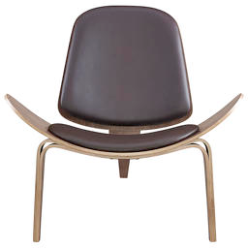

ChinaStyle uses a class called “ItemManage” to manage the furniture records. The system has couple basic methods to support the daily operations.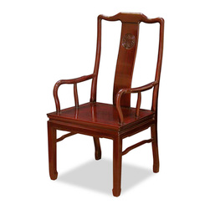

# Function Requirement

1. To create a Furniture object with one year warranty period.
2. To search a Furniture object by id.
3. To update the designer of a Furniture object.
4. To update the warranty period of a Furniture object.
5. To add the given quantity to a Furniture object.
6. To deduct the given quantity from a Furniture object.
7. ModernDesign Corporation can access the ModernDesign Corporation system.
8. A undo and redo function should be offered by the new system.
9. The new system should extendable for the future.
10. To show the detail of the Furniture.

# Non-Function Requirement

Any accessing database activity should be logged by the system.

An Automagical backup should be offered by the system.