HONG KONG INSTITUTE OF VOCATIONAL EDUCATION (TSING YI)

DEPARTMENT OF INFORMATION AND COMMUNICATIONS TECHNOLOGY

HIGHER DIPLOMA IN SOFTWARE ENGINEERING (IT114105)

HIGHER DIPLOMA IN COMPUTER SYSTEMS ADMINISTRATION (IT124106)

Module Name: Contemporary Topics in CSA/

Contemporary Topics in Software Engineering

Module Code: ITP4605/ITP4507

Assignment Number: One

Hand-in: 20 November, 2013
(On or before 4:30 PM
to Collection Boxes outside Room C440)

Weighting of This Assignment: 50% of the End of Module Assessment

This assignment is a group assignment (group size: max. two students) and must be done by group members only. Plagiarism will be treated seriously. Any assignments that are found involved wholly or partly in plagiarism (no matter the assignments are from the original authors or from the plagiarists) will score Zero mark. Late submission will NOT be accepted.
-------------------------------------------------------------------------------------------------------

Task Specification

ModernDesign Corporation is a large furniture store. It sells furniture made from different countries. The company manages different furniture by using an advanced stock control system to maintain the furniture record and the stock level. Recently, ModernDesign plans to acquire ChinaStyle Company which is a small furniture firm solely sells furniture from China.

ModernDesign uses a class called “FurnitureControl” to manage the furniture records. The system has couple basic methods to support the daily operations.
- createFurniture ( ) to create a Furniture object with one year warranty period
- searchFurniture ( ) to search a Furniture object by id
- updateDesigner ( ) to update the designer of a Furniture object
- updateWarrantyPeriod ( ) to update the warranty period of a Furniture object
- addStock ( ) to add the given quantity to a Furniture object
- deductStock ( ) to deduct the given quantity from a Furniture object

ChinaStyle uses a class called “ItemManage” to manage the furniture records. The system has couple basic methods to support the daily operations.
- createItem ( ) to create an Item object with one year guarantee period
- findItem ( ) to search an Item object by itemNo
- modifyDesigner ( ) to update the designer of an Item object
- amendGuaranteePeriod ( ) to update the guarantee period of an Item object
- addItem ( ) to add the given quantity to an Item object
- deductItem () to deduct the given quantity to an Item object

The followings are the simplified class diagrams of the existing systems for your reference.
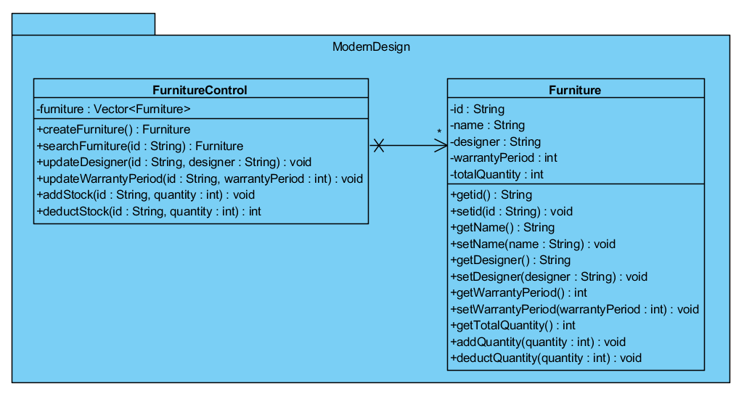
Note: In the Furniture class,
        - addQuantity ( ) method will add the given quantity to the totalQuantity.
        - deductQuantity ( ) method will subtract the given quantity from the totalQuantity.

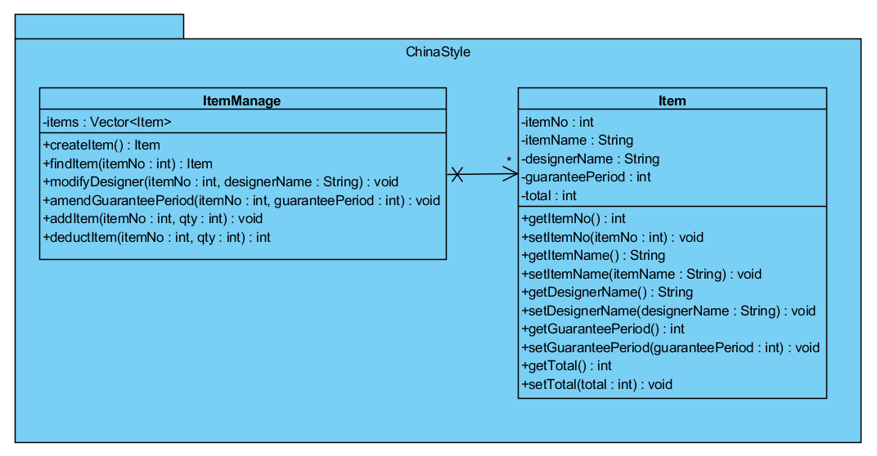
Note: For the methods deductStock ( ) and deductItem ( ), if the user enters a number which is greater than the stock-in-hand, these methods will return an error code (1). If the user enters a number which is smaller than or equal to the stock-in-hand, these methods will return an error code (0).

As a system analyst of the Company, you are required to support the system integration. You are asked to design and develop the MODERN_DESIGN Furniture Control System for integrating the classes in the existing two systems. You are reminded that the design of the existing classes: FurnitureControl, Furniture, ItemManage, and Item must be kept unchanged.

You should minimize the impact of future change on data structures and operations in both existing systems; however, your new system should integrate the operations with one common user interface. Moreover, ModernDesign may acquire other company in the future and your new system must support for future integration.

The new system module should provide the following functions:
- Create a new furniture record for new furniture in a company (ModernDesign, or ChinaStyle, or any new company in the coming future).
- Show furniture details (such as id/itemNo, name/itemName, designer/designerName, warrantyPeriod/guaranteePeriod, totalQuantity/total) by a given id (input id=*** to show all records)
- Add/deduct quantity to/from a furniture record.
- Update warranty period
- Undo last command
- Redo the last undone command
- Show undo/redo list

Your system design should conform to the Open Closed Principle so that your design should easily support new functions and stock items, for example, creation of different types of furniture.

You MUST apply the following design patterns for your new system
- Adapter pattern to support the operations between the two existing companies, and consider the future changes for any new company acquired by ModernDesign Corporation.
- Command pattern to provide the “create furniture”, “show furniture detail”, “add quantity”, “deduct quantity”, “update warranty period”, “undo”, “redo” and “show undo/redo list” functions
- Factory pattern or Abstract Factory Pattern to create different Command objects and furniture objects (e.g. Furniture object, Item object, etc.)
- Memento pattern to provide “Undo” and “Redo” functions

Assignment Report
In addition to the system development, you are required to write up a Short Report covers the following sections:
1. Assumptions regarding the problem context //?
2. Application design with class diagram //?
3. Discussion and explanation on each of the design patterns applied to the application//ok
4. User Guide//ok
5. Test Plan and Test Cases
6. Well documented Source Code //ok
Mark Allocation

Your assignment work will be marked according to the following criteria.
Work | Mark Allocated
System Coding and Implementation
- Implementation of the system and coding style  (Hard-coded output will result in zero mark.) | 30%
- Demonstration *  (Hard-coded output will result in zero mark.) | 15%
- User Guide | 5%
- Test Plan and Test Cases  (Will be used in testing your own application.) | 5%
System Analysis and Design, and Discussion
- Design of your system and correct use of design patterns | 20%
- Application design with class diagram | 10%
- Discussion and explanation on each of the design patterns applied to the application | 15%
Total | 100%
Note: * Please note that you will be asked to recompile all you Java classes during demonstration, and to answer questions regarding your implementation.

Submission of Assignment Work
- The front page of your submission should include the course title, module title, student identity number(s), student name(s), and group number.

- Submit a hard copy and TWO sets of soft copy in CD of all your work including
(Please check your CD before submission; any unreadable CD will receive zero mark.)
  - Well documented Source Code of your program
  - User Guide and Test Plan with Test Cases (describe how your program works and develop different test cases for testing each functionality of your program – please include all the required screen dumps).
  - Report for analysis and discussion on system
    - The assumption made during analysis and design of the application
    - System design on your application with class diagram
    - Discussion on the design patterns that applied on your application

- Submit according to the guideline on the top part of cover page. Late submission will NOT be accepted.

Extra Reference
This sample run is served for reference only. You are free to design your own user interface.

Sample Run of assignment

You may follow the design of user interface shown in this sample run in DOS command prompt.

User’s inputs are in bold face.
- Create Furniture Information (c)
Modern_Design Furniture Control System
Please enter command: [c | s | a | d | w | u | r | l | x]
c = create furniture, s = show furniture details, a = add stock, d = deduct stock,
w = update warranty period, u = undo, r = redo, l = list undo/redo, x= exit system

c
Enter company code (md/cs):
md
Enter id, name, designer and quantity:
45675, table, Simon, 12
New furniture record created.

Create ChineStyle furniture
Modern_Design Furniture Control System
Please enter command: [c | s | a | d | w | u | r | l | x]
c = create furniture, s = show furniture details, a = add stock, d = deduct stock,
w = update warranty period, u = undo, r = redo, l = list undo/redo, x= exit system

c
Enter company code (md/cs):
cs
Enter id, type, name and stock:
45676, chair, Taichi, 20
New furniture record created.

- Show one furniture information (s)
Modern_Design Furniture Control System
Please enter command: [c | s | a | d | w | u | r | l | x]
c = create furniture, s = show furniture details, a = add stock, d = deduct stock,
w = update warranty period, u = undo, r = redo, l = list undo/redo, x= exit system

s
Enter id (*** to show all):
45675

Furniture information
ID: 45675
Name: table
Designer: Simon
Warranty period: 1
Stock: 12

Show all records
Modern_Design Furniture Control System
Please enter command: [c | s | a | d | w | u | r | l | x]
c = create furniture, s = show furniture details, a = add stock, d = deduct stock,
w = update warranty period, u = undo, r = redo, l = list undo/redo, x= exit system

s
Enter id (*** to show all):
***

Furniture information
ID Name Designer Warranty Stock
45675 table Simon 1 12
45676 chair Taichi 1 20

Create 2 furniture (1 ModernDesign furniture, and 1ChinaStyle furniture)
Modern_Design Furniture Control System
Please enter command: [c | s | a | d | w | u | r | l | x]
c = create furniture, s = show furniture details, a = add stock, d = deduct stock,
w = update warranty period, u = undo, r = redo, l = list undo/redo, x= exit system

c
Enter company code (md/cs):
md
Enter id, name, designer and quantity:
32561, bed, Peter, 6
New furniture record created.

Modern_Design Furniture Control System
Please enter command: [c | s | a | d | w | u | r | l | x]
c = create furniture, s = show furniture details, a = add stock, d = deduct stock,
w = update warranty period, u = undo, r = redo, l = list undo/redo, x= exit system

c
Enter company code (md/cs):
cs
Enter id, type, name and stock:
45673, shelf, YelloRiver, 3
New furniture record created.

Show all records
Modern_Design Furniture Control System
Please enter command: [c | s | a | d | w | u | r | l | x]
c = create furniture, s = show furniture details, a = add stock, d = deduct stock,
w = update warranty period, u = undo, r = redo, l = list undo/redo, x= exit system

s
Enter id (*** to show all):
***

Furniture information
ID Name Designer Warranty Stock
32561 bed Peter 1 6
45673 shelf YellowRiver 1 3
45675 table Simon 1 12
45676 chair Taichi 1 20

- Add stock (a)
Modern_Design Furniture Control System
Please enter command: [c | s | a | d | w | u | r | l | x]
c = create furniture, s = show furniture details, a = add stock, d = deduct stock,
w = update warranty period, u = undo, r = redo, l = list undo/redo, x= exit system

a
Enter id (*** to show all):
45673
Quantity to add:
2
Furniture stock added.

Modern_Design Furniture Control System
Please enter command: [c | s | a | d | w | u | r | l | x]
c = create furniture, s = show furniture details, a = add stock, d = deduct stock,
w = update warranty period, u = undo, r = redo, l = list undo/redo, x= exit system

s
Enter id (*** to show all):
45673

Furniture information
ID: 45673
Name: shelf
Designer: YellowRiver
Warranty period: 1
Stock: 5

- Deduct stock (d)
Modern_Design Furniture Control System
Please enter command: [c | s | a | d | w | u | r | l | x]
c = create furniture, s = show furniture details, a = add stock, d = deduct stock,
w = update warranty period, u = undo, r = redo, l = list undo/redo, x= exit system

d
Enter id (*** to show all):
45675
Quantity to deduct:
4
Furniture stock deducted.

Modern_Design Furniture Control System
Please enter command: [c | s | a | d | w | u | r | l | x]
c = create furniture, s = show furniture details, a = add stock, d = deduct stock,
w = update warranty period, u = undo, r = redo, l = list undo/redo, x= exit system

s
Enter id (*** to show all):
45675

Furniture information
ID: 45675
Name: table
Designer: Simon
Warranty period: 1
Stock: 8

Deducting an invalid quantity (stock-in-hand < stock deduct) from stock will display a warning message. Note that this invalid operation should not be shown in Undo List afterward.
Modern_Design Furniture Control System
Please enter command: [c | s | a | d | w | u | r | l | x]
c = create furniture, s = show furniture details, a = add stock, d = deduct stock,
w = update warranty period, u = undo, r = redo, l = list undo/redo, x= exit system

d
Enter id (*** to show all):
45676
Quantity to deduct:
88
Invalid quantity (stock-in-hand< stock deduct).

Modern_Design Furniture Control System
Please enter command: [c | s | a | d | w | u | r | l | x]
c = create furniture, s = show furniture details, a = add stock, d = deduct stock,
w = update warranty period, u = undo, r = redo, l = list undo/redo, x= exit system

- Update warranty period (w)
Modern_Design Furniture Control System
Please enter command: [c | s | a | d | w | u | r | l | x]
c = create furniture, s = show furniture details, a = add stock, d = deduct stock,
w = update warranty period, u = undo, r = redo, l = list undo/redo, x= exit system

w
Enter id (*** to show all):
32561
Enter warranty period:
3
Furniture warranty period updated.

Modern_Design Furniture Control System
Please enter command: [c | s | a | d | w | u | r | l | x]
c = create furniture, s = show furniture details, a = add stock, d = deduct stock,
w = update warranty period, u = undo, r = redo, l = list undo/redo, x= exit system

s
Enter id (*** to show all):
***

Furniture information
ID Name Designer Warranty Stock
32561 bed Peter 3 6
45673 shelf YellowRiver 1 5
45675 table Simon 1 8
45676 chair Taichi 1 20

- Display the Undo/Redo List (l)
Modern_Design Furniture Control System
Please enter command: [c | s | a | d | w | u | r | l | x]
c = create furniture, s = show furniture details, a = add stock, d = deduct stock,
w = update warranty period, u = undo, r = redo, l = list undo/redo, x= exit system

l

Undo List:
Create 45675
Create 45676
Create 32561
Create 45673
Add stock 45673 2
Deduct stock 45675 4
Update warranty 32561 3

Redo List:
Empty

- Undo Last Command in the Undo List (u)
Modern_Design Furniture Control System
Please enter command: [c | s | a | d | w | u | r | l | x]
c = create furniture, s = show furniture details, a = add stock, d = deduct stock,
w = update warranty period, u = undo, r = redo, l = list undo/redo, x= exit system

u
undo completed.

Modern_Design Furniture Control System
Please enter command: [c | s | a | d | w | u | r | l | x]
c = create furniture, s = show furniture details, a = add stock, d = deduct stock,
w = update warranty period, u = undo, r = redo, l = list undo/redo, x= exit system

l

Undo List:
Create 45675
Create 45676
Create 32561
Create 45673
Add stock 45673 2
Deduct stock 45675 4

Redo List:
Update warranty 32561 3

Modern_Design Furniture Control System
Please enter command: [c | s | a | d | w | u | r | l | x]
c = create furniture, s = show furniture details, a = add stock, d = deduct stock,
w = update warranty period, u = undo, r = redo, l = list undo/redo, x= exit system

u
undo completed.

Modern_Design Furniture Control System
Please enter command: [c | s | a | d | w | u | r | l | x]
c = create furniture, s = show furniture details, a = add stock, d = deduct stock,
w = update warranty period, u = undo, r = redo, l = list undo/redo, x= exit system

l

Undo List:
Create 45675
Create 45676
Create 32561
Create 45673
Add stock 45673 2

Redo List:
Update warranty 32561 3
Deduct stock 45675 4

Modern_Design Furniture Control System
Please enter command: [c | s | a | d | w | u | r | l | x]
c = create furniture, s = show furniture details, a = add stock, d = deduct stock,
w = update warranty period, u = undo, r = redo, l = list undo/redo, x= exit system

s
Enter id (*** to show all):
***

Furniture information
ID Name Designer Warranty Stock
32561 bed Peter 1 6
45673 shelf YellowRiver 1 5
45675 table Simon 1 12
45676 chair Taichi 1 20

- Redo the last undo command (r)
Modern_Design Furniture Control System
Please enter command: [c | s | a | d | w | u | r | l | x]
c = create furniture, s = show furniture details, a = add stock, d = deduct stock,
w = update warranty period, u = undo, r = redo, l = list undo/redo, x= exit system

l

Undo List:
Create 45675
Create 45676
Create 32561
Create 45673
Add stock 45673 2

Redo List:
Update warranty 32561 3
Deduct stock 45675 4

Modern_Design Furniture Control System
Please enter command: [c | s | a | d | w | u | r | l | x]
c = create furniture, s = show furniture details, a = add stock, d = deduct stock,
w = update warranty period, u = undo, r = redo, l = list undo/redo, x= exit system

r
redo completed.

Modern_Design Furniture Control System
Please enter command: [c | s | a | d | w | u | r | l | x]
c = create furniture, s = show furniture details, a = add stock, d = deduct stock,
w = update warranty period, u = undo, r = redo, l = list undo/redo, x= exit system

s
Enter id (*** to show all):
***

Furniture information
ID Name Designer Warranty Stock
32561 bed Peter 1 6
45673 shelf YellowRiver 1 5
45675 table Simon 1 8
45676 chair Taichi 1 20

Modern_Design Furniture Control System
Please enter command: [c | s | a | d | w | u | r | l | x]
c = create furniture, s = show furniture details, a = add stock, d = deduct stock,
w = update warranty period, u = undo, r = redo, l = list undo/redo, x= exit system

l

Undo List:
Create 45675
Create 45676
Create 32561
Create 45673
Add stock 45673 2
Deduct stock 45675 4

Redo List:
Update warranty 32561 3

- Exit the System (X)
Modern_Design Furniture Control System
Please enter command: [c | s | a | d | w | u | r | l | x]
c = create furniture, s = show furniture details, a = add stock, d = deduct stock,
w = update warranty period, u = undo, r = redo, l = list undo/redo, x= exit system

x

Leaving System...

End of Sample Run
*** END ***

