ACTIVITY 4.0
Insert the following picture and format based on the given:

Penguin
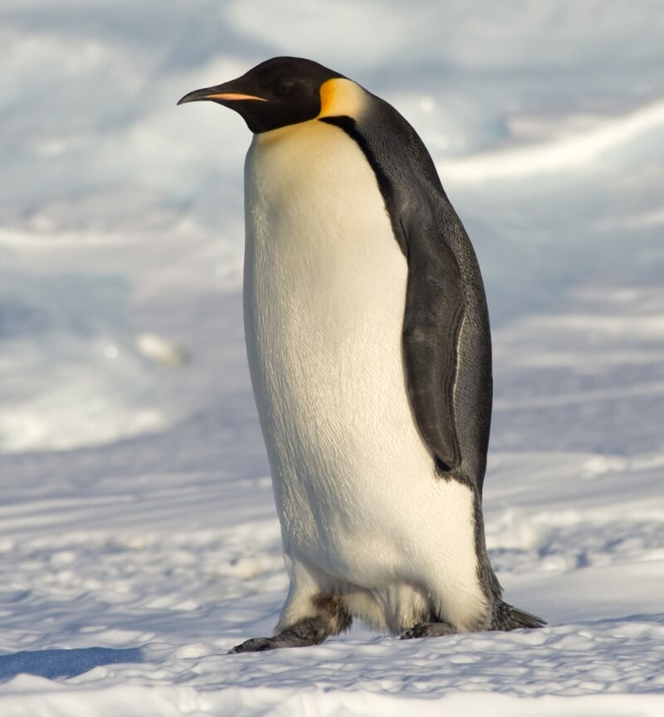
Penguin are a group of aquatic flightless birds. They live almost exclusively in the South Hemisphere, with only one species, the Galapagos penguin, found north of the Equator. Highly adapted for life in the water, penguins have counter shaded dark and white plumage and flippers for swimming.
Picture Format Applied:
• Height: 2.73" | Width: 3.34"
• Picture Styles: Metal Rounded Rectangle
• Picture Shape: Oval
• Picture Border: Aqua, Accent 5, Darker 25%
• Picture Effect: Shadow - Offset Diagonal Top Left
• Picture Effect: Glow - Accent Color 1, 8pt glow
• Picture Effect: Bevel - Hard Edge
• Text Wrapping: Square

Koala
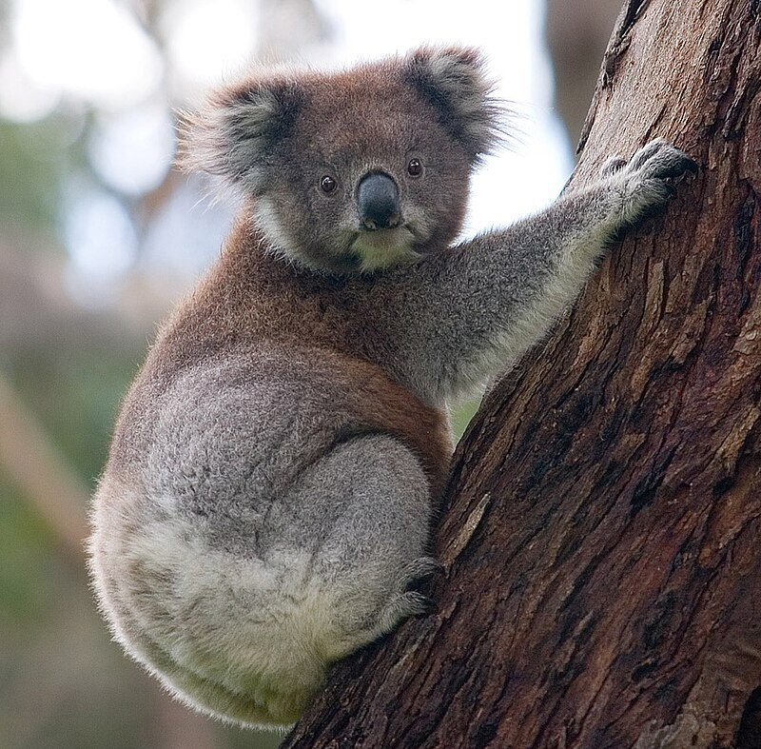
Koala or inaccurately, koala bear is an arboreal herbivorous marsupial native to Australia. It is the only extant representative of the family Phascolarctidae and its closest living relatives are the wombats, which are members of the family Vombatidae. The koala is found in coastal areas of the mainland's eastern and southern regions, inhabiting Queensland, New South Wales, Victoria and South Australia.
Picture Format Applied:
• Height: 3.54" | Width: 3.3"
• Picture Styles: Bevel Rectangle
• Picture Border: Blue, Accent 1, Darker 50%
• Picture Effect: 3D Rotation - Perspective Relaxed Moderately
• Picture Effect: Glow - Accent Color 5, 8pt glow
• Picture Effect: Bevel - Soft Round
• Text Wrapping: Square

My Picture - About Me

My Photo
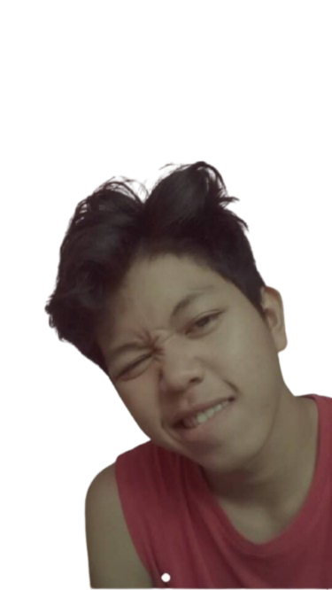
This is my personal picture for Activity 4.0. As instructed, I have inserted my own image and formatted it according to the given specifications. The picture showcases my personality and is part of the Advanced Word Processing activities at Imus Computer College.
Picture Format Applied:
• Height: 2.63" | Width: 2.41"
• Picture Styles: Metal Oval
• Picture Border: Light Blue
• Picture Effect: 3D Rotation - Off Axis 2 Left
• Picture Effect: Shadow - Offset Top
• Picture Effect: Reflection - Full Reflection, Touching
• Text Wrapping: Square

Imus Computer College since 1988

