SELF INTRODUCTION

ACKNOWLEDGEMEnt

I would like to express my sincere gratitude to Swami Aatmanand Government English Medium Model College, Atari, for providing me with the opportunity and academic environment to complete this assignment entitled “Agri-Business Venture Plan: Chironji Processing and Kernel Extraction Micro-Unit.”
I am especially thankful to Mr. Kuleshawer Prasad Sahu, Commerce Department, for his valuable guidance, encouragement, and suggestions throughout the preparation of this project. His guidance helped me understand the various aspects of business planning, market analysis, financial planning, legal requirements, and operational management involved in establishing an agri-business venture.
I would also like to thank the Commerce Department and the college administration for providing the necessary academic support and resources required to complete this assignment successfully.
I am grateful to the books, government publications, official websites, articles, and other reliable sources that provided useful information for understanding the technical, financial, legal, and market aspects of a Chironji Processing and Kernel Extraction Micro-Unit.

Finally, I would like to thank my classmates, friends, and family members for their encouragement and support during the preparation of this assignment.

INDEX

CHAPTER 1: INTRODUCTION AND EXECUTIVE SUMMARY
- INTRODUCTION
Chironji Processing and Kernel Extraction Micro-Unit

Chironji, scientifically known as Buchanania lanzan, is an important minor forest produce found widely in central and eastern parts of India, particularly in Chhattisgarh, Madhya Pradesh, Jharkhand, Odisha and Maharashtra. The seeds of chironji contain edible kernels that are valued for their rich nutritional content, pleasant taste and use in traditional Indian food products. Chironji kernels are commonly used in sweets, desserts, bakery products, confectionery, dry-fruit mixtures and various traditional dishes.

Despite its economic and nutritional importance, a considerable portion of chironji is still processed using traditional and labour-intensive methods. Manual breaking, shell removal, cleaning, grading and kernel extraction can result in considerable time consumption, physical effort, kernel breakage and post-harvest losses. Lack of organized processing and value addition also limits the income potential of collectors, farmers and local communities.

The proposed Chironji Processing and Kernel Extraction Micro-Unit aims to address these problems by establishing a small-scale, organized processing facility equipped with appropriate machinery for cleaning, drying, shell breaking, kernel separation, grading, quality control and packaging. The unit will convert raw chironji into higher-value, market-ready kernels and potentially other value-added products.

The proposed business is planned with an investment budget of approximately ₹75 lakh to ₹1 crore. The unit will focus on efficient processing, hygienic production, attractive packaging, quality assurance and systematic marketing. It can source raw chironji from local collectors, farmers, forest produce groups, traders and other suppliers, thereby creating a connection between primary producers and organized markets.

The project has both commercial and social importance. Commercially, it creates an opportunity to earn revenue through value addition and the sale of processed chironji kernels. Socially, it can generate employment, encourage local entrepreneurship, support forest-produce collectors and contribute to rural economic development. It can also help reduce wastage by improving post-harvest handling and processing practices.

The unit can target several markets, including local retailers, wholesalers, sweet manufacturers, bakeries, dry-fruit distributors, food-processing companies, restaurants and online consumers. With proper branding and packaging, the business can gradually develop a regional and national market for premium-quality chironji kernels.

Therefore, the proposed Chironji Processing and Kernel Extraction Micro-Unit represents a value-addition-based agribusiness opportunity that combines local natural resources, modern processing technology, employment generation and market-oriented entrepreneurship. The project aims to transform traditionally processed chironji into a commercially organized product while contributing to sustainable rural and regional economic development.
- Executive Summary
Business Concept
The proposed venture involves establishing a Chironji (Buchanania lanzan) Processing and Kernel Extraction Micro-Unit. Chironji nuts are high-value forest produce widely harvested in semi-arid and tribal belts of India. While the raw hard-shelled nuts command low prices, processed Chironji kernels yield premium prices in spice markets, traditional sweets (mithai), cosmetics, and Ayurvedic medicine.
The micro-unit will source raw nuts directly from local gatherers and agricultural cooperative markets, process them through modern decorticating, grading, and vacuum packaging equipment, and supply value-added kernels to national and regional markets.
- Mission & Vision
- Vision: To become a leading regional producer of premium-quality, unadulterated Chironji kernels while empowering forest-dependent communities through sustainable local processing and fair pricing.
To adopt hygienic, mechanized processing technology that maximizes kernel recovery and reduces breakage.
- Mission:
To minimize waste by converting processing by-products (nut shells) into commercial biomass/bio-fuel.
To create sustainable rural entrepreneurship and direct local employment, particularly for women and rural youth.
- Project Objectives
Capacity Utilization: Establish an annual processing capacity of 15 to 20 metric tons (MT) of raw Chironji nuts in Phase 1.
Quality Benchmark: Achieve kernel recovery rates above 45–50% with low breakage using specialized grading and de-shelling machinery.
Market Expansion: Build distribution linkages with confectionery units, wholesale dry-fruit dealers, and direct-to-consumer (D2C) organic brand aggregators.
Economic Viability: Deliver high Return on Investment (ROI) with a payback period within 2.5 to 3 years under normal operating conditions.

- PROJECT SNAPSHOT

PARAMITER | DETAILS
Project Type | Agro-Processing & Forest-Produce Micro Enterprise
Primary Product | Whole Chironji Kernels (Charoli)
Secondary By-Product | Broken Kernels, Outer Nut Shells (Biomass Fuel)
Target Raw Material | Dry Chironji Nuts (Buchanania lanzan)
Installed Capacity | ~50–60 kg/day raw nut input (15–18 MT annually)
Target Market | B2B (Mithai manufacturers, dry fruit wholesalers) & B2C (Retail Packets)
Estimated Capital Cost | ₹8,000,000 – ₹12,000,000 (US $10,000 – $15,000 approx.)
Financial Assistance | Eligible under MSME / PMEGP / PM-FME Schemes

A) Need and Scope for the Project:

1) Value Addition at Source: Processing Chironji close to harvest belts eliminates intermediary exploitation and ensures raw material freshness. 2)High Market Demand: India faces a persistent demand-supply gap for premium-grade Chironji kernels, making it a high-margin agro-processing commodity.

3)Employment & Rural Upliftment: Setting up a micro-unit offers steady employment opportunities to rural women, who excel in hand-sorting and packaging operations.

B) Processing Methodology Overview

The processing flow converts hard raw nuts into export/market-ready packed kernels:
- Cleaning & Washing: Removal of dirt, stones, and light foreign particles.
- Soaking & Drying: Moisture conditioning to weaken the bond between kernel and outer hard shell.
- Calibrated Grading: Sizing nuts into standard diameter batches for uniform cracking.
- Mechanized Decortication: Cracking nuts through specialized rubber/steel roller decorticators to liberate whole kernels.
- Winnowing & Shell Separation: Air-blower separation of light shell fragments from heavy kernels.
- Skin Peeling & Final Drying: Removal of the thin inner testa skin followed by controlled tray drying.
- Sorting & Vacuum Packaging: Manual/optical color sorting and air-tight vacuum sealing to ensure shelf-life up to 12 months.

CHAPTER 2: MARKET ANALYSIS AND STRATEGY

A) Market Overview & Demand Drivers
- Premium Dry Fruit Segment: Whole chironji kernels command high retail prices ($15–$25+ / ₹1,200–₹2,500+ per kg depending on grade and processing quality) due to high labor intensity and limited commercial cultivation.
- B2B Food & Sweets Sector: Commercial sweet manufacturers (Halwais), bakery chains, packaged dessert brands, and FMCG players use chironji extensively in sweets (laddoo, halwa, kheer), pan masala, and trail mixes.
- Emerging Cosmetic & Pharma Uses: Chironji oil and fine kernel meal are growing in demand for herbal skincare (face packs, anti-aging creams) and traditional Ayurvedic formulations.
- By-Product Valorization: The hard outer shell (decorticated hulls) has a high calorific value and can be sold to biomass pellet manufacturers or boiler industries as fuel, maximizing unit profitability.

Value Chain Analysis
Wild Collection / Tribal Mandis {Raw Nuts} {Processing & Extraction Micro-Unit} {Kernel & Oil}{Wholesalers / FMCG / Retail}

Target Market Segmentation

- Institutional B2B (Bulk Kernels):
  - Regional and national sweet and snack manufacturers.
  - Wholesale spice and dry fruit merchants (Kirana Mandis).
  - Catering businesses and luxury hotels.

- Industrial B2B (Kernels & By-Products):
  - Ayurvedic medicine manufacturers and cosmetic/herbal skincare companies.
  - Biomass pellet plants (for purchasing crushed hard shells).

- Retail & D2C (Value-Added Packs):
  - Organic food stores, gourmet grocery outlets, and Amazon/Flipkart/D2C store sales (vacuum-packed 100g/250g pouches).

- Competitive Advantage Strategy

To stand out in an unorganized market dominated by crude manual processors:
Mechanical Efficiency & Grade Accuracy: Utilize modern decorticators and multi-tier mechanical sieves to achieve high whole-kernel recovery rates (>80-85%) with minimal kernel breakage.
- Vacuum-Sealed Nitrogen Packaging: Chironji kernels are prone to rancidity due to high fat content. Offering nitrogen-flushed, moisture-proof vacuum packaging doubles shelf life and commands a premium price from exporters and organized retail.
- Direct Farmer/Tribal Sourcing: Cut out 2–3 layers of middle traders by setting up direct purchase centers or partnerships with Tribal Cooperatives (e.g., TRIFED/Forest Produce Societies), lowering raw material procurement costs by 15–20%.
- Zero-Waste Operations: Monetize 100% of the input weight:
  - Grade A kernels: Gourmet retail & sweet chains.
  - Broken kernels: Powdered for cosmetic/bakery use.
  - Outer hard shells: Sold as industrial biomass fuel.

- SWOT Analysis
Strengths | Weaknesses
• High retail margin product with steady, inelastic festive demand.  • Low land and operational space requirements for a micro-unit (~500–1,000 sq. ft.).  • Fully monetizable inputs (zero waste). | • Seasonal raw material supply (harvest typically restricted to April–June).  • Delicate kernel extraction requiring precise calibration to avoid crushing.

Opportunities | Threats
• Government subsidies under micro-enterprise schemes (e.g., PMEGP, PM-FME, Tribal Self-Employment).  • Expansion into cold-pressed Chironji oil extraction.  • Organic certification and export to Gulf/Middle East markets. | • Fluctuations in raw nut crop yield due to climate change or unseasonal rains.  • Competition from local unorganized manual processors on price alone.

- Strategic Execution Roadmap
- Procurement Strategy:
  - Secure working capital credit lines before peak harvest (April–June) to buy raw nuts in bulk at low prices.
  - Set up proper drying and storage infrastructure (cool, dry warehouse) to hold inventory for year-round processing.
- Processing & Quality Control:
  - Step-by-step mechanized line: Sun drying $\rightarrow$ Size Grading $\rightarrow$ Shell Conditioning/Soaking $\rightarrow$ Mechanical Decortication $\rightarrow$ Skin Separation $\rightarrow$ Grade Sorting $\rightarrow$ Vacuum Packing.
  - Ensure FSSAI compliance and strict hygiene to target premium export and retail buyers.
- Go-To-Market (GTM) Plan:
  - Phase 1 (Months 1–6): Focus on institutional B2B sales (local sweet manufacturers & wholesale traders) to generate immediate cash flow.
  - Phase 2 (Months 6–12): Launch branded, vacuum-packed retail units (100g, 200g) on e-commerce platforms and gourmet stores.

Chapter 3: Technical & Operational Plan

- Location & Layout (15,000 – 20,000 sq ft)

Optimal Site Selection
- Proximity to Raw Material: Locate near major forest collection belts (e.g., Madhya Pradesh, Chhattisgarh, Jharkhand, Odisha, Maharashtra) to minimize raw nut procurement and transport costs.
- Climatic Needs: High solar irradiance is critical because sun-drying raw nuts and moisture conditioning before cracking reduces processing energy costs by up to 40%.
- Utilities: 3-phase commercial power connection (minimum 25–30 kW load requirement), clean water source for soaking/cleaning (5,000–8,000 liters/day), and well-drained, elevated terrain to prevent waterlogging during monsoon.
- Logistics: Direct access to state/national highways for heavy transport vehicles (10–20 ton trucks).

Floor Space & Area Allocation (Based on 18,000 sq ft Total Area)
A linear-flow industrial layout avoids cross-contamination between raw, unwashed nuts and processed food-grade kernels.
Zone / Section | Allocated Area | Spatial & Technical Function
Raw Material Yard (Covered) | 4,500 sq ft | Storage for raw, unhusked chironji nuts in ventilated gunny bags; unloading bay.
Sun Drying Yard (Open Platforms) | 5,000 sq ft | Raised concrete beds for solar drying, moisture control, and preliminary cleaning.
Cleaning & Pre-treatment Zone | 2,000 sq ft | Soaking tanks, destoning, rotary washing, and air-drying conveyors.
Decortication & Processing Hall | 3,000 sq ft | Main machinery area (graders, decorticators, shell separators, gravity tables).
Kernel Sorting & Grading Room | 1,500 sq ft | Enclosed, climate-controlled, air-conditioned room for manual/optical sorting & packing.
Finished Goods Warehouse | 1,000 sq ft | Cool, dry, pest-free storage for vacuum-packed kernels and bagged shell by-products.
Admin, Quality Lab & Amenities | 1,000 sq ft | Office, moisture-meter/lab testing setup, worker changing rooms, and toilets.
- Machinery and Equipment
For a micro-unit operating at a baseline capacity of 1.0 to 1.5 Tons per day (T/D) of raw nut intake, the total capital expenditure for plant and machinery is estimated between ₹17.3 Lakhs and ₹25.8 Lakhs.
Equipment Item | Qty | Technical Specifications / Capacity | Est. Capital Cost (INR ₹)
Raw Seed Cleaner & Destoner | 1 | 500 kg/hr capacity, dual-deck air-suction blower, 3 HP motor | ₹1,20,000 – ₹1,80,000
Size Grader Machine (Rotary/Vibratory) | 1 | 250–300 kg/hr, 3–4 sieve screens (separates nuts into 3 uniform sizes before cracking) | ₹1,50,000 – ₹2,20,000
Chironji Decorticator / Sheller Units | 3 | 100–150 kg/hr each, adjustable stone/emery disc clearances, 2–3 HP motors | ₹4,20,000 – ₹5,50,000
Aspirator / Husk Separator | 2 | Air-velocity blower system to separate light outer shells from broken & whole kernels | ₹1,40,000 – ₹2,00,000
Specific Gravity Separator | 1 | 200–300 kg/hr, separates un-cracked nuts from partially cracked and whole kernels | ₹3,20,000 – ₹4,50,000
Tray Dryer / Dehydrator | 1 | 48-tray electrically/diesel-heated batch dryer (for moisture reduction post-conditioning) | ₹2,50,000 – ₹3,50,000
Kernel Sorting Conveyor Tables | 2 | Food-grade SS-304 belt conveyor with overhead LED lighting | ₹1,00,000 – ₹1,60,000
Vacuum Nitrogen Packaging Machine | 1 | Double chamber vacuum sealer (for extended shelf life & export-grade packing) | ₹1,50,000 – ₹2,50,000
Utility Infrastructure | Lot | Weighing scales, plastic crates, moisture meters, air compressor, water tanks | ₹80,000 – ₹1,70,000
Total Estimated Machinery CapEx |  | 1.0 to 1.5 T/D Plant Capacity | ₹17.30 Lakhs – ₹25.80 Lakhs
Note: Prices are indicative estimates excluding GST, transport, and installation costs.

Operational Workflow & Manpower Layout

Process Flowchart
[Raw Chironji Nut Receiving]
│
▼
[Sun Drying & Moisture Leveling (8-10%)]
│
▼
[Destoning & Air-Washing (Removal of soil, stones, sticks)]
│
▼
[Nut Size Grading (Crucial: prevents kernel crushing)]
│
▼
[Soaking / Conditioning (Softens outer shell for clean cracking)]
│
▼
[Decortication / Shelling]
│
▼
[Air Aspirator Shell Separation] ───► [By-product: Shells (Sold as Fuel/Bio-char)]
│
▼
[Gravity Separation (Returns uncracked nuts back to Decorticator)]
│
▼
[Hot Air Tray Drying (Dries kernels to ~3-4% moisture)]
│
▼
[Manual Inspection & Color Sorting]
│
▼
[Nitrogen Vacuum Packing & Warehousing]

Manpower Allocation (per Shift)
A micro-unit processing ~1 to 1.5 tons/day operates efficiently with a lean team of 11–14 personnel.
- Plant Manager / Supervisor (1 Skilled):
  - Role: Operations oversight, supply chain management, sales, and daily production reporting.
- Maintenance Technician / Lead Operator (1 Skilled):
- .Role: Machine calibration (adjusting decorticator gaps based on nut grading size), mechanical maintenance, and trouble-shooting.
- Machine & Processing Operators (2 Semi-Skilled):
  - Role: Running cleaners, destoners, decorticators, gravity tables, and tray dryers.
- Quality & Packaging Assistant (1 Semi-Skilled):
  - Role: Moisture content checking, supervising vacuum packing, and tracking lot batch numbers.
- General Yard & Sorting Laborers (6 to 8 Unskilled):
  - Role: Material handling, spreading/collecting nuts in sun-drying yards, feeding hoppers, manual inspection/sorting on light tables, and stacking packed bags.

Chapter 4: Licenses, Permits & Legal Documentation (Comprehensive Placement)

1. Legal Entity & Registration
Choosing the correct business structure dictates liability, taxation, and compliance. Options range from Sole Proprietorships (unlimited liability) and LLPs to Private Limited Companies (asset protection and capital raising). Securing a foundational tax ID/registration is mandatory before opening commercial bank accounts.

2. Licenses vs. Permits
- Licenses: Broad legal permissions to engage in a specific commercial trade (e.g., General Business or Trade License) ensuring tax accountability.
- Permits: Specific authorizations for structural actions, public safety, or environmental compliance (e.g., Building Permits, Fire Safety NOCs).

3. Essential Industry Clearances
- Establishment & Trade: Municipal permissions regulating operations, working hours, and employee welfare.
- Zoning & Land Use: Local urban planning approval for commercial or industrial real estate use.
- Sector-Specific: Specialized authorizations such as food safety registrations (e.g., FSSAI), drug licenses, or Import-Export codes.

4. Required Documentation Checklist
- Entity Proof: Incorporation certificates, AoA, MoA, or partnership deeds.
- Promoter Identification: Government-issued IDs of directors/partners.
- Premises Proof: Commercial lease agreements, property deeds, and utility bills.
- Tax/Financial Records: Initial bank statements and tax registration filings (e.g., GST).
Compliance Note: Operating without required licenses risks heavy financial penalties, business shutdowns, and voided commercial contracts. Always complete a regulatory audit tailored to your sector and geography.
( The information provided below is taken from www.google.com )
LOCATION
1) PARTNERSHIP DEED
2) INCORPORATIPON CERIFICATE
3)UDYAM (MSME)
4) FSSAI
5)SPCB CLEARENCE
6) APMC CERTIFICATE
7) GST REGESTRATION
8) LOCAL MUNCIPAL TRADE LICENCE
9)COMMERCIAL ELECTRICITY CONNECTION SANCTION LETTER
10) GROUND WATER EXTRACTION CLEARENCE
11) PAN CARD
12) AADHAR CARD
13) INSAURANCE
LOCATION ;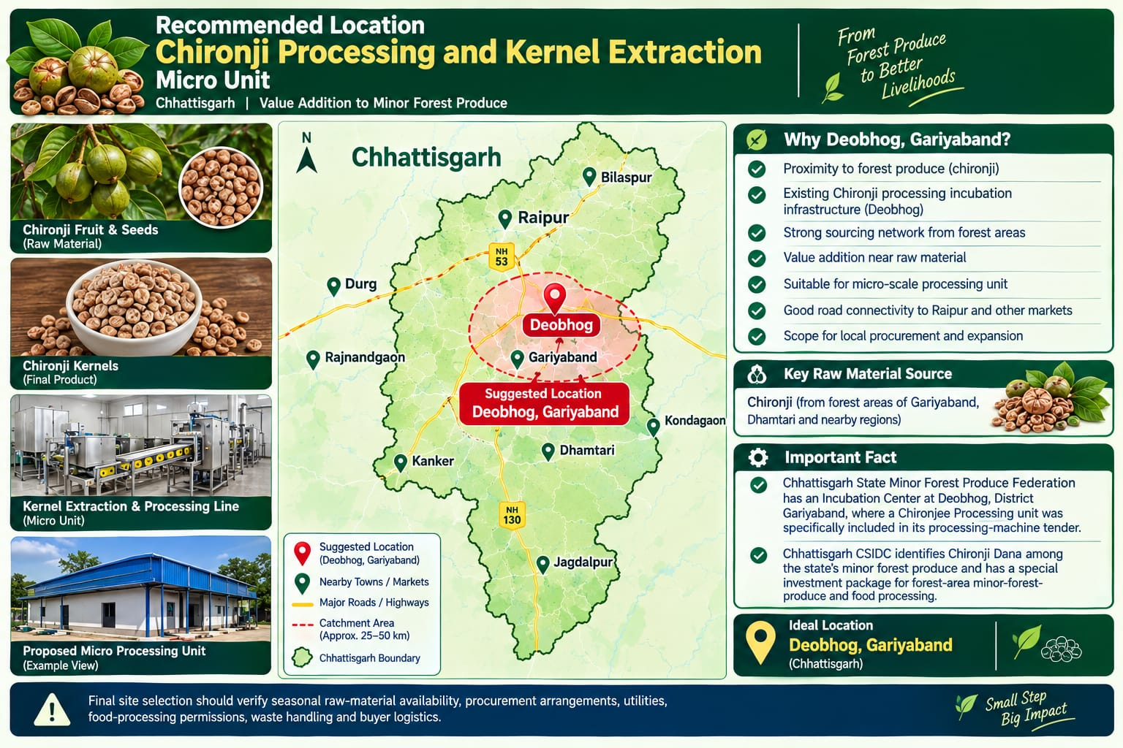


1) PARTNERSHIP DEED
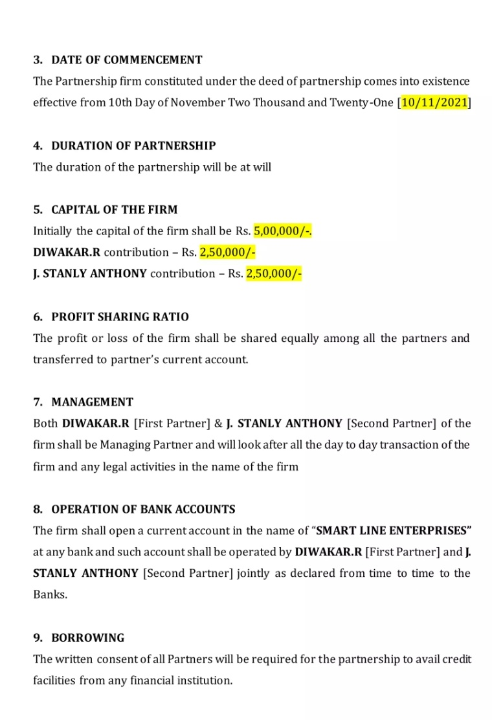

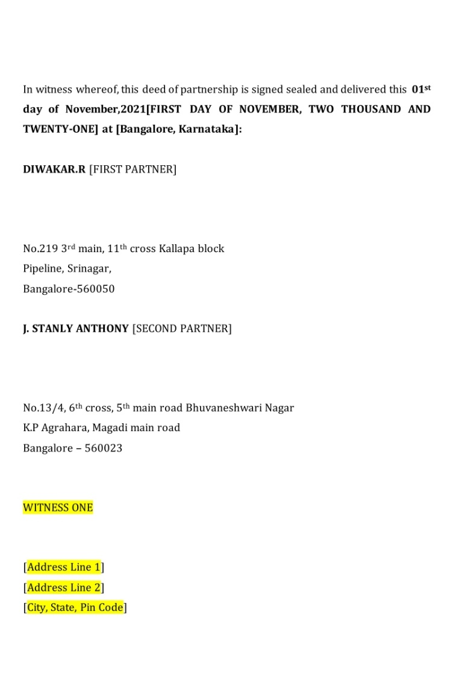
2) INCORPORATIPON CERIFICATE

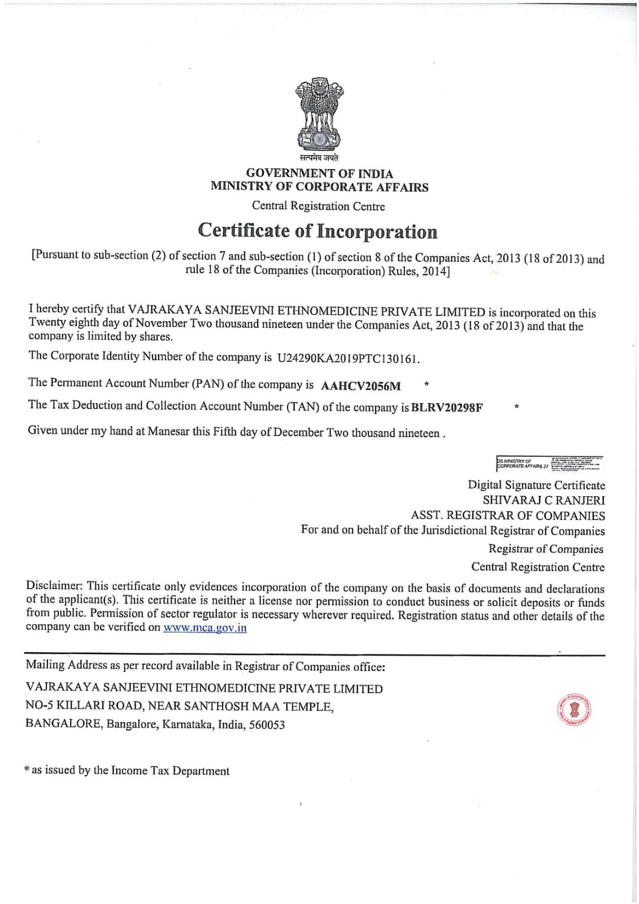

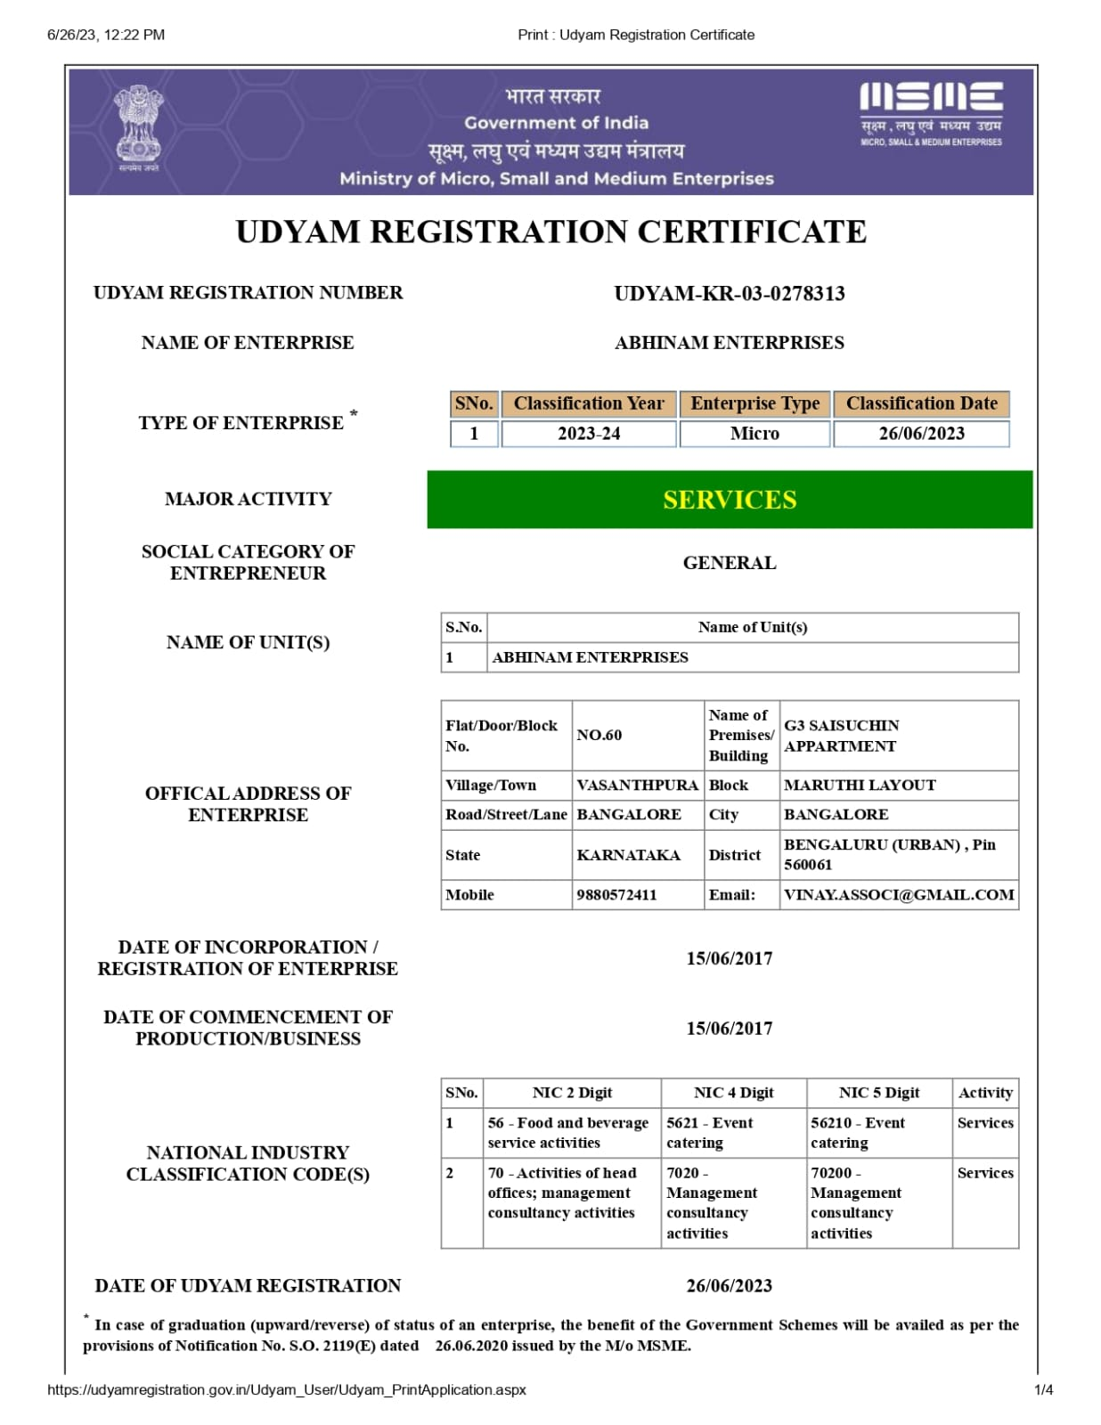
3)UDYAM (MSME)

4) FSSAI
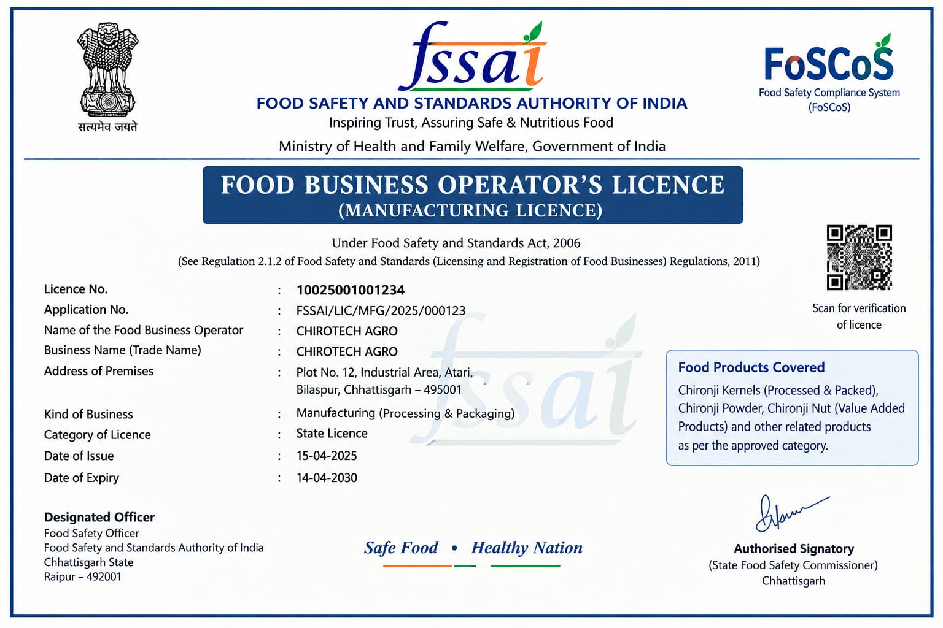
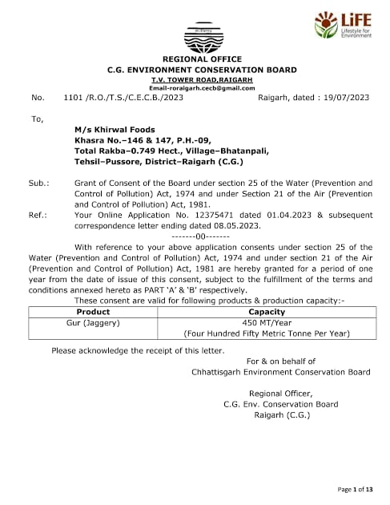
5)SPCB CLEARENCE

6) APMC CERTIFICATE
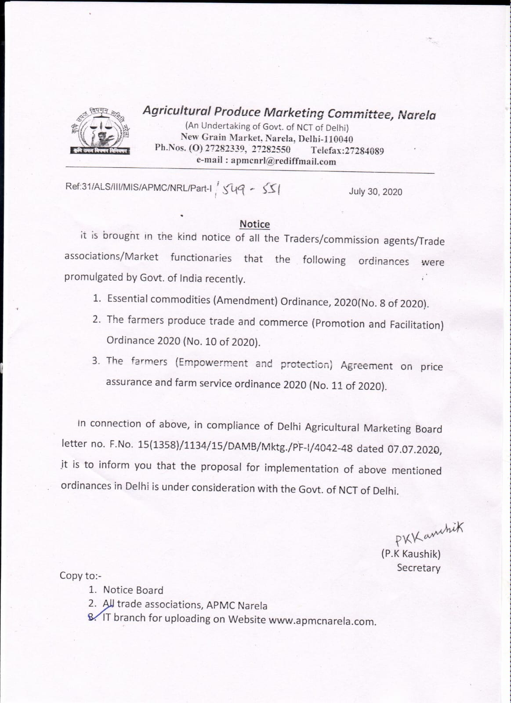

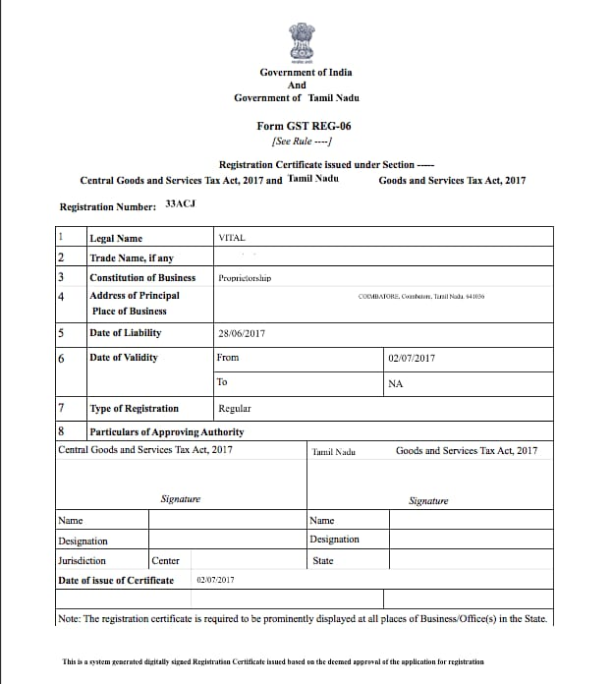
7) GST REGESTRATION CERTIFICATE

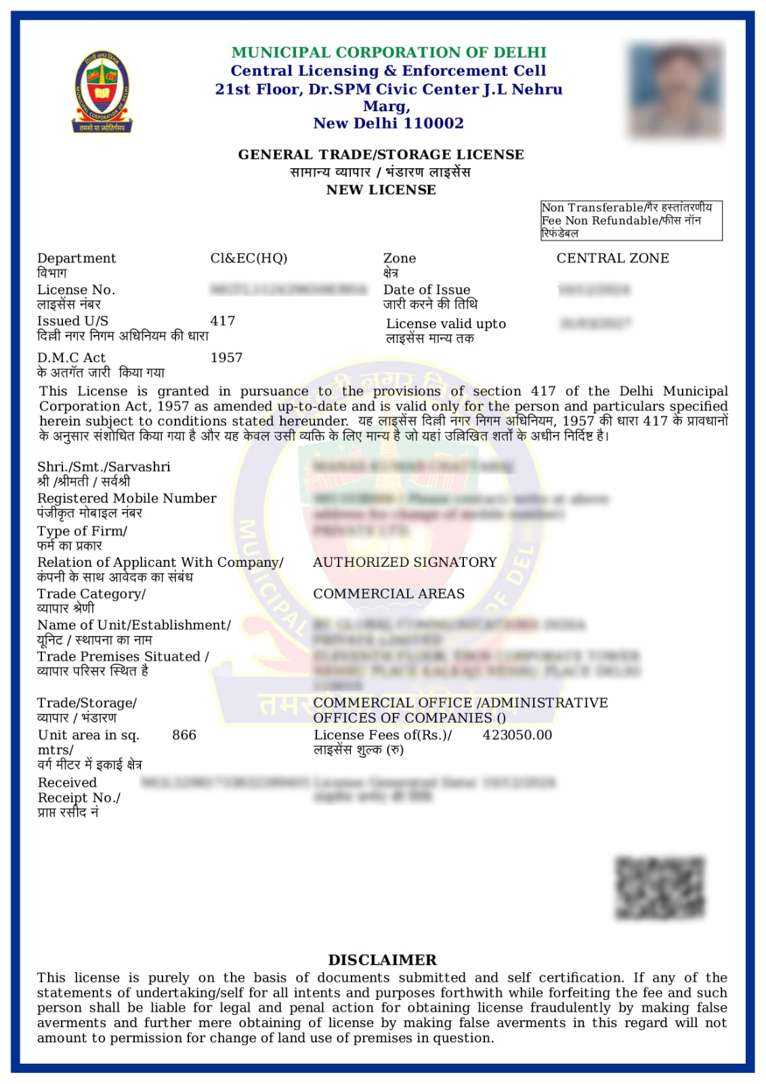
8) LOCAL MUNCIPAL TRADE LICENCE

9)COMMERCIAL ELECTRICITY CONNECTION SENCTION LETTER

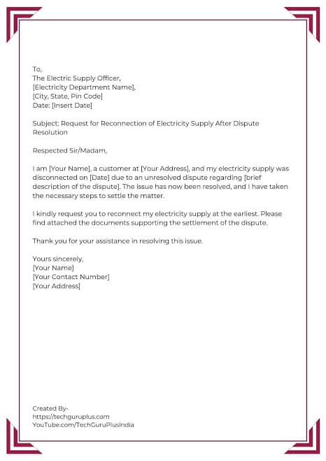

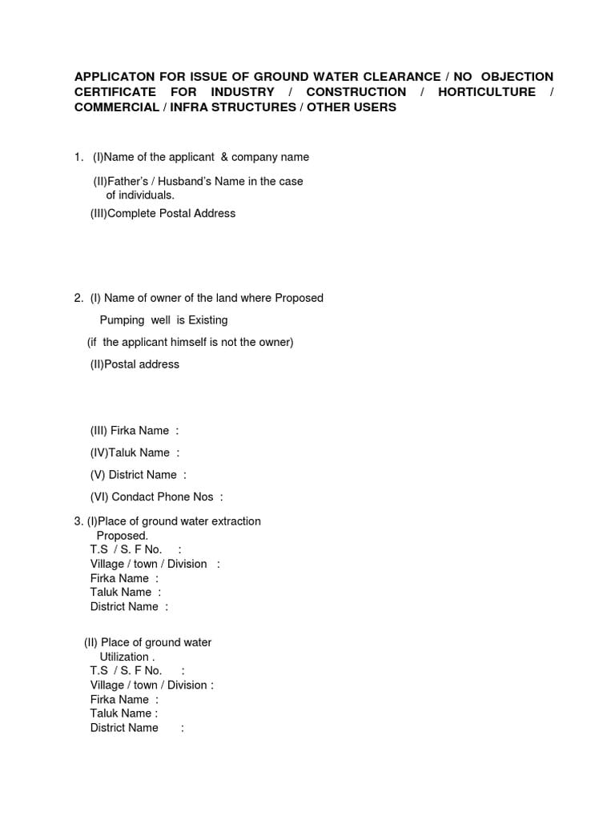
10) GROUND WATER EXTRACTION CLEARENCE

11) PAN CARD

12 ) AADHAR CARD

13) SMALL BUSINESS INSURANCE

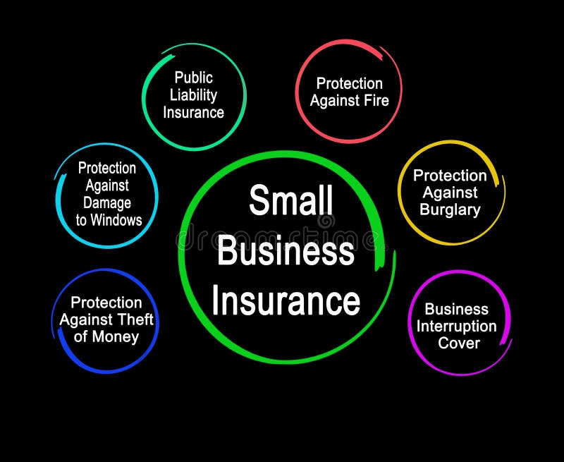

CHAPTER 5: FINANCIAL PLAN & PROJECTION

Financial Plan & Projections means planning how much money a business needs, where that money will come from, how it will be spent, and how much profit the business is expected to earn in the future.
The financial plan of CHIROTECH AGRO outlines the estimated investment, sources of finance, operating expenses, projected sales, profitability, break-even point and future financial performance of the proposed Chironji Processing and Kernel Extraction Micro-Unit.
The main objective is to establish a financially sustainable agro-processing business that purchases raw chironji seeds, processes them using suitable machinery, extracts kernels, and sells quality-graded products to wholesalers, retailers, food processors and other buyers.
All figures below are illustrative estimates for an academic business project, not verified supplier quotations or guaranteed earnings. Actual results will depend on plant capacity, raw-material prices, kernel recovery rate, selling prices and market demand.
Assuming a micro-unit processing unit with an initial Fixed Capital investment of ₹1,00,00,000 (₹1 Crore) located in India, here is a comprehensive financial model and operational projection for a Chironji Processing & Kernel Extraction Unit.

- Capital Requirement Breakdown
The initial setup requires a total capital outlay of ₹1,25,00,000 (₹1.25 Crore), covering both fixed infrastructure and initial working capital cycle.

A. Fixed Capital Breakdown (₹1,00,00,000)
Asset Category | Specification / Details | Cost (INR)
Land & Site Preparation | ~0.50 Acre Industrial / Semi-Rural Land + Boundary & Grading | ₹25,00,000
Civil Works & Building | 3,000 sq. ft. shed (Processing area, drying yard, storage warehouse) | ₹30,00,000
Plant & Machinery | De-stoner, Chironji Huller/Decorticator, Grader, Color Sorter, Mechanical Dryer | ₹32,00,000
Packaging & Utilities | Vacuum packaging machine, nitrogen flushing unit, weigh scales, backup generator (25 kVA) | ₹8,00,000
Pre-operative & Contingencies | Electrification (3-phase power link), licenses (FSSAI, GST, MSME), trial runs | ₹5,00,000
Total Fixed Capital |  | ₹1,00,00,000

B. Monthly Working Capital Estimates (₹25,00,000)
Chironji seeds (Buchanania lanzan) are seasonal, requiring substantial liquidity for raw material procurement during peak harvesting months (April–June).
Expenditure Head | Monthly Estimate (INR) | Notes / Assumptions
Raw Material (Raw Chironji Seeds) | ₹18,00,000 | ~12 metric tons (MT) @ ₹150/kg raw seed
Direct Wages & Labor | ₹2,50,000 | 1 Unit Supervisor, 2 Machine Operators, 8 Semi-skilled Sorting/Packing Workers
Utilities & Fuel | ₹1,20,000 | Power, generator diesel, water, and mechanical drying fuel
Packaging Materials | ₹80,00,000 | Food-grade vacuum pouches, corrugated outer cartons, labeling
Admin, Maintenance & Transport | ₹2,50,000 | Logistics, machinery maintenance, sales/marketing, office overheads
Total Monthly Working Capital | ₹25,00,000 | (Covers 1 operating cycle / buffer period)
- Sources of Funds & Financing Structure
To optimize cost of capital while leveraging government incentives (such as the PM Formalisation of Micro Food Processing Enterprises / PMFME scheme):

Financing Distribution:
├── Debt Financing (Bank Loan): ₹93,75,00,000 (75%)
└── Equity (Promoter Margin): ₹31,25,00,000 (25%)

- Promoter Equity Contribution (25%): ₹31,25,000
- Term Loan / Working Capital Loan (75%): ₹93,75,000
  - Term Loan (for Fixed Capital): ₹75,00,000 @ 10.5% p.a. interest over 7 years.
  - Working Capital Facility (CC Limit): ₹18,75,000 @ 10.5% p.a.

Subsidy & Incentive Note: Under the PMFME Scheme, micro-units can avail a credit-linked capital subsidy of 35% (up to a maximum cap of ₹10 Lakhs). Additionally, interest subvention under Agri Infrastructure Fund (AIF) may apply if registered as an agricultural enterprise.

- Financial Model & Break-Even Analysis (BEA)

Operational Yield & Revenue Assumptions
- Raw Seed Processing Capacity: 12 MT (12,000 kg) raw nuts per month (~144 MT annually).
- Kernel Extraction Yield: Average kernel yield is ~20% of raw seed weight.
  - Finished Chironji Kernels Output: 2,400 kg per month (28.8 MT annually).
  - By-product Output (Shells/Oil cake): ~9,600 kg per month (sold to oil mills or biomass units).
- Selling Price (Finished Kernels): ₹1,100 per kg wholesale market rate.
- Monthly Revenue:
  - Chironji Kernels: 2,400 kg × ₹1,100 = ₹26,40,000
  - By-products (Shells): 9,600 kg × ₹10 = ₹96,000
  - Total Gross Revenue per Month: ₹27,36,000 (₹3.28 Crore annually)

Cost Classification (Monthly Basis at 100% Target Capacity)

- Variable Costs (VC):
  - Raw Material: ₹18,00,000
  - Utilities & Packaging: ₹2,00,000
  - Direct Labor (Piece-rate / Casual): ₹1,50,000
  - Freight & Processing Chemicals/Consumables: ₹1,00,000
  - Total Variable Cost (VC): ₹22,50,000 / month (or ~₹187.50 per kg of finished kernel produced)

- Fixed Costs (FC):
  - Permanent Salaries & Admin: ₹2,00,000
  - Bank Loan Interest (Term Loan + CC Avg): ₹82,000
  - Fixed Overheads, Licenses, Insurance: ₹50,000
  - Depreciation on Plant & Buildings (~10% p.a.): ₹62,500
  - Total Fixed Cost (FC): ₹3,94,500 / month (₹47,34,000 / year)

Break-Even Calculations
- Contribution Margin = Total Revenue - Total Variable Costs = ₹27,36,000 - ₹22,50,000 = ₹4,86,000
- Contribution Margin Ratio (CMR) = ₹4,86,000}\{₹27,36,000} = 17.76(approx)

- Monthly Break-Even Revenue = Fixed Costs \CMR = ₹3,94,500 {0.1776} = ₹22,21,283 (per month)

- Annual Break-Even Revenue = ₹2,66,55,400 (per year)

- Break-Even Production Volume = Monthly Break-Even Revenue\Selling Price per kg (blended) =1,950 kg of kernels / month (81.25% of operational capacity)

Chapter 6: Government Schemes & Subsidy Support

- INTRODUCTION
Government schemes and subsidies play an important role in establishing and developing small-scale agro-processing industries in India. CHIROTECH AGRO proposes to establish a Chironji Processing and Kernel Extraction Micro-Unit with an estimated investment of ₹75 lakh to ₹1 crore. The unit will process raw chironji seeds, extract kernels, and prepare them for packaging and marketing.
Financial assistance from central and state government schemes may help the business purchase machinery, establish processing infrastructure, improve product quality, create employment, and reduce the burden of initial investment. However, assistance depends on the scheme's current rules, business eligibility, project location, and approval by the concerned authority.

- Agriculture Infrastructure Fund (AIF)
The Agriculture Infrastructure Fund is a central government financing facility intended to support investment in agricultural infrastructure.
For a jackfruit-processing business, eligible infrastructure may potentially include facilities associated with post-harvest management, storage, processing and value addition, subject to the applicable AIF guidelines and eligibility conditions.
Possible benefits
Access to institutional credit for eligible infrastructure projects.
Interest-support benefits may reduce the effective cost of borrowing.
Support for investment in post-harvest and agricultural infrastructure.

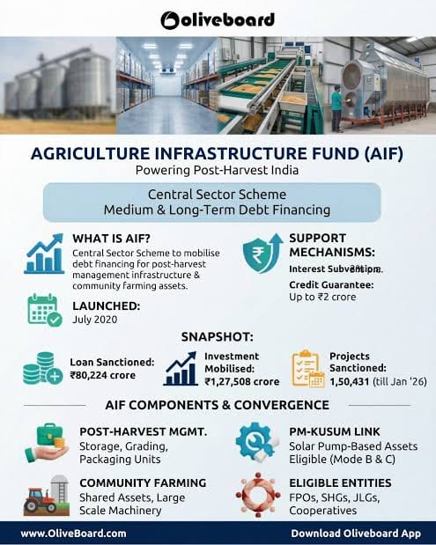
Can improve the feasibility of setting up processing and storage facilities.
Encourages value addition to agricultural produce.
Processing machinery
Eligible primary-processing equipment for cleaning, grading, shelling and kernel extraction, subject to approval of the project.

The Agriculture Infrastructure Fund (AIF) is a Government of India financing scheme designed to support investment in agricultural infrastructure, including post-harvest management facilities, storage, processing-related infrastructure, and supply-chain development.
For your CHIROTECH AGRO — Chironji Processing and Kernel Extraction Micro-Unit, AIF may be a useful financing option for setting up the plant, purchasing eligible equipment, and developing post-harvest infrastructure.

1. Key features of AIF
- Interest subvention: Eligible loans receive a 3% annual interest subsidy on loans up to ₹2 crore, subject to scheme conditions.
- Credit guarantee: Eligible loans may receive credit-guarantee coverage under the applicable scheme provisions.
- Loan tenure: The scheme provides a repayment period of up to 7 years, including a moratorium of up to 2 years on principal repayment, subject to applicable terms.
- Purpose: To encourage investment in agricultural infrastructure and improve post-harvest management.

2. How AIF can support CHIROTECH AGRO

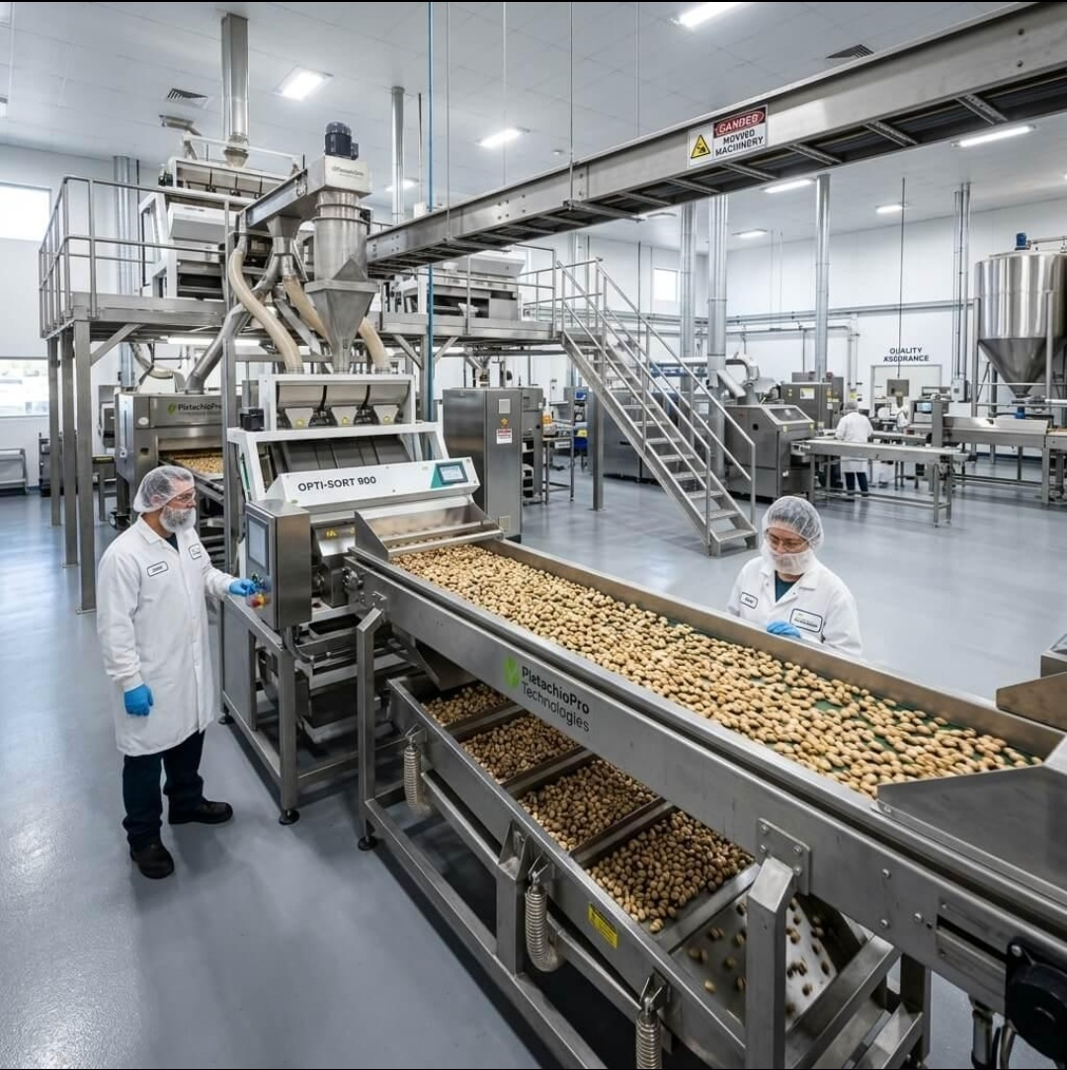
Processing machinery
Eligible primary-processing equipment for cleaning, grading, shelling and kernel extraction, subject to approval of the project.

Storage and post-harvest facilities

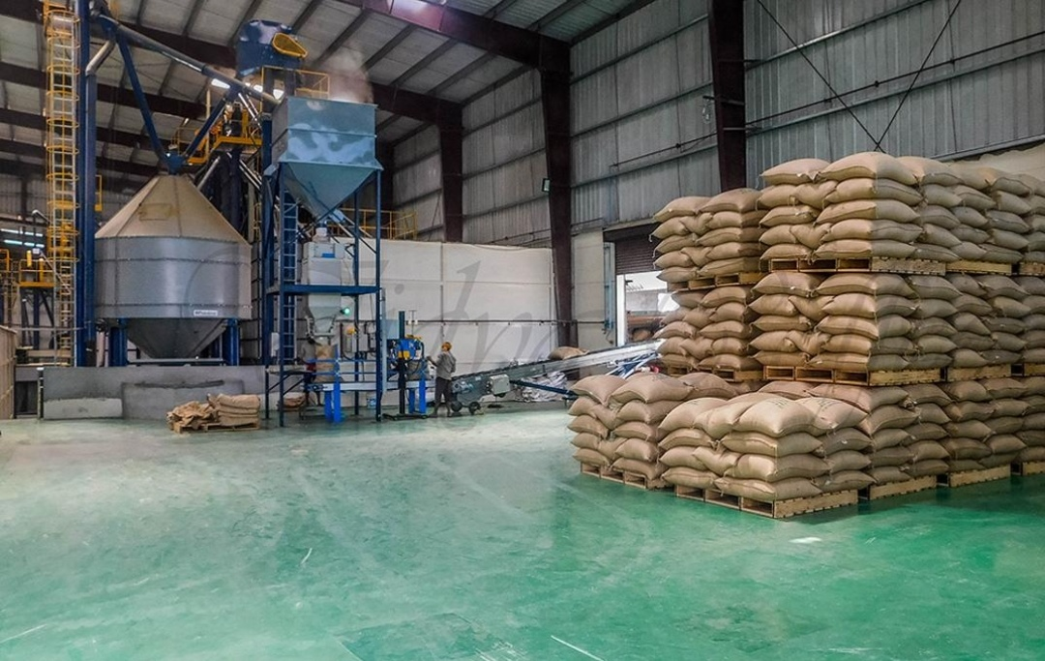

Storage and post-harvest facilities
Raw chironji seed storage, suitable godown infrastructure and handling facilities.

Primary processing infrastructure
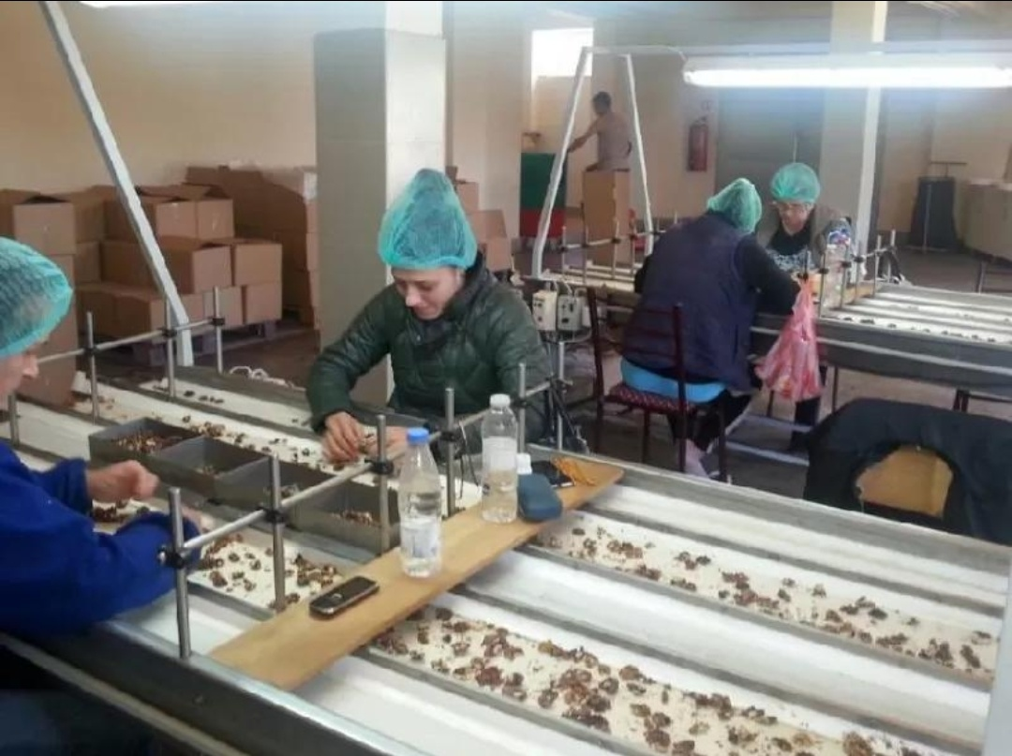

An eligible processing unit that improves the value of agricultural produce and reduces post-harvest losses.

3. Example of financial support
Suppose CHIROTECH AGRO takes an eligible term loan of ₹50 lakh.
Particulars | Amount
Eligible loan | ₹50,00,000
Illustrative annual interest rate | 9%
Interest subsidy rate under AIF | 3%
Effective interest rate after subsidy | Approximately 6%
Approximate first-year interest saving | ₹1,50,000
This is an illustration assuming the full loan qualifies for the subsidy and the outstanding principal remains ₹50 lakh for the year. Actual savings depend on the bank's rate, repayments and eligibility. AIF is a loan-support scheme, not an automatic grant of ₹50 lakh or a 3% capital subsidy.

4. How to apply
- Prepare a Detailed Project Report (DPR) for the chironji processing unit.
- Arrange land ownership or lease documents, machinery quotations, project cost estimates and financial projections.
- Approach a participating bank or financial institution for a term loan and eligibility assessment.
- Check the current application window and submit the proposal through the official Agriculture Infrastructure Fund portal.

5. Project report conclusion
The Agriculture Infrastructure Fund may help CHIROTECH AGRO reduce its borrowing costs and finance eligible post-harvest and primary-processing infrastructure. The proposed project budget of ₹75 lakh–₹1 crore does not itself guarantee AIF approval. The bank and scheme authorities must confirm that the proposed chironji kernel extraction machinery and other project components qualify.
Important: Check the current scheme-sanction period before including AIF as confirmed funding in your financial projections, because published scheme information has specified different implementation and financing timelines.

NABARD
NABARD stands for the National Bank for Agriculture and Rural Development. It is an apex development financial institution in India that supports agriculture, rural development, rural enterprises, and agricultural infrastructure.
For your CHIROTECH AGRO – Chironji Processing and Kernel Extraction Micro-Unit, NABARD may be relevant because your business processes an agricultural forest produce into a value-added product.

1. How NABARD can support your business
Area of support | How it may help CHIROTECH AGRO
Rural enterprise development | May support eligible rural and agro-processing activities through relevant programmes or financial institutions.
Agricultural infrastructure | Financing support may be available for eligible processing, storage, and post-harvest infrastructure.
Bank finance and refinance | NABARD may refinance eligible lending institutions; this does not automatically mean a direct loan to your business.
Technical guidance | Relevant development programmes may provide guidance for improving rural agricultural enterprises.
Farmer and producer linkages | Opportunities may exist to develop procurement relationships with farmers, collectors, and eligible producer organisations.

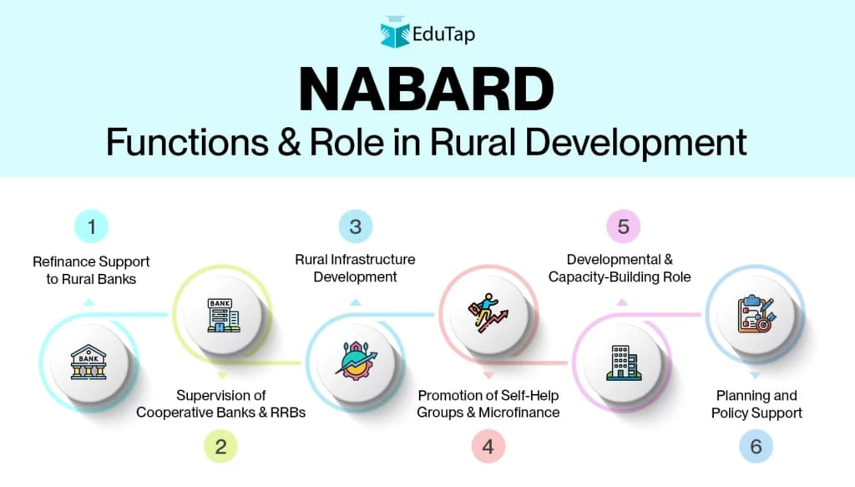

NABARD Support and Refinance

NABARD (National Bank for Agriculture and Rural Development) plays an important role in financing and refinancing agricultural and rural-sector activities.

For the proposed project, NABARD-related financing may be relevant where the project involves:

Agricultural produce processing

Post-harvest management

Rural infrastructure

Value addition

Food-processing activities

Agricultural supply-chain infrastructure

It is important to distinguish refinance support from a direct capital subsidy. NABARD refinance generally works through eligible financial institutions and does not automatically mean that the entrepreneur receives a fixed percentage of the project cost as a subsidy.

2. Can CHIROTECH AGRO get financial assistance?
Your proposed investment is ₹75 lakh–₹1 crore. Your unit may qualify for bank finance under eligible agro-processing or MSME lending arrangements, subject to the project's viability and the lender's assessment. NABARD's refinance is generally provided to eligible financial institutions, which then lend to qualifying borrowers.

NABARD
Important: NABARD support does not mean your business automatically receives a direct loan or subsidy.

3. Documents to prepare
- Detailed Project Report (DPR) with financial projections.
- Business registration and Udyam registration, as applicable.
- Land ownership or lease documents.
- Machinery quotations and building estimates.
- Projected sales, expenses, cash flow and repayment plan.
- Applicable food-processing licences and environmental approvals.
- Promoter's KYC and bank documents.

4. Where to start in Chhattisgarh
Contact your bank's MSME/agriculture finance department and ask whether your project is eligible for agro-processing finance supported by NABARD refinance. You can also consult the official NABARD website for scheme information.
NABARD Financial Support: CHIROTECH AGRO will explore eligible institutional financing and refinance-linked lending facilities supported by NABARD for agro-processing and rural enterprise development. Any financial assistance will depend on the applicable scheme guidelines, bank appraisal, project eligibility and availability of support.

- PMFME Scheme

The PM Formalisation of Micro Food Processing Enterprises (PMFME) scheme is particularly relevant to food-processing enterprises.

The scheme is designed to support the formalisation and upgrading of micro food-processing enterprises and encourage better technology, branding, packaging and market access.

For an eligible unit, support may potentially cover areas such as:

Modernisation of processing equipment
Technology upgradation
Packaging and branding
Quality improvement
Formalisation of the enterprise
Training and capacity building
Common infrastructure and related activities under applicable components

For individual micro food-processing units, the commonly cited capital-investment support is credit-linked subsidy of 35% of eligible project cost, subject to the scheme's applicable ceiling and conditions. The exact amount should be confirmed with the implementing agency before incorporating it as a guaranteed receipt in the project's financial plan.

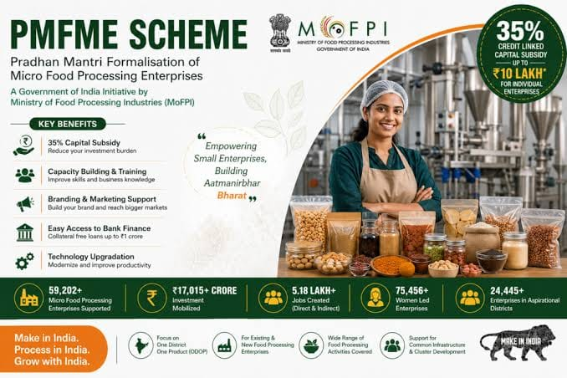

CHAPTER 7: RISK MANAGEMENT

1. Operational & Environmental Risks
Chironji relies heavily on forest-foraged yields, making it uniquely susceptible to environmental and post-harvest spoilage risks.

- Crop Failure & Supply Volatility (Due to Erratic Weather):

  - The Risk: Unseasonal rains during flowering, hailstorms, or severe droughts can drastically reduce the wild chironji fruit yield, leading to extreme raw material shortages.

  - Mitigation & Backup Strategies:

    - Diversify Sourcing Regions: Do not rely on local forest collectors from a single district. Establish a network of suppliers across multiple forest divisions or tribal cooperative federations (such as TRIFED).

    - Multi-Commodity Processing: Design your micro-unit machinery (like de-hulled nut crackers, grading screens, and roasters) to handle alternative minor forest produce (MFP) or seasonal dry fruits (such as mahua flowers, tamarind seeds, or charoli-like nuts) during off-seasons to keep the unit operational and retain skilled labor.

    - Strategic Buffer Stocking: Procure and store dried, un-shelled chironji (charoli in shell) during peak harvest years. In-shell chironji has a significantly longer shelf life than extracted kernels if stored in moisture-controlled conditions.

- Perishability & Quality Degradation (Moisture & Pest Infestation):

  - The Risk: Raw chironji fruits rot quickly if pulped fruits aren't processed promptly. Furthermore, extracted kernels have a high oil content, making them prone to rancidity, fungal growth (aflatoxins), and insect infestation if improperly stored.

  - Mitigation & Backup Strategies:

    - Rapid Processing Protocol: Enforce a strict first-in, first-out (FIFO) pulping and drying protocol. Train collectors to sun-dry the seeds immediately after de-pulping before delivering them to your unit.

    - Hermetic & Cold Storage: Invest in hermetic storage bags or a small temperature-controlled cool room for finished kernels. Vacuum-packing kernels in food-grade foil packaging instantly extends shelf life and prevents moisture absorption.

    - Moisture Monitoring: Maintain raw and finished material moisture levels below 7% before packaging to eliminate mold risks.

- Machine Breakdown & Labor Dependency:

  - The Risk: Specialized manual or semi-automated chironji cracking machines are rare. A breakdown can halt production during peak festival demand seasons (like Diwali or wedding seasons).

  - Mitigation & Backup Strategies:

    - Maintain a critical inventory of fast-wearing spare parts (blades, belts, motor components) on-site.
    - Cross-train local workers so operations do not grind to a halt if a key machine operator is absent.

2. Market & Financial Risks
Because chironji is a high-value commodity often traded through traditional mandis or unorganized middlemen, price swings and cash flow delays can cripple a micro-unit.

- Price Volatility (Raw Material Spikes & End-Product Slumps):

  - The Risk: A poor harvest year drives raw chironji prices sky-high, squeezing your profit margins if you cannot pass costs to buyers. Conversely, a bumper crop can crash market prices.

Mitigation & Backup Strategies:

    - Value Addition over Bulk Sales: Avoid selling raw, un-graded kernels. Implement a rigorous grading system (sizing, color, unbroken whole kernels) and package them into retail-ready, branded consumer packs (e.g., 100g, 250g, 500g vacuum packs) to sell directly to local bakeries, sweet manufacturers, or supermarkets at premium margins.

    - Contract Farming / Pre-Arranged Partnerships: Form direct procurement agreements with Self-Help Groups (SHGs) and forest-dwelling collectors at pre-agreed floor prices to ensure a steady supply without bidding wars.

    - B2B Diversification: Balance your client portfolio between bulk spice/dry fruit wholesalers and direct B2B institutional buyers (confectionery brands, Ayurvedic cosmetic manufacturers who use chironji oil/paste).

- Delayed Payments & Bad Debts from Traders:

  - The Risk: Wholesale grain and dry fruit markets often operate on credit terms of 30 to 90 days. Delayed payments from arhtiyas (commission agents) or distributors can cause severe liquidity crunches.

  - Mitigation & Backup Strategies:
    - Staggered Credit Terms: Enforce a strict credit policy: maximum 15 days for new buyers, and up to 30 days only for vetted, long-term clients with bank guarantees or post-dated checks (PDCs).

    - Advance Payment Incentives: Offer a 2% to 3% cash discount for buyers who make upfront or immediate digital payments upon delivery.

    - Digital Channels & Direct-to-Consumer (D2C): Build an online presence or tie up with local organic grocery networks to sell smaller batches directly to consumers on a cash-and-carry or prepaid basis.

- Cash Flow Crunches & Working Capital Shortages:

  - The Risk: Chironji harvesting happens in a very narrow annual window (typically April to June). You need substantial liquid cash upfront during these months to buy and store the entire year's raw material inventory.

  - Mitigation & Backup Strategies:

    - Working Capital Credit Line: Secure a Mudra loan or a micro-enterprise cash credit/overdraft (OD) facility from your bank well in advance of the harvest season specifically for seasonal inventory stocking.

    - Invoice Discounting: Partner with fintech or banking platforms to discount verified wholesale invoices immediately upon dispatch, ensuring steady cash flow without waiting for the 30-day payment cycle to end.

- Conclusion

- Final Verdict: The establishment of a specialized Chironji Processing & Kernel Extraction Micro Unit demonstrates strong commercial viability, robust legal feasibility, and substantial economic utility within the agri-business sector:

- Commercial Viability: Chironji (Buchanania lanzan) kernels command high market value across confectionery, traditional medicine, and cosmetics sectors. Transitioning from raw nut selling to mechanical kernel extraction enables rural processors to capture up to 60–80% higher margins, satisfying steady domestic and export market demands.

- Legal Feasibility: The project seamlessly aligns with standard regulatory frameworks in India. The unit achieves complete compliance by securing MSME (Udyam) Registration, FSSAI Licensing for hygienic food handling, State Pollution Control Board clearances, and local/Panchayat Trade Permits.

- Economic Utility: Modernizing kernel extraction replaces traditional manual cracking methods, significantly reducing kernel breakage rate (from ~30% down to <5%), preserving quality, and generating sustained rural employment. Financial viability is further enhanced by utilizing central/state subsidies (e.g., PMFME scheme offering a 35% credit-linked capital subsidy up to ₹10 Lakhs), resulting in a short payback period and strong Return on Investment (ROI).

- References / Bibliography
- Ministry of Food Processing Industries (MoFPI). PMFME Scheme Guidelines & Handbook on Chironji Processing (Buchanania lanzan). National Institute of Food Technology Entrepreneurship and Management (NIFTEM), Government of India.

- National Bank for Agriculture and Rural Development (NABARD). Model Project Profiles on Post-Harvest Processing and Value Addition of Non-Timber Forest Produce (NTFP), NABARD Regional Office.

- Indian Council of Agricultural Research (ICAR) & CIPHET. Post-Harvest Processing Techniques and Machine Engineering for Nut Decortication and Kernel Extraction, ICAR-CIPHET Reports.

- Food Safety and Standards Authority of India (FSSAI). Compendium of Food Safety and Standards Regulations for Nuts and Processed Foods, Ministry of Health and Family Welfare, Government of India.

- Ministry of Micro, Small & Medium Enterprises (MSME). Udyam Registration Portal Guidelines & Financial Support Models for Agri-Food Enterprises, Government of India.

