**5.Write a python program on BMI Calculator.**

**Program :**

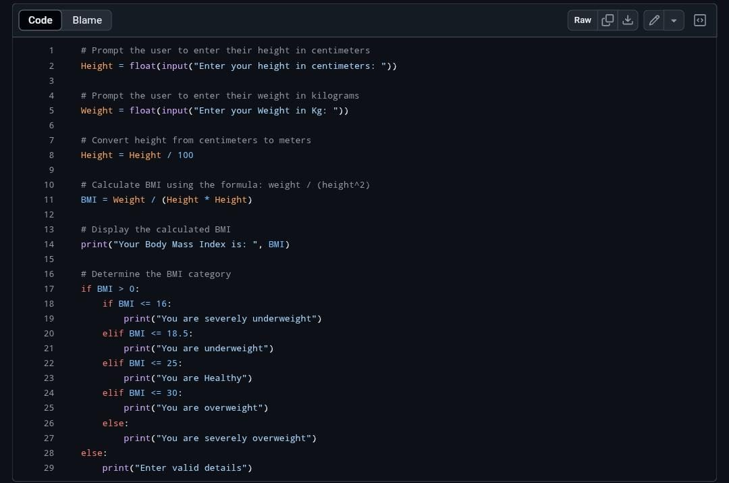

**Output:**

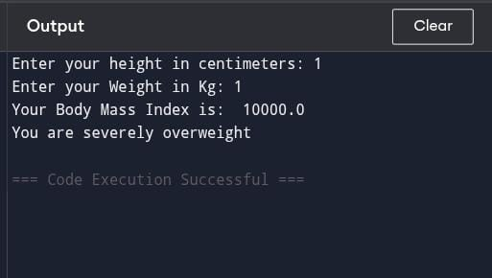

**4. Draw Rainbow using Turtle Graphics in Python**

**Program :**

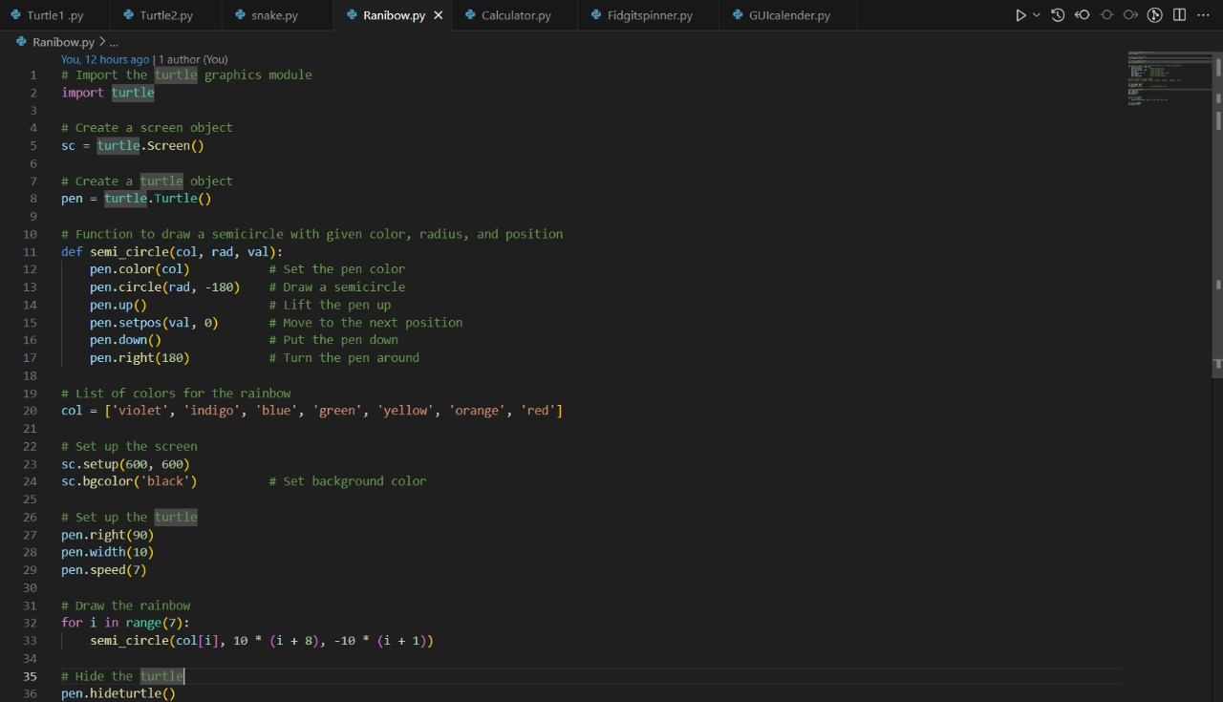

**Output:**

