**“PERSOANLITY TEST Using Jawa & HTML”**

....................................................................

TABLE OF CONTENTS

TITLE PAGE NO

LIST OF FIGURES 9

NOTATION TABLE 10

ABSTRACT 17

CHAPTER 1: INTRODUCTION

1.1 GENERAL 18

1.2 OBJECTIVE 20

1.3 EXISTING SYSTEMS 20

1.4 PROPOSED SYSTEM 22

CHAPTER 2: PROJECT DESCRIPTION

2.1 GENERAL 26

2.2 METHODOLOGIES 24

CHAPTER 3: REQUIREMENTS

3.1 GENERAL 29

3.2 HTML 43

3.3 SQL 27

3.4 FUNCTIONAL REQUIREMENT 28

CHAPTER 4: SYSTEM DESIGN

4.1 GENERAL 32

4.2 SYSTEM ARCHITECTURE 32

4.3 UML DIAGRAM 33

4.4 ALGORETHM 34

4.5 DATABASE DESIGN 44

4.6 GUI(GRAPHICAL USER INTERFACE) 45

CHAPTER 5: IMPLEMENTATION

5.1 GENERAL 37

5.2 CODING 38

CHAPTER 6: OUTPUT

6.1 GENERAL 50

6.2 OUTPUT 51

CHAPTER 7: SOFTWARE TESTING

7.1 GENERAL 53

7.2 TEST PLANS 54

7.3 TYPES OF TEST 55

7.4 TEST CASE TEMPLATE 56

CHAPTER 8: FUTURE ENHANCEMENT

8.1 APPLICATIONS 57

8.2 FUTURE ENHANCEMENT 58

CHAPTER 9: CONCLUSION AND REFERENCE

9.1 CONCLUSION 60

**LIST OF FIGURES**

|  |  |  |
| --- | --- | --- |
| **FIGURE NO** | **NAME OF THE FIGURE** | **PAGE NO.** |
| 4.3 | Pie chart | 32 |
| 1 | Bar chart | 35 |
| 2 |  | 36 |
| 3 |  | 37 |
| 4 |  | 38 |
| 5 |  | 39 |
| 6 |  | 40 |
| 7 |  | 45 |
| 8 | Deployment Diagram | 46 |

|  |  |  |  |
| --- | --- | --- | --- |
| **S.NO** | **NOTATION**  **NAME** | **NOTATION** | **DESCRIPTION** |
| 1. | CLASS | CLASS NAME  -ATTRIBUTE  -ATTRIBUTE  + public  -private | REPRESENTS A COLLACTION OF SIMILER ENTITIES GROUPED TOGETHER |
| 2. | ASSOCIATION | |  |  |  | | --- | --- | --- | | Class A | NAME | Class B | |  | |  |  | | Class A | Class B | |  | | ASSOCIATION REPRESENTS STATIC RELATIONSHIPS BETWEEN CLASSES.ROLES REPRESENTS THE WAY THE TWO CLASSES SEE EACH . |
| 3. | ACTOR |  | IT AGGREGATES SEVERAL CLASSES INTO A SINGLE CLASSES. |
| 4. | Aggregation | |  |  |  |  |  |  |  |  | | --- | --- | --- | --- | --- | --- | --- | --- | | |  | | --- | | Class A | |  | | Class B | | |  | | --- | | Class A | |  | | Class B | | | Interaction between the system and external environment |
| 5. | Relation  (uses) | uses | Used for additional process communication |
| 6. | Relation  (extends) | extends | Extends relationship is used when one use case is similar to another use case but does a bit more. |
| 7. | Communication |  | Communication between various use cases. |
| 9. | Initial State |  | Initial state of the object |
| 9. | Initial State |  | Initial state of the object |
| 10. | Final state |  | F inal state of the object |
| 11. | Control flow |  | Represents various control flow between the states. |
| 12. | Decision box |  | Represents decision making process from a constraint |
| 13. | Usecase | Usescase | Interact ion between the system and external environment. |
| 14. | Component |  | Represents physical modules which are a collection of components. |
| 15. | Node |  | Represents physical modules which are a collection of components. |
| 16. | Data  Process/State |  | A circle in DFD represents a state or process which has been triggered due to some event or acion. |
| 17. | External entity |  | Represents external entities such as keyboard,sensors,etc. |
| 18. | Transition |  | Represents communication that occurs between processes. |
| 19. | Object Lifeline |  | Represents the vertical dimensions that the object communications. |
| 20. | Message | Message | Represents the message exchanged. |

**ABSTRACT**

Personality tests are tools used to understand and measure people's characteristics, behaviors, and preferences. They help in personal growth, career planning, and team building. These tests can be in the form of questionnaires, where individuals answer questions about themselves, or observations of how people behave in different situations. Some well-known tests focus on traits like the Big Five (such as openness, conscientiousness, extraversion, agreeableness, and neuroticism) or the Myers-Briggs Type Indicator (which categorizes personality into different types). While useful, personality tests have limitations and ethical considerations, so their results should be interpreted carefully. Overall, they play a crucial role in helping individuals understand themselves better and improving interactions in both personal and professional settings.

Personality tests are tools designed to assess individual traits, behaviors, and preferences in straightforward terms. They are commonly used in psychology, education, and workplace settings to aid personal development, career counseling, and team dynamics. These tests typically involve self-reported questionnaires or behavioral observations to categorize individuals into specific personality types or traits. Examples include the Big Five personality traits (openness, conscientiousness, extraversion, agreeableness, and neuroticism) and the Myers-Briggs Type Indicator (MBTI), which classify personalities based on preferences in perception and decision-making. Despite their utility, personality tests have limitations, including cultural biases and oversimplification of complex human behaviors. Ethical considerations involve ensuring confidentiality and using results responsibly. Overall, personality tests provide valuable insights for individuals and organizations seeking to enhance self-awareness, interpersonal relationships, and overall performance.

**GENERAL**

Personality tests hold significant importance across various domains, serving as valuable tools for understanding and evaluating individuals' psychological characteristics. Firstly, in **educational settings**, these tests aid educators in identifying students' learning styles, strengths, and potential challenges, thereby enabling tailored teaching strategies and academic support. They also assist in career counseling by guiding students towards suitable career paths aligned with their personality traits, interests, and aptitudes.

In **clinical psychology**, personality tests contribute to diagnosing and treating mental health disorders, particularly personality disorders. They provide clinicians with insights into patients' personalities, behaviors, and emotional responses, facilitating more effective therapeutic interventions and treatment plans tailored to individual needs. Additionally, in **organizational contexts**, these tests are instrumental in recruitment and selection processes. They help assess candidates' suitability for specific roles based on their personality traits, leadership styles, and compatibility with organizational culture, thereby enhancing hiring decisions and team dynamics.

Moreover, personality tests are crucial in **personal development** initiatives, offering individuals valuable insights into their own strengths, weaknesses, and areas for growth. By fostering self-awareness and understanding, these assessments empower individuals to make informed decisions about career choices, interpersonal relationships, and personal goals. Overall, personality tests play a pivotal role in enhancing educational outcomes, facilitating effective therapeutic interventions, optimizing organizational performance, and promoting personal growth and development. Their significance lies in their ability to provide nuanced insights into the complexities of human personality, guiding both individuals and professionals towards informed decisions and positive outcomes.

**1.3 EXISTING SYSTEMS**

Existing Systems in Personality Testing

Personality tests have been around for decades, and the field has seen significant advancements. Here's an overview of some common systems and approaches:

Popular Personality Models

Myers-Briggs Type Indicator (MBTI): One of the most widely recognized, it categorizes individuals into 16 personality types based on four dichotomies: Extraversion-Introversion, Sensing-Intuition, Thinking-Feeling, and Judging-Perceiving.

Big Five Model (OCEAN): A scientifically validated model that assesses personality traits along five dimensions: Openness, Conscientiousness, Extraversion, Agreeableness, and Neuroticism.

DISC Assessment: Focuses on four behavioral styles: Dominance, Influence, Steadiness, and Conscientiousness.

Enneagram: A personality typing system that categorizes individuals into nine personality types based on core motivations and fears.

Testing Methodologies

Self-Report Questionnaires: The most common method, involving individuals answering questions about their thoughts, feelings, and behaviors.

Observer Ratings: Involves others rating an individual's personality characteristics.

Projective Tests: Ambiguous stimuli are presented to elicit unconscious thoughts and feelings.

Behavioral Assessments: Observing individuals in real-world situations to assess personality traits.

Technological Advancements

Online Testing: Personality tests are increasingly accessible through online platforms, offering convenience and reach.

Adaptive Testing: Tailors questions based on previous responses, improving test efficiency.

AI-Powered Analysis: Advanced algorithms can analyze test data to provide deeper insights and personalized recommendations.

Applications of Personality Testing

Career Counseling: Matching individuals to suitable occupations based on personality traits.

Relationship Counseling: Understanding compatibility between partners.

Team Building: Building effective teams based on complementary personalities.

Marketing and Sales: Developing targeted marketing campaigns and sales approaches.

Human Resources: Selecting and developing employees based on personality fit.

Challenges and Considerations

Test Validity and Reliability: Ensuring that tests accurately measure what they claim to measure and produce consistent results.

Cultural Bias: Avoiding biases in test development and interpretation.

Privacy and Ethical Considerations: Protecting test-takers' information and using it responsibly.

Self-Report Bias: Addressing the tendency of individuals to present themselves in a socially desirable way.

Would you like to delve deeper into a specific area, such as a particular personality model or testing methodology?

I can also provide more information on the technical aspects of personality test development, such as question design, scoring algorithms, and data analysis.

**Software**

"software" refers to programs and applications that run on a computer or other electronic devices, performing specific tasks or functions.

**types**:

**Operating systems (os)**: system software that manages computer hardware and software resources, providing a user interface and facilitating communication between hardware and applications.

**Application software**: programs designed for end-users to perform specific tasks, such as word processors, spreadsheets, email clients, and web browsers.

**Utility software**: tools that assist in managing and maintaining the computer system, such as antivirus programs, backup utilities, and disk defragmenters.

**Development software**: tools used by software developers to create, debug, and maintain applications, such as ides (integrated development environments) and version control systems.

**lifecycle**:

* **Development**: creating and coding software applications based on user requirements and specifications.
* **Testing**: ensuring software reliability, functionality, and security through various testing methodologies.
* **Deployment**: installing and implementing software on target devices or within organizational it infrastructure.
* **Maintenance**: providing ongoing support, updates, and troubleshooting to ensure optimal performance and security.

**1.4 PROPOSED SYSTEM**

Proposed System for Personality Testing

Overview

A proposed personality testing system should aim to provide accurate, reliable, and user-friendly assessments. Here's a potential system architecture:

Core Components

Question Bank:

A comprehensive collection of questions aligned with different personality models (e.g., Big Five, MBTI, DISC).

Questions should be carefully crafted to avoid bias and ambiguity.

Categorization of questions based on personality traits or dimensions.

Test Engine:

Dynamically generates tests based on user preferences (e.g., test length, personality model).

Implements adaptive testing for efficient assessment.

Handles question randomization and response validation.

Scoring Algorithm:

Calculates personality scores based on user responses.

Employs statistical methods for accurate and reliable scoring.

Provides detailed score reports and interpretations.

User Interface:

Intuitive and user-friendly interface for test administration.

Clear instructions and visual aids.

Customizable test appearance and language.

Data Management:

Securely stores user data and test results.

Implements data privacy and security measures.

Allows for data analysis and reporting.

Reporting Module:

Generates comprehensive personality reports.

Provides visual representations of results (e.g., graphs, charts).

Offers personalized recommendations based on personality profile.

Additional Features

User Authentication: Protects user data and ensures test integrity.

Test Customization: Allows for creation of custom tests for specific purposes.

Integration with Other Systems: Compatibility with HR systems, learning management systems, or career counseling platforms.

AI-Powered Insights: Utilizes machine learning to provide deeper personality analysis and recommendations.

Technology Stack

Frontend: HTML, CSS, JavaScript (React, Angular, or Vue) for user interface.

Backend: Python (Django, Flask), Node.js, or Ruby on Rails for server-side logic.

Database: PostgreSQL, MySQL, or MongoDB for data storage.

Cloud Platform: AWS, Azure, or GCP for scalability and reliability.

AI Integration: TensorFlow, PyTorch, or other machine learning frameworks.

Challenges and Considerations

Test Validity and Reliability: Ensuring the accuracy and consistency of the test.

Data Privacy: Protecting user data and complying with relevant regulations.

User Experience: Creating a user-friendly and engaging interface.

Ethical Considerations: Avoiding biases and ensuring fair representation of different personality types.

Potential Improvements

Adaptive Testing: Continuously adjusting the difficulty of questions based on user responses.

Item Response Theory (IRT): Using advanced statistical models for precise score estimation.

Personality Change Tracking: Monitoring personality development over time.

Mobile Optimization: Providing a seamless experience on mobile devices.

By addressing these components and challenges, a robust and effective personality testing system can be developed.

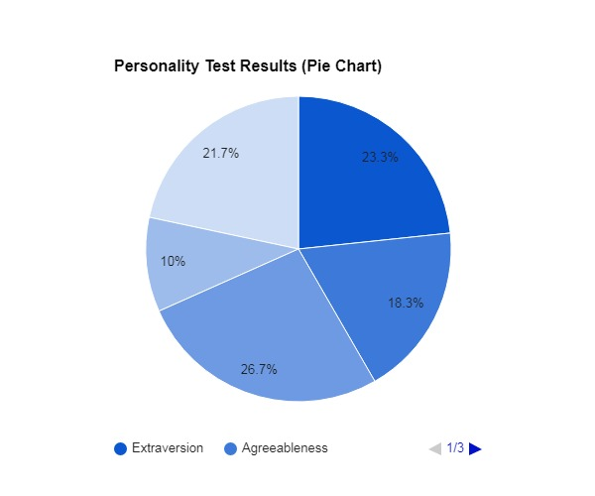

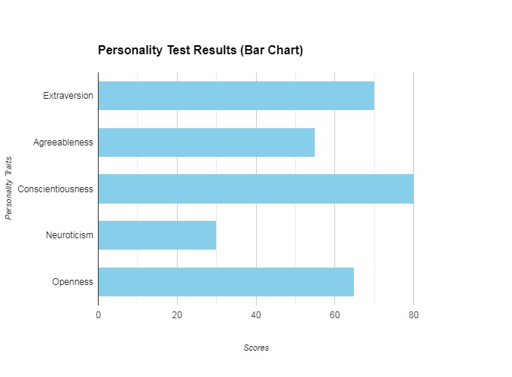



## CHAPTER 2

## PROJECT DESCRIPTION

**2.1 GENERAL:**

On a personal level, personality tests offer individuals valuable self-awareness and insights into their own behaviors, motivations, and interpersonal styles. By recognizing their strengths and areas for improvement, individuals can make informed decisions about career paths, personal relationships, and personal development goals. This self-awareness fosters resilience, adaptability, and effective communication skills, which are essential for navigating various life challenges and achieving personal fulfillment.

In essence, the importance of personality tests lies in their multifaceted contributions to education, clinical practice, organizational management, and personal growth. They serve as powerful instruments for enhancing understanding, optimizing interventions, fostering positive environments, and empowering individuals to lead fulfilling lives aligned with their unique personality traits and aspirations.

## 2.2 MODULES

## Modules for Personality Test in Java and HTML

## Understanding the Requirements

## Before diving into specific modules, it's essential to clarify the scope of your personality test:

## Personality Model: Which personality model will you use (e.g., Big Five, MBTI, DISC)?

## Test Type: Self-report, observer-rated, or a combination?

## Test Length and Complexity: How many questions, what type of questions (multiple choice, Likert scale, etc.)?

## Result Presentation: How will you display the results (text, charts, graphs)?

## Core Modules

## Based on general requirements, here's a breakdown of potential modules:

## Java Backend

## Question Bank:

## Stores question text, answer options, and associated personality traits.

## Provides methods for retrieving questions based on test type and length.

## Test Engine:

## Manages test flow, question presentation, and response handling.

## Implements scoring logic based on the chosen personality model.

## Generates test results in a structured format.

## Data Persistence:

## Handles user data storage, test history, and result management.

## Ensures data privacy and security.

## Report Generation:

## Creates personalized personality reports based on test results.

## Offers various report formats (PDF, HTML, etc.).

## HTML Frontend

## User Interface:

## Displays test instructions, questions, and answer options.

## Provides a user-friendly experience.

## Handles user interactions and sends data to the backend.

## Result Display:

## Presents personality test results in a clear and visually appealing manner.

## Offers interactive features (e.g., charts, graphs).

## Additional Modules

## Authentication: User login and session management.

## User Profile: Stores user information and test history.

## Feedback Mechanism: Allows users to provide feedback on the test.

## Admin Panel: For managing test content, user data, and system settings.

## Technology Stack

## Java: Core backend logic, database interactions, and report generation.

## HTML, CSS, JavaScript: Frontend development for user interface and interaction.

## CHAPTER 3

## DEVELOPMENT TOOLS

Developing a personality test in Java involves using various tools and techniques to create a robust and user-friendly application. Here are some key developmental tools and steps explained in simple terms:

### 1. **IDE (Integrated Development Environment):**

Choose an IDE like Eclipse, IntelliJ IDEA, or NetBeans. These tools provide a user-friendly interface for writing, debugging, and testing Java code.

### 2. **Java Programming Language:**

Java is the primary language used for developing the personality test application. It offers strong support for object-oriented programming, which helps organize the code into manageable components.

### 3. **User Interface (UI) Development:**

Use JavaFX or Swing libraries for creating the graphical user interface (GUI). These libraries provide components such as buttons, text fields, and checkboxes to design the interface where users can answer questions and view results.

### 4. **Data Structures:**

Define data structures to store questions, responses, and scores. For example, arrays or lists can be used to hold questions, and arrays or maps can store responses and calculate scores based on user input.

### 5. **Event Handling:**

Implement event handling to respond to user interactions with the UI components. For instance, when a user selects an answer or clicks a button to submit their responses, event handlers capture these actions and process them accordingly.

### 6. **Scoring Algorithm:**

Develop a scoring algorithm based on the personality model you're using (e.g., Big Five traits). This algorithm calculates scores based on the user's responses to questions, assigning values to each response and aggregating them to determine trait levels.

### 7. **File Handling (Optional):**

Use file handling techniques if you want to load questions from external files (e.g., text files or databases). This approach makes it easier to manage and update the test questions without modifying the code.

### 8. **Testing and Debugging:**

Test your application thoroughly to ensure it functions as expected. Use debugging tools provided by your IDE to identify and fix any errors or issues in the code.

### Example Summary:

Creating a personality test in Java involves using tools like Eclipse for coding, JavaFX for building the user interface, and implementing algorithms to score user responses. With event handling, you can make the application interactive, while file handling allows for flexible management of test questions. Testing ensures the application works smoothly, providing a reliable tool for assessing personality traits.

By leveraging these developmental tools effectively, you can build a functional and user-friendly personality test application in Java that helps users gain insights into their personalities based on structured assessments.

**3.2 HTML**

HTML, or Hypertext Markup Language, is the standard markup language used to create and design web pages. It provides the structure and content of a webpage by using a system of tags and attributes. HTML tags are used to mark up elements such as headings, paragraphs, images, links, forms, and more, allowing web browsers to interpret and display the content accordingly. HTML works in conjunction with Cascading Style Sheets (CSS) and javascript to create visually appealing and interactive web pages.

**HISTORY OF HTML**

HTML, or Hypertext Markup Language, has a rich history that dates back to the early days of the World Wide Web. Here's a brief overview of its evolution:

1. **Origins (1989-1991)**:

- HTML was initially conceived by Tim Berners-Lee in 1989 while working at CERN (European Organization for Nuclear Research).

- The first version, HTML 1.0, was released in 1991 as a simple markup format with a small set of tags for structuring documents.

2. **Standardization (1995-1997)**:

- HTML began to gain popularity rapidly with the growth of the web.

- In 1995, the World Wide Web Consortium (W3C) was founded to standardize web technologies, including HTML.

- HTML 2.0 was released in 1995, followed by HTML 3.2 in 1997, which introduced new features and improved capabilities.

3. **XHTML and HTML4 (1999-2000)**:

- XHTML (Extensible Hypertext Markup Language) emerged as a reformulation of HTML based on XML standards, promoting cleaner and more structured code.

- HTML 4.01, released in 1999, introduced more sophisticated features and became widely adopted as the standard for web development.

## 

## 4. SYSTEM DESIGN

## 4.1 GENERAL

A personality test system is a sophisticated software application designed to assess and profile individual psychological attributes. It involves a complex interplay of psychological theory, technological implementation, and data management. Fundamentally, the system presents a series of questions or statements designed to elicit responses indicative of specific personality traits. These responses are then processed through algorithms rooted in psychological models, such as the Big Five or Myers-Briggs, to generate comprehensive personality profiles.

The system's architecture typically comprises a user-facing interface, a backend for data processing and storage, and a robust database to house user information, test results, and system metadata. To ensure reliability and accuracy, it employs advanced statistical techniques and psychometric principles. A critical aspect is the preservation of data privacy and security, given the sensitive nature of the information handled. Moreover, the system must be adaptable to accommodate various personality models and cultural nuances, while also being scalable to handle increasing user loads. Ultimately, the goal of a personality test system is to provide valuable insights into an individual's personality, aiding in career counseling, relationship dynamics, and personal growth.

**4.2 SYSTEM ARCHITECTURE**

Functional Requirements for a Personality Test System

Core Functionalities

**Test Creation and Management**:

Ability to create, edit, and delete personality tests.

Configure test parameters (number of questions, time limit, question types).

Define question banks and associate them with tests.

**Question Management**:

Create, edit, and delete questions.

Define question types (multiple choice, Likert scale, etc.).

Assign questions to personality traits or dimensions.

**Test Administration**:

Present test questions in a clear and user-friendly manner.

Implement question randomization and time tracking.

Collect and store user responses.

**Scoring and Reporting**:

Calculate personality scores based on user responses.

Generate detailed personality reports with interpretations.

Provide visual representations of results (charts, graphs).

**Data Management**:

Store user data, test results, and system logs securely.

Implement data privacy and security measures.

**User Interface**:

Design intuitive and user-friendly interfaces for both test takers and administrators.

Provide clear instructions and feedback.

Additional Functionalities

**Test Customization**: Allow users to create custom tests based on their specific needs.

**Adaptive Testing**: Adjust test difficulty based on user responses.

**Language Support**: Support multiple languages for test content and user interface.

**Integration**: Integrate with other systems (HR, learning management systems, etc.).

**Analytics:** Track user behavior and test performance for improvement.

**Non-Functional Requirements**

**Performance**: The system should handle a high volume of users and tests efficiently.

**Security**: Protect user data and system integrity from unauthorized access.

**Reliability**: Ensure system availability and uptime.

**Usability**: The system should be easy to use and navigate.

**Maintainability**: The codebase should be well-structured and easy to maintain.

Specific Requirements (Based on Personality Model)

The specific functional requirements will vary depending on the chosen personality model. For example:

**Big Five Model**: Focus on measuring the five personality traits (Openness, Conscientiousness, Extraversion, Agreeableness, Neuroticism).

MBTI: Categorize users into one of 16 personality types based on four dichotomies.

DISC: Assess individuals based on four behavioral styles (Dominance, Influence, Steadiness, Conscientiousness).

By carefully considering these functional requirements, you can develop a robust and effective personality testing system.

**4.4 ALGORETHM**

### **HTML as a Structured Markup Language:**

1. **Document Structure**: HTML documents follow a hierarchical structure defined by opening and **closing tags. For example:**

html

Copy code

<!DOCTYPE html>

<html>

<head>

<title>Page Title</title>

</head>

<body>

<h1>This is a Heading</h1>

<p>This is a paragraph.</p>

</body>

</html>

1. **Semantic Markup**: HTML elements provide semantic meaning to content, making it accessible to both humans and machines. Elements like <header>, <nav>, <section>, <article>, <footer>, etc., clarify the purpose and structure of content.
2. **Attributes**: HTML elements can have attributes that provide additional information or modify their behavior. For example, the <img> element has attributes such as src (source), alt (alternative text), width, height, etc.

### Algorithms in Web Development Contexts:

While HTML itself doesn't involve algorithms, web development often incorporates algorithms in other areas such as:

**JavaScript**: Used for client-side scripting, JavaScript includes algorithms for tasks like data manipulation, sorting, searching, and more complex operations.

**Backend Development**: Server-side programming languages (e.g., Python, Java, PHP) involve algorithms for processing data, generating dynamic content, interacting with databases, etc.

**4.5 DATABASE DESIGN**

**Requirements Gathering**: Understanding the requirements of the application and the data it will manage. This involves identifying the types of data, their relationships, and the operations that will be performed on the data.

**Conceptual Design**: Creating a high-level conceptual model of the database structure. This often involves using entity-relationship (ER) diagrams to depict entities (tables), their attributes (columns), and relationships between entities.

**Logical Design**: Translating the conceptual model into a logical schema that can be implemented in a specific database management system (DBMS). This step defines the tables, columns, data types, constraints (such as primary keys, foreign keys, and unique constraints), and relationships.

**Normalization**: Ensuring that the database schema is normalized to minimize redundancy and ensure data integrity. Normalization involves breaking down data into smaller, manageable parts and organizing it to reduce data redundancy and dependency.

**Physical Design**: Optimizing the logical schema for performance and storage considerations. This includes defining physical storage structures (such as tablespaces and files), indexing strategies, partitioning, and denormalization (if necessary for performance reasons).

**Data Integrity**: Enforcing data integrity constraints to maintain data accuracy and consistency. This involves defining rules and constraints (like primary keys, foreign keys, unique constraints, and check constraints) to ensure that only valid data is stored in the database.

**Security Considerations**: Implementing security measures to protect data from unauthorized access and ensuring compliance with regulatory requirements (such as GDPR, HIPAA, etc.).

**Data Migration and Integration**: Planning for data migration from existing systems, if applicable, and ensuring compatibility and integration with other systems or applications that interact with the database.

**Documentation**: Documenting the database design, including schemas, relationships, constraints, and any design decisions made during the process. This documentation is crucial for understanding and maintaining the database in the future.

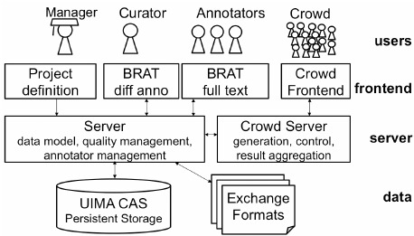

**Figure 4.a**

**CHAPTER 5**

**IMPLEMENTATION**

## 5.1 GENERAL

Implementing a personality test system involves a multifaceted approach encompassing design, development, and deployment. The foundational architecture typically includes a user-facing interface for test administration and result display, a backend to process test logic and data, and a robust database to store information securely. Key functionalities such as user management, test creation, question management, scoring, and reporting are essential. Leveraging technologies like React, Node.js, and PostgreSQL can provide a solid foundation.

To ensure a successful implementation, meticulous attention to user experience, data security, and system performance is paramount. Integrating advanced features like adaptive testing, AI, and gamification can enhance the system's value. Scalability is crucial to accommodate increasing user numbers, while maintaining data privacy and adhering to relevant regulations is mandatory. By adhering to software development best practices, including thorough testing and continuous improvement, a personality test system can become a valuable tool for individuals and organizations alike.

**5.2 CODING:**

MAIN CODED (CSS)

body {

font-family: 'Roboto', sans-serif;

margin: 0;

padding: 0;

background-color: #f0f8ff; /* Light background for the body */

}

.intro {

text-align: center;

padding: 50px;

background-color: #ffffff;

border-radius: 8px;

box-shadow: 0 4px 8px rgba(0, 0, 0, 0.1);

margin: 50px auto;

max-width: 600px;

transition: opacity 0.5s ease;

}

.start-quiz {

background-color: #00796b;

color: white;

border: none;

padding: 15px 30px;

border-radius: 4px;

cursor: pointer;

font-size: 18px;

transition: background-color 0.3s ease, transform 0.3s ease, box-shadow 0.3s ease;

}

.start-quiz:hover {

background-color: #004d40;

transform: scale(1.05);

box-shadow: 0 6px 12px rgba(0, 0, 0, 0.3);

}

.hidden {

display: none;

}

.quiz-container {

max-width: 600px;

margin: 50px auto;

padding: 20px;

background-color: #ffffff;

border-radius: 8px;

box-shadow: 0 4px 8px rgba(0, 0, 0, 0.1);

transition: opacity 0.5s ease;

}

.question {

font-size: 20px;

margin-bottom: 20px;

}

.option {

display: block;

margin: 10px 0;

transition: transform 0.3s ease;

}

.option input[type="radio"] {

display: none;

}

.option span {

display: inline-block;

padding: 15px;

border-radius: 8px;

border: 2px solid #00796b;

cursor: pointer;

transition: background-color 0.3s ease, color 0.3s ease, transform 0.3s ease, box-shadow 0.3s ease;

box-shadow: 0 2px 5px rgba(0, 0, 0, 0.2);

}

.option input[type="radio"]:checked + span {

background-color: #00796b;

color: #ffffff;

transform: scale(1.1);

box-shadow: 0 4px 10px rgba(0, 0, 0, 0.3);

}

.option span:hover {

background-color: #004d40;

color: #ffffff;

transform: scale(1.05);

box-shadow: 0 4px 8px rgba(0, 0, 0, 0.3);

}

.controls {

margin-top: 20px;

}

button {

background-color: #00796b;

color: white;

border: none;

padding: 10px 20px;

border-radius: 4px;

cursor: pointer;

transition: background-color 0.3s ease, transform 0.3s ease;

margin: 5px;

position: relative;

overflow: hidden;

}

button:hover {

background-color: #004d40;

transform: scale(1.05);

}

button::before {

content: '';

position: absolute;

top: 50%;

left: 50%;

width: 300%;

height: 300%;

background: rgba(255, 255, 255, 0.2);

transition: transform 0.5s ease;

border-radius: 50%;

transform: translate(-50%, -50%) scale(0);

z-index: 0;

}

button:hover::before {

transform: translate(-50%, -50%) scale(1);

}

button span {

position: relative;

z-index: 1;

}

.restart {

background-color: #d32f2f;

}

.restart:hover {

background-color: #b71c1c;

}

/* New styles for the result page */

.result {

max-width: 600px;

margin: 50px auto;

padding: 30px;

background-color: #004d40; /* Dark teal background */

color: #ffffff; /* White text */

border-radius: 8px;

box-shadow: 0 4px 8px rgba(0, 0, 0, 0.1);

text-align: center;

}

.final-score {

font-size: 28px;

margin-bottom: 20px;

}

.summary h1 {

font-size: 24px;

margin-bottom: 15px;

}

.summary p {

font-size: 18px;

margin: 10px 0;

}

.restart {

background-color: #d32f2f;

}

.restart:hover {

background-color: #b71c1c;

}

**HTML**

<html lang="en">

<head>

<meta charset="UTF-8">

<meta name="viewport" content="width=device-width, initial-scale=1.0">

<title>Personality Quiz</title>

<link href="https://fonts.googleapis.com/css?family=Roboto" rel="stylesheet">

<link rel="stylesheet" href="styles.css"> <!-- Link to your CSS file -->

</head>

<body>

<div id="intro" class="intro">

<h1>Welcome to the Personality Quiz</h1>

<p>This quiz will help you understand yourself better by asking a series of questions. At the end, you'll receive a summary of your results. Click the button below to start the quiz!</p>

<button id="startQuiz" class="start-quiz">Start Quiz</button>

</div>

<div id="quiz" class="quiz-container hidden">

<div class="title">Personality Quiz</div>

<div id="question" class="question"></div>

<label class="option">

<input type="radio" name="option" value="1">

<span class="option1"></span>

</label>

<label class="option">

<input type="radio" name="option" value="2">

<span class="option2"></span>

</label>

<label class="option">

<input type="radio" name="option" value="3">

<span class="option3"></span>

</label>

<div class="controls">

<button class="previous">Previous</button>

<button class="next">Next</button>

</div>

</div>

<div id="result" class="result hidden">

<h1 class="final-score"></h1>

<div class="summary">

<h1>Summary</h1>

<p>Possible - Personality Traits, see below for a summary based on your results:</p>

<p>15 - 21: You Need Help</p>

<p>10 - 15: Good Soul</p>

<p>5 - 10: Meh</p>

<p>5 and below: Are You Even Real</p>

</div>

<button class="restart">Restart Quiz</button>

</div>

<script src="script.js"></script> <!-- Link to your JavaScript file -->

</body>

</html>

**JAVASCRIPT**

const questions = [

{

"question": "Age range?",

"answer1": "under 18",

"answer1Total": "1",

"answer2": "18 - 30",

"answer2Total": "2",

"answer3": "over 30",

"answer3Total": "3"

},

{

"question": "I am very imaginative.",

"answer1": "Agree",

"answer1Total": "1",

"answer2": "Neutral",

"answer2Total": "2",

"answer3": "Disagree",

"answer3Total": "3"

},

{

"question": "Select in which order you would value these \"Money, Love & Career\"",

"answer1": "Love, Career, Money",

"answer1Total": "1",

"answer2": "Money, Career, Love",

"answer2Total": "3",

"answer3": "Career, Love, Money",

"answer3Total": "2"

},

{

"question": "Best Sentence to describe you?",

"answer1": "You feel superior to other people.",

"answer1Total": "3",

"answer2": "You consider yourself more practical than creative.",

"answer2Total": "2",

"answer3": "Winning a debate matters less to you than making sure no one gets upset.",

"answer3Total": "1"

},

{

"question": "Which best describes your relationship with food",

"answer1": "You tend to over-eat when you have company.",

"answer1Total": "1",

"answer2": "You tend to eat snacks secretly.",

"answer2Total": "2",

"answer3": "You prepare food and don’t even look at the recipe.",

"answer3Total": "3"

},

{

"question": "You make plans with a friend and they cancel on you, what do you do?",

"answer1": "Say \"whatever\" and plan a night that'll be GREAT so they don't cancel again.",

"answer1Total": "3",

"answer2": "Feel hurt because you were looking forward to tonight.",

"answer2Total": "2",

"answer3": "No problem, you kinda wanted to stay home anyway.",

"answer3Total": "1"

},

{

"question": "Which of the following colours do you like most?",

"answer1": "Black",

"answer1Total": "1",

"answer2": "Yellow or light blue",

"answer2Total": "2",

"answer3": "Red or orange",

"answer3Total": "3"

}

];

let currentQuestion = 0;

let score = [];

const totalQuestions = questions.length;

const introPage = document.querySelector('#intro');

const quizContainer = document.querySelector('#quiz');

const resultPage = document.querySelector('#result');

const questionEl = document.querySelector('#question');

const option1 = document.querySelector('.option1');

const option2 = document.querySelector('.option2');

const option3 = document.querySelector('.option3');

const nextButton = document.querySelector('.next');

const previousButton = document.querySelector('.previous');

const restartButton = document.querySelector('.restart');

const finalScoreEl = document.querySelector('.final-score');

const startQuizButton = document.querySelector('#startQuiz');

function generateQuestions(index) {

const question = questions[index];

const option1Total = question.answer1Total;

const option2Total = question.answer2Total;

const option3Total = question.answer3Total;

questionEl.innerHTML = `${index + 1}. ${question.question}`;

option1.setAttribute('data-total', option1Total);

option2.setAttribute('data-total', option2Total);

option3.setAttribute('data-total', option3Total);

option1.innerHTML = `${question.answer1}`;

option2.innerHTML = `${question.answer2}`;

option3.innerHTML = `${question.answer3}`;

}

function loadNextQuestion() {

const selectedOption = document.querySelector('input[name="option"]:checked');

if (!selectedOption) {

alert('Please select your answer!');

return;

}

const answerScore = Number(selectedOption.nextElementSibling.getAttribute('data-total'));

score.push(answerScore);

currentQuestion++;

selectedOption.checked = false;

if (currentQuestion === totalQuestions) {

const totalScore = score.reduce((total, currentNum) => total + currentNum, 0);

quizContainer.classList.add('hidden');

resultPage.classList.remove('hidden');

finalScoreEl.innerHTML = `Your score: ${totalScore}`;

return;

}

// Add fade-out animation for the current question

quizContainer.style.opacity = '0';

setTimeout(() => {

generateQuestions(currentQuestion);

quizContainer.style.opacity = '1';

}, 500);

}

function loadPreviousQuestion() {

if (currentQuestion > 0) {

currentQuestion--;

score.pop();

// Add fade-out animation for the current question

quizContainer.style.opacity = '0';

setTimeout(() => {

generateQuestions(currentQuestion);

quizContainer.style.opacity = '1';

}, 500);

}

}

function restartQuiz() {

currentQuestion = 0;

score = [];

quizContainer.classList.remove('hidden');

resultPage.classList.add('hidden');

introPage.classList.remove('hidden');

}

function startQuiz() {

introPage.classList.add('hidden');

quizContainer.classList.remove('hidden');

generateQuestions(currentQuestion);

}

startQuizButton.addEventListener('click', startQuiz);

nextButton.addEventListener('click', loadNextQuestion);

previousButton.addEventListener('click', loadPreviousQuestion);

restartButton.addEventListener('click', restartQuiz);

## CHAPTER 6

## OUTPUT

**6.1 GENERAL:**

This project is implements like application using HTML, JAVASCRIPT and The Server process is maintained using the SQL and the Design 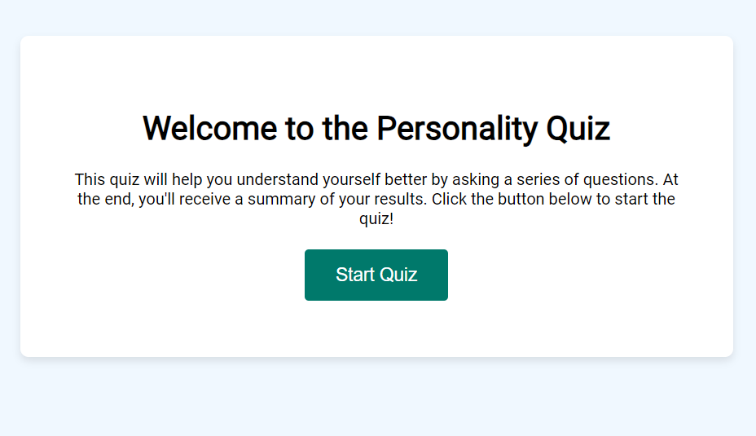

Figure 6.a

part is played by Cascading Style Sheet .

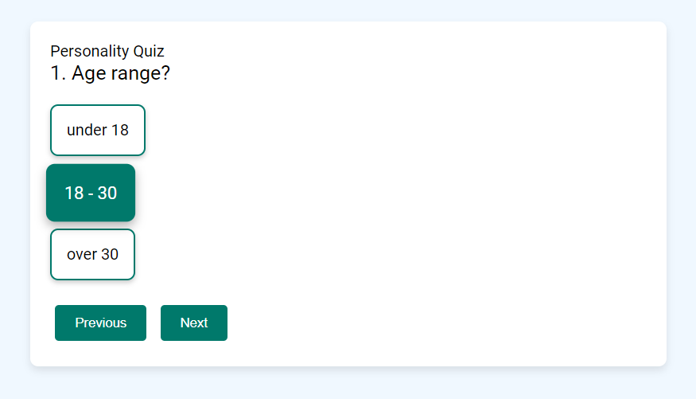

Figure 6.b

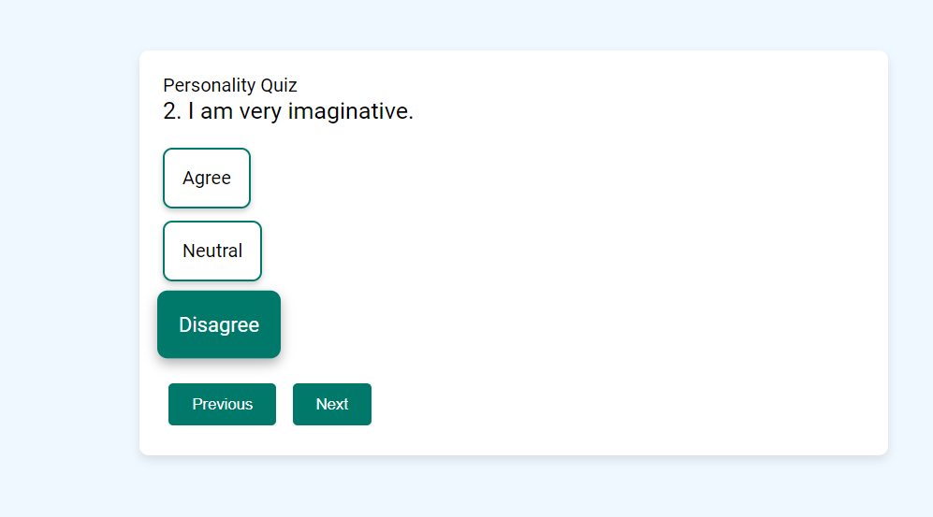

Figure 6.c

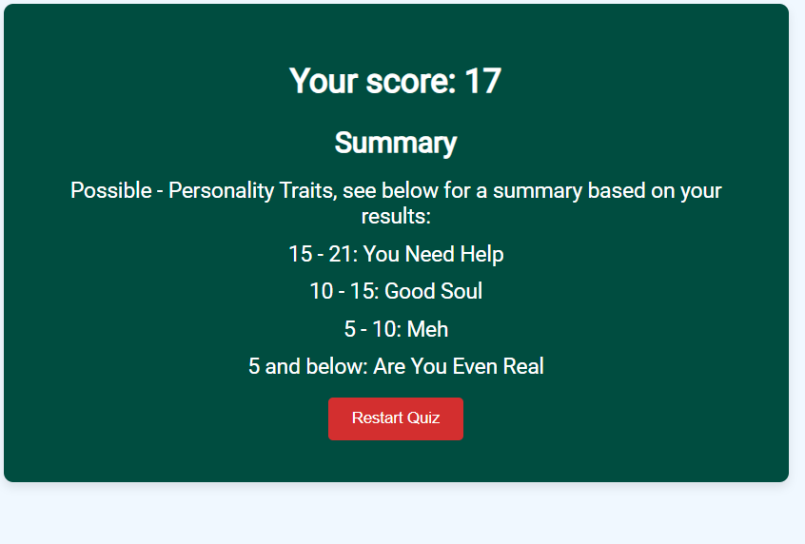

Figure 6.d

## CHAPTER 7

## SOFTWARE TESTING

**7.1 GENERAL:**

Testing is the debugging program is one of the most critical aspects of the computer programming triggers, without programming that works, the system would never produce an output of which it was designed. Testing is best performed when user development is asked to assist in identifying all errors and bugs. The sample data are used for testing. It is not quantity but quality of the data used the matters of testing. Testing is aimed at ensuring that the system was accurately an efficiently before live operation commands.

Testing objectives:

The main objective of testing is to uncover a host of errors, systematically and with

Minimum effort and time. Stating formally, we can say, testing is a process of executing a program with intent of finding an error.

1. A successful test is one that uncovers an as yet undiscovered error.
2. A good test case is one that has probability of finding an error, if it exists.
3. The test is inadequate to detect possibly present errors.
4. The software more or less confirms to the quality and reliable standards.

**7.2 Testing PLAN**:

**Testing levels**: defines the testing levels to be performed (e.g., unit testing, integration testing, system testing, acceptance testing).

**Testing types**: specifies the types of testing to be conducted (e.g., functional testing, performance testing, security testing).

**Testing techniques**: describes the methods and techniques to be used for testing (e.g., black-box testing, white-box testing, exploratory testing).

**Test deliverables**:

Lists the documents, reports, and artifacts that will be produced as part of the testing process (e.g., test cases, test scripts, test data, defect reports).

**Testing tasks**:

**Test environment setup**: details the setup and configuration of the testing environment, including hardware, software, and network configurations.

**Test execution**: outlines the procedures and steps for executing tests, including who will perform them and when they will be conducted.

**Test data preparation**: describes how test data will be created, selected, and prepared for testing purposes.

**Defect management**: specifies how defects will be identified, reported, tracked, and managed throughout the testing process.

**Risks and contingencies**:

**Risk assessment**: identifies potential risks and challenges that may impact testing activities (e.g., resource constraints, schedule delays, technical dependencies).

**Mitigation strategies**: proposes strategies and contingency plans to mitigate risks and address challenges as they arise during testing.

**7.3 TYPES OF TESTING**

Testing in software development encompasses various types and techniques, each serving specific purposes to ensure the quality and reliability of the software. Here are some of the key types of testing commonly used in software engineering:

### **Functional testing**:

**Definition**: functional testing verifies that each function of the software application operates in accordance with the requirement specifications.

**Types**:

**Unit testing**: tests individual units or components of the software in isolation.

**Integration testing**: tests the interaction between integrated components or systems.

**System testing**: tests the entire system as a whole against the functional requirements.

**Acceptance testing**: validates whether the software meets the user's acceptance criteria.

### **Non-functional testing**:

**Definition**: non-functional testing checks the non-functional aspects of the software, such as performance, reliability, usability, security, and scalability.

**Types**:

**Performance testing**: evaluates how the system behaves under specific workload conditions.

**Load testing**: tests the system's ability to handle anticipated load levels.

**Stress testing**: tests the system's behavior beyond normal operational capacity.

**Usability testing**: evaluates how user-friendly and intuitive the software is.

**Security testing**: checks for vulnerabilities and potential security threats.

**7.4 TEST CASE TEMPLATE**

Creating a test case template helps maintain consistency and clarity across all test cases within a software testing project. Here's a structured test case template that includes essential components typically found in a comprehensive test case:

### **Test case template:**

**Test case id**: unique identifier for each test case (e.g., tc001, tc002, etc.).

**Test case title**: clear and concise title that summarizes the objective of the test case.

**Description**: detailed description of the test case, including the feature or functionality being tested.

**Preconditions**: any necessary conditions that must be met before executing the test case (e.g., specific data setup, system state).

**Test data**: specific data inputs required for executing the test case.

**Test steps**:

**Step number**: sequential number for each step.

**Action**: detailed actions to be performed (e.g., navigate to a specific screen, enter data).

**Expected result**: expected outcome or behavior after performing each action.

**Actual result**: space to record the actual outcome observed during test execution.

**Pass/fail**: indicates whether the test case passed or failed based on the actual result compared to the expected result.

**Severity**: severity level of the issue if the test case fails (e.g., critical, major, minor).

**Priority**: priority level assigned to the test case (e.g., high, medium, low).

**Comments**: additional notes or comments relevant to the test case execution or results. **Attachments:** links or references to related documents, screenshots, logs, or files associated with the test case.

**CHAPTER 8:**

**FUTURE ENHANCEMENT**

**8.1 APPLICATIONS**

When planning future enhancement applications for the upcoming generation, it's crucial to consider trends, technologies, and user expectations that will shape the software landscape. Here are some forward-looking areas where future enhancements can be focused:

### **1. Artificial intelligence (ai) and machine learning (ml):**

**Personalization**: implement ai-driven recommendations and personalized experiences based on user behavior and preferences.

**Natural language processing (nlp)**: integrate nlp capabilities for enhanced user interactions through voice commands and chatbots.

**Predictive analytics**: utilize ml algorithms to predict user needs, optimize workflows, and improve decision-making processes.

**Automation**: automate repetitive tasks and workflows to streamline operations and enhance efficiency.

### **2. Augmented reality (ar) and virtual reality (vr):**

**Enhanced user experience**: integrate ar/vr technologies to provide immersive experiences for training, product visualization, and gaming applications.

**Virtual meetings and collaboration**: develop vr environments for virtual meetings, conferences, and collaborative workspaces.

**Ar for retail and marketing**: implement ar solutions for virtual try-ons, interactive product demonstrations, and enhanced marketing campaigns.

**8.2 FUTURE ENHANCEMENT**

Applications and Future Enhancements of a Personality Test System

A personality test system offers a wide range of applications across various domains. Here are some prominent examples:

Applications

Human Resources:

Talent acquisition and recruitment: Matching candidates to suitable job roles.

Employee development: Identifying strengths and areas for improvement.

Team building: Creating effective teams based on personality compatibility.

Performance management: Linking personality traits to performance metrics.

Education:

Career counseling: Guiding students toward suitable career paths.

Learning style identification: Tailoring teaching methods to individual learning preferences.

Student well-being: Assessing emotional states and providing support.

Marketing and Sales:

Customer segmentation: Identifying target market segments based on personality profiles.

Personalized marketing: Tailoring marketing messages to individual preferences.

Sales force optimization: Matching salespeople to customer types.

Mental Health:

Identifying potential mental health issues: Screening for depression, anxiety, or personality disorders.

Personalized treatment plans: Tailoring interventions based on personality traits.

Future Enhancements

AI Integration:

Developing AI-powered chatbots to provide personalized feedback and support.

Using machine learning to improve test accuracy and predictive capabilities.

Adaptive Testing:

Tailoring test questions based on user responses for a more efficient assessment.

Dynamically adjusting test difficulty to match user ability.

Gamification:

Incorporating game elements to make the test more engaging and enjoyable.

Increasing user motivation and participation.

Cross-Cultural Adaptation:

Developing culturally sensitive test items and scoring algorithms.

Ensuring fairness and validity across different cultures.

Privacy and Security:

Enhancing data protection measures to safeguard user information.

Implementing advanced security protocols to prevent data breaches.

Integration with Other Systems:

Connecting with HR systems, learning management systems, and healthcare platforms.

Mobile Optimization:

Developing mobile-friendly versions of the test for wider accessibility.

**CHAPTER 9**

**CONCLUSION**

# 9.1 CONCLUSION

A personality test system is a complex software application with the potential to significantly impact various domains, including human resources, education, marketing, and mental health. By effectively combining psychological theory, technological advancements, and user-centered design, these systems can provide valuable insights into individual personalities.

While this paper has explored the core components, functionalities, and challenges of developing such a system, it is essential to recognize that the field is continually evolving. Future research should focus on enhancing test accuracy, privacy, and accessibility. Additionally, exploring the integration of AI and machine learning technologies can unlock new possibilities for personalized assessments and interventions.