Table of Content

CHAPTER ONE 2

GENERAL INTRODUCTION 2

1.1 BACKGROUND OF WEB BASED E-REGISTRATION SYSTEMS 2

1.1.1 HISTORICAL BACKGROUND 2

1.1.2 CONCEPTUAL BACKGROUND 3

1.1.3 THEORETICAL BACKGROUND 3

1.2 PROBLEM STATEMENT. 4

1.3 OBJECTIVES OF THE STUDY 5

1.3.1 MAIN OBJECTIVES 5

1.3.2 SPECIFIC OBJECTIVES 5

1.4 RESEARCH QUESTONS 6

1.4.1 GENERAL RESEARCH QUESTIONS 6

1.4.2 SPECIFIC RESEARCH QUESTIONS 6

1.5 RESEARCH HYPOTHESIS 6

1.5.1 GENERAL RESEARCH HYPOTHESIS 6

1.5.2 GENERAL RESEARCH HYPOTHESIS 6

1.6 SIGNIFICANCE OF THE STUDY 7

1.6.1 TO THE GOVERNMENT 7

1.6.2 TO THE PUBLIC 7

1.7 SCOPE OF THE STUDY 8

1.7.1 GEOGRAPHICAL SCOPE 8

1.7.2 THEMATIC SCOPE 8

1.7.3 TIME SCOPE 8

CHAPTER TWO 9

SURVEY OF TECHNOLOGY AND REVIEW OF RELATED LITERATURE 9

2.0 INTRODUCTION 9

2.1 CONCEPTUAL REVIEW 9

2.2 THEORITICAL REVIEW 9

2.2.1 REVIEW OF MANUAL VOTING SYSTEM 10

2.2.2 REVIEW OF OTHER EXISTING ELECTRONIC ELECTORAL SYSTEMS 11

2.3 PRESENTATION OF INTERNSHIP ACTIVITIES 12

2.3.1 ACTIVITIES CARIED OUT 12

2.4 INTERNSHIP EXPIRIENCE 12

2.4.1 PROFESSIONAL EXPERIENCE 12

2.4.2 PERSONAL EXPERIENCE 12

2.5 STRENGTH AND WEAKNESSES 13

2.5.1 STRENGTH 13

2.5.2 WEAKNESSES 13

2.5.3 PROBLEMS ENCOUNTERED 13

2.6 SUMMARY 13

# CHAPTER ONE

# GENERAL INTRODUCTION

**INTRODUCTION.**

## BACKGROUND OF WEB BASED E-REGISTRATION SYSTEMS

Cameroon is a country located in Central Africa with a population of over 25 million people. The country has a presidential electoral system, and the president is elected every 7 years through a two-round system. The most recent presidential election was held in October 2018, which was widely criticized for irregularities and low voter turnout. The electoral system in Cameroon has been a topic of debate and controversy in recent years. Many stakeholders, including political parties, civil society organizations, and international observers, have raised concerns about the transparency, fairness, and effectiveness of the electoral system.

### HISTORICAL BACKGROUND

Cameroon gained independence from France and the United Kingdom in 1960 and 1961, respectively, and has since experienced a series of political upheavals. The country's first president, Ahmadou Ahidjo, ruled for 22 years and was succeeded by Paul Biya, who has been in power for over 38 years (Nkongho, 2019). During this period, Cameroon has held several presidential elections, but the electoral process has been marred by allegations of fraud, irregularities, and violence (Takougang & Krieger, 2019).

The most recent presidential election was held in 2018, and it was marked by low voter turnout, allegations of fraud, and violence in some regions (Nkongho, 2019). These issues have raised concerns about the transparency, fairness, and effectiveness of the electoral process in Cameroon.

Online presidential electoral systems have been used in other countries, and they have been shown to have several advantages over traditional paper-based systems. For example, online systems can improve transparency, reduce the potential for fraud, and increase voter participation (Dahal et al., 2019). However, there are also challenges associated with online electoral systems, including cybersecurity threats and concerns about the accuracy and reliability of the systems (Bannister & Connolly, 2017).

### CONCEPTUAL BACKGROUND

The most recent presidential election held in Cameroon in 2018 was characterized by allegations of voter fraud, leading to a call for electoral reforms and greater transparency in the electoral process (HRW, 2019).

One potential solution to address the challenges of the electoral process in Cameroon is the adoption of an online presidential electoral system. An online electoral system would allow voters to cast their ballots electronically and reduce the risk of electoral irregularities such as ballot stuffing, voter intimidation, and manipulation of the vote count. Moreover, an online electoral system would allow for greater transparency, accountability, and accessibility of the electoral process, which are essential elements of democracy (UN, 2012).

However, the adoption of an online presidential electoral system in Cameroon faces several challenges, including the lack of infrastructure, the digital divide, and the potential for cybersecurity threats. Moreover, the political will to implement such a system may be limited by the ruling party's desire to maintain its grip on power and the opposition's distrust of the government's intentions (Freedom House, 2021).

### THEORETICAL BACKGROUND

The adoption of an online electoral system is a complex process that involves technical, political, and social factors. Several theoretical frameworks can be used to analyze the feasibility, benefits, and limitations of such a system.

One relevant theoretical framework is the Technology Acceptance Model (TAM), which posits that the perceived usefulness and ease of use of a technology are key determinants of its adoption and usage (Davis, 1989; Venkatesh & Davis, 2000). According to TAM, the adoption of an online presidential electoral system in Cameroon would depend on the stakeholders' perceptions of its usefulness and ease of use, including the voters, election officials, political parties, and civil society organizations. In addition, the perceived risks and barriers of using such a system, such as cybersecurity threats and digital divide, would also influence its adoption and sustainability (Venkatesh et al., 2012).

Another relevant theoretical framework is the Diffusion of Innovation theory, which explains how new technologies are adopted and diffused in a social system (Rogers, 2003). According to this theory, the adoption of an online presidential electoral system in Cameroon would depend on the characteristics of the innovation, the communication channels used to promote it, the social system's readiness to adopt it, and the opinion leaders' influence on the adoption process. Moreover, the innovation's relative advantage, compatibility, complexity, trialability, and observability would also affect its adoption and diffusion (Rogers, 2003).

## PROBLEM STATEMENT.

Cameroon has a presidential electoral system where the president is elected every 7 years through a two-round system. However, the electoral system in Cameroon has been criticized for various reasons, including low transparency, fairness, and effectiveness (Takougang & Krieger, 2019). In addition, the country's electoral process has been plagued by irregularities, fraud, and violence (Nkongho, 2019). These issues have led to a lack of trust in the electoral system, and there is a need for a more transparent and effective system.

Online presidential electoral systems have been used in other countries, and they have been shown to have several advantages over traditional paper-based systems. For example, online systems can improve transparency, reduce the potential for fraud, and increase voter participation (Dahal et al., 2019). However, there are also challenges associated with online electoral systems, including cybersecurity threats and concerns about the accuracy and reliability of the systems (Bannister & Connolly, 2017).

Given the challenges associated with traditional electoral systems in Cameroon and the potential benefits of online systems, this study seeks to investigate the feasibility and effectiveness of an online presidential electoral system in Cameroon.

## OBJECTIVES OF THE STUDY

In carrying out this research work, our objective is divided into main and specific objective which are as follows.

### MAIN OBJECTIVES

The main objective of this research is to design and implement interactive, secured, usable, reliable, correct, flexible and efficient electronic electoral system for ELECAM.

### SPECIFIC OBJECTIVES

We want to design:

* A user-friendly digital platform to manage elections for ELECAM in Cameroon.
* An electoral system that can reduce the risk of electoral irregularities such as ballot stuffing, voter intimidation, and manipulation of the vote count.
* An electronic electoral system that can increase the accessibility of the electoral process and ensure the participation of all eligible voters, including those with disabilities or living in remote areas and accommodate different languages and literacy levels.
* An electronic electoral system that can ensure the security and privacy of voter information. The system should be able implement robust cybersecurity measures, such as encryption, firewalls, and intrusion detection systems, to prevent unauthorized access and data breaches.
* A system that can ensure rapid retrieval of records and information from the systems’ database.

These objectives can guide the design and implementation of an electronic electoral system for ELECAM and ensure that it meets the needs and expectations of all stakeholders.

## RESEARCH QUESTONS

Here we are going to look at the general question and the specifics questions which by the end of this project has to be answered for a better understanding of the topic.

### GENERAL RESEARCH QUESTIONS

“Will designing and implementing an electronic electoral system be an effective method for managing elections for ELECAM in Cameroon?”

### SPECIFIC RESEARCH QUESTIONS

* Can a user friendly digital platform be put in place to manage elections in Cameroon?
* Can an electronic electoral system reduce the risk of electoral irregularities such as ballot stuffing, voter intimidation, and manipulation of the vote count?
* Can an electronic electoral system ensure the security and privacy of voter information?
* Can an electoral system ensure rapid retrieval of records and information from the systems’ database?

## RESEARCH HYPOTHESIS

### GENERAL RESEARCH HYPOTHESIS

The design and implementation of an electronic electoral system for ELECAM will actually be an effective method for managing elections for ELECAM in Cameroon.

### GENERAL RESEARCH HYPOTHESIS

* An electronic electoral system will reduce the risk of electoral irregularities such as ballot stuffing, voter intimidation, and manipulation of the vote count.
* An electronic electoral system ensure the security and privacy of voter information.
* An electronic electoral system will increase the accessibility of the electoral process and ensure the participation of all eligible voters.

## SIGNIFICANCE OF THE STUDY

The implementation of a presidential electronic electoral system can have several significant impacts on the government and the public of Cameroon. Here are some potential benefits:

### TO THE GOVERNMENT

* Enhancing the credibility and legitimacy of the electoral process: By adopting an electronic electoral system, the government can increase the transparency, accuracy, and accountability of the electoral process. This, in turn, can enhance the credibility and legitimacy of the election results and promote public trust and confidence in the government.
* Improving the efficiency and cost-effectiveness of the electoral process: An electronic electoral system can reduce the time, resources, and costs required to conduct elections. This can result in a more efficient and cost-effective electoral process, which can free up government resources for other priorities.
* Demonstrating the government's commitment to democratic values: By adopting an electronic electoral system, the government can demonstrate its commitment to democratic principles, such as free and fair elections, transparency, and accountability. This can help to promote democratic governance and strengthen the government's legitimacy and reputation both domestically and internationally.

### TO THE PUBLIC

The implementation of a presidential electronic electoral system in Cameroon could have several significant implications for the public.

* Improved accessibility and inclusivity: An electronic system could be more accessible and inclusive than a paper-based system, as it would enable eligible voters to cast their vote from anywhere with an internet connection, and the system could be designed to accommodate the needs of people with disabilities and those living in remote areas.
* Greater engagement in the democratic process: An electronic system could make it easier for people to participate in the electoral process, which could lead to greater engagement and participation in the democratic could process overall.
* Reduced cost of elections: An electronic system could be more cost-effective than a paper-based system, as it would reduce the need for printing and distributing paper ballots, and could potentially reduce the need for manual vote counting.
* Increased trust and confidence in the electoral process: An electronic electoral system could help reduce the perceived risk of electoral fraud and manipulation, which could increase the public's trust and confidence in the electoral process.

## SCOPE OF THE STUDY

### GEOGRAPHICAL SCOPE

### THEMATIC SCOPE

The project is aimed at designing and implementation of an electronic electoral system for ELECAM. This is a greater concern for the IT technicians of ELECAM.

### TIME SCOPE

This research was carried out within a three Months critical study of the manual electoral system from October 2022 to January 2023. It brings to knowledge the strengths and weaknesses of the project. The implementation of the project will be made to solve the problem concerned as time requires.

# CHAPTER TWO

# SURVEY OF TECHNOLOGY AND REVIEW OF RELATED LITERATURE

# INTRODUCTION

This chapter briefly describes the literature review relevant to the Electronic Electoral system. It provides enough background knowledge based on relevant literature reviews of related works. The chapter analyzed relevant literatures and technologies to the proposed project and identified gaps in connected systems that the suggested system could address.

## CONCEPTUAL REVIEW

An electronic electoral system is a computer-based system that enables voters to cast their votes electronically, with the aim of improving the accuracy, efficiency, and transparency of the electoral process. The implementation of an electronic electoral system involves the use of hardware and software components, such as voting machines, databases, and software applications. The electronic electoral system can be designed to meet the specific needs and requirements of each country or jurisdiction.

## THEORITICAL REVIEW

Information Technology is rapidly growing in most developing countries. Many countries including tertiary institutions worldwide are doing away with the manual way of voting with Electronic voting systems (E-voting) that are geared towards increasing voters’ participation, protecting votes’ votes and expediting the release of election results. Countries like the United States of America (USA), Russia; and tertiary institutions like Kwame Nkrumah University of Science and Technology (KNUST) and University of Ghana, Legon (UG) are examples of countries and institutions that are using e-voting systems for both general and students’ elections. The E-Voting Mechanisms (EVMs) used in India statistically shows that there has been the frequent occurrence of invalid votes during elections. Before this system came into use, there were lots of invalid votes recorded and the margin between the winning and losing candidate was very large. The EVMs were developed to eradicate these invalid votes. Apart from this, it also ensured that the results of the election were counted and released within a few hours after voting as compared to the manual means of voting.

### REVIEW OF MANUAL VOTING SYSTEM

The manual system of carrying out elections in Cameroon has been in place since 1992. The manual system of carrying out elections in Cameroon involves several steps and processes. Here is a brief description of the manual system of carrying out elections in Cameroon:

1. Voter registration: The first step in the manual system of carrying out elections in Cameroon is voter registration. The Electoral Board is responsible for compiling a list of eligible voters for each election. Voters are required to present their identification documents to register.

2. Campaigning: Political parties and candidates are allowed to campaign for their respective parties or themselves. Campaigns are conducted through public rallies, door-to-door campaigns, and media advertisements.

3. Polling stations: On the day of the election, polling stations are set up across the country. Voters are required to go to their respective polling stations to cast their votes.

4. Voting process: The voting process is conducted manually. Voters are required to present their identification documents to the polling officials, who verify their eligibility to vote. Voters then proceed to the voting booth, where they mark their ballot paper by placing an X next to the candidate of their choice.

5. Vote counting: After the voting process is completed, the ballot boxes are transported to a central location where the votes are counted manually. The Electoral Board is responsible for overseeing the vote counting process.

6. Results declaration: The Electoral Board announces the results of the election after the vote counting process is completed. The winning candidate or party is declared based on the number of votes received.

Overall, the manual system of carrying out elections in Cameroon is an important process that ensures that citizens have a voice in the governance of their country. While there are challenges associated with this system, efforts are being made to improve it and ensure that elections are free, fair, and transparent

### REVIEW OF OTHER EXISTING ELECTRONIC ELECTORAL SYSTEMS

Information Technology is rapidly growing in most developing countries. Many countries including tertiary institutions worldwide are doing away with the manual way of voting with Electronic voting systems (E-voting) that are geared towards increasing voters’ participation, protecting voters’ votes and expediting the release of election results. Countries like the United States of America (USA), Russia; and tertiary institutions like Kwame Nkrumah University of Science and Technology (KNUST) and University of Ghana, Legon (UG) are examples of countries and institutions that are using e-voting systems for both general and students’ elections.

The Online Voting used in Nigeria statistically shows that there has been the frequent occurrence of invalid votes during elections. Some people believe that the online electoral system has helped to reduce electoral fraud and increase transparency in the voting process. They argue that the system has made it easier for voters to register and cast their votes, and has provided a more accurate and efficient way of counting votes.

On the other hand, some critics have raised concerns about the security and reliability of the system. They argue that the online system is vulnerable to hacking and cyber-attacks, which could compromise the integrity of the election results. Additionally, some people have raised concerns about the accessibility of the system, particularly for voters who do not have access to the internet or who are not tech-savvy, and with the recent elections (2022-2023), concerns have been raised as to the integrity and validity of the information gotten from the system.

## PRESENTATION OF INTERNSHIP ACTIVITIES

The working environment at YIBS is pleasant. The researcher found the internship term at this company to be both educational and enjoyable for the following reasons; someone kept a close eye on the researcher and was quite welcoming. He taught the researcher the majority of what he knows and was always there to answer his inquiries whenever he had a problem. The personnel were quite accommodating and accommodating.

### ACTIVITIES CARIED OUT

During the internship, the researcher participated in the following activities:

* Learning advanced HTML, CSS and JavaScript.
* Learning the Django python framework.
* Learning the basics of Bootstrap and applying it to create basic web pages.
* Creating a basic website with Django..

## INTERNSHIP EXPIRIENCE

### PROFESSIONAL EXPERIENCE

During the internship, the researcher gained experience in a variety of fields. Some of which include:

* Teamwork experience that ensures solidarity as a driving factor for getting work done faster.
* Introduction to exposers, that is, presenting a work done in front of other people. This made the researcher gain lots of experience in public speaking.
* Time management that is, giving tasks and setting deadlines for the accomplishment of those tasks.

### PERSONAL EXPERIENCE

During his internship, the researcher had personal experiences such as;

* Some understanding of frameworks such as Bootstrap and Django.
* Knowing how to speak in public.
* Knowing how to manage time.
* Knowledge of Microsoft Office has improved.

## STRENGTH AND WEAKNESSES

This section of the research focuses on the internship experience. It takes into account both professional and personal experiences.

### STRENGTH

They also strive to be the best, and when it comes to service delivery, they put their clients first.

"We stand united, divided we fall," and at YIBS, there is unity and collaboration among the stakeholders.

Employees of YIB are highly helpful and friendly to everyone, especially interns.

### WEAKNESSES

There are language difficulties because there are two official languages, English and French. French Speakers find it difficult to converse in English at times, and vice versa. Inadequate internet access because it is only available to a few employees.

### PROBLEMS ENCOUNTERED

Throughout the internship, the researcher encountered a variety of issues. Some of these issues, however difficult to overcome, include:

* The language spoken at the internship location was unfamiliar, making it difficult to comprehend the present system and how it operates.
* The researcher had to be at the internship site every day from 8:00 a.m. until 5 p.m., which was difficult as there was a need of feeding.
* The researcher had limited amount of time to work on his project.

## SUMMARY

The literature covered in this chapter provides a brief summary of the current system as well as certain project-related papers that are relevant to the proposed system.

# CHAPTER THREE

# REQUIREMENT ANALYSIS AND DESIGN

# INTRODUCTION

The system development generally consists of two major components which are the system requirement analysis and system requirement design. The system analysis helps to understand details of an existing system or an envisioned system and deciding whether the existing system needs improvement and also deciding if the envisioned system is desirable or not. The system design is the process of using the fact finding techniques to build and plan a new system or to replace an existing system (mahmud, 2020).

This Chapter will present the Requirements Analysis and Design of the proposed system of the Service Oriented Electronic Electoral System in details. It will also look at how the new planned system will be set up, as well as the fact-gathering approaches that were utilized during the system's design and development. The report will also provide a brief description of the system's development methodology to demonstrate adequate comprehension of the approaches used. The proposed system's functional and non-functional needs are presented, along with data modeling using a class diagram that will be converted into codes, a use cases diagram that lists the system's processes, and other associated useful diagrams.

## DESCRIPTION OF THE ARCHITECTURE OF THE SYSTEM

The system is based on a Service Oriented Architecture. A service-oriented architecture (SOA) is a software design approach that organizes an application as a collection of loosely coupled services. Each service performs a specific business function and communicates with other services through standardized protocols. In the context of an electronic electoral system, SOA can be applied to enhance the efficiency and flexibility of the system. By breaking down the different components of the electoral system into individual services, such as voter registration, ballot management, and results tabulation, each service can be developed and maintained independently.

This modular approach allows for easier scalability, as new services can be added or modified without disrupting the entire system. It also enables interoperability, allowing different services to communicate and share data seamlessly. For example, the voter registration service can interact with the ballot management service to ensure only eligible voters receive the appropriate ballots.

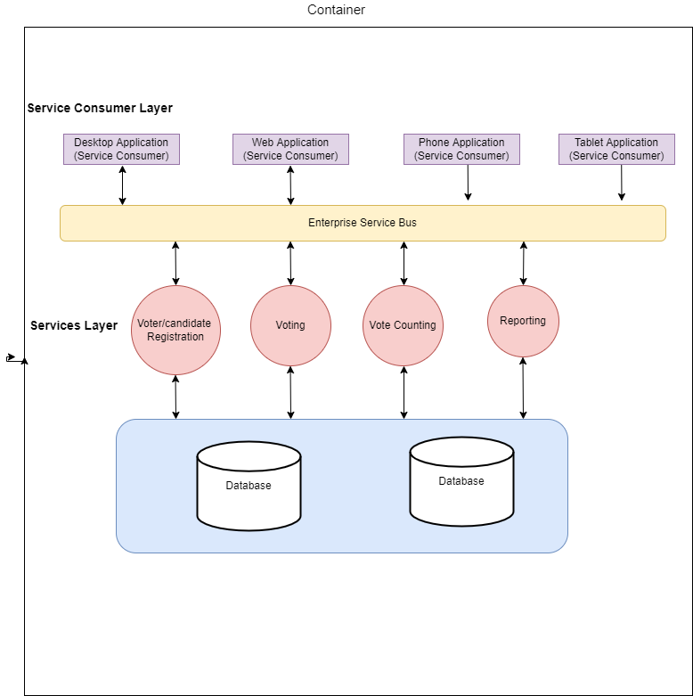

**Figure 3. 1: Service Oriented Architecture for the Electronic Voting System**

## DATA COLLECTION METHOD AND USER’S NEED

Data collecting and information gathering must come first in order to create this system, allowing for the creation of the application while taking into account all of the system's requirements and needs. To determine the needs of the user, observations and interviews are conducted.

### OBSERVATION

From our observations we realized that most people often complain about low transparency, fairness, and effectiveness (Takougang & Krieger, 2019). In addition, the country's electoral process has been plagued by irregularities, fraud, and violence (Nkongho, 2019). These issues have led to a lack of trust in the electoral system. the unfair attendance control in most academic institutions. The traditional method of using ballot boxes to cast votes and manually counting votes recorded on the paper ballots has been ineffective and has failed to an extent. The process could easily be tricked.

A lot of people equally complain about the tedious process of voting as one has to stand in a long queue just to cast a vote.

With these observations the web-based system is needed with urgency

### INTERVIEWS

The interview was carried out with some voters where they gave lots of complains against the manual system. Here are some common complaints and concerns expressed by them:

* Long Waiting Times: Voters often complain about the long queues and waiting times at polling stations during elections. This can be particularly inconvenient for individuals with time constraints, such as those with work or family commitments.
* Inefficiency and Delays: Some voters express frustration with the overall inefficiency of the manual voting process. The time taken to manually verify identification, mark the ballot, and deposit it in the ballot box can be perceived as slow and cumbersome.
* Errors and Confusion: Voters may raise concerns about errors and confusion during the manual voting process. Illegible handwriting on the ballot, improper marking, or confusion over the voting procedure can lead to invalid votes or challenges in accurately reflecting their choices.
* Accessibility Challenges: Individuals with disabilities or those with mobility issues may face difficulties accessing polling stations that lack appropriate facilities or accommodations. This can hinder their ability to vote independently and effectively.
* Lack of Privacy: Some voters express concerns about the lack of privacy in the manual voting system. The visibility of other voters and the potential for coercion or influence can make them uncomfortable in expressing their true choices.

## FUNCTIONAL REQUIREMENTS

* Voter and Candidate Registration and Verification:

To guarantee that only qualified voters can participate in the election, the system should allow eligible voters and nominated candidates to register and authenticate themselves. To confirm the legitimacy of voters, the system should incorporate multi-factor authentication techniques, such as biometric identification, requesting for voters’ cards and ID Cards.

* Candidate Nomination and Verification:

Political parties and candidates should be able to nominate themselves through the system and go through verification to make sure they fit the requirements.

* Ballot Creation and Delivery:

Each eligible voter should receive only one ballot, thus the system should generate and distribute ballots accordingly.

* Vote Casting:

Voters should be able to use the electronic voting interface to cast their ballots safely and discreetly.

* Vote Counting and Tabulation:

Voters' votes should be accurately counted and tabulated by the system to guarantee fair and transparent results.

* Results Reporting and Certification:

The system shall provide accurate and thorough information on the number of votes cast for each candidate as well as fast and transparent reporting of the election results.

* User-friendly Interface:

Even for voters who are not tech savvy, the system should have a user-friendly interface that is simple to navigate and understand.

* Multi-Language Support:

The system should provide support to accommodate voters who speak different languages.

## NON-FUNCTIONAL REQUIREMENTS

* Security and Integrity of the Voting Process:

The system must be safe and secure in order to guard against any illegal access, data tampering, or manipulation. The integrity and confidentiality of the voting data are protected by encryption and secure transmission methods.

* Accuracy:

Votes must be correctly counted and recorded by the system without any mistakes or inconsistencies.

* Transparency:

Voters must be able to confirm that their votes have been correctly recorded, and the system must be transparent in this regard.

* Accessibility:

All eligible voters, including those with impairments, must be able to use the system, through the use of assistive technologies.

* Reliability:

Throughout the election process, the system must be dependable and run without any malfunctions or outages.

* Scalability and Flexibility:

The system must be scalable, meaning it must be able to manage a high number of voters, and flexible to accommodate changing voter needs and evolving technology.

* Auditability:

The system has to be auditable so that the results can be thoroughly examined and verified after the election. The system needs to keep a thorough audit record of all election-related actions, allowing for impartial verification of the vote results.

* Data privacy:

The voting data and personal information of voters must be protected by the system.

## RESEARCH DESIGN

After interpretation of the data, tables were drawn and process of data determined to guide the researcher of the implementation stage of the project. The tools, which were employed during this methodology stage, where mainly tables, Use Case Diagrams and Class Diagrams. The design ensures that only authorized users are allowed to access the systems information.

## ANALYSIS METHODS

Analysis methods are processes which make it possible to formalize the preliminary stages of the development of an information system. In order to make this development more fruitful to the candidates and voters requirements, we will successively study the object-oriented methods and the functional methods.

## OBJECT ORIENTED METHOD

We used is UML as modeling language. Object oriented methods describe the static structure of the objects, the classes and their relations. One can quote among others: OMT method, UML method and UP method.

## CHOICE OF METHOD METHOD

## APPLICATION OF METHOD

UML stands for Unified Modelling Language, which is standardized language used to visualize, design, and document software systems. It provides a set of graphical notations and diagrams to represent the various aspects of a software system, such as its structure, behavior and interactions.

### ACTORS

An actor in a system is a human being or an external software which interacts with the system to make a system complete.

* **System** **Administrator:** The admin refers to the individual handling or doing the general overseeing of the platform by adding, deleting and updating voters, polling officers, and candidates in the system. This personality controls the election process.
* **Voters:** The voters registers into the system as voters and cast his/her vote.
* **Candidates:** Candidates refer to those who are to be elected. They simply register into the system as candidates and check their tally.
* **Polling Officers:** They simply monitor the ballots and check the tally to ensure that everything is moving on well.

### DIAGRAMS

* **USE CASE DIAGRAM**

The Use case or user case diagram is one which clearly shows all the actors in a given system, and how those said actors interact with that system.

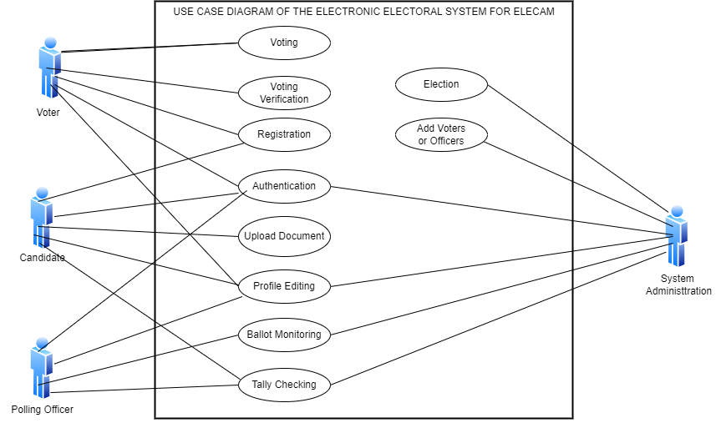

**Figure 3. 2: Use Case Diagram for the Electronic Voting System**

* **CLASS DIAGRAM**

A class diagram is a type of UML diagram that represents the structure of a software system by showing the classes, their attributes, methods, and the relationships between them.

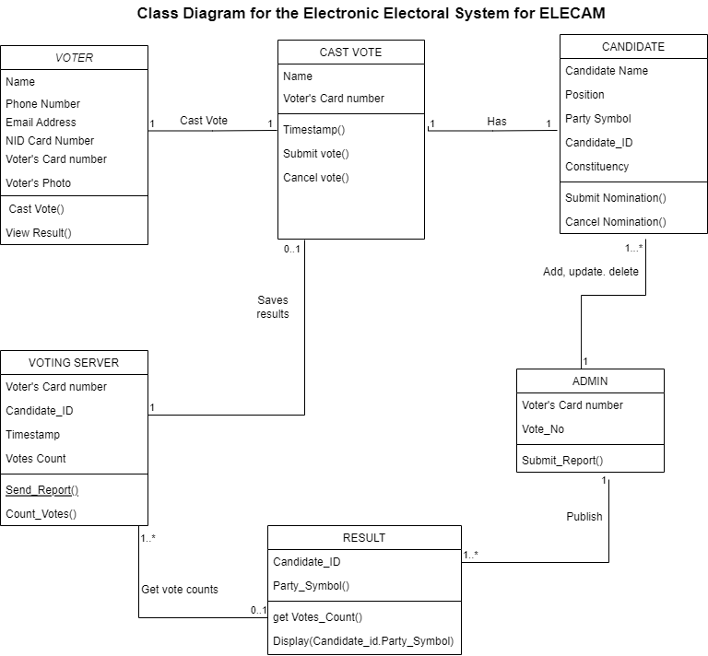

**Figure 3. 3: Class Diagram for the Electronic Voting System**

### COMPONENTS OF THE SYSTEM

* Client Devices (users): The client devices include computers and all devices used to get into the system.
* Server (Web Servers): The web server is used to host the web app so that it can be accessed by users through web browsers.
* Database (SQLite): The database used is SQLite. It stores the information about voters, candidates, polling officers and admin. SQLite is a server application for database which is able to carry out a great number of SQL commands.

## VARIOUS MODELS OF THE SYSTEM USED FOR DESIGN

### DATA DICTIONARY

After the analysis of the various stages, the data dictionary is then established. These are tables of data listed in precise details; column number, Reference, Significance, Type and Size. This data is represented in the dictionary below.

|  |  |  |  |  |
| --- | --- | --- | --- | --- |
| No | Reference | Significance | Type | Size |
| 1 | Voter_id | Voter Identifier | IntegerField | 10 |
| 2 | Voter_name | Voter name | CharField | 30 |
| 3 | Gender | sex | CharField | 6 |
| 4 | email | Email address | EmailField | 20 |
| 5 | Phone_number | Phone number | IntegerField | 9 |
| 6 | Candidate_id | Candidate identifier | IntegerField | 10 |
| 7 | biography | Candidate biography | CharField | 500 |
| 8 | candidate_voted_for | Candidate voted for | CharField | 30 |
| 9 | priority | Priority of candidates after votes | IntegerField | 2 |
| 10 | Officer_id | Officer identifier | IntegerField | 10 |
| 11 | Report_id | Report identifier | IntegerField | 10 |

## SOFTWARE USED

There are various software used to come out with the final results of the platform in question. They are:

* **VISUAL STUDIO CODES** (text editor): This is the code editor we have used to code all the system no matter the programming language used.
* **GOOGLE CHROME:** This is the browser used throughout my project to view if we really got the required output at any stage of my project.
* **LOCALHOST SERVER:** This is the local server we used since we must use a server to store the system’s data.
* **SQLITE:** This was the Database Management System used in creating and handling all the databases of the voting web app.
* **DRAW.IO:** This app was used in drawing various logical diagrams, like the UML class diagram, and service oriented architecture of the system.

## PROGRAMMING TECHNOLOGIES USED

* **HTML:** HTML which stands for Hyper Text Markup Language is the main language of all the languages in web development. Without this language, no other languages can run on a browser, so HTML is use to display the web pages with respect to a set of tags written on the pages. The first version was written by (Tim, 1993).
* **BOOTSRAP:** It is a JavaScript framework which was released by (Twitter, 2010). This contains thousands of CSS and JavaScript codes which are added to our website to make it look appealing and responsive.
* **CSS:** Cascading Styles Sheets is used to add beauty (styles) to content displayed on web pages. It is embedded in HTML tags or linked with HTML files. CSS enhanced the layout of the web site and make the site look more attractive. Released by (W3C, 1996), there are many types of CSS (1, 2.0, 2.1, and 3)
* **JAVASCRIPT:** Released by (Netscape and Sun Microsystems, 1995). JavaScript is a programming language, an interpreted language, object-based programming. It is a script-client-side language used for interactive web pages.
* **DJANGO:** It is a high level python framework that enables the rapid development of secure and maintainable web applications. It follows the model-view-controller (MVC) architectural pattern and emphasizes on the use of reusable code components.

## HARDWARE USED

The following hardware tools were used in the implementation of the electronic electoral system.

* **A CAMTEL** Mobile access point was used for internet access.
* **A TOSHIBA** laptop equipped with a WINDOWS 10 operating system, showing three principal characteristics: a hard disk of 500Go, a memory RAM of 4Go and an INTEL processor with 3.12 GHz processor speed.
* **A MOBILE PHONE** for research purposes.