

MRHE Dynamics 365 CRM – Functional Requirement Document

Project Name:

MRHE_Dynamics 365 CRM On-premise

Prepared by:

Venkata SambasivaRao Rao Kesanam

Date :

10-Feb-19



Table of Contents

1. | Version Control ........................................................................................................................... |  | 3
2. | PROJECT DETAILS........................................................................................................................ |  | 3
 | 2.1 | Objective ............................................................................................................................. | 4
 | 2.2 | Project Description............................................................................................................ | 4
 | 2.3 | Project Scope/Functional Requirements ................................................................... | 6

 | 2.3.1 | Infrastructure Setup ................................................................................................... | 7
 | 2.3.2 | Customer Management .......................................................................................... | 7
 | 2.3.3 | Marketing Module ................................................................................................... | 12
 | 2.3.4 | MRHE Integrations with CRM ................................................................................ | 14
 | 2.3.5 | Microsoft Social Engagement .............................................................................. | 25
 | 2.3.6 | Case Management (Complaints / Suggestions) ........................................... | 27
 | 2.4.7 | Call Center Integration with Dynamics CRM................................................... | 37
 | 2.4.8 | Master Data .............................................................................................................. | 38
 | 2.4.9 | Reports & Dashboards............................................................................................ | 42
3 | Pre-requisites & Dependencies ........................................................................................... |  | 43
4 | Assumptions ............................................................................................................................... |  | 43
5 | Training ........................................................................................................................................ |  | 44
6 | Application Security Requirements .................................................................................... |  | 44
7 | Annexure .................................................................................................................................... |  | 44
8 | Glossary ...................................................................................................................................... |  | 45
9 | Project Scope Approval / Signatures ................................................................................ |  | 46

2

1. Version Control

Date | Version | Author | Remarks
08-08-24 | 1.0 | Syed Amanullah | Draft Version

3
2. PROJECT DETAILS

2.1 Objective

The Time Off Tracker is a model-driven application designed to streamline the process of requesting, tracking, and approving time off for employees within an organization. The application will be built on the Power Platform, utilizing Dataverse as the backend data storage solution. This system will allow U.S. employees to submit time-off requests, which will then be routed to their respective managers or the HR department for approval. Additionally, the application will provide visibility into approved time off for teams and enable managers to manage various types of time off such as Sick, Vacation, Unpaid Time, and Comp Time.

2.2 Project Description

Power Platform used to build the below modules for T-O-T [Time off Tracker] application Implementation.

- Customer Management

- Marketing

- Service Module – Case Management

- Microsoft Social Engagement Integration

- Integrations:

- Integration with Exchange Server o Call center Integration

o Mobile Integration o SMS Integration

o Portal Integration o Kiosk Integration

o Backend oracle system o EID Customer Visits

o FileNet Archiving System

Dynamics 365 CRM would primarily be used by MRHE Users and Call Center Users to store all Customers and Cases from CRM, Kiosk, Portal and Mobile App. The CRM system will provide the guided business processes for the Customer Management, Case Management & Microsoft Social Engagement.

The below diagram would describe the expected detailed MRHE Dynamics 365 CRM Architecture and Integrations.

4

Call Center

Users

Online | MS Social
Online | Engagement
Person | Engagement
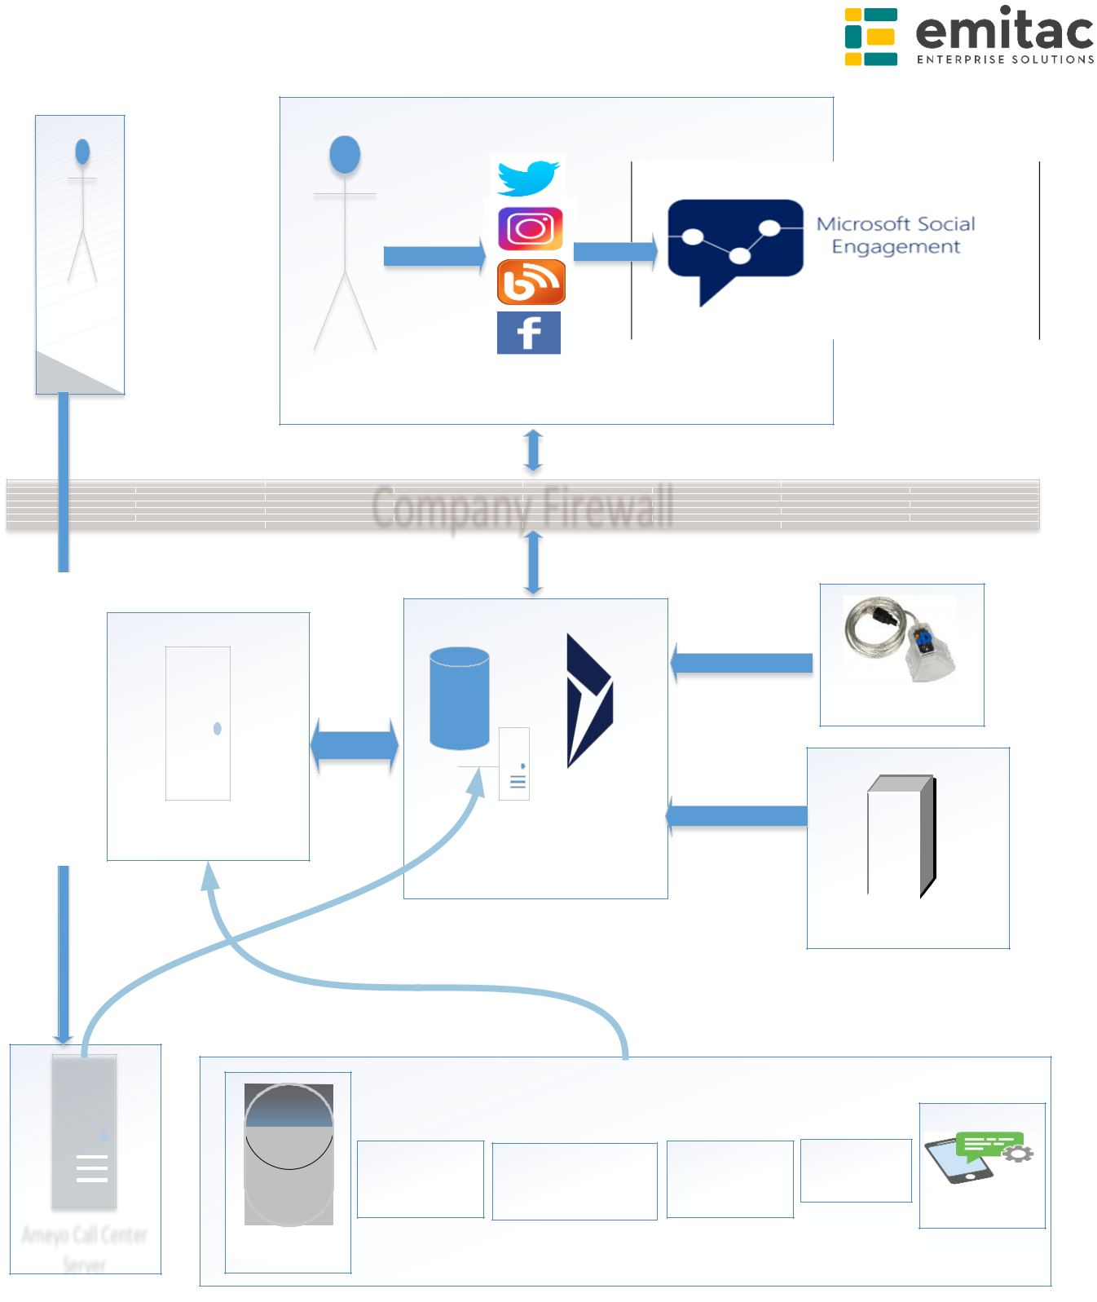

Company Firewall

MRHE API Server

SQL Server | MS
 | Dynamics
 | 365 - CRM

Below Systems will use MRHE API

EID Reader

Email Exchange Server

Ameyo Call Center

Server

Kiosk System | MRHE Website Portal | Mobile | FileNet
Kiosk System | MRHE Website Portal | App(Iskan App) | FileNet
 |  | App(Iskan App) | SMS Gateway
OracleDB

- SMS Gateway is using it for sending SMS’s from CRM to Customers.

- Email Exchange Server is using it for sending Email Notifications to Customers from CRM.

5

- EID reader should be used for reading the Customer details and store it in CRM as a Customer and store the visit activity.

- FileNet Archiving system should be used for displaying the Customer Archived documents using MRHE API.

- Kiosk should be used it for registering the Customers and Cases from MRHE API Server to CRM.

- Website Portal should be used it for registering the Customers and Cases from MRHE API Server to CRM.

- Mobile App should be used it for registering the Customers and Cases from MRHE API Server to CRM.

- Oracle DB should be used it for synching the Customers from MRHE API Server to CRM. This should not be a direct sync program from CRM side, and from CRM side EES would provide the code to embed in existing MRHE sync program to sync the Customers from Oracle DB to CRM.

- Microsoft Social Engagement should be used it for creating the Customers & Cases for negative posts.

- Call Center Integration should be used it for incoming calls and CRM will display the pop-up window for the registered customer whenever the call comes from the customer.

2.3 Project Scope/Functional Requirements

Design, Development, Implementation and Delivery of Dynamics 365 On premise CRM for MRHE.

The scope of Dynamics 365 On premise CRM for MRHE includes the below modules.

- Customer Management

- Marketing

- Service Module – Case Management

- Microsoft Social Engagement Integration

- Integrations:

- Integration with Exchange Server

6
  - Call center Integration o Mobile Integration

o SMS Integration o Portal Integration o Kiosk Integration

o Backend oracle system o EID Customer Visits

o FileNet Archiving System

- Master Data

- Reports & Dashboards

2.3.1 Infrastructure Setup

Following environment would be provided by MRHE for development & Production.

- Dynamics 365 On premise Server would be used for both development & production. The Dynamics 365 On premise server would have following two instances:
o Production

o Development/QA

- Microsoft Social Engagement Instance would be used to Integrate with Microsoft Dynamics 365 for Social Channels like Facebook, Twitter, Instagram, Videos and News etc.

- Exchange Server would be used with CRM. The main CRM Admin user would be configured for triggering emails.

- SMS API would be used to send SMS’s to Customers & MRHE CRM Users for Complaint/Suggestion/Enquiry creation & resolution.

2.3.2 Customer Management

Microsoft Dynamics 365 Customer Management should allow to store and manage Accounts & Contacts.

7
Accounts: Accounts are organizations and would be used for Organizations/Partners/Contractors/Call Center Vendors.

Contacts: Contacts are individual people and would be used for Individual People/Customers.

The Entity & field details should be as follows:

Accounts/Contractors:

Field Name | Field Type | Validation/Comments (if
(* - mandatory) |  | any)
Account Name * | Single Line of Text
Account Type * | Drop Down
 | ➢ Partner
 | ➢ Contractor
 | ➢ Call Center
Strategy * | Lookup | Link the Strategy Entity
Relationship Type * | Lookup | Link the Relationship Entity
Business | Lookup | Link the Business Unity Entity
Unit(Department)*
Agreement Date | Date
Impact on Services | Drop Down
 | ➢ Engineering
 | ➢ Housing
 | ➢ Finance
Impact on Strategy | Drop Down
 | ➢ Engineering
 | ➢ Housing
 | ➢ Finance
Impact on | Drop Down
Customer | ➢ Engineering
Satisfaction | ➢ Housing
 | ➢ Finance
Classification | Checkbox
 | ➢ Engineering
 | Strategic Partner
 | ➢ Housing Strategic
 | Partner
 | ➢ Finance Strategic
 | Partner
Email * | Single Line of Text – Email
Mobile Phone * | Single Line of Text –

8
 |  | Phone
 | Business Phone | Single Line of Text –
 |  | Phone
 | Fax | Single Line of Text
 | Website | Single Line of Text – URL
 | Primary Contact | Lookup – Contact
 | Address Details:
 | Street 1 | Single Line of Text
 | Street 2 | Single Line of Text
 | Street 3 | Single Line of Text
 | City | Single Line of Text
 | State/Province | Single Line of Text
 | P.O. Box Number | Single Line of Text
 | Country/Region | Single Line of Text
 | Contact
 | Preferences:
 | Contact Method | Drop Down
 |  | ➢ Any
 |  | ➢ Email
 |  | ➢ Phone
 |  | ➢ Fax
 |  | ➢ Mail
 | Email | Two Options
 |  | ➢ Allow
 |  | ➢ Do Not Allow
 | Phone | Two Options
 |  | ➢ Allow
 |  | ➢ Do Not Allow
 | Fax | Two Options
 |  | ➢ Allow
 |  | ➢ Do Not Allow
 | Mail | Two Options
 |  | ➢ Allow
 |  | ➢ Do Not Allow
 | Contracts | Entity | New Entity to Account (1:N
 |  |  | Relationship)
Strategy:
 | Field Name | Field Type | Validation/Comments (if
 | (* - mandatory) |  | any)
 | Name * | Single Line of Text
 | Description | Multiple Line of Text

9

Contracts:

 | Field Name | Field Type | Validation/Comments (if
 | (* - mandatory) |  | any)
 | Name * | Single Line of Text
 | Description | Multiple Line of Text
Relationship Type:
 | Field Name | Field Type | Validation/Comments (if
 | (* - mandatory) |  | any)
 | Name * | Single Line of Text
 | Description | Multi Line of Text
Services/Products:
 | Field Name | Field Type | Validation/Comments (if
 | (* - mandatory) |  | any)
 | Name * | Single Line of Text
 | Description | Multi Line of Text
Customer Service:
 | Field Name | Field Type | Validation/Comments (if
 | (* - mandatory) |  | any)
 | Name * | Single Line of Text
 | Description | Multi Line of Text
Contacts:
 | Field Name | Field Type | Validation/Comments (if
 | (* - mandatory) |  | any)
 | First Name * | Single Line of Text
 | Last Name * | Single Line of Text
 | Full Name * | Single Line of Text | First Name + Last Name
 | Application No* | Whole Number
 | Title | Drop Down
 |  | ➢ The Master
 |  | ➢ Mr.
 |  | ➢ Ms.
 | Job Title | Single Line of Text
 | Email * | Single Line of Text - Email

10
Mobile Phone * | Single Line of Text - Phone | Validate Mobile Number
Business Phone | Single Line of Text - Phone
Fax | Single Line of Text
UAE Identity Card | Whole Number | The number must be 15
Number |  | digits and without any
 |  | separator
Preferred Method | Drop Down
of Contact * | ➢ Phone
 | ➢ Mobile Phone
 | ➢ Email
Language | Drop Down
Preference | ➢ Arabic
 | ➢ English
Emirate | Drop Down | Create Global Option Set
 |  | and link
Education Level* | Drop Down | Create Global Option Set
 |  | and link
New/Age * | Drop Down
 | ➢ Below 18
 | ➢ 18-30
 | ➢ 30-40
 | ➢ 40-50
 | ➢ 50-60
 | ➢ Above 60
Nationality * | Drop Down | Create Global Option set
 |  | and link
Address Details:
Street 1 | Single Line of Text
Street 2 | Single Line of Text
Street 3 | Single Line of Text
City | Single Line of Text
State/Province | Single Line of Text
P.O. Box Number | Single Line of Text
Country/Region | Single Line of Text
Personal Details:
Sex * | Drop Down
 | ➢ Male
 | ➢ Female
Marital Status | Drop Down
 | ➢ Single
 | ➢ Married
 | ➢ Divorced
 | ➢ Widowed

11
Spouse/Partner | Single Line of Text
Name
Birthday/Date of | Date
Birth
Anniversary | Date
Contact
Preferences:
Contact Method | Drop Down
 | ➢ Any
 | ➢ Email
 | ➢ Phone
 | ➢ Fax
 | ➢ Mail
Email | Two Options
 | ➢ Allow
 | ➢ Do Not Allow
Phone | Two Options
 | ➢ Allow
 | ➢ Do Not Allow
Fax | Two Options
 | ➢ Allow
 | ➢ Do Not Allow
Mail | Two Options
 | ➢ Allow
 | ➢ Do Not Allow
Customer Services
Finance Details | Section | Display the Total Financial
 |  | Details using MRHE API.

2.3.3 Marketing Module

Out of the box D365 CRM marketing features should be configured which would include the following:

- Marketing List: Marketing Lists to allow the segmentation of the leads, contacts and accounts into marketing lists to communicate with targeted audiences.

Marketing Lists would be used majorly for the following:

  - To send out company newsletters

12
  - To distribute promotional emails

  - To send event information and updates

  - To use in mail merges

- Campaigns: Campaigns for campaigning and use them to track the ROI. It should allow to keep track of any activities involved in a campaign, such as emails, phone calls, and other activities that are distributed. You can also add planning activities to a campaign.

Marketing Module should have the below Entities and Fields:

Marketing List:

 | Field Name | Field Type |  | Validation/Comments (if
 | (* - mandatory) |  |  | any)
 | Name * | Single Line of Text
 | List Type * | Dropdown
 |  | • | Static
 |  | • | Dynamic
 | Purpose | Single Line of Text
 | Targeted At | Dropdown
 |  | • | Account
 |  | • | Contact
 |  | • | Lead
 | Source | Single Line of Text
 | Marketing List | Multi Line Text
 | Description
 | Currency | Currency (Default set to
 |  | AED)
 | Modified on | Date & Time
 | Last Used on | Date & Time
Campaign:
 | Field Name | Field Type |  | Validation/Comments (if
 | (* - mandatory) |  |  | any)
 | Campaign Details:
 | Campaign Name * | Single Line of Text
 | Campaign Code | Single Line of Text
 | Currency * | Currency (Default set to
 |  | AED)
 | Campaign Type | Dropdown
 |  | • | Paper Ads

13
 | • | Radio Ads
 | • | Social Media
 | • | Email
 | • | SMS
 | • | Outdoor
 | • | Advertisement
 | • | Direct Marketing
 | • | Event
 | • | Co-branding
 | • | Other
Expected Response | Whole Number
(%)
Estimated Revenue | Currency
Status Details | Dropdown
 | • | Proposed
 | • | Ready to Launch
 | • | Launched
 | • | Completed
 | • | Canceled
 | • | Suspended
Schedules:
Proposed Start | Date Field
Proposed End | Date Field
Actual Start | Date Field
Actual End | Date Field
Offer Details | Multi Line Text
Financials:
Allocated Budget | Currency
Misc. Cost | Currency
Activity Cost | Currency |  | Automatic Calculation
Total Cost | Currency |  | Automatic Calculation
Description | Multi Line Text

2.3.4 MRHE Integrations with CRM

As part of Integrations, Dynamics 365 On premise CRM should be integrated with the below components for Registration of Customers (mostly contacts), Cases.

- Mobile Apps

- Kiosk

- Website Portal

- Oracle DB

14
- EID Visitors & Visits

- FileNet Archiving System

The CRM Integration API should be created and hosted in MRHE DMZ in house server. MRHE will provide the required infrastructure to deploy the CRM Integration API. MRHE has a Unified API layer that works with Mobile Apps, Kiosk and Website.

So MRHE will push the below mentioned details from MRHE API server (considering from Mobile Apps, Kiosk, Oracle DB & Website) to Dynamics CRM using this CRM API.

CRM API should allow to do following:

- Customer(Contact) Registration: (Applicable for Mobile Apps, Website, Oracle DB & Kiosk)

Customer(Contact) registration will happen from Mobile Apps, Website, Oracle DB and Kiosk. So these details would be integrated with Dynamic CRM. CRM API would be provided to register the Customer details into CRM from MRHE API Server.

This would be one way integration from MRHE API Server to Dynamics CRM.

The following is the process flow for registering the Contact details into Dynamics CRM and for the Fields referring the Customer Management Contact details.

15



Customer Contact Details

MRHE will Push the Customer

Contact Details using CRM API

MRHE API Server


Contact

Registration

Ms Dynamics

365 - CRM

- Contractor (Account) Registration: (Applicable for Mobile Apps, Website & Kiosk)

Contractor (Account) registration will happen from Mobile Apps, Website and Kiosk. So these details would be integrated with Dynamic CRM. CRM API would be provided to register the Contractor (Account) details into CRM from MRHE API Server.

This would be one way integration from MRHE API Server to Dynamics CRM.

The following is the process flow for registering the Contractor (Account) details into Dynamics CRM and for the Fields referring the Customer Management Account details.

16



Contractor Details

MRHE will Push the Contractor
Details using CRM API

MRHE API Server


Ms Dynamics

365 - CRM
Contractor/
Account
Registration

- Case Registration:

Case registration will happen from Mobile App, Kiosk & Website to Dynamic CRM. So from CRM side, a CRM API would be provided to register the case from MRHE Mobile App, Kiosk and Website into dynamic CRM.

This would be one way integration from MRHE API Server to Dynamics CRM.

  - Request for Financial Information

Financial Information details would be stored on Contact form in CRM through CRM API. CRM API would be provided to register/update the Customer Financial Information on Contact form.

17

This would be one way integration from MRHE API Server to Dynamics CRM.

The following fields should be maintained on Contact form for Financial Information.
Field Name | Field Type | Validation/Comments (if
(* - mandatory) |  | any)
Application No | Whole Number
Application Name | Drop Down | Get the List from Master
 |  | Services
Date of Last Bill | Date
Monthly Payment | Currency
Over Due Amount | Currency
Remaining Loan | Currency
Maturity Date | Date
Starting Balance | Currency
Next Payment Date | Date
Remaining Months | Whole number
Remaining Years | Whole number
Discount | Currency
Discount | Decimal number
Percentage
Early Settlement | Currency
Amount to Pay | Currency

The following is the process flow for updating/registering the Financial details into Dynamics CRM.

18

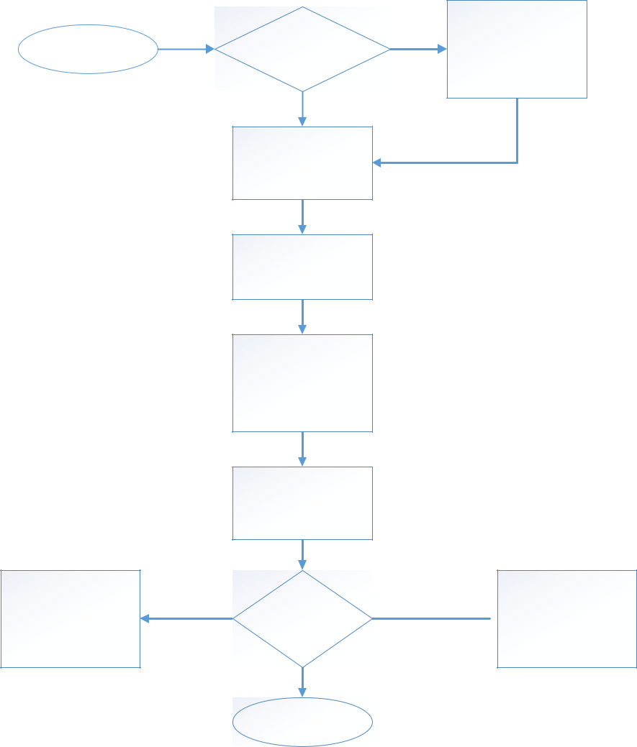
Start | Customer(Contact)
Start | Exist or Not

Not | Create
Not | Customer(Contact)

Priority:

Complex
Critical

Get the Certificate from

E-Collection and Send it
via Email

Exist

Create Case with Case
type as Request for
Financial Info

Assign the Case To Front
Office Team -> Review
& Evaluate the Case

Assign the Case to
Corresponding BU
Team/Member

Team/Member would
check the Enquiry

Subject & Financial Data

Certificate Certificate/Enquiry

Send the Financial

Enquiry Information Via Email
To Customer
Regular
Featured
Good
Normal


Origin/Channels:
Smart App
Call Center
Phone
Email
Web
In-Person
Facebook
Twitter

Close Case

19



Financial Details

MRHE will Push the Financial
Details Details using CRM API

MRHE API Server


Ms Dynamics

365 - CRM

2. Request for Appointment

Financial
Information

Appointment details should be stored as an Appointment and linked with Contact form in CRM through CRM API. CRM API should allow to create the Customer Appointment.

This would be one way integration from MRHE API Server to Dynamics CRM.

The following fields should be maintained on Appointment form.

Field Name | Field Type | Validation/Comments (if
(* - mandatory) |  | any)
Business Unit to Visit | Lookup
Customer | Lookup
Mobile No | Mobile | Get the Customer Mobile
 |  | Number from Customer
 |  | Lookup
Email | Email | Get the Customer Email id

20

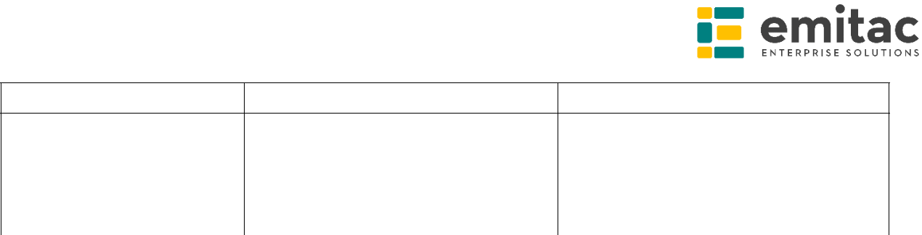
from Customer Lookup

Request Number | Whole Number
Service Type | Lookup
Meeting Subject | Single Line of Text
Meeting Type | Lookup

The following is the process flow for Request for Appointment.
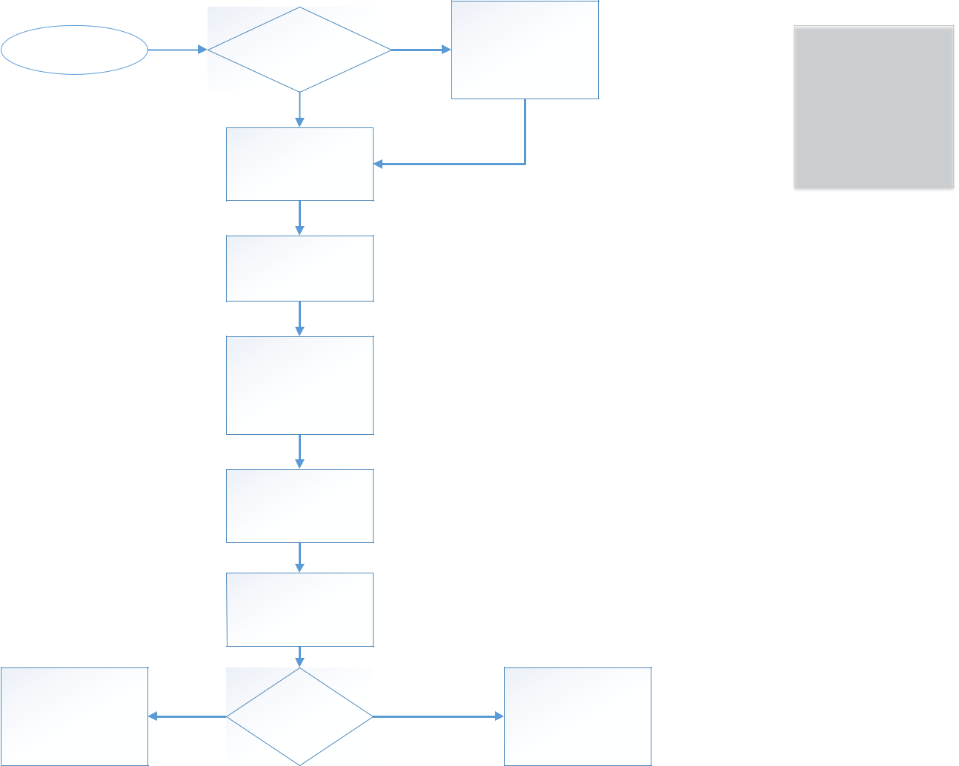

Start | Customer(Contact)
Start | Exist or Not

Not | Create
Not | Customer(Contact)

Priority:

Complex
Critical

Close Appointment & | Yes
Case in CRM | Yes

Exist

Create Case with Case

type as Request for

Appointment

Assign the Case to

Corresponding BU

Corresponding BU

Team/Member Create

Appointment in

Coordination with

Responsible Emp.

Send SMS and Email

Details of Appointment

to Customer & Emp

Appointment would be

added to CRM Calendar

& Outlook Calendar

Customer Visit

 | Close Appointment &
 | Case at the End of the
No | Day with Status
 | Customer did not
 | come
Regular
Featured

Good
Normal



Origin/Channels:
Smart App

Call Center

Phone
Email
Web

In-Person

Facebook
Twitter

21



Case & Appointment Details

MRHE will Push the Case & Appointment Details using CRM API

MRHE API Server


Request for Appointment

Ms Dynamics

365 - CRM

- Request for General Information

General Information details should be stored as a Case in CRM through CRM API. CRM API should allow to create the Customer Case for Request for General Information.

This would be one way integration from MRHE API Server to Dynamics CRM.

The following is the process flow for Request for General Information.

22

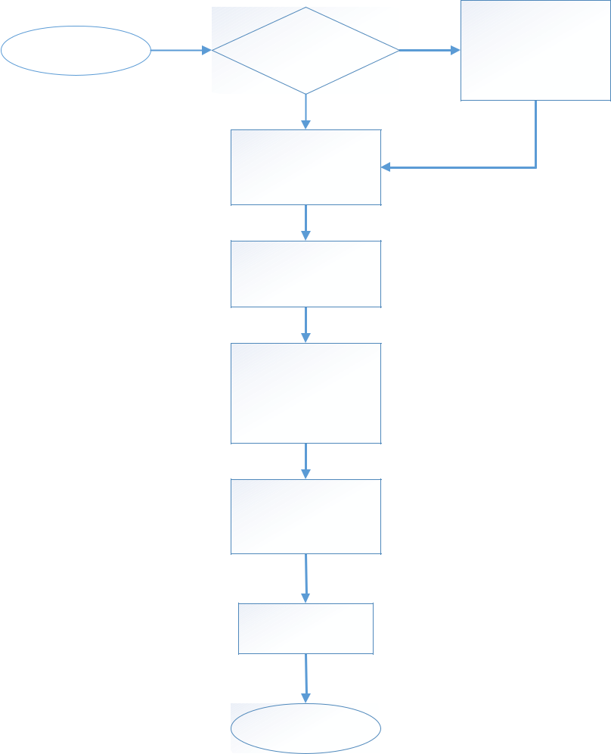
Start | Customer(Contact)
Start | Exist or Not

Exist

Create Case with Case

type as Request for

General Information

Assign the Case To Front

Office Team -> Review

& Evaluate the Case

Assign the Case to

Corresponding BU

Team/Member

Team/Member would

check the Enquiry

Subject & Financial Data

Review the Case

Close Case

Not | Create
Not | Customer(Contact)

Priority:

Complex

Critical

Regular

Featured

Good

Normal


Origin/Channels:

Smart App

Call Center

Phone

Email

Web

In-Person

Facebook

Twitter

23



Case for Request for General Finformation

Request for General Information

MRHE will Push the Request for
General Information Details using
CRM API

MRHE API Server


Ms Dynamics

365 - CRM

- FileNet Archiving System:

FileNet Archiving system should be used to show the archived documents from MRHE FileNet system.

CRM would maintain the unique Application No on the Customer(Contact) form to show/display the archived documents from FileNet.

The below process would be used for FileNet Archiving System from MRHE FileNet to Dynamics 365 CRM.

24

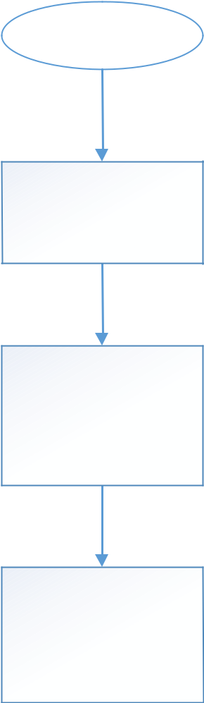
Start

Keep the Button on the
Customer(Contact) form

Click on the Button,
pass the Application No
and ID no stored in CRM
from MRHE FileNet

Display the details from
MRHE FileNet System
for Archived Documents

- EID Visitors & Visits:

Visitors would be created in CRM as a Contacts and Visits would be linked with Contacts as an Activity.

Once the Customer/Contact Visit the MRHE then send an Email/SMS to the Customer.

2.3.5 Microsoft Social Engagement

The Microsoft Social Engagement should be configured for social listening.

MSL Channels:

25
Microsoft Social Engagement should be configured with the below Social Channels.

➢ Facebook

➢ Twitter

➢ Instagram

MSL Keywords:

The following keywords should be configured to start with Microsoft Social

Engagement for MRHE.

General Tags

#مؤسسة_محمد_بن_راشد_لإلسكان ➢

#معرف_إسكان ➢

#مشاريع_سكنية ➢

#خدمات_إسكانية ➢

#تطبيق_إسكان ➢

#كيف_تبني_مسكنك ➢

#سامي_قرقاش ➢

#لجنة_البحوث_والدراسات_الهندسية ➢

#تطبيق_صون ➢

#تطبيق_المستشار_الهندسي ➢

#تطبيق_معرف_االسكان ➢

#حضانة_المنال ➢

#مبادرة_مدخور ➢

#اليسر ➢

#السداد_المبكر ➢

#العوض ➢

Specific Tags:

➢ #careers_mrhe

➢ #mrhe_gitex

#اليوم_العالمي_لإلسكان ➢

MRHE Social Pages:

26
Following pages to be configured in Microsoft Social Engagement.

- Instagram: @MRHE_Gov

- Twitter: @MRHE_Gov
- Facebook: @MRHE_Gov

MSE: Notification:

Automatic email notifications should be pushed to Corporate Department Head for Negative Sentiment Post and for Case Creation in CRM via Microsoft Social Engagement.

Process Flow of Microsoft Social Engagement:
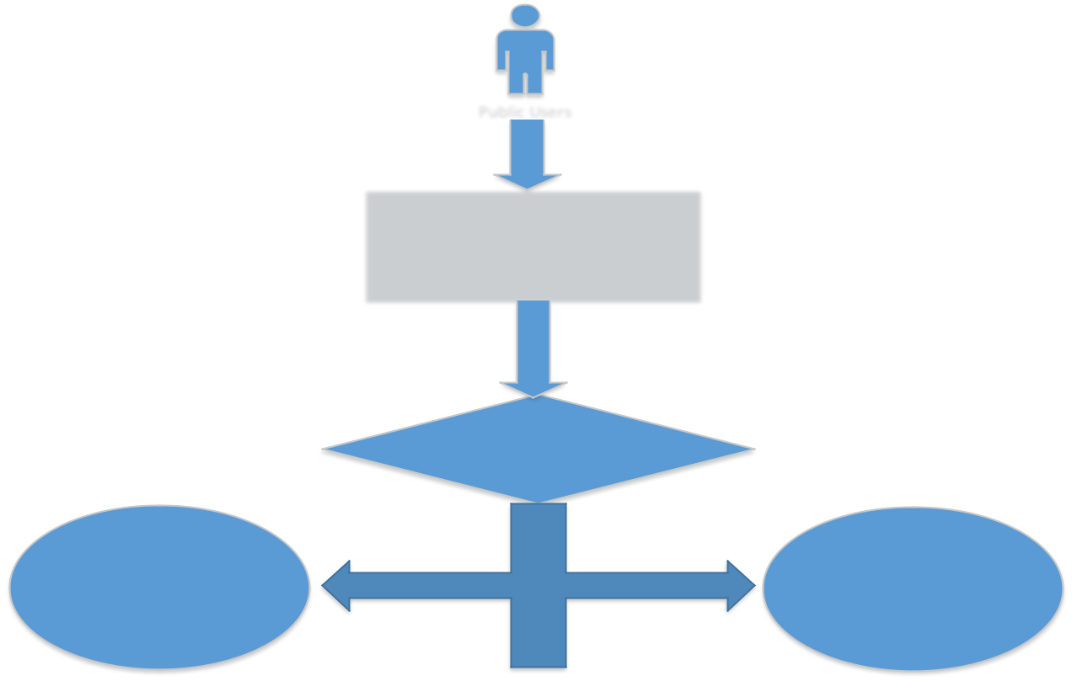

Public Users

 |  | Social Posts from
 |  | Public Users
 | Microsoft Social Engagement
Create Complaints/ |  | Create Complaints/
 |  | Suggestions for
Suggestions from Social
 |  | Negative
Posts(Manual)
 |  | sentiments(Manual)
 | Complaint/Suggestion Creation

Send Email To Corporate | Send Email To Customer On
Department Head On creation | creation of Complaint/
of Complaint/Suggestion | Suggestion

2.3.6 Case Management (Complaints / Suggestions)

Case Management (Complaint/Suggestion) should include Complaints/Suggestions Registrations and notifications to stakeholders & customers based on the status of the case.

Notifications will include both Email and SMS. So the Email and SMS Notifications would trigger on Complaint/Suggestion creation and resolution to Customers and respective CRM users in MRHE.

27
The Case Business process should be configured for Complaints & Suggestions respectively as below:

- Complaint Process Flow:
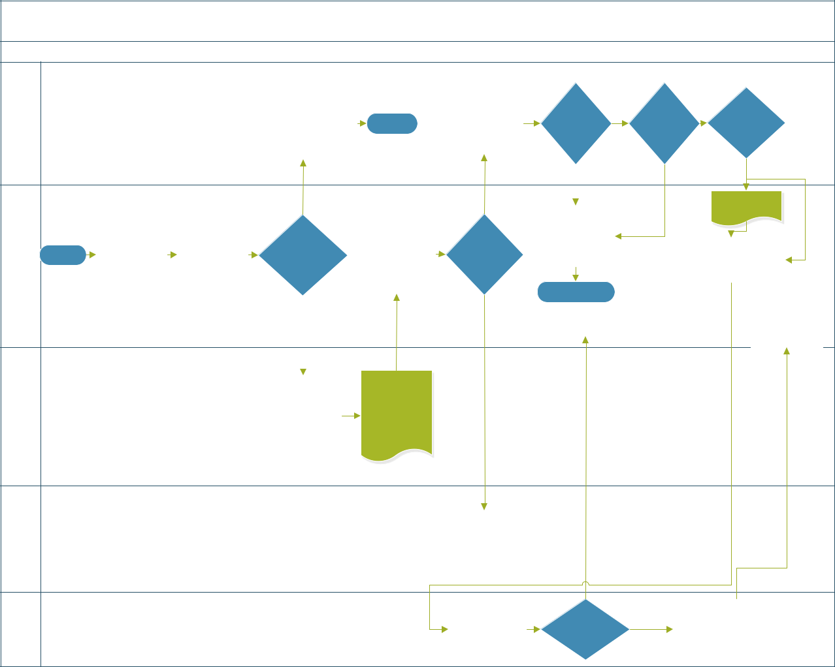

Complaint Process

Customer |  |  |  |  | Send Apologize |  | Communicat | Agree on |  |  | Any
 |  |  |  |  | Message & Close | End | e to | Agree on | No | Escalate | Yes Suggestio
 |  |  |  |  | Case |  | Customer | Solution |  |  | n
 |  |  |  |  |  |  | Yes | Yes |  |  | Yes
Complains Responsible |  |  |  |  | No |  | Yes | Yes |  |  | Create | No
Complains Responsible |  |  |  | Send Email |  |  |  | Update the |  | No | Suggestion
Complains Responsible |  |  | Complaint | To | Real | Study Case | Suitable | Case & |  |  | Assign to
Complains Responsible | User | Start | Complaint | Customer | Real | Study Case | Suitable | Close |  |  | Assign to
Complains Responsible | User | Start | Creation | Customer | Complaint | Solution | Solution | Close |  |  | Assign to
Complains Responsible | User |  | Creation | with Case | Complaint | Solution | Solution |  |  |  | Grievance User
Complains Responsible | User |  |  | Ref No |  |  |  | End |  |  | Store the
Complains Responsible | User |  |  |  |  |  |  |  |  |  | Suggestion
Complains Responsible | User |  |  |  | Yes |  |  | Comm. To Customer |  |  | in CRM to
 |  |  |  |  |  |  |  |  |  |  | Followup
Complains | Coordinator/Team |  |  |  | Send Email | Review the
Complains | Coordinator/Team |  |  |  | Send Email | Case and | No
Complains | Coordinator/Team |  |  |  | To | Case and | No
Complains | Coordinator/Team |  |  |  | To | Send First
Complains | Coordinator/Team |  |  |  | Complains | Send First
Complains | Coordinator/Team |  |  |  | Complains | Response
Complains | Coordinator/Team |  |  |  | Coordinator | Response
Complains | Coordinator/Team |  |  |  |  |  |  | No
CEO OfficeAsst. |  |  |  |  |  |  | Re-Study
Grievance |  |  |  |  |  |  | Check the |  |  | Answer in 3 W Days
Grievance | User |  |  |  |  |  | Suggestion | Feasible |  | Yes | & Define
Grievance | User |  |  |  |  |  | Already | Feasible |  | Yes | Implementation
Grievance | User |  |  |  |  |  | Exists or Not |  |  |  | Timeframe

- Suggestion Process Flow:

28
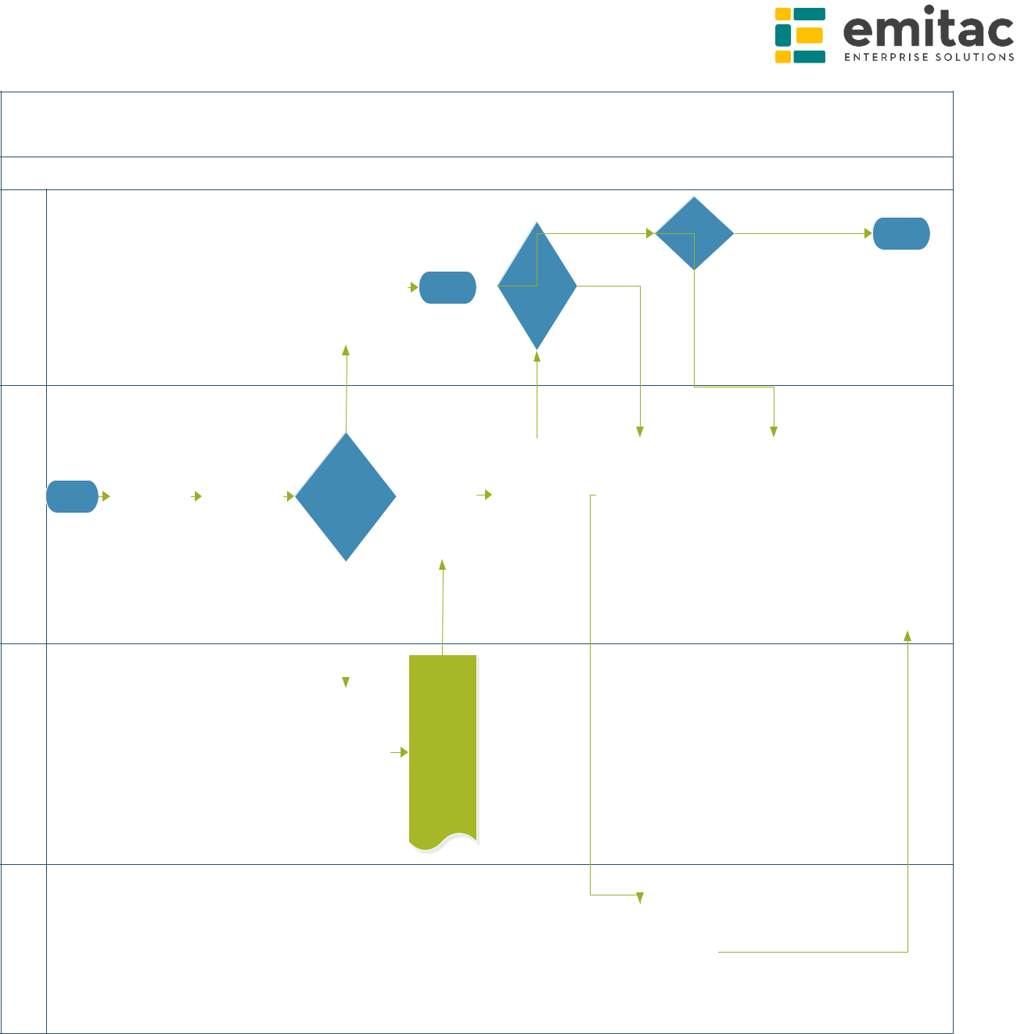
Suggestion Process
Customer |  |  |  |  | Send Apologize |  |  | Feasible | Not Feasible | End
 |  |  |  |  | Send Apologize |  | Agree To
 |  |  |  |  | Message & Close | End | Agree To
 |  |  |  |  | Message & Close | End | Evaluate
 |  |  |  |  | Case |  | Evaluate | No
 |  |  |  |  |  |  |  | Feasible
 |  |  |  |  | No
Suggestion Officer/ |  |  |  | Send Email |  | Receive |  | Forward/
Suggestion Officer/ |  |  |  | Send Email |  | Receive | Send | Assign
Suggestion Officer/ |  |  |  | To |  | Suggesti | Send | Assign
Suggestion Officer/ |  |  | Suggestion | To | Real | Suggesti | Evaluation | Suggestion | Implement
Suggestion Officer/ | Team | Start | Suggestion | Customer | Real | on | Evaluation | Suggestion | Implement
Suggestion Officer/ | Team | Start | Creation | Customer | Suggestion | on | Suggestion | To | Suggestion
Suggestion Officer/ | Team |  | Creation | with Case | Suggestion | Evaluatio | Suggestion | To | Suggestion
Suggestion Officer/ | Team |  |  | with Case |  | Evaluatio | to Customer | Grievance |  | Receive
Suggestion Officer/ | Team |  |  | Ref No |  | n | to Customer | Grievance |  | Receive
Suggestion Officer/ | Team |  |  | Ref No |  | n |  | Officer |  | S.Status and
Suggestion Officer/ | Team |  |  |  |  |  |  |  |  | Send to
Suggestion Officer/ | Team |  |  |  | Yes |  |  |  |  | Customer
 |  |  |  |  |  | Review
Suggestion | Coordinator |  |  |  | Send Email | the Case
Suggestion | Coordinator |  |  |  | Send Email | and Send
Suggestion | Coordinator |  |  |  | To | First
Suggestion | Coordinator |  |  |  | Suggestion | Response
Suggestion | Coordinator |  |  |  | Coordinator | in 15
Suggestion | Coordinator |  |  |  |  | Days Max
Grievance | Officer |  |  |  |  |  | Answer Suggestion &
Grievance | Officer |  |  |  |  |  |  | Try to find Suitable
Grievance | Officer |  |  |  |  |  |  | Solution

The system should allow the Complaints to be converted to Suggestions during the analysis process and if the created/converted Suggestion is not feasible then the person can apply for “Grievance” within the 3 days period otherwise the Suggestion can be closed.

- Suggestion Evaluation:

29
A suggestion evaluation form should be created in CRM for Evaluating the Suggestions received from the Customers. Below template can be used as reference for designing the CRM form:

30
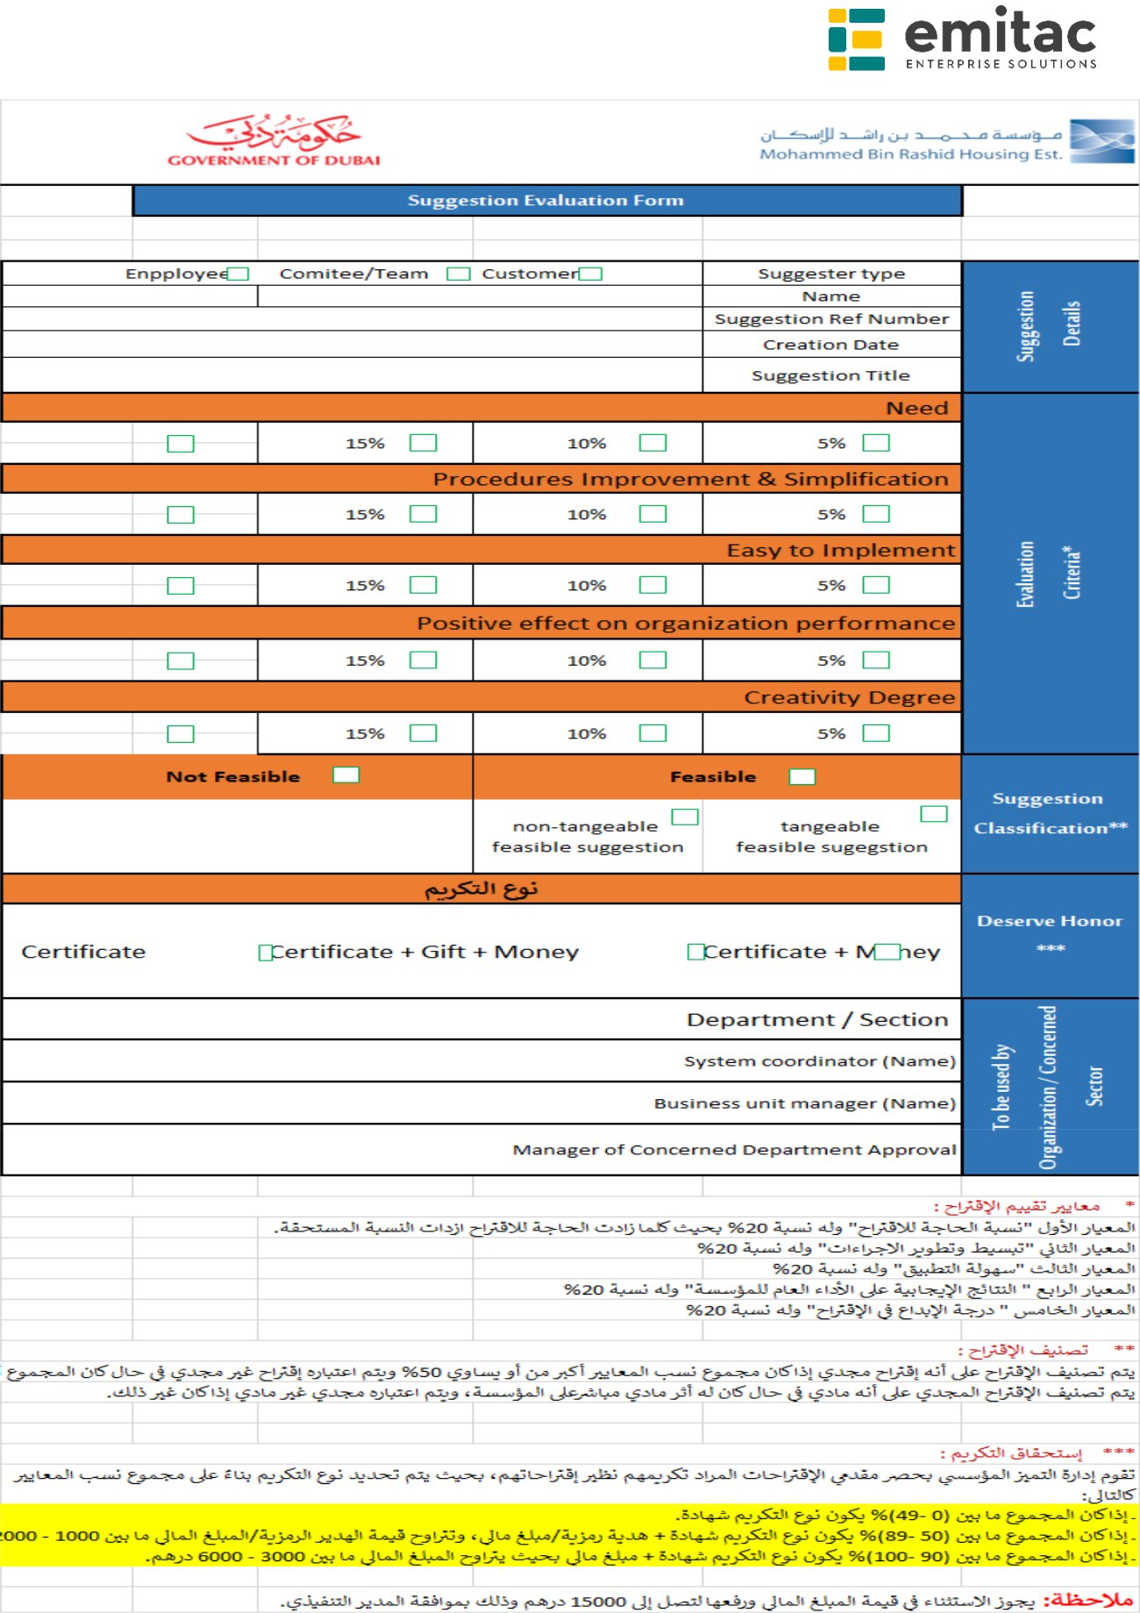

- Email Conversion to Case:

31
CRM should automatically convert Emails to Cases.

Complaint/Suggestion Process by
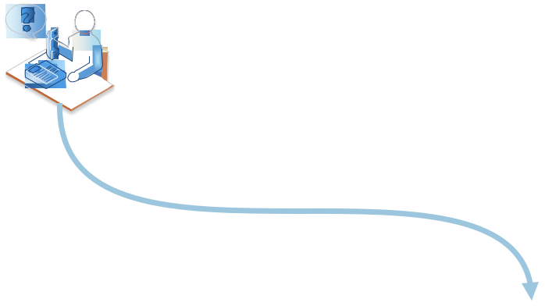
Email

Customer Sends
an Email | New Cases


Ms Dynamics
365 - CRM


- Feedbacks to Case:

Feedbacks should be created from MRHE Website and treated as cases in CRM.

The following entities and fields should be created for tracking Complaints/Suggestions.

Complaint/Suggestion:

Field Name | Field Type | Validation/Comments (if
(* - mandatory) |  | any)
Case Title/Subject * | Single Line of Text
Case ID * | Single Line of Text | Auto Generated
Date/Created on | Date | Auto Generated
Case | Multiple Line of Text
Description/Details
*
Nature of | Drop Down
Complaint/Proposa | ➢ Tourist
l * | ➢ Citizen
 | ➢ Government
 | Employee

32
 | ➢ Resident
Classification* | Lookup |  | Link Classification Entity
Case Type/Purpose | Drop Down: |  | Note: CRM will not generate
* | ➢ Complaint |  | Certificates and these
 | ➢ Suggestion |  | Certificates would send from
 | ➢ Request for |  | Oracle System.
 |  | General | 1. CRM will push the
 |  | General | Case(Request for
 |  | Information | Case(Request for
 | ➢ | Request for | Liability Certificate)
 |  | Request for | details to Oracle
 |  | Appointment | details to Oracle
 |  | Appointment | using API.
 | ➢ | Request for | using API.
 |  | Request for | 2. The API should be
 |  | Financial Info | 2. The API should be
 |  | Financial Info | provided from
 | ➢ Request for Liability |  | provided from
 |  | Certificate | Oracle system to
 |  | Certificate | push the details from
 | ➢ | Engineer Control | push the details from
 |  | Engineer Control | Dynamics CRM to
 | ➢ Housing |  | Dynamics CRM to
 |  | Maintenance | Oracle.
 | ➢ IT
 | ➢ Marketing Dept.
 | ➢ Legal
 | ➢ Enquiry
 | ➢ National Ponds
Origin/Channel * | Drop Down:
 | ➢ Phone/Call Center
 | ➢ Email
 | ➢ Website
 | ➢ Fax
 | ➢ In-Person
 | ➢ Live Broadcast
 | ➢ Complaints/Sugges
 |  | tion Box
 | ➢ HH. MBR Smart
 |  | Majlis
 | ➢ Facebook
 | ➢ Twitter
Priority * | Drop Down
 | ➢ Complex
 | ➢ Critical
 | ➢ Normal
Customer * | Lookup (Accounts & |  | Display the Customer
 | Contacts) |  | Details on Quick View form
 |  |  | with the below details.
 |  |  | ➢ Name
 |  |  | ➢ Email

33
 |  |  |  |  |  |  | ➢ Mobile Number
 |  |  |  |  |  |  | ➢ Address
 | Complaint Details:
 | Department |  |  | Checkbox |  |  | Enable this field if Case
 |  |  |  |  |  |  | Type is Complaint
 | Employee |  |  | Checkbox |  |  | Enable this field if Case
 |  |  |  |  |  |  | Type is Complaint
 | Service |  |  | Checkbox |  |  | Enable this field if Case
 |  |  |  |  |  |  | Type is Complaint
 | Suggestion Details:
 | Suggestion |  |  | Drop Down |  |  | Enable this field If Case
 | Sources* |  |  | ➢ Employees |  |  | Type is Suggestion
 |  |  |  | ➢ Public
 |  |  |  | ➢ Customers
 |  |  |  | ➢ Partners
 |  |  |  | ➢ Others
 | Suggestion Date* |  |  | Date
 | Evaluation* |  |  | Drop Down
 |  |  |  | ➢ Feasible
 |  |  |  | ➢ Not Feasible
 | Evaluation Date* |  |  | Date
 | Expected Date |  |  | Date
 | From
 | Expected Date To |  |  | Date
 | Status Details:
 | Status * |  |  | Drop Down
 |  |  |  | ➢ In Progress
 |  |  |  | ➢ On Hold
 |  |  |  | ➢ Waiting for Details
 |  |  |  | ➢ Researching
 | SLA:
 | Resolve By |  |  | Date & Time
 | KB Articles:
Classification:
 | Field Name |  | Field Type |  | Validation/Comments (if any)
 | (* - mandatory)
 | Name * |  | Single Line of Text |  | Maintain the following values as
 |  |  |  |  | initial.
 |  |  |  |  | • Satisfaction on Service Level
 |  |  |  |  | • Service Availability from more
 |  |  |  |  |  | than one channel
 |  |  |  |  | • | Service Time
 |  |  |  |  | • | Satisfaction with employee

34
 |  |  | behavior while offering
 |  |  | services
 |  | • Compare with other Gov.
 |  |  | Departments in the service
 |  | • Waiting Place and Hospitality
 |  | • | Response Time
 |  | • | Clarity of Procedures
 |  | • | Others
Description | Multiple Line of Text

- Thank you Letter Printing:

CRM should create a ‘Thank you Letter’ word template for Complaints & Suggestions. Following template should be used:
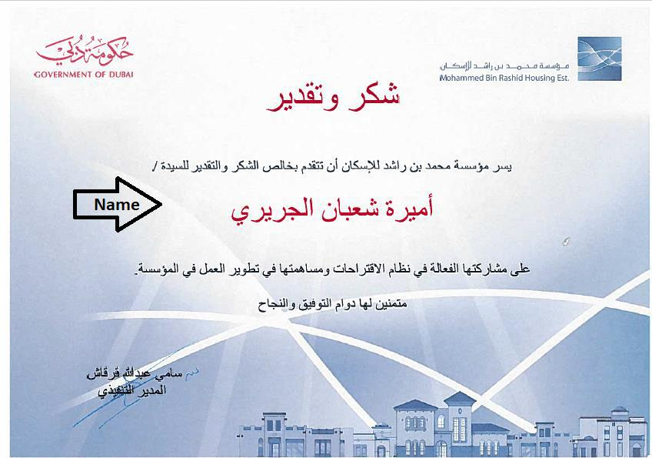

The following is the process follow for Thank you Letter Printing from CRM.

35

Start

Register/Receive Thank
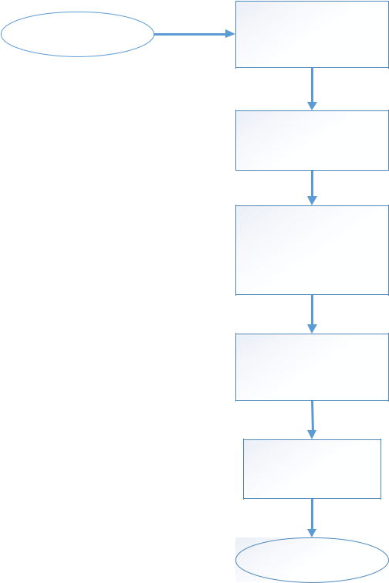
you & Appreciation and
Create as a Case

Assign the Case To Front
Office Team -> Review
& Evaluate the Case

Assign the Case to
Corresponding BU
Team/Member

Team/Member would
check the Subject of
Thanks & Appreciation

Communications Unit
would send Thank
you Note Employee/
Department

Publish by Email or
Social Media

Priority:

Complex

Critical

Regular

Featured

Good

Normal


Origin/Channels:

Smart App

Call Center

Phone

Email

Web

In-Person

Facebook

Twitter

• | Escalation Matrix:
 | The following Escalation Matrix should be used and configured for
 | escalating Cases and the SLAs should be configured as defined below.
 | Escalation | Escalation | Timeframe
 | 1st Level | CEO Assistant | 10 Working days from Creation Date
 | 2nd Level | CEO | 5 working days from 1st Level Escalation
• | Knowledge Base Articles:
 | CRM should allow to create Knowledge Based articles.
 | The articles to be published would be provided during UAT/Training.

The following Entity & fields should be created to capture Knowledge Base Articles.

Field Name

Field Type

Validation/Comments (if

36

(* - mandatory) |  | any)
Title * | Single Line of Text
Description * | Multi Line of Text
Key Words | Single Line of Text
Language | Drop Down
 | ➢ English
 | ➢ Arabic
Question &
Answers/Article
Content
Notes
Documents
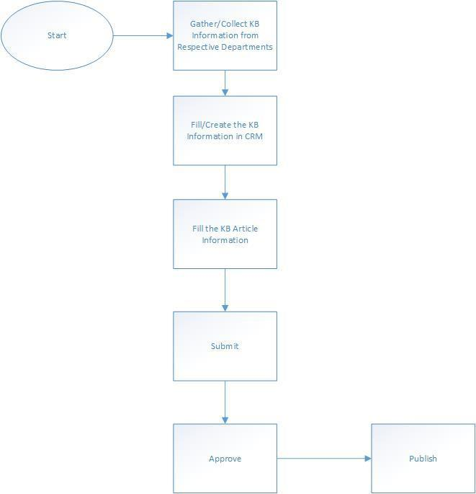

2.4.7 Call Center Integration with Dynamics CRM

Dynamics 365 On-premise CRM should be Integrated with Ameyo Call Center. The scope for the Ameyo Call Center Integration with Dynamics 365 On premise CRM would be as follows.

37
- Integration should be considered only for Incoming Calls

- Based on Customer Mobile Number, customer details should pop-up in CRM from Ameyo to CRM

- All Phone Calls related reports should be generated from Ameyo’s Phone system. There will be no reports from CRM side for Phone calls.

- CRM should keep track and create the Phone Calls Activity whenever the Agent gets the call from Customer.

- Ameyo vendor needs to cooperate in this activity and provide access and configuration from their side.
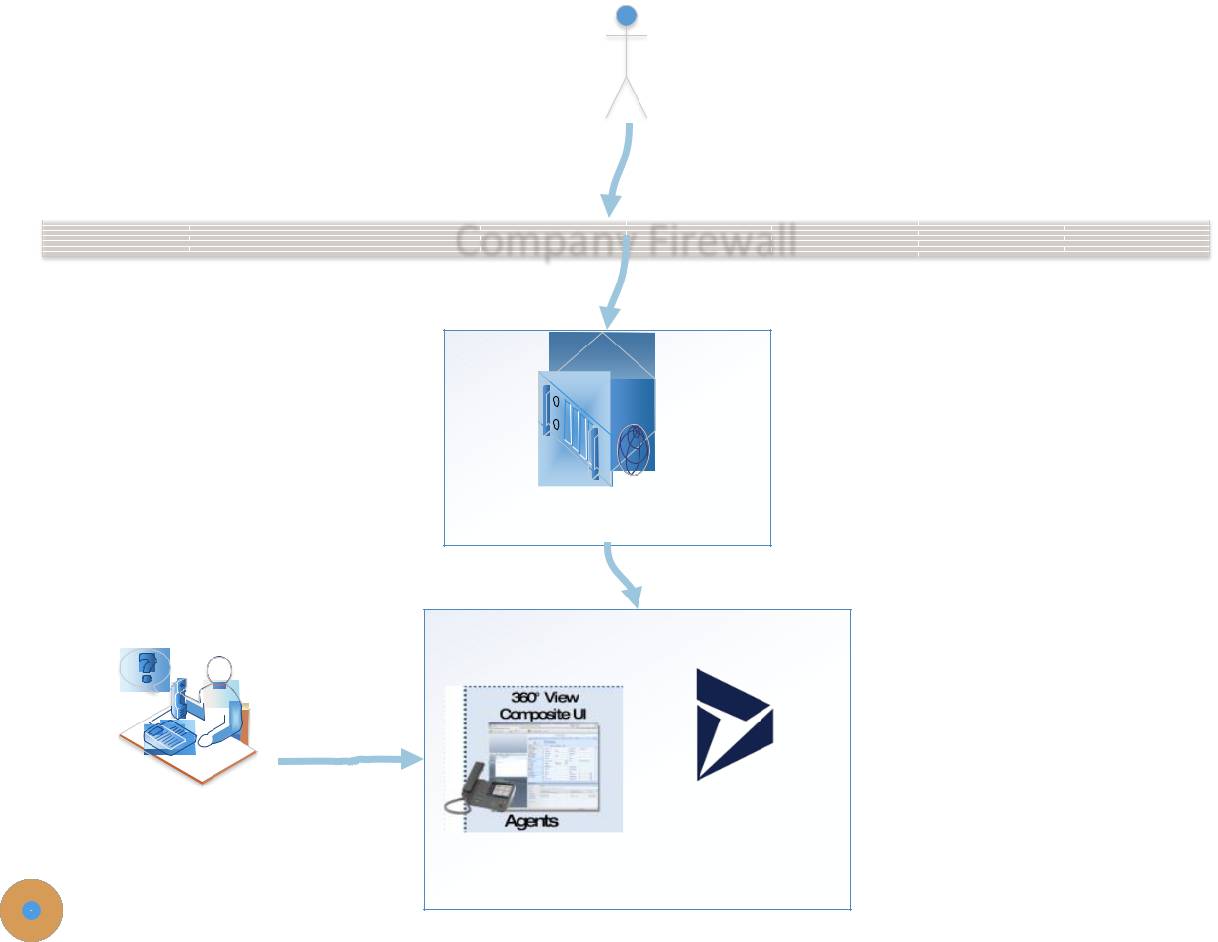

Customer Calls To MRHE

Company Firewall

Call Center User

Ameyo CTI Server

Ms Dynamics
365 - CRM

2.4.8 Master Data

The master data should be pre-populated as part of data migration exercise and master data management.

38

Master data should comprise of following entities & fields in CRM:

- Country/Nationality

China | Rwanda | Cyprus
India | Czech Republic | Fiji
United States | Somalia | Reunion (France)
Indonesia | Haiti | Guyana
Brazil | Benin | Comoros
Pakistan | Burundi | Bhutan
Nigeria | Bolivia | Montenegro
Bangladesh | Hungary | Macau (China)
Russia | Sweden | Solomon Islands
Japan | Belarus | Western Sahara
Mexico | Dominican Republic | Luxembourg
Philippines | Azerbaijan | Suriname
Vietnam | Honduras | Cape Verde
Ethiopia | Austria | Malta
Egypt | United Arab Emirates | Guadeloupe (France)
Germany | Israel | Martinique (France)
Iran | Switzerland | Brunei
Turkey | Tajikistan | Bahamas
Democratic
Republic of the
Congo | Bulgaria | Iceland
Thailand | Hong Kong (China) | Maldives
France | Serbia | Belize
United Kingdom | Papua New Guinea | Barbados
 |  | French Polynesia
Italy | Paraguay | (France)
Burma | Laos | Vanuatu
 |  | New Caledonia
South Africa | Jordan | (France)
 |  | French Guiana
South Korea | El Salvador | (France)
Colombia | Eritrea | Mayotte (France)
Spain | Libya | Samoa
Ukraine | Togo | Sao Tom and Principe
Tanzania | Sierra Leone | Saint Lucia
Kenya | Nicaragua | Guam (USA)
 |  | Curacao
Argentina | Kyrgyzstan | (Netherlands)
Algeria | Denmark | Saint Vincent and the

39
 |  | Grenadines
Poland | Finland | Kiribati
 |  | United States Virgin
Sudan | Slovakia | Islands (USA)
Uganda | Singapore | Grenada
Canada | Turkmenistan | Tonga
Iraq | Norway | Aruba (Netherlands)
 |  | Federated States of
Morocco | Lebanon | Micronesia
Peru | Costa Rica | Jersey (UK)
 | Central African
Uzbekistan | Republic | Seychelles
Saudi Arabia | Ireland | Antigua and Barbuda
Malaysia | Georgia | Isle of Man (UK)
Venezuela | New Zealand | Andorra
 | Republic of the
Nepal | Congo | Dominica
Afghanistan | Palestine | Bermuda (UK)
Yemen | Liberia | Guernsey (UK)
North Korea | Croatia | Greenland (Denmark)
Ghana | Oman | Marshall Islands
 | Bosnia and | American Samoa
Mozambique | Herzegovina | (USA)
Taiwan | Puerto Rico | Cayman Islands (UK)
Australia | Kuwait | Saint Kitts and Nevis
 |  | Northern Mariana
Ivory Coast | Moldov | Islands (USA)
 |  | Faroe Islands
Syria | Mauritania | (Denmark)
 |  | Sint Maarten
Madagascar | Panama | (Netherlands)
Angola | Uruguay | Saint Martin (France)
Cameroon | Armenia | Liechtenstein
Sri Lanka | Lithuania | Monaco
Romania | Albania | San Marino
 |  | Turks and Caicos
Burkina Faso | Mongolia | Islands (UK)
Niger | Jamaica | Gibraltar (UK)
 |  | British Virgin Islands
Kazakhstan | Namibia | (UK)
Netherlands | Lesotho | Aland Islands (Finland)
 |  | Caribbean
Chile | Qatar | Netherlands

40
 |  | (Netherlands)
Malawi | Macedonia | Palau
Ecuador | Slovenia | Cook Islands (NZ)
Guatemala | Botswana | Anguilla (UK)
 |  | Wallis and Futuna
Mali | Latvia | (France)
Cambodia | Gambia | Tuvalu
Senegal | Kosovo | Nauru
 |  | Saint Barthelemy
Zambia | Guinea-Bissau | (France)
 |  | Saint Pierre and
Zimbabwe | Gabon | Miquelon (France)
Chad | Equatorial Guinea | Montserrat (UK)
 |  | Saint Helena,
 |  | Ascension and Tristan
South Sudan | Trinidad and Tobago | da Cunha (UK)
 |  | Svalbard and Jan
Belgium | Estonia | Mayen (Norway)
Cuba | Mauritius | Falkland Islands (UK)
 |  | Norfolk Island
Tunisia | Swaziland | (Australia)
 |  | Christmas Island
Guinea | Bahrain | (Australia)
Greece | Timor-Leste | Niue (NZ)
Portugal | Djibouti | Tokelau (NZ)
 | Cocos (Keeling)
Vatican City | Islands (Australia) | Pitcairn Islands (UK)

- Emirate

Abu Dhabi Dubai Sharjah Ajman Fujairah

Ras Al Khaimah Umm Al Quwain

- Education Level

Learner Primary Preparatory Secondary

41
Collectors

M.A

Ph.D

Other

2.4.9 Reports & Dashboards

The following CRM out of box reports should be available:

Marketing Reports: (No Additional Reports to be considered in the scope)

- Campaign Activity Status

- Campaign Comparison

- Campaign Performance

Administrative Reports:

- User Summary

Service Reports:

- Case Summary Table

- Neglected Cases

- Top Knowledge Base Articles

Customer Reports:

- Contacts Summary

- Accounts Distribution

- Account Overview

- Account Summary

The following Dashboards should be configured for MRHE (OOB dashboards).

Case Management:

- Customer Service Representative Dashboard

- Customer Service Performance Dashboard

- Customer Service Operations Dashboard

- Customer Service Dashboard

42
- Customer Service Manager Dashboard

Marketing:

- Marketing Dashboard

- Pre-requisites & Dependencies

  - SMS API Details to be shared with EES for sending SMS to Customers.

    - SMS API Credentials

    - SMS API

    - SMS API Reference Documents

  - Exchange Server/SMTP Server Details to be shared with EES for configuring the Email Notifications.

  - MRHE need to share the Microsoft Social Engagement URL to start with Configuration and Integration with Dynamics 365.

  - MRHE should provide the required infrastructure to deploy the CRM API for Integrating Dynamics 365 CRM with other Integrated components.

- Assumptions

  - Only Cases & Customers master data would be setup as part of Production master data.

  - Changes to predefined reports requires change request.

  - User interface would be in English and Arabic only.

  - All power, Infrastructure and network failures would not be counted in the project and it is the responsibility of MRHE to sort out any issue related to the above areas which might have an impact on the project deliverables.

  - Any changes in requirements apart from defined requirements in Functional Requirements Document (FRD) would go through the change management (CR) process and based on the requirements, efforts and cost estimates will be provided to MRHE.

43
- System has specific functionalities in each screen, users need to follow the flow specified by EES.

- Issues may arise in the system due to wrong data entry. Any issue arising after go live support period will be handled through separate AMC.

EES will approach the Client Project Coordinator for any clarifications required prior or during the project. Intermediate deliverables provided by EES during the project must be accepted or rejected on a timely basis. Delays in this process will impact the project schedule, cost.

Any changes to the above assumptions could lead to an impact on effort/cost and schedule.

- Training

  - Conference Room Pilot(CRP) – 1 Day (Core Users)

  - End-User/Key Users Training – 2 Days (Core Users – Train the trainer)

  - Admin Training – 1 Day

- Application Security Requirements

User Access Control:

User access control shall be implemented to ensure that only authenticated users are permitted to access application solution.

- Access to the application software shall be restricted to only authenticated and authorized users.

- All the users of the system should be categorized into the pre-defined CRM Security Roles like Corporate Department Head, Customer Service Representatives, Service Managers etc. The CRM solution shall restrict access for specific users to only certain resources in the solution based on their role definition & assignment.

7 Annexure

44

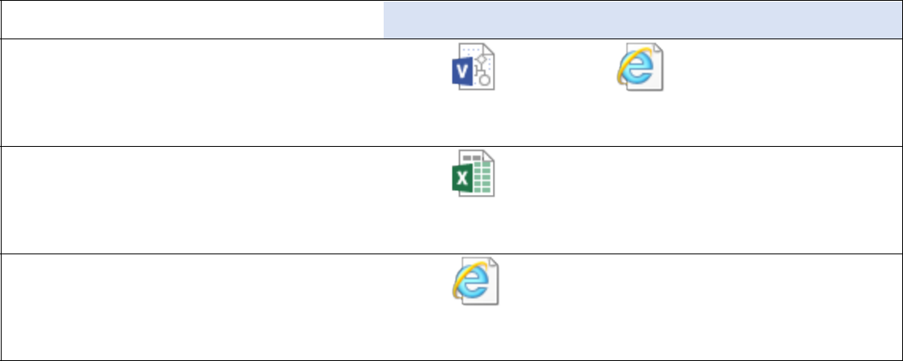  Name | Document
MRHE Organization Structure
 | MRHE_Org.vsdx
DEV & PROD Server Details
 | Dynamics 365 CRM
 | Pre-Requisites V1.5.x
Thank You Letter template
 | Thank you.png

MRHE_Org_Str(JPEG
).jpg

8 Glossary

Word/Abbreviation | Description
EES | Emitac Enterprise Solutions
CRM | Customer Relationship Management
MSE | Microsoft Social Engagement
ISH | Interactive Service Hub
CR | Change Request
DMS | Document Management System
CRP | Conference Room Pilot
SLA | Service Level Agreements

45

9 Project Scope Approval / Signatures

Project Name: MRHE_Dynamics 365 On premise CRM

Project Manager: Luai Abdullah AlFadni

The purpose of this document is to provide a vehicle for documenting the scope & functional requirements for the project. It is used to reach a satisfactory level of agreement between the Project Manager and the Account Manager(s) and owners with respect to the objectives and scope of the project before significant resources are committed and expenses incurred.

I have reviewed the information contained in this Project Scope Document and agree:

Name | Role | Signature | Date
Sekhar Ramarao | Head (MBS) – EES
Mouhanad Alkhaldi | PM – EES
Luai Abdullah | Chief Project
AlFadni | Manager

The signatures above indicate an understanding of the purpose and content of this document by those signing it. By signing this document, they agree to this as the formal Project Scope document.

46

