*CODING*

|  |  |  |
| --- | --- | --- |
| CRYPTOGRAPHY APPLICATION  Encryption and Decryption | ENROLLMENT NO : 14159  NAME : DHANUSH KUMAR S   |  | | --- | | INCHARGE : Mr.UBENDRAN |   COURSE : HDFD |

#include <iostream>

#include <string>

using namespace std;

string encrypt(const string& plaintext, int shift) {

string difftext = "";

for (size_t i = 0; i < plaintext.length(); ++i) {

char ch = plaintext[i];

if (isalpha(ch)) {

char base = isupper(ch) ? 'A' : 'a';

ch = static_cast<char>((ch - base + shift) % 26 + base);

}

difftext += ch;

}

return difftext;

}

string decrypt(const string& difftext, int shift) {

return encrypt(difftext, 26 - shift);

}

int main() {

string plaintext, difftext,decrypttext;

int shift,ans;

cout<<"\n\n\t\t\t\tWelcome To The ENCRYPTING And DECRYPTING Program!!!\n\n";

cout<<"----------------------------------------------------------------------------------------------------------------------";

while(1){

cout<<"\n\n\t1.Encrypt The Text\n\n";

cout<<"\t2.Decrypt The Text\n\n";

cout<<"\t3.Encrypt And Decrypt The Text\n\n";

cout<<"\t4.Exit From Program\n\n";

cout<<"Please Enter The Preferred Option[1/2/3/4] : ";

cin>>ans;

if(ans==1){

cout << "\n\nEnter plaintext: ";

cin.ignore();

getline(cin, plaintext);

cout << "\n\nEnter shift (a positive integer): ";

cin >> shift;

difftext = encrypt(plaintext, shift);

cout << "\n\nEncrypted text: " << difftext << endl;

}

if(ans==2){

cout<<"\n\nEnter The Encrypted Text To Decrypt : ";

cin.ignore();

getline(cin,decrypttext);

string decryptedText = decrypt(decrypttext, shift);

cout << "\n\nDecrypted text: " << decryptedText << endl;

}

if(ans==3){

cout << "\n\nEnter plaintext: ";

cin.ignore();

getline(cin, plaintext);

cout << "\n\nEnter shift (a positive integer): ";

cin >> shift;

difftext = encrypt(plaintext, shift);

cout << "\n\nEncrypted text: " << difftext << endl;

string decryptedText = decrypt(difftext, shift);

cout << "\n\nDecrypted text: " << decryptedText << endl;

}

if(ans==4){

cout<<"\n\nThank You For Using Our Program!!!\n";

cout<<"\n\nHave A Good Day";

break;

}

}

return 0;

}

*OUTPUT*

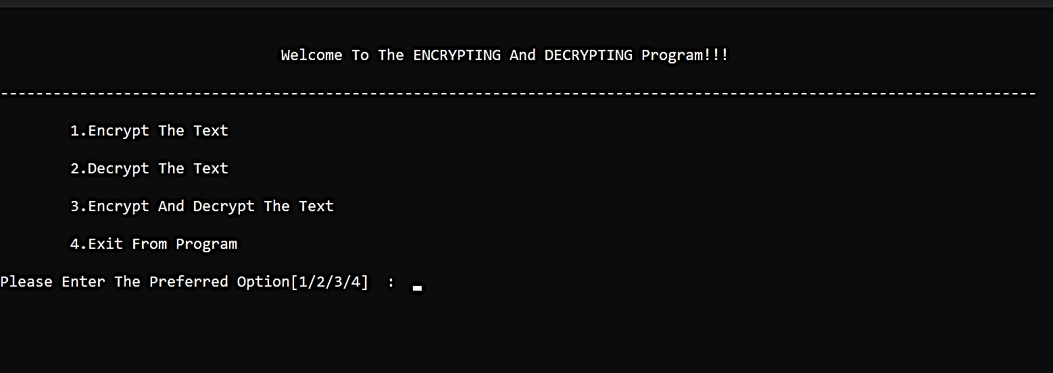

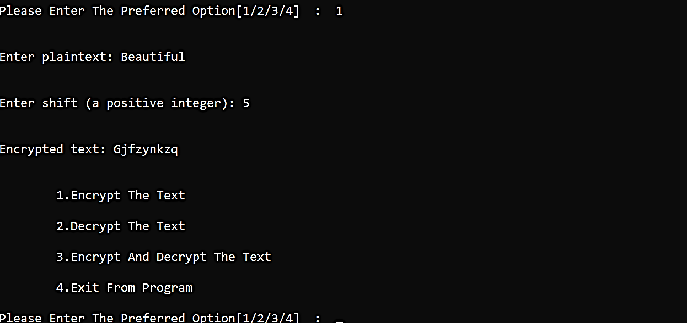

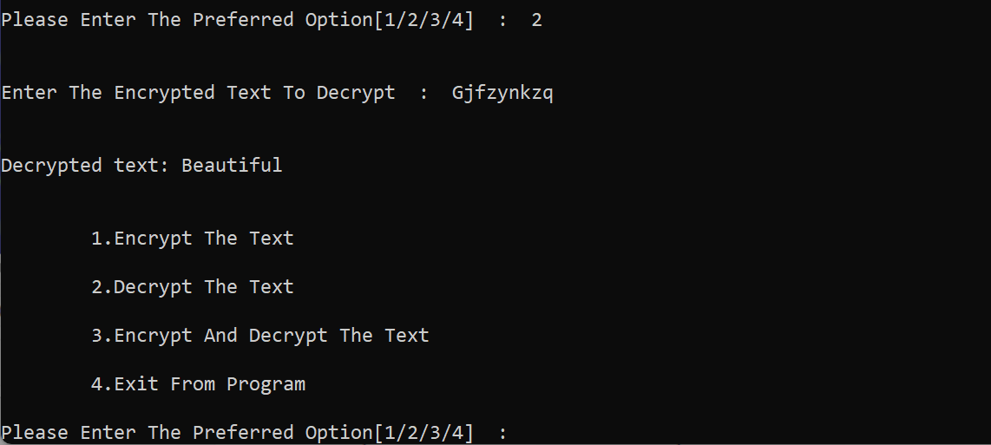

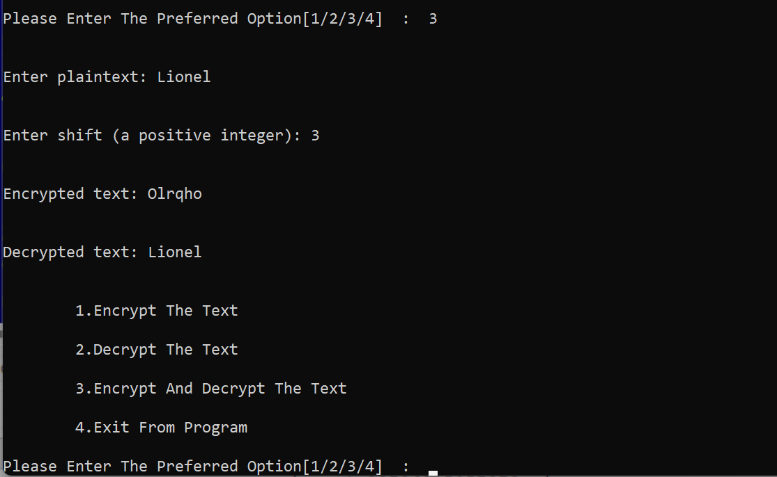

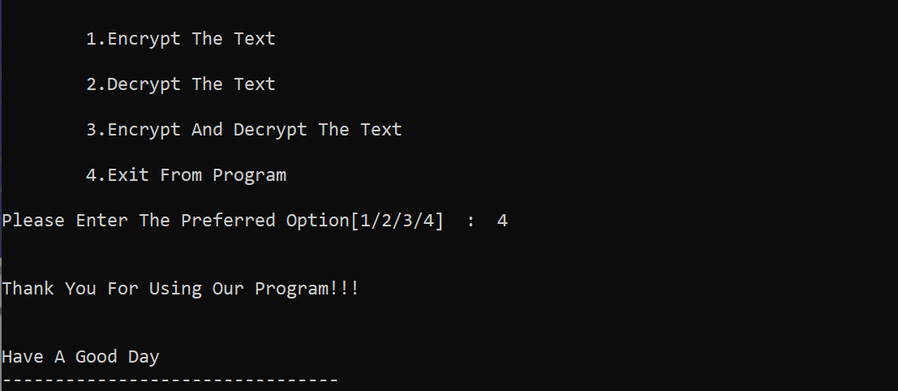

*Thank You*