**FitPeo**

1. Setup latest chrome driver in driver folder
2. Update the path in openBrowser method in System.setProperty present in src/main/java  
   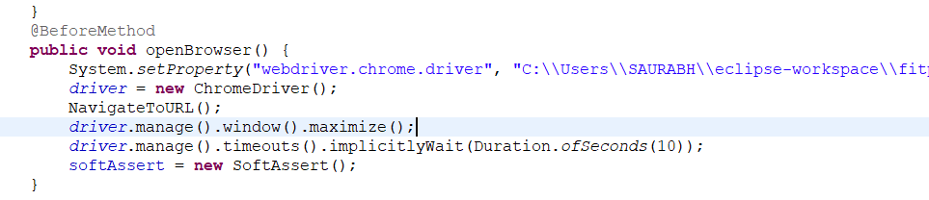
3. Go to runner class in src/test/java
4. Run the testOne method.