Download **postgres** using the link <https://www.postgresql.org/download/>

C:\ERD-Install-and-Configuring-A-Database-Server-PostgreSQL-and-MySQL\Images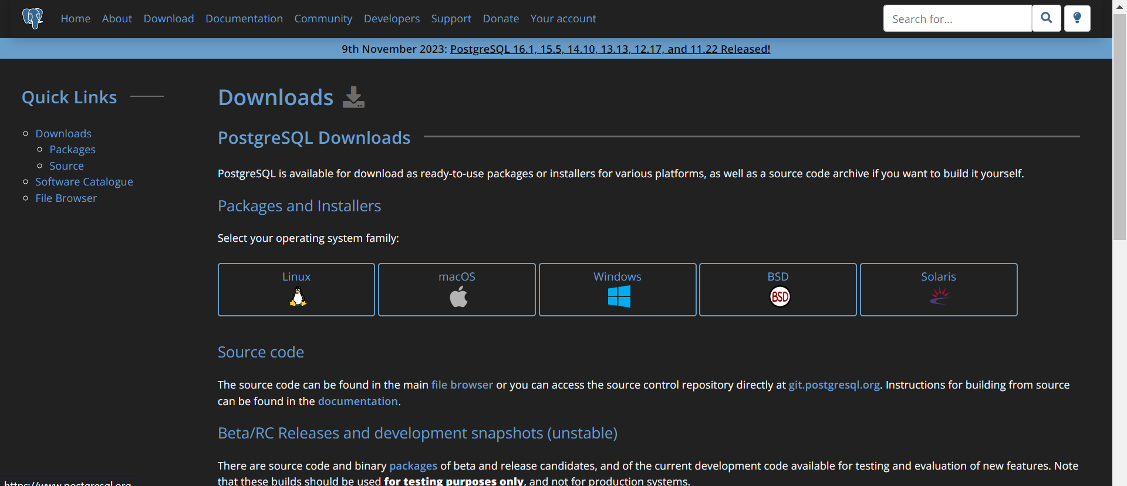

Ensure to add the directory of the **postgres** from your file explorer if you are using windows to your system path, so you could run **postgres** commands and **SQL** commands from your command line or terminal.

After your installation, configure postgres to work, by creating your **username** and **password** during the installation process.

Main Steps:

1. Open your **terminal** or **command line** if you are using **windows.**

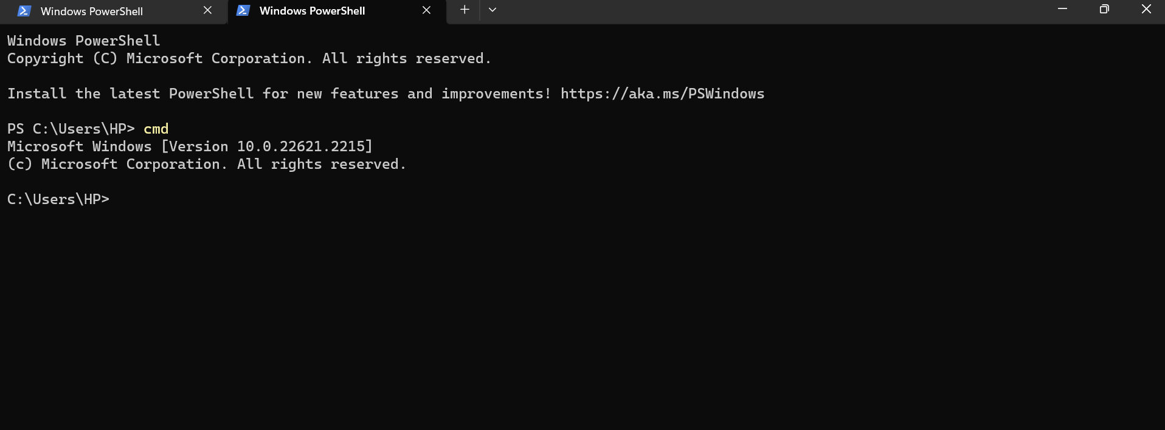

1. Check which **username** is current logged in postgres, but first use the command below to loggin postgres.

**psql -U postgres**

Insert your password the one you created during the installation.

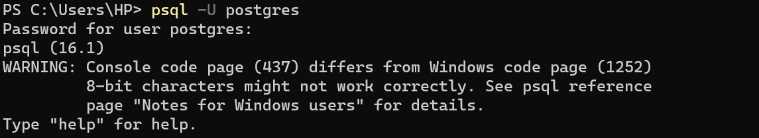

Find out the user logged in using this command “ **SELECT usename FROM pg_user;**”

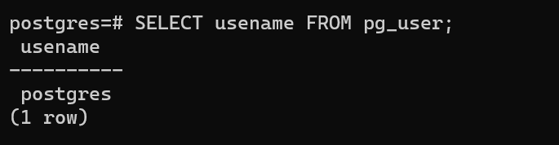

1. Create a database using the command “ **CREATE DATABASE Design1;**” and on next shell line “ **SELECT datname FROM pg_database;**” follow the picture below.

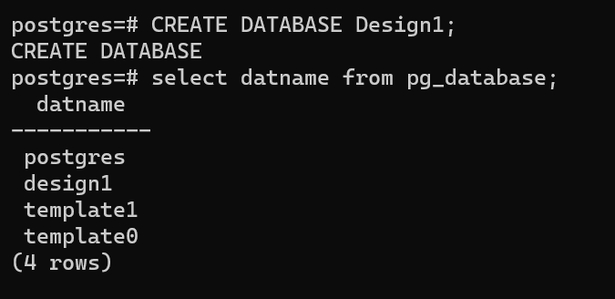

1. To check in to the database you just created use “ **\c design1**” follow the picture below.



1. To create the tables using the SQL schema follow the scripts below.

**To create the Customers Table.**

**-- Create Customers table**

CREATE TABLE Customers (

customer_id SERIAL PRIMARY KEY,

customer_sname VARCHAR(50),

first_name VARCHAR(50),

email VARCHAR(100),

phone_number VARCHAR(20),

address VARCHAR(255),

registration_date DATE

);

**-- Create Product table**

CREATE TABLE Product (

product_id SERIAL PRIMARY KEY,

product_name VARCHAR(100),

description TEXT,

price NUMERIC,

manufacturer VARCHAR(50),

production_date DATE,

expiration_date DATE

);

**-- Create Transactions table**

CREATE TABLE Transactions (

transaction_id SERIAL PRIMARY KEY,

customer_id INT REFERENCES Customers(customer_id),

transaction_date DATE

);

**To create the ProductTransactions Table.**

**-- Create ProductTransactions table**

CREATE TABLE ProductTransactions (

product_transaction_id SERIAL PRIMARY KEY,

customer_id INT REFERENCES Customers(customer_id),

product_id INT REFERENCES Product(product_id),

quantity INT,

total_price NUMERIC,

transaction_id INT REFERENCES Transactions(transaction_id),

transaction_date DATE

);

**To create the Warehouse Table.**

**-- Create Warehouse table**

CREATE TABLE Warehouse (

warehouse_id SERIAL PRIMARY KEY,

product_id INT REFERENCES Product(product_id),

quantity INT,

received_date DATE,

expiration_date DATE,

transaction_id INT,

CONSTRAINT fk_product_id

FOREIGN KEY (product_id)

REFERENCES Product(product_id),

CONSTRAINT fk_transaction_id

FOREIGN KEY (transaction_id)

REFERENCES Transactions(transaction_id)

);

-- Add Index on product_id and transaction_id for optimization

CREATE INDEX idx_warehouse_product_transaction

ON Warehouse (product_id, transaction_id);

**To create the store Table.**

**-- Create Store table**

CREATE TABLE Store (

store_id SERIAL PRIMARY KEY,

customer_id INT REFERENCES Customers(customer_id),

product_id INT REFERENCES Product(product_id),

transaction_id INT REFERENCES Transactions(transaction_id),

warehouse_id INT REFERENCES Warehouse(warehouse_id),

quantity INT,

total_price NUMERIC,

sale_date DATE

);

-- Add Index on product_id, transaction_id, and warehouse_id for optimization

CREATE INDEX idx_store_product_transaction_warehouse

ON Store (product_id, transaction_id, warehouse_id);