DEPARTMENT OF ELECTRONICS & COMMUNICATION ENGINEERING
ST JOSEPH ENGINEERING COLLEGE
VAMANJOOR MANGALURU-575028

Course Title: Digital Design using HDL
Course Code: 22ECE42
Semester: Fourth Semester
PBL Secondary Research Report
FPGA Based-Advanced Encryption Standard (AES)

Submitted by
NAME | USN
ALPHIN DAVID KUNHIMON | 4SO24EC008
ASHTON REGO | 4SO24EC016
CYRUS HEROLD FERNANDES | 4SO24EC028
JAWAHAR LAWRENCE RODRIGUES | 4SO24EC049

Under the guidance of
Vijay Ganesh P C
Assistant Professor

Chapter 1: Introduction

1.1 Overview of Cryptographic Applications Requiring AES
In today’s digital world, secure data transmission is essential across various applications such as online banking, military communication, cloud storage, and Internet of Things (IoT) devices. To ensure confidentiality and integrity of data, cryptographic algorithms are widely used.
One of the most widely adopted encryption standards is the Advanced Encryption Standard (AES). AES is a symmetric key encryption algorithm that operates on fixed-size data blocks of 128 bits and supports key sizes of 128, 192, and 256 bits. It is extensively used in applications such as secure communication systems, wireless networks, data encryption in storage devices, financial systems, and embedded systems.
Due to its strong security and efficiency, AES has become a global standard for data protection.

1.2 Problem Statement
Although AES provides strong security, its implementation in software introduces several challenges, especially in real-time and resource-constrained environments.
The key limitations include high latency due to sequential execution of AES rounds, limited throughput for large-scale data encryption, increased computational complexity of operations such as SubBytes and MixColumns, and higher power consumption in continuous processing systems.
These issues make software-based AES implementations inefficient for applications requiring high-speed and real-time secure communication.

1.3 Objective
The objective of this project is to explore and implement the fundamental operations of the Advanced Encryption Standard (AES) using Verilog HDL, in order to understand how modern cryptographic algorithms are mapped into hardware design.
As AES is built on mathematical transformations in Galois Field (GF(2⁸)), this project focuses on implementing and simulating its core functional blocks such as SubBytes, ShiftRows, MixColumns, and AddRoundKey.
Since this is a beginner-level hardware implementation, the SubBytes operation is realized using a Lookup Table (LUT) instead of direct computation of the GF multiplicative inverse and affine transformation. This simplification allows the design to remain practical while still preserving the correct AES behaviour.
The primary goal is to:
- Understand how AES transformations work at a structural level
- Implement individual encryption steps in Verilog
- Simulate and verify the correctness of each module

Chapter 2: Literature Review (Secondary Research)

Paper 1: Enhanced AES Using NLFSR-Based Dynamic S-Box (2026)
Architecture: NLFSR-based dynamic S-box AES
Throughput: Moderate
Resource Utilization: High (increased LUTs)
Limitations: Only S-box optimized, high area, no system-level improvement

Paper 2: Lightweight AES for Resource-Constrained Environments (2025)
Architecture: Iterative AES with Composite Field S-box
Throughput: Low to Moderate
Resource Utilization: Low
Limitations: Low speed due to sequential execution

Paper 3: AES Architecture with Shared S-Box Resources
Architecture: Iterative with shared S-box
Throughput: Low
Resource Utilization: Very Low
Limitations: High latency, not suitable for real-time

Paper 4: High-Throughput Pipelined AES Architecture
Architecture: Pipelined AES
Throughput: High
Resource Utilization: High
Limitations: Large area and power consumption

Paper | Architecture | Throughput | Resource Usage | Key Limitation
Paper 1 | NLFSR-based S-box | 33.68Gbps | 684LUTs | Only S-box optimized
Paper 2 | Iterative (CFA) | 15.265Gbps | 1497LUTs | Slow processing
Paper 3 | Shared S-box | 50Gbps | 2200LUTs | High latency
Paper 4 | Pipelined | 2.6Gbps | 844LUTs | High area & power

Chapter 3: Proposed System Design

3.1 Design Justification
The proposed AES architecture is selected to achieve a better balance between hardware efficiency, flexibility, and performance, which is not fully addressed in existing works.
The lightweight AES study by Salman Ahmed mainly focuses on optimizing individual components and introducing security countermeasures. However, it increases design overhead and complexity, whereas the proposed system improves efficiency through overall architectural optimization without adding extra overhead.
The AES survey by Rahoul Ganesh provides theoretical analysis and discusses implementations but does not propose a practical optimized hardware architecture. In contrast, the proposed design is a complete implementable system.
The iterative AES design by R. Parthasarathy reduces hardware using shared resources, but lacks flexible control and modular data handling. The proposed architecture improves this by introducing column-wise processing and better control logic, making it more scalable.
The enhanced AES work by Arulmurugan Azhaganantham improves security using modified S-box techniques, but this leads to increased hardware complexity and power consumption. The proposed design avoids this by keeping the standard AES structure and improving efficiency at the architecture level.
Overall, unlike existing works that focus on individual optimizations or increased complexity, the proposed system provides a balanced solution with reduced hardware usage, unified encryption and decryption, and better flexibility, making it more practical for real-world FPGA and embedded applications.

3.2 Block Diagram
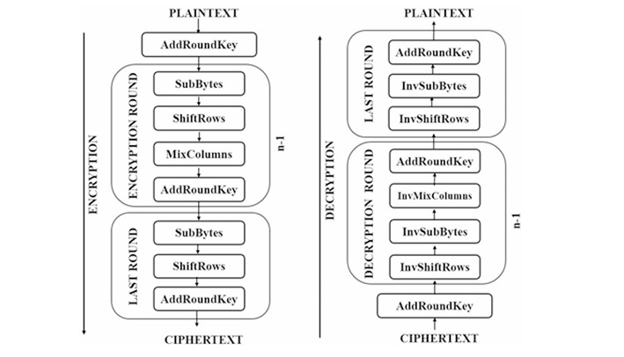

3.3 Architecture Diagram

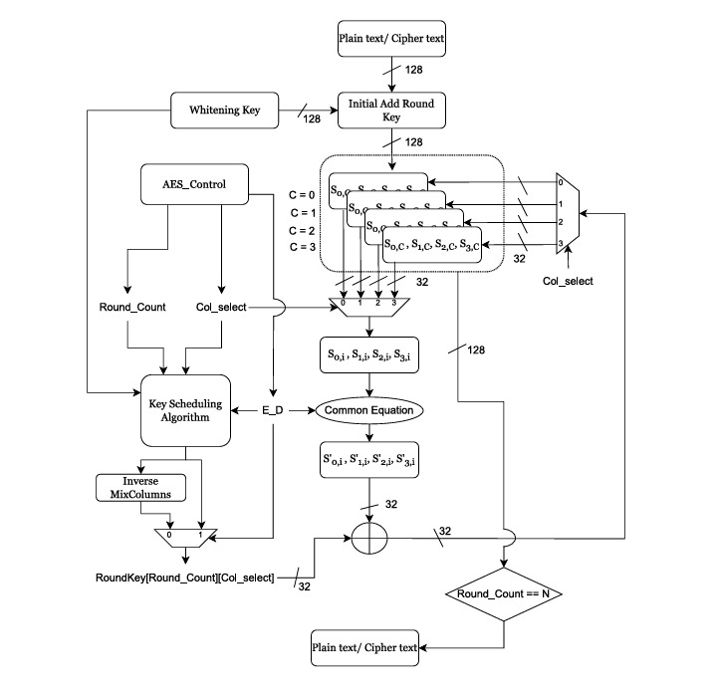

Chapter 4: Leaf Cell Design (Core Module Design)

4.1 Identification of Leaf Cells
The identified leaf cells in this system are:
- S-Box Unit – Performs byte substitution
- Galois Field Multiplier – Used in MixColumns transformation
- XOR Unit (Adder/Subtractor) – Used in AddRoundKey and MixColumns

4.2 Leaf Cell Description

4.2.1 S-Box Unit
Functionality:
The S-Box performs non-linear byte substitution by mapping an 8-bit input to an 8-bit output. The S-box is a fixed LUT which has 256 different possible values through Finite Field of 256 elements(Galois Field GF(2^8)) .The matrix is 16x16 Matrix having 256 different values. The state matrix containing 4x4 matrix replaces each value according to its fixed value, each value containing 8 bits.
RTL Design:
Implemented using a lookup table (case statement) as combinational logic.
Optimization:
LUT-based design ensures fast and efficient FPGA implementation.

4.2.2 Galois Field Multiplier
Functionality:
Performs multiplication in GF(2^8), used in MixColumns.
RTL Design:
Implemented using shift and conditional XOR operations.
Optimization:
Avoids complex multiplication using efficient shift-XOR logic.

4.2.3 XOR Unit (Adder/Subtractor)
Functionality:
Performs bitwise XOR used in AddRoundKey and MixColumns.
RTL Design:
Implemented using simple XOR logic gates.
Optimization:
Minimal hardware with high speed performance.

4.3 Leaf Cell Simulation

4.3.1 Galois Field Multiplier

Program:
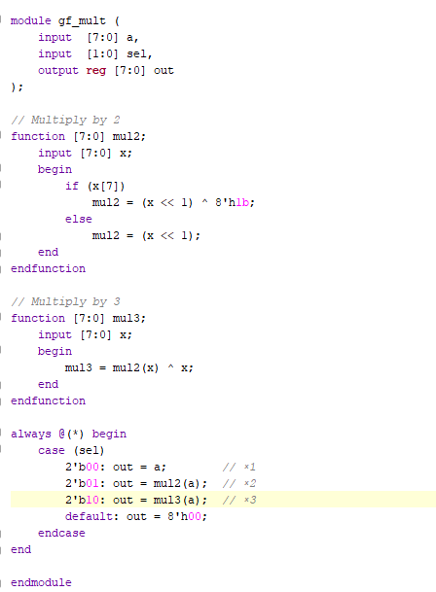

Testbench:

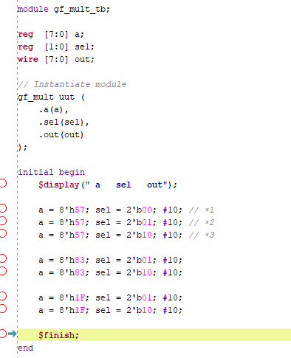

Simulation:
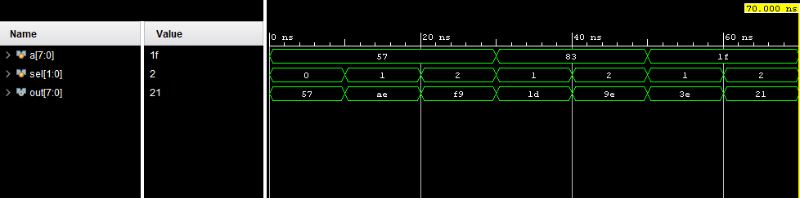

4.3.2 Sbox using LUT

Program:

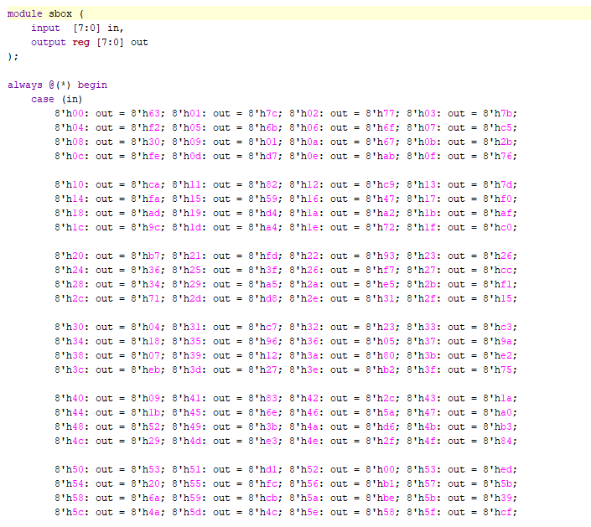
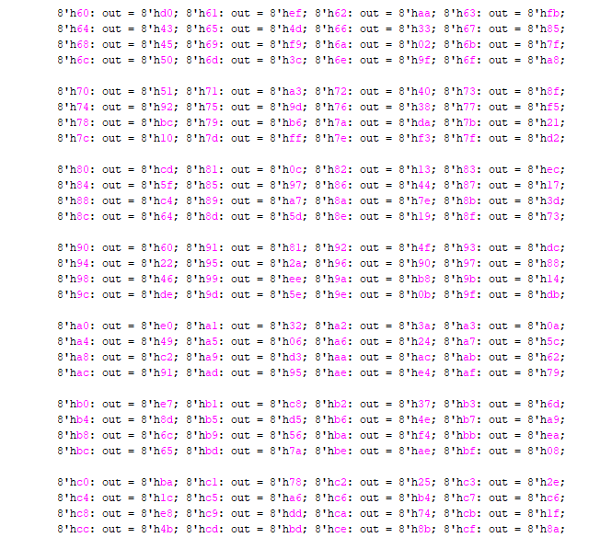
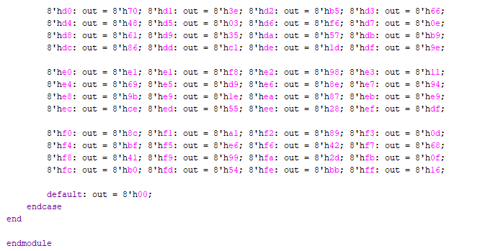
Testbench:
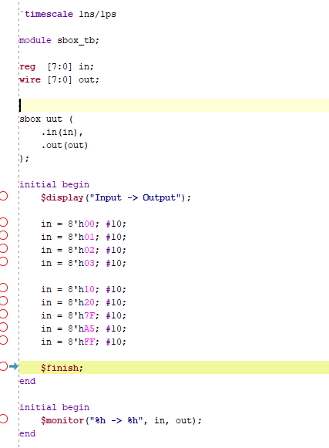

Simulation: 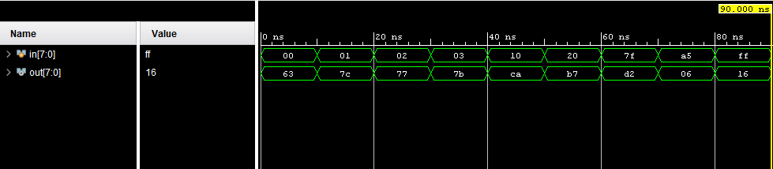

4.3.3 AddRoundKey(XOR)

Program:
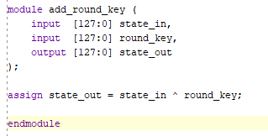

Testbench:
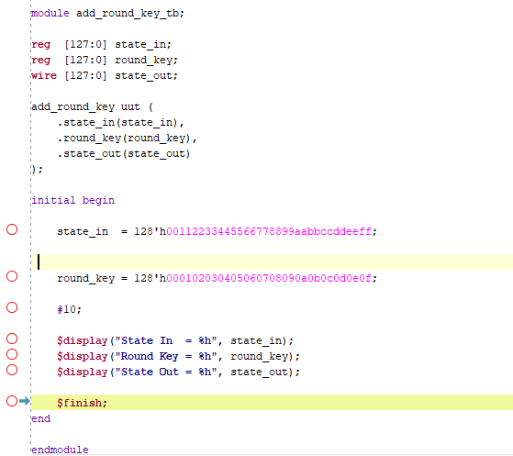
Simulation:
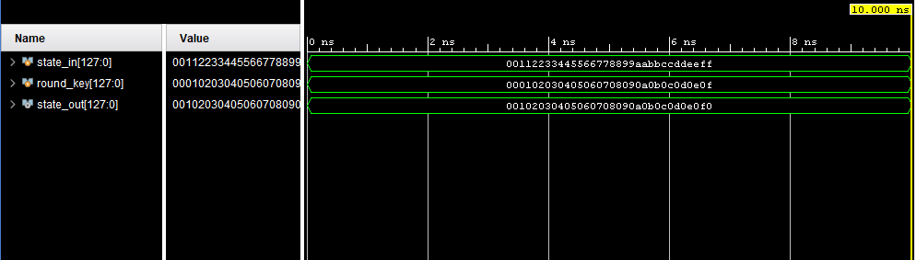

References:
1.
Title: Lightweight AES Design for IoT Applications: Optimizations in FPGA and ASIC With DFA Countermeasure Strategies
Authors: Salman Ahmed, Nabihah Ahmad, Nasir Ali Shah, Ghulam E. Mustafa Abro, Ardhi Wijayanto, Abdinasir Hirsi, Abdul Rehman Altaf
Published: 24 January 2025 (Current version: 5 February 2025)

2.
Title: A Panoramic Survey of the Advanced Encryption Standard: From Architecture to Security Analysis, Key Management, Real-World Applications, and Post-Quantum Challenges
Authors: Rahoul Ganesh, Burhan Ul Islam Khan, Abdul Raouf Khan, Amirrudin Bin Kamsin
Published: 25 September 2025

3.
Title: Lightweight Implementation of AES for Resource Constrained Environment
Authors: R. Parthasarathy, P. Saravanan, S. Rajesh Srivatsav, C. M. Manisha
Published: 4 March 2025

4.
Title: A Robust AES Implementation using FPGA with Enhanced Security Features
Authors: Arulmurugan Azhaganantham, Vivek Balasubramaniam
Published: 29 January 2026

Tools Used: Xilinx Vivado

