SET-4

1) Develop a prm that accept a 10 digit mobile number ,and find the absent digit

output
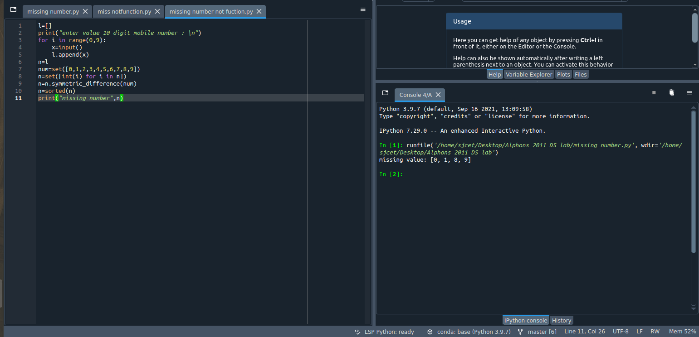
2)implement KNN algorithm
