**Texture Atlas Editor**

I want to create a texture atlas editor to make managing sprites a lot easier for designers and artists combined. Artists will not have to keep making new files for each sprite sheet and will be able to use just one to put sprites on to (basically an upgraded sprite sheet editor) and on the designer's side I want to make it easier for them to manipulate the sprites by having extra functionality on the editing side of the tool.

* drag and drop capabilities
* Image scaling abilities
* Image rotating
* Selecting and deselecting sprites
* A previewing of the sprite sheet in action
* Function to save and load an edited sprite sheet
* Able to have different categories for sprite sheet (background, characters, objects)
* Be able to export and import different file formats
* Be able to trim and crop images

**Minimum viable product**

Be able to group sprites together in one sheet and preview, needs to have drag and drop and some ability to save and load sheets. Also needs to be able to edit sprite sheets like re-ordering images and moving them around.

**Potential Drawbacks**

Never attempted to make a tool before don’t really have a lot of time to make it. Not knowing what the tool is supposed to have because I have no real experience using a texture atlas from other sources. Drag and drop might also be a challenge considering I also have no experience coding something similar to it.

**User Interface**

Hoping to make a clean and simple UI that anyone can understand and use, functionality will be priority. There will be buttons on the side like load, save and edit sheet. Edit sheet is where the whole magic will happen on the right side a box will appear with the texture atlas you’ve made loaded in and in there you will be able to drag and drop the sprites around and you’ll be able to delete a sprite. You can also resize and rotate the images with ease. 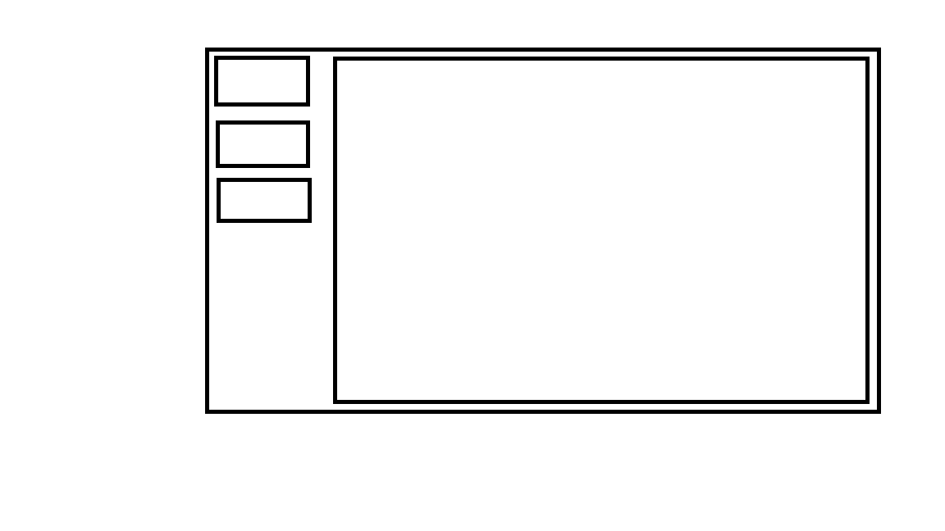

save

edit

load

**Load**: allows you to load sprites so that you can create a tecture atlas or allows you to load already created texture atlas so you can edit it.

**Save:** allows you to save a texture atlas you’ve edited.

**Edit:** would allow you to drag and drop sprites that have been loaded into the sheet and reorder them as you like.

**Big Box:** the box on the right would be where the image is displayed and edited

**Delete button(on keyboard):** will be used to delete selected items.