**Name:**

**ID:**

**Date:**

**ITU, Computer Engineering Dept.**

**BLG527E, Machine Learning HW3**

Due: December 08, 2019, 23:00 through Ninova.

# Instructors:), Yusuf Yaslan (yyaslan@itu.edu.tr)

**Grading:** You must complete the table below according to what you expect to get out of each question.

|  |  |  |  |  |  |
| --- | --- | --- | --- | --- | --- |
|  |  | Q1 | Q2 | Q3 | Total |
| Grade | Max | 1 | 2 | 2 | 5 pts |
| Expected |  |  |  |  |

# Policy:

# Please do your homeworks on your own. You are encouraged to discuss the questions with your class mates, but the code and the hw you submitted must be your own work. Cheating is highly discouraged for it could mean a zero or negative grade from the homework.

# If a question is not clear, please let us know (via email or in class). Unless we indicate otherwise, do not use libraries for machine learning methods. When in doubt, email us.

There will be 5 homeworks this term. Each hw is worth 5 points and each question will be evaluated on a 0/1 basis.

# In order to be able to take the final exam for BLG527E you have to have a weighted average score of 30 (over 100) for midterm and homeworks. Otherwise you will get a VF from the course.

**DO NOT SUBMIT YOUR HOMEWORKS VIA E-MAIL!**

**QUESTIONS**

**In your report you should write your findings neatly.**

**Q1) You will use the attached opdigits dataset for this hw. The last column of the file shows the label (class 0,1…9)** [You need to write down the PCA code yourself, do not use a library pca() function. Do not use cov() and mean() function, but you may use eig() function to compute eingevalues]

**For both cases, project the instances into two dimensional space and plot the projections in your report.**

Implement a PCA projection on given the data.txt. The last attribute of the data.txt is the class label, range from 0..9

• Use the covariance matrix Σ to calculate the PCA components

• Plot the transformed data points in 2D as shown in Figure 2. Only label randomly selected 200 instances in your report. You need to use annotate() like function to write text(class label) at each randomly selected 200 data points.

• Give all your plots in your report.

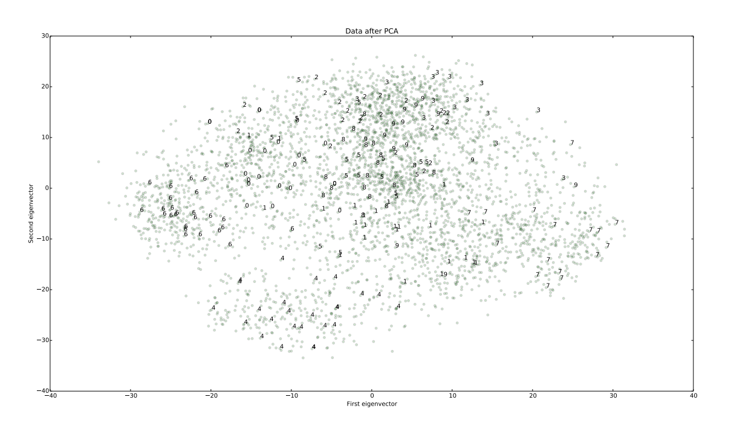

**Q2)** Write a program that clusters the q3.mat data using the EM on Gaussian Mixture Models with K=2, 3, 4 clusters. **Plot the clustering results.** What is the best number of clusters? Use the following update equations from Bishop and Ng slides (MoG_EM-Part2.pdf):

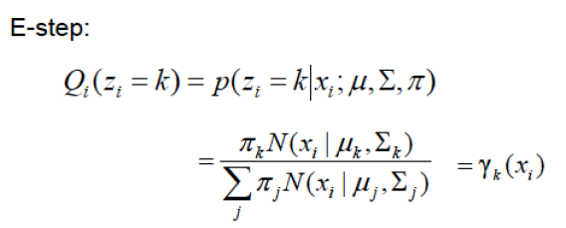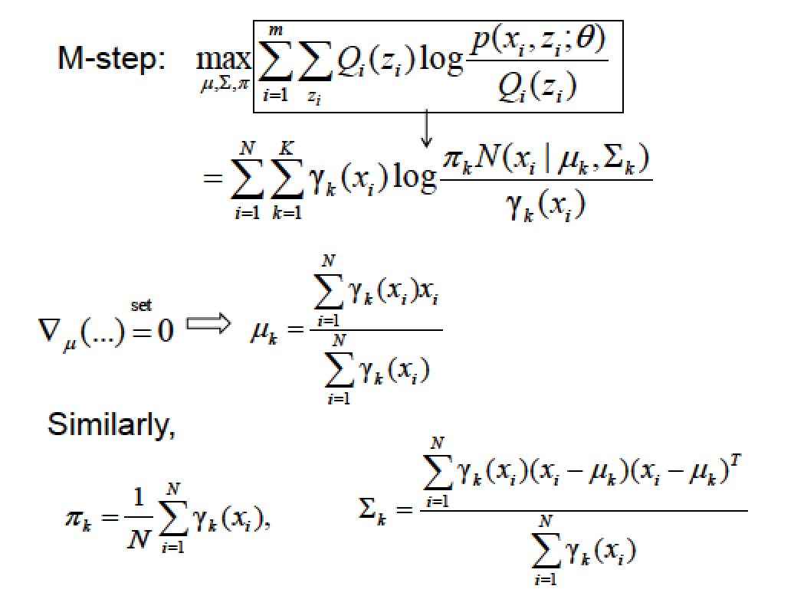

**Q3)** We are given two coins A and B where the probabilities for heads are *QA* and *QB* respectively. Each coin is selected randomly with a probability p(zk = 1) = πk , (k=1,2 and $\sum_{k=1}^{2}{π_{k}}=1$). After a coin is selected we take 10 observations from that coin. Suppose that you are given the following observations:

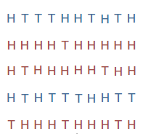

1. Write down the expectation maximization steps to find the parameters. **Show the derivation of the formulas that find the parameters (E and M steps).**
2. Write a program that computes the parameters of the given experiment. **Give the parameters in your report**.

**Hint:** Use Binomial distribution.

(See <http://ai.stanford.edu/~chuongdo/papers/em_tutorial.pdf> for detailed descriptions of the sample experiment)