+ Data: ['CTU13_8', 'CTU13_13', 'CTU13_10', 'CTU13_9']

+ Scaler: maxabs

1. CTU13_8 ...

+ Hidden Sizes: 40 [29, 18, 7] - Batch_sizes: 200

+ Data: 5000 (4000 train, 1000 vali) - 43694 normal, 3677 anomaly

￼

￼

[ 807. 0.202125 0.183851]

￼

+ Standard Deviation of Hidden data:

[ 0.000686 0.004561 0.002905 0.003199 0.003236 0.001908 0.002039]

+ AUC input, AUC hidden:

[[ 0.742 0.971 0.966 0.959 0.959 0.799 0. 0. ]

[ 0.985 0.984 0.986 0.984 0.984 0.984 0.96 18.385]]

2. CTU13_13 ...

+ Hidden Sizes: 40 [29, 18, 7] - Batch_sizes: 200

+ Data: 5000 (4000 train, 1000 vali) - 19164 normal, 24002 anomaly

￼

￼

[ 1000. 0.191915 0.177877]

￼

+ Standard Deviation of Hidden data:

[ 0.000402 0.003922 0.000514 0.004085 0.000463 0.000813 0.002747]

+ AUC input, AUC hidden:

[[ 0.681 0.914 0.89 0.889 0.925 0.888 0. 0. ]

[ 0.939 0.966 0.946 0.928 0.942 0.95 0.625 17.788]]

3. CTU13_10 ...

+ Hidden Sizes: 38 [28, 17, 7] - Batch_sizes: 200

+ Data: 5000 (4000 train, 1000 vali) - 9509 normal, 63812 anomaly

￼

￼

[ 1000. 0.155213 0.173566]

￼

+ Standard Deviation of Hidden data:

[ 0.000556 0.00044 0.000827 0.001741 0.005809 0.002564 0.000788]

+ AUC input, AUC hidden:

[[ 0.569 0.996 0.998 0.998 0.998 0.983 0. 0. ]

[ 0.997 0.999 0.999 0.999 0.999 0.999 0.998 17.357]]

4. CTU13_9 ...

+ Hidden Sizes: 41 [30, 18, 7] - Batch_sizes: 200

+ Data: 5000 (4000 train, 1000 vali) - 17981 normal, 110993 anomaly

￼

￼

[ 617. 0.210114 0.177319]

￼

+ Standard Deviation of Hidden data:

[ 0.000728 0.001131 0.000344 0.001076 0.000538 0.000377 0.001488]

+ AUC input, AUC hidden:

[[ 0.742 0.902 0.734 0.722 0.851 0.852 0. 0. ]

[ 0.942 0.947 0.942 0.941 0.94 0.939 0.722 17.732]]

[[ 0.243 0.013 0.021 0.025 0.025 0.185 0.96 18.385]

[ 0.258 0.052 0.055 0.039 0.017 0.062 0.625 17.788]

[ 0.428 0.004 0.001 0.001 0.002 0.016 0.998 17.357]

[ 0.2 0.044 0.208 0.219 0.089 0.087 0.722 17.732]]

**+ Data: ['CTU13_08', 'CTU13_13', 'CTU13_10', 'CTU13_09']**

**+ Scaler: maxabs**

**1. CTU13_08 ...**

+ Hidden Sizes: 40 [29, 18, 7] - Batch_sizes: 1165

+ Data: 29128 (23303 train, 5825 vali) - 43694 normal, 3677 anomaly

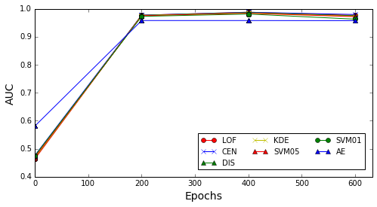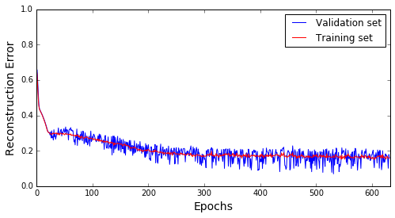

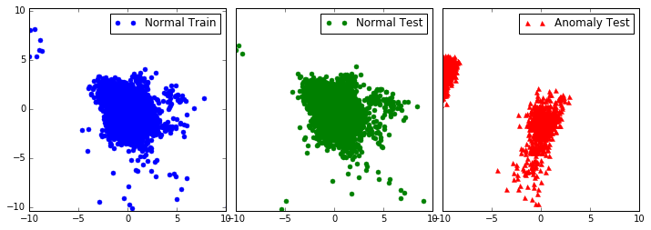

[ 631. 0.159089 0.15971 ]

**+ Standard Deviation of Hidden data:**

[ 0.000243 0.000466 0.000228 0.000402 0.00027 0.000221 0.000565]

**+ AUC input, AUC hidden:**

[[ 0.754 0.971 0.966 0.958 0.958 0.797 0. 0. ]

[ 0.978 0.981 0.976 0.973 0.972 0.965 0.958 15.971]]

**2. CTU13_13 ...**

+ Hidden Sizes: 40 [29, 18, 7] - Batch_sizes: 511

+ Data: 12775 (10220 train, 2555 vali) - 19164 normal, 24002 anomaly

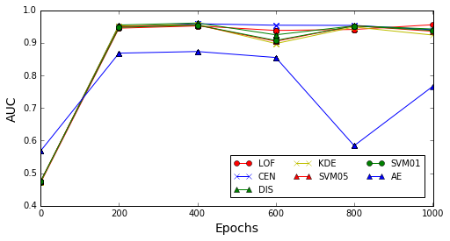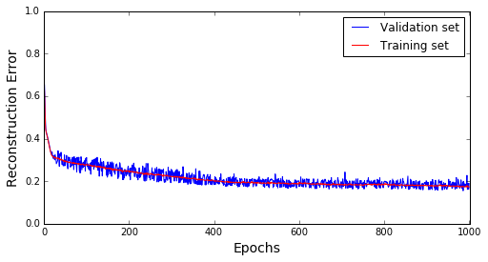

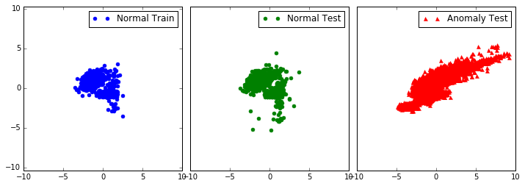

[ 1000. 0.188987 0.173096]

**+ Standard Deviation of Hidden data:**

[ 0.001669 0.004364 0.001326 0.004295 0.002362 0.003095 0.003252]

**+ AUC input, AUC hidden:**

[[ 0.69 0.916 0.891 0.889 0.925 0.898 0. 0. ]

[ 0.956 0.94 0.943 0.925 0.937 0.94 0.765 17.31 ]]

**3. CTU13_10 ...**

+ Hidden Sizes: 38 [28, 17, 7] - Batch_sizes: 253

+ Data: 6338 (5071 train, 1267 vali) - 9509 normal, 63812 anomaly

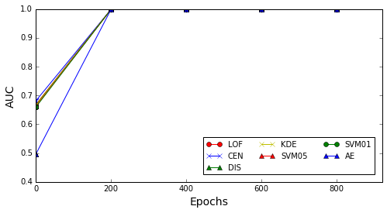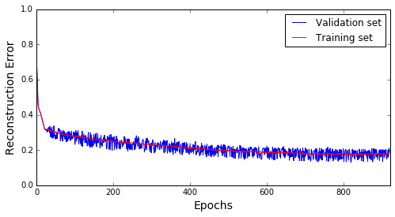

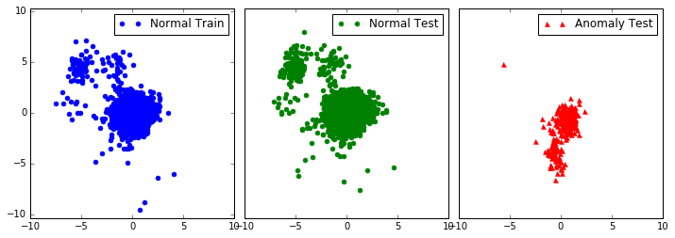

[ 920. 0.186723 0.178054]

**+ Standard Deviation of Hidden data:**

[ 0.000404 0.000251 0.00028 0.005457 0.001205 0.000335 0.000397]

**+ AUC input, AUC hidden:**

[[ 0.569 0.996 0.998 0.998 0.998 0.983 0. 0. ]

[ 0.999 0.999 0.999 0.999 0.999 0.999 0.998 17.805]]

**4. CTU13_09 ...**

+ Hidden Sizes: 41 [30, 18, 7] - Batch_sizes: 479

+ Data: 11986 (9589 train, 2397 vali) - 17981 normal, 110993 anomaly

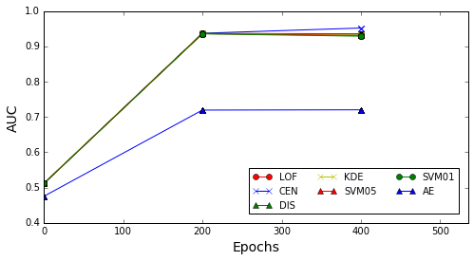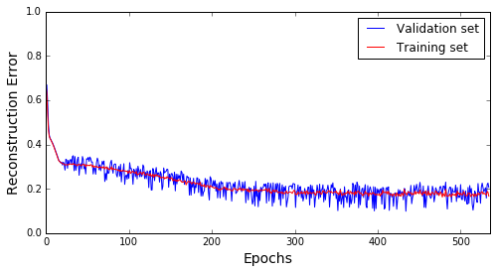

[ 534. 0.206538 0.166679]

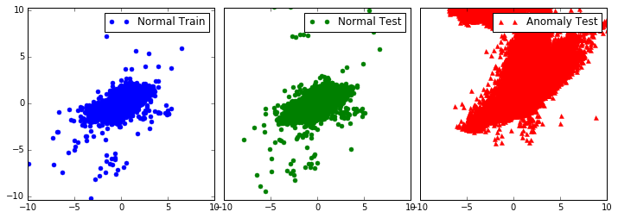

**+ Standard Deviation of Hidden data:**

[ 0.000462 0.00087 0.0006 0.000771 0.000694 0.000379 0.000518]

**+ AUC input, AUC hidden:**

[[ 0.743 0.915 0.734 0.72 0.851 0.852 0. 0. ]

[ 0.937 0.952 0.937 0.934 0.933 0.934 0.72 16.668]]

**The different AUCs when training on hidden data of VAE and input data:**

[[ 0.224 0.01 0.01 0.015 0.014 0.168 0.958 15.971]

[ 0.266 0.024 0.052 0.036 0.011 0.042 0.765 17.31 ]

[ 0.43 0.004 0.001 0.001 0.002 0.016 0.998 17.805]

[ 0.193 0.037 0.203 0.214 0.083 0.082 0.72 16.668]]