Yards Brewing Variety-Pack Automation
Team 1: Domain Knowledge Project Portfolio
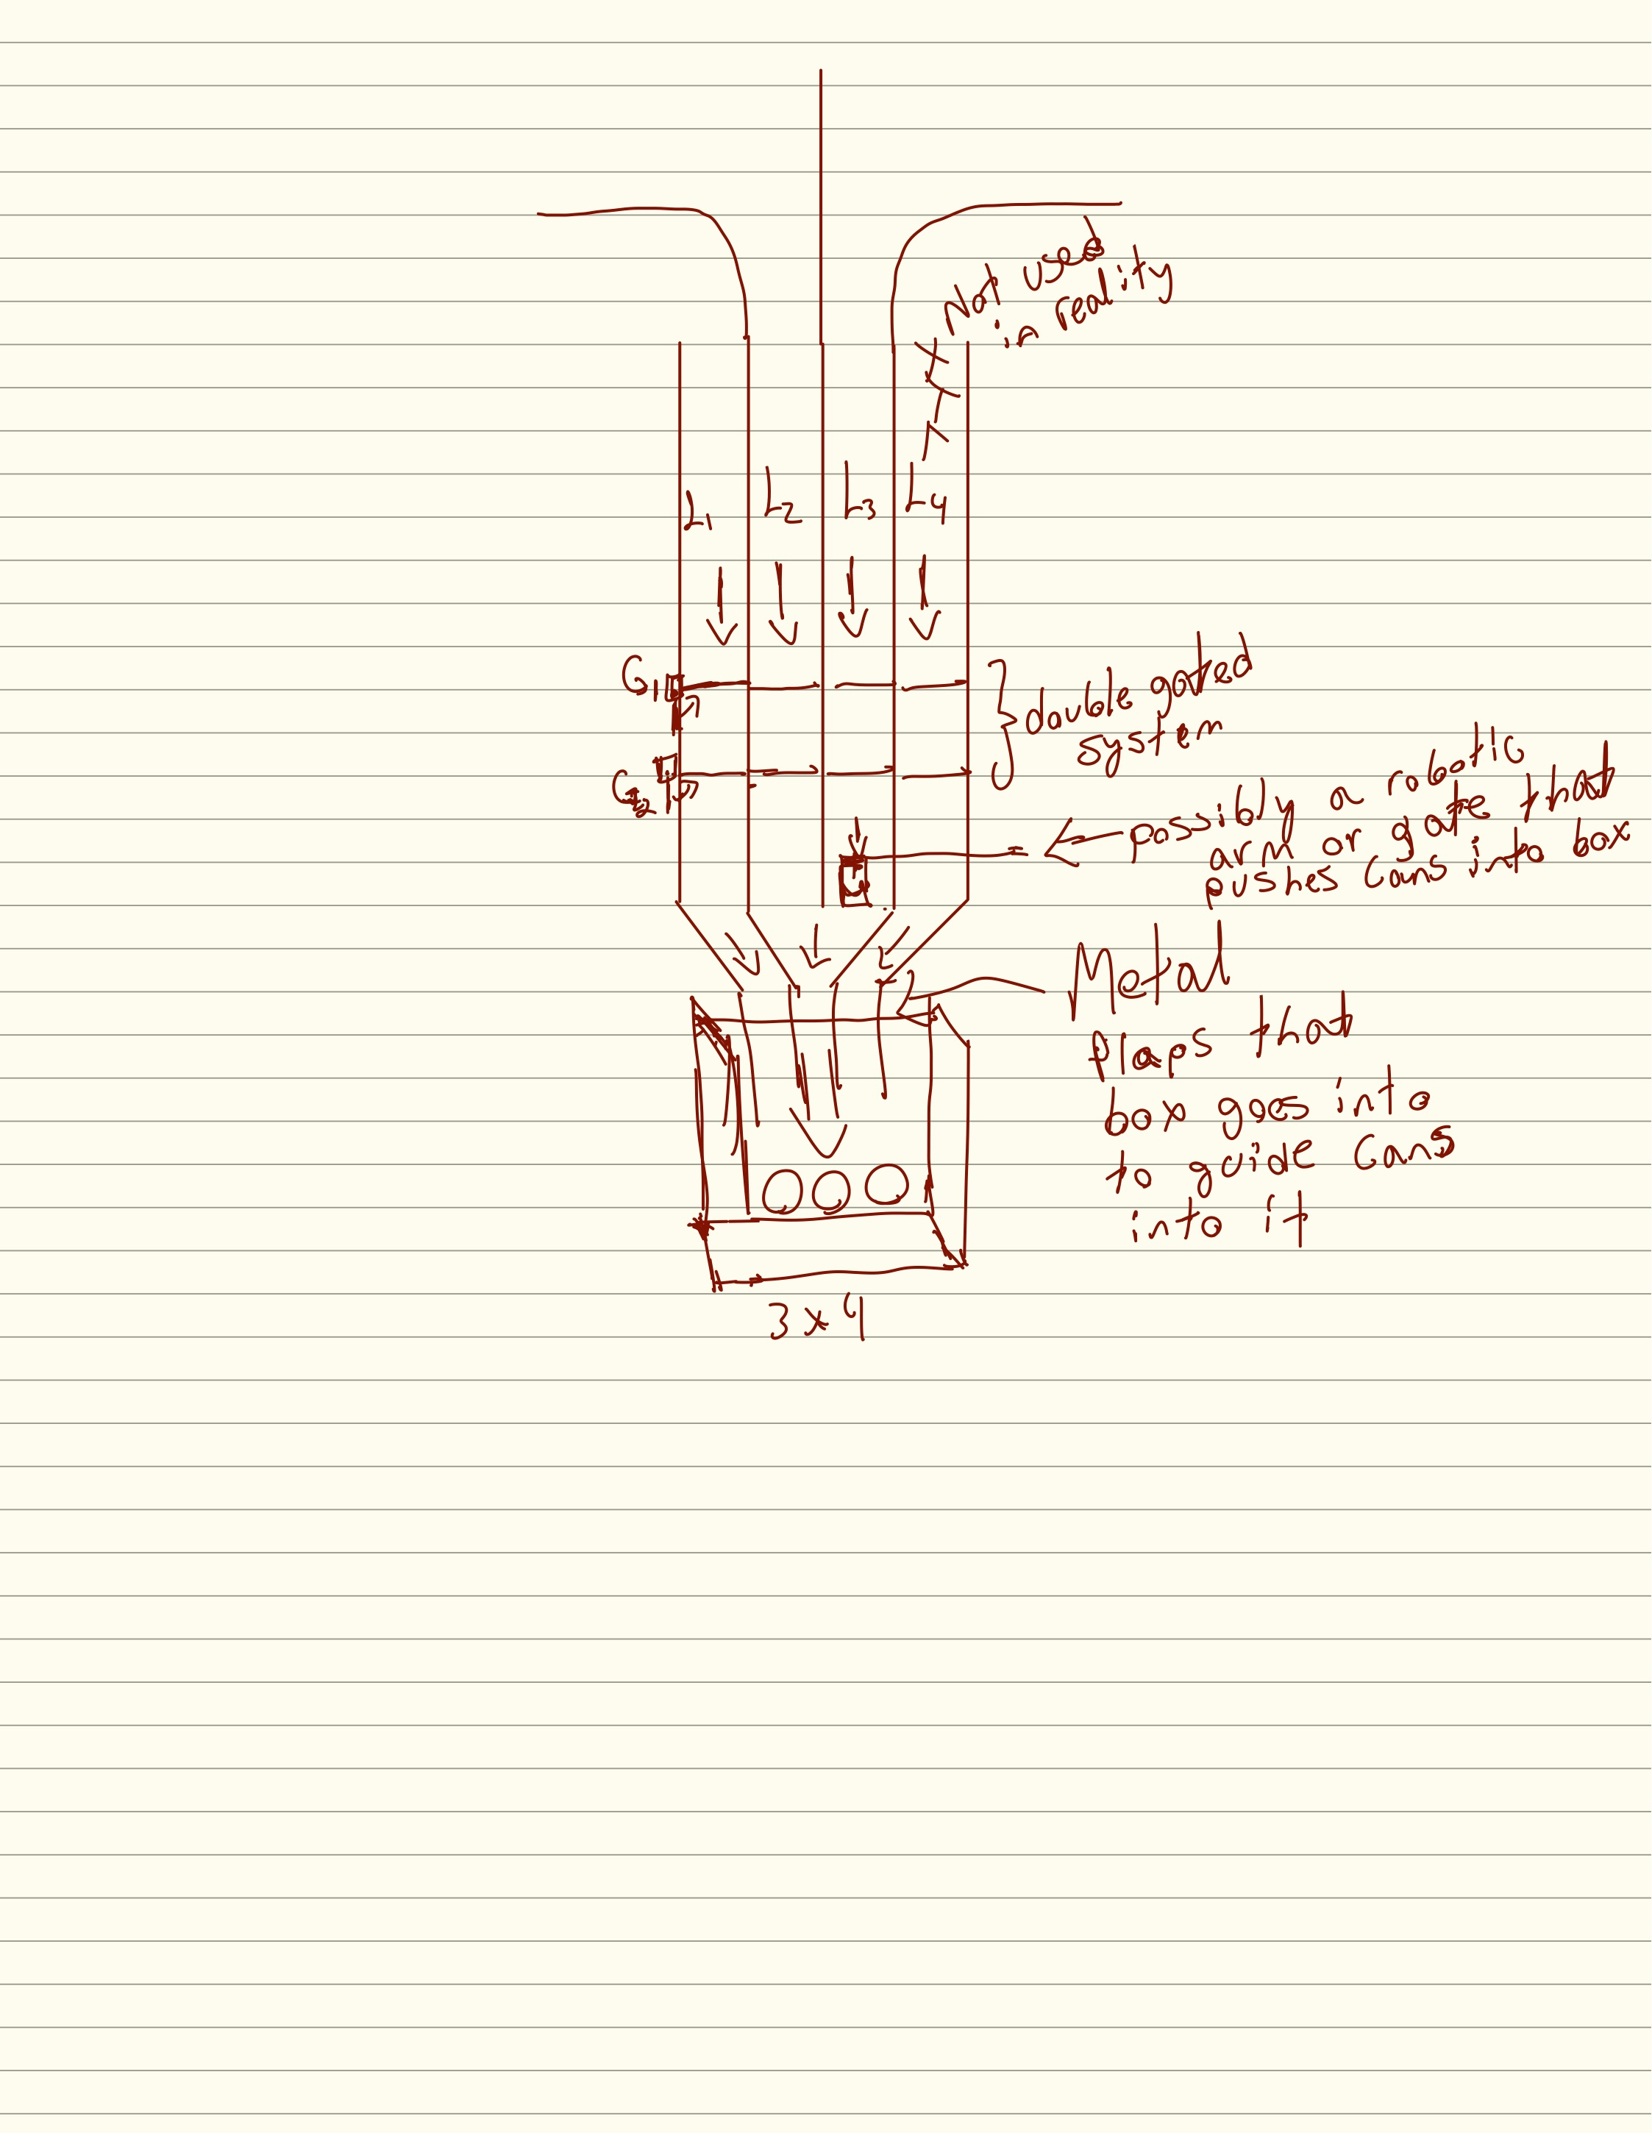

Purpose: a single source of truth for Team 1’s understanding of Yards’ variety-packaging process and the evolution of the proposed automation solution.

How to Use This Portfolio
This document is intentionally both a technical knowledge base and a project history. It preserves early assumptions, later corrections, and the current validated state so that the team can understand not only what is believed today, but why the design changed.
Evidence label | Meaning
Initial assumption | Derived from early videos, notes, or brainstorming before direct plant validation.
Observed / site validated | Seen or confirmed during the September 4 plant visit.
Yards-confirmed | Confirmed by Yards personnel during the September 4 visit or September 10 admin/engineering meeting.
External benchmark | Supported by competitive research into other beverage or brewery variety-pack systems.
Open item | Still requires measurements, drawings, testing, or a follow-up visit.

The current project boundary is variety-pack automation. The broader canning-process material is retained only where it explains why the variety process exists or where Yards already uses relevant technologies such as sensors, pneumatic rejection, or machine vision.

1. Executive Summary
Team 1 began with a broad understanding that Yards’ variety-pack process was labor intensive and that cans from different SKUs were manually recombined into reused 12-pack cartons. Initial work focused on understanding the full canning process, researching automation used elsewhere, and asking whether the team should automate upstream can handling, can selection, box loading, or all three.
The project became much more specific after direct plant validation. The central quality problem is not simply that the process is manual. It is that employees must remember and manually select the correct counts from separate product lanes, and there is no reliable in-process confirmation that the final carton contains the intended variety mix. Wrong mixes can remain undetected until a customer complaint. Can damage and carton loading are also meaningful secondary issues.
The current concept is therefore a retrofit to the existing variety-pack station rather than a new line. The design direction is: separate fixed-SKU lanes → two-stage escapement/double-gate control → formation of the correct 12-can combination → independent camera/color validation and fail-safe → controlled transfer across a dead plate into a reused carton using side discharge / pneumatic pushing → manual or later-automated sealing.
The September 10 meeting materially increased confidence in this architecture. Yards personnel confirmed that a similar double-gate escapement is already used elsewhere in the brewery, suggested thin stainless-steel guide plates, recommended a dead-plate side-discharge pusher concept, offered to provide basic mechanical hardware, and emphasized modularity and fail-safe quality control. The main open engineering challenge is now reliable can corralling and transfer into the carton, not whether escapement-based metering is viable.

2. Knowledge Progression Timeline
Date | Phase | What happened | Effect on knowledge/design
Pre-9/1 | Initial knowledge-domain research | Studied Yards’ overall canning and brewing processes, packaging videos, manual variety-pack workflow, possible camera inspection, and early automation opportunities. | Broad assumptions; project scope not yet narrowed.
9/1 | Competitive research | Benchmarked other breweries and packaging vendors; identified offline repacking, separate SKU lanes/buffers, recipe-controlled collation, robotics, and low-speed craft automation as recurring patterns. | Established that Yards’ manual workflow has direct industry analogs.
9/3 | Requirements discovery preparation | Converted assumptions into non-leading questions designed to let Yards define the actual pain points, throughput needs, package configurations, and constraints. | Moved from solution-first thinking to discovery-first/FDE-style problem framing.
9/4 | Plant site visit | Observed the line, learned how the lanes, passive backfill area, cartons, staffing, throughput, SKU scheduling, damage, and error modes actually work. | Major assumptions were validated, rejected, or refined.
9/4–9/9 | Concept refinement | Developed gating, escapement, funnel/guide, horizontal carton loading, servo/pneumatic, and pusher ideas. Corrected visual misunderstandings and converged on a top-down horizontal-flow concept. | Design became a retrofit concept based on the real station.
9/10 | Yards admin/engineering review | Presented concept; received feedback from Mark and Neal Goss on double-gate escapements, throughput, camera fail-safe, stainless guides, modularity, available parts, dead-plate side discharge, and pusher geometry. | Current design direction is now partially validated by Yards’ existing machinery and engineering practices.

3. Yards Context Relevant to the Project
Early knowledge-domain notes recorded seven year-round beers and four seasonal beers, along with multiple variety-pack formats. The same notes also captured the then-recent ownership/reorganization context involving B3 Beverage. These company-level details are background rather than design requirements, but they reinforce why flexibility matters: product mixes and contract-packaging needs can change over time.

3.1 Why the upstream canning process matters
The variety problem exists because Yards runs the main canning line efficiently by producing one or two SKUs per day rather than simultaneously producing all products needed for a variety pack. The normal cartoning equipment can build a clean case of one brand/SKU, but variety production requires later recombination of separately produced products.
Initial video research recorded a can-line speed near 220 cans/minute; the September 4 plant discussion described approximately 225 cans/minute for 12-ounce cans. Those figures describe the main canning line, not the variety-pack station. The distinction is important because the capstone should not be designed around 220–225 cans/minute variety throughput.
Yards already uses automated inspection and rejection elsewhere in the plant: x-ray/height inspection, seam-quality processes, sensors, and pneumatic rejection. This is relevant because the proposed variety system can reuse familiar industrial patterns: sensed events, deterministic controls, fault tracking, and physical reject/stop actions.

4. Phase 1 – Initial Video-Based Understanding and Brainstorming
Before the plant visit, the team’s understanding came primarily from Yards videos, class materials, and research notes. At that point, several important facts were still assumptions.
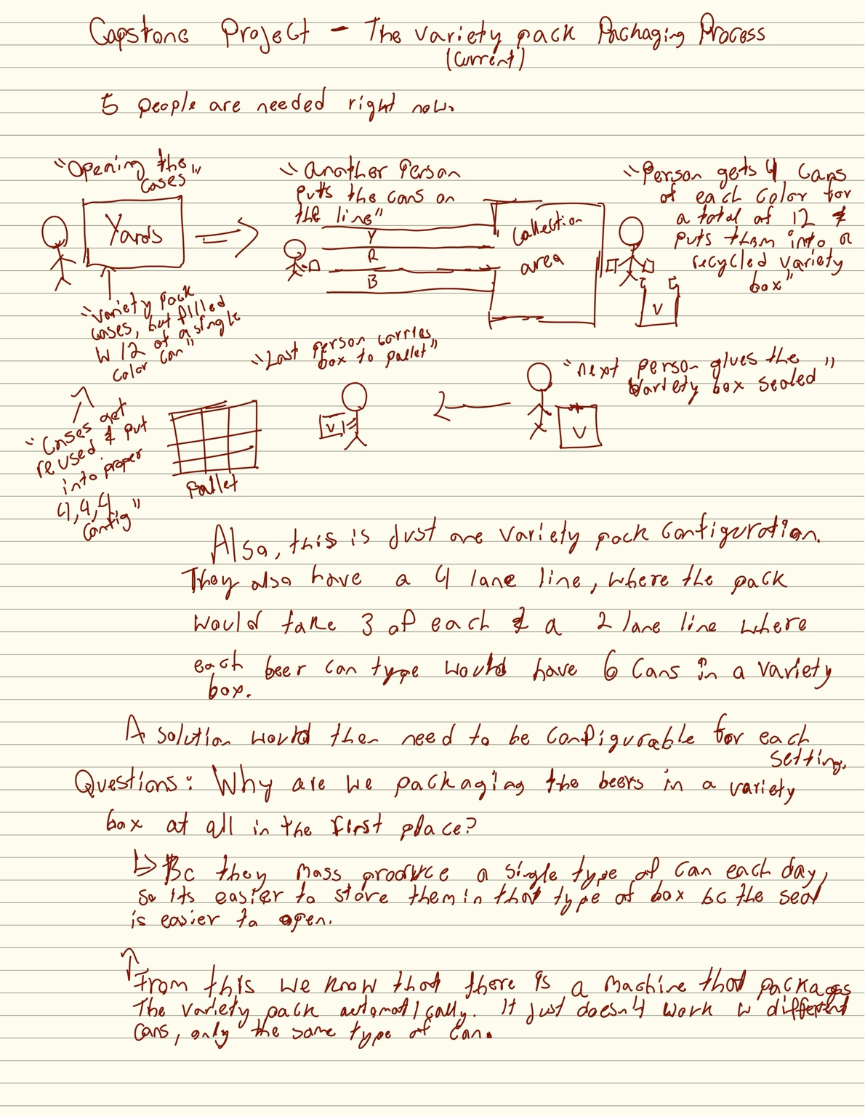
Figure 1. Initial handwritten process map derived from the available variety-pack video. It captured the five-person manual flow, separate can lanes, reuse of cartons, manual mixing, sealing, and pallet movement.
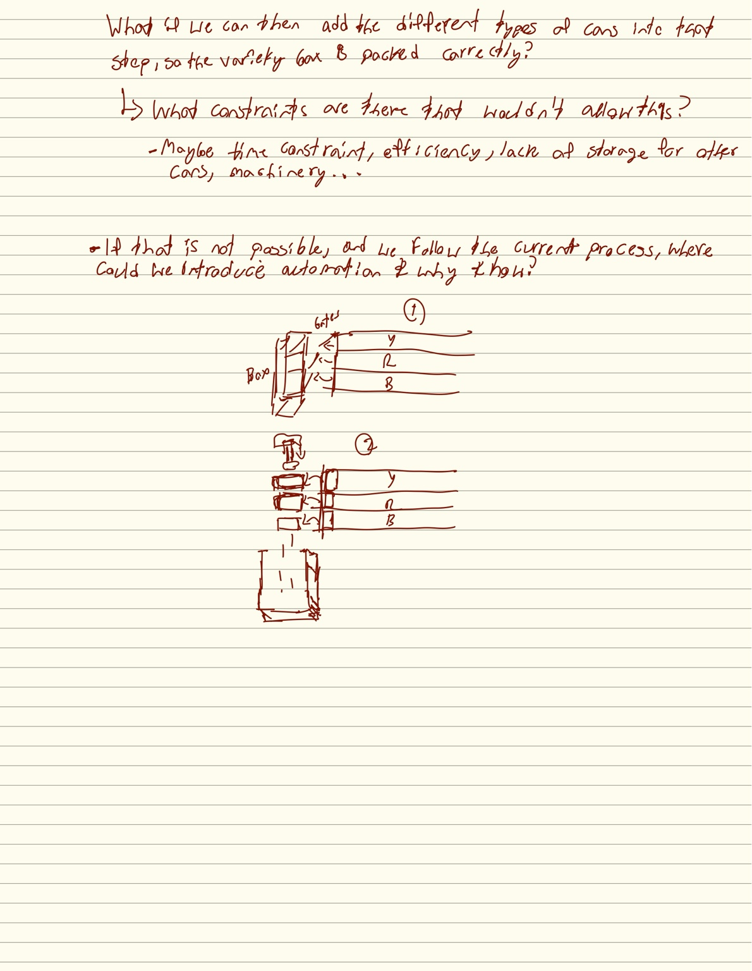
Figure 2. Early brainstorming page asking whether the different SKUs could be combined earlier, what constraints prevented that, and where automation could be inserted if the existing workflow had to remain.

4.1 Initial working model of the process
- Single-SKU beer is mass-produced and packaged/stored separately.
- Cases are reopened for variety work.
- Employees place different SKUs onto separate lanes.
- A worker manually selects the required quantity from each SKU lane.
- The selected cans are placed into a reused variety carton.
- The carton is manually sealed and moved downstream.
The team initially considered configurations such as 4+4+4, 3+3+3+3, and 6+6 for a 12-pack. The early design implication was correct even before the exact active products were known: the automation should be recipe/configuration driven rather than hard-coded to a single mix.

4.2 Initial assumptions and uncertainties
Early assumption/question | Why it mattered | What later happened
The line may need to support up to four active can SKUs. | Determines number of input lanes and recipe logic. | Site visit showed Yards-branded cans currently use three flavors; the physical system historically supported more. Current concept should prioritize three active lanes while remaining modular.
A camera may need to identify every can. | Could make vision central to the control system. | Fixed lane identity reduced the need for vision as the primary counter; after 9/10, vision returned as an independent color/QC fail-safe.
The conveyor or gravity might be enough to load the carton. | Could eliminate a dedicated pusher. | Later design work clarified that loading is horizontal; 9/10 feedback favored a dead plate with side discharge and an opposing cylinder/pusher.
Two gates might be useful for metering. | Potential low-cost alternative to robotics. | Initially uncertain because cans are back-to-back; 9/10 Yards confirmed double-gate escapements are already used elsewhere in the brewery.
Speed may be the main problem. | Would drive high-throughput design. | Site evidence shifted the main value proposition toward mix accuracy, reduced human error, and repeatability; throughput remains a constraint, not the sole objective.

5. Problem Definition Evolution

5.1 Early design question
“How can we automate or reduce the manual labor involved in assembling variety packs containing multiple can types while still supporting different variety-pack configurations?”
This was useful as a design question, but it assumed automation was the answer and did not yet capture the validated quality problem.

5.2 Post-site-visit problem statement
Yards’ variety-pack process relies on employees to remember, count, and select the correct number of cans from fixed-SKU lanes before loading reused cartons. There is limited in-process verification, so incorrect mixes can reach customers; carton loading and resealing also create handling and quality challenges.

5.3 Current problem framing after 9/10
Develop a modular retrofit that reliably meters the correct variety-pack combination, independently verifies the mix, and transfers the grouped cans into the reused carton while maintaining useful throughput and fitting Yards’ existing intermittent process.
The current framing deliberately treats speed, labor reduction, quality, and maintainability as separate dimensions. Yards’ feedback suggests the design should not claim value solely through faster cycle time.

6. Phase 2 – Competitive and Industry Research
Competitive research focused on how breweries and beverage packers handle the same structural problem: SKUs are produced separately, but the customer wants them combined into one mixed pack. The strongest pattern was not simultaneous multi-flavor production. It was offline repacking: buffer each SKU separately, then combine the required quantities later in a dedicated variety-pack operation.
Benchmark | Observed architecture | Design lesson for Yards | Source type
Spoetzl Brewery / Shiner | Separately handled beers feed a dedicated multi-lane variety-pack operation; robotic collation creates repeatable mixes; mother cartons are reused. | Closest conceptual analog. Keep SKU streams separate, automate the collation point, and do not assume mega-brewery speed is required. | Packaging World
Maui Brewing | Single production line; mix-pack cans are stored/handled separately and later fed to dedicated mix-pack cells. Four product positions can be configured for fewer active varieties. | Fixed physical inputs + software/configuration changes are appropriate. Reuse of packaging materials is compatible with automation. | Packaging World
Mark Anthony / White Claw | Later facility deliberately decoupled variety-pack creation from filling by using independent repackaging systems. | Do not redesign Yards’ main filler/canner. Keep variety assembly as a downstream standalone operation. | KHS case study
KHS variety-pack architecture | Separate adjacent product lanes are grouped into mixed packs, supporting multiple flavor counts. | Validates lane-based metering and recipe-driven grouping as an industry architecture. | KHS technology
Graphic Packaging QuikFlex 40 | Low-speed, small-footprint secondary packaging targeted at craft/manual operations. | Automation at craft-brewery scale is legitimate; the answer does not have to be a high-speed robotic cell. | Graphic Packaging
Pacteon / Descon | Robotic variety-pack uncasing and multi-lane handling at industrial scale. | Useful upper-end benchmark; not a practical semester implementation. | Vendor case material
Molson Coors / Topo Chico | Variety assembly was handled separately/externally before major investment in an automated in-house variety packer. | Shows variety repacking can be a distinct downstream business process and can justify staged investment. | Molson Coors

6.1 Why Shiner was the strongest comparison
Shiner was the most useful analog because the products are produced separately, moved to a dedicated variety operation, kept in separate inputs, and collated into a repeatable mixed configuration. Yards already has a simpler version of that physical logic. The transferable lesson is not the industrial robot; it is the architecture: known SKU source → controlled quantity → repeatable collation → packaging.

6.2 Research-driven design principles retained today
- Do not couple variety-pack automation to the main filler/canner.
- Keep SKU streams physically separate until the controlled grouping point.
- Make the recipe/configuration software-driven or mechanically modular.
- Use deterministic counting/metering for core control; use vision as verification rather than the sole source of truth.
- Treat carton loading as its own mechanical problem after the correct assortment is formed.
- Prefer a retrofit around Yards’ existing station over replacing the line.
- Prioritize reliability and maintainability over unnecessarily high throughput.

7. Phase 3 – Requirements Discovery Before the Site Visit (9/1–9/3)
The team intentionally shifted from proposing a solution to asking discovery questions. The goal was to behave more like an engineering consultant/FDE: first let Yards define the real pain points, then use the answers to validate or reject the team’s assumptions.
The requirements document covered: the primary problem, process walkthrough, staffing, run frequency, throughput, configuration flexibility, SKU sequence requirements, can-handling constraints, existing equipment, carton condition, reusable resources, and non-modifiable areas.
The most important methodological change was to avoid leading questions. For example, instead of asking whether Yards would accept a four-lane automated selector, the team asked how SKUs are currently introduced, separated, counted, and brought together. This preserved the value of the site visit as genuine discovery rather than confirmation bias.

8. Phase 4 – September 4 Plant Visit
The September 4 visit was the first major evidence update. It clarified the physical station, the actual error modes, how cartons are reused, when variety work is performed, and what parts of the process Yards considers difficult.
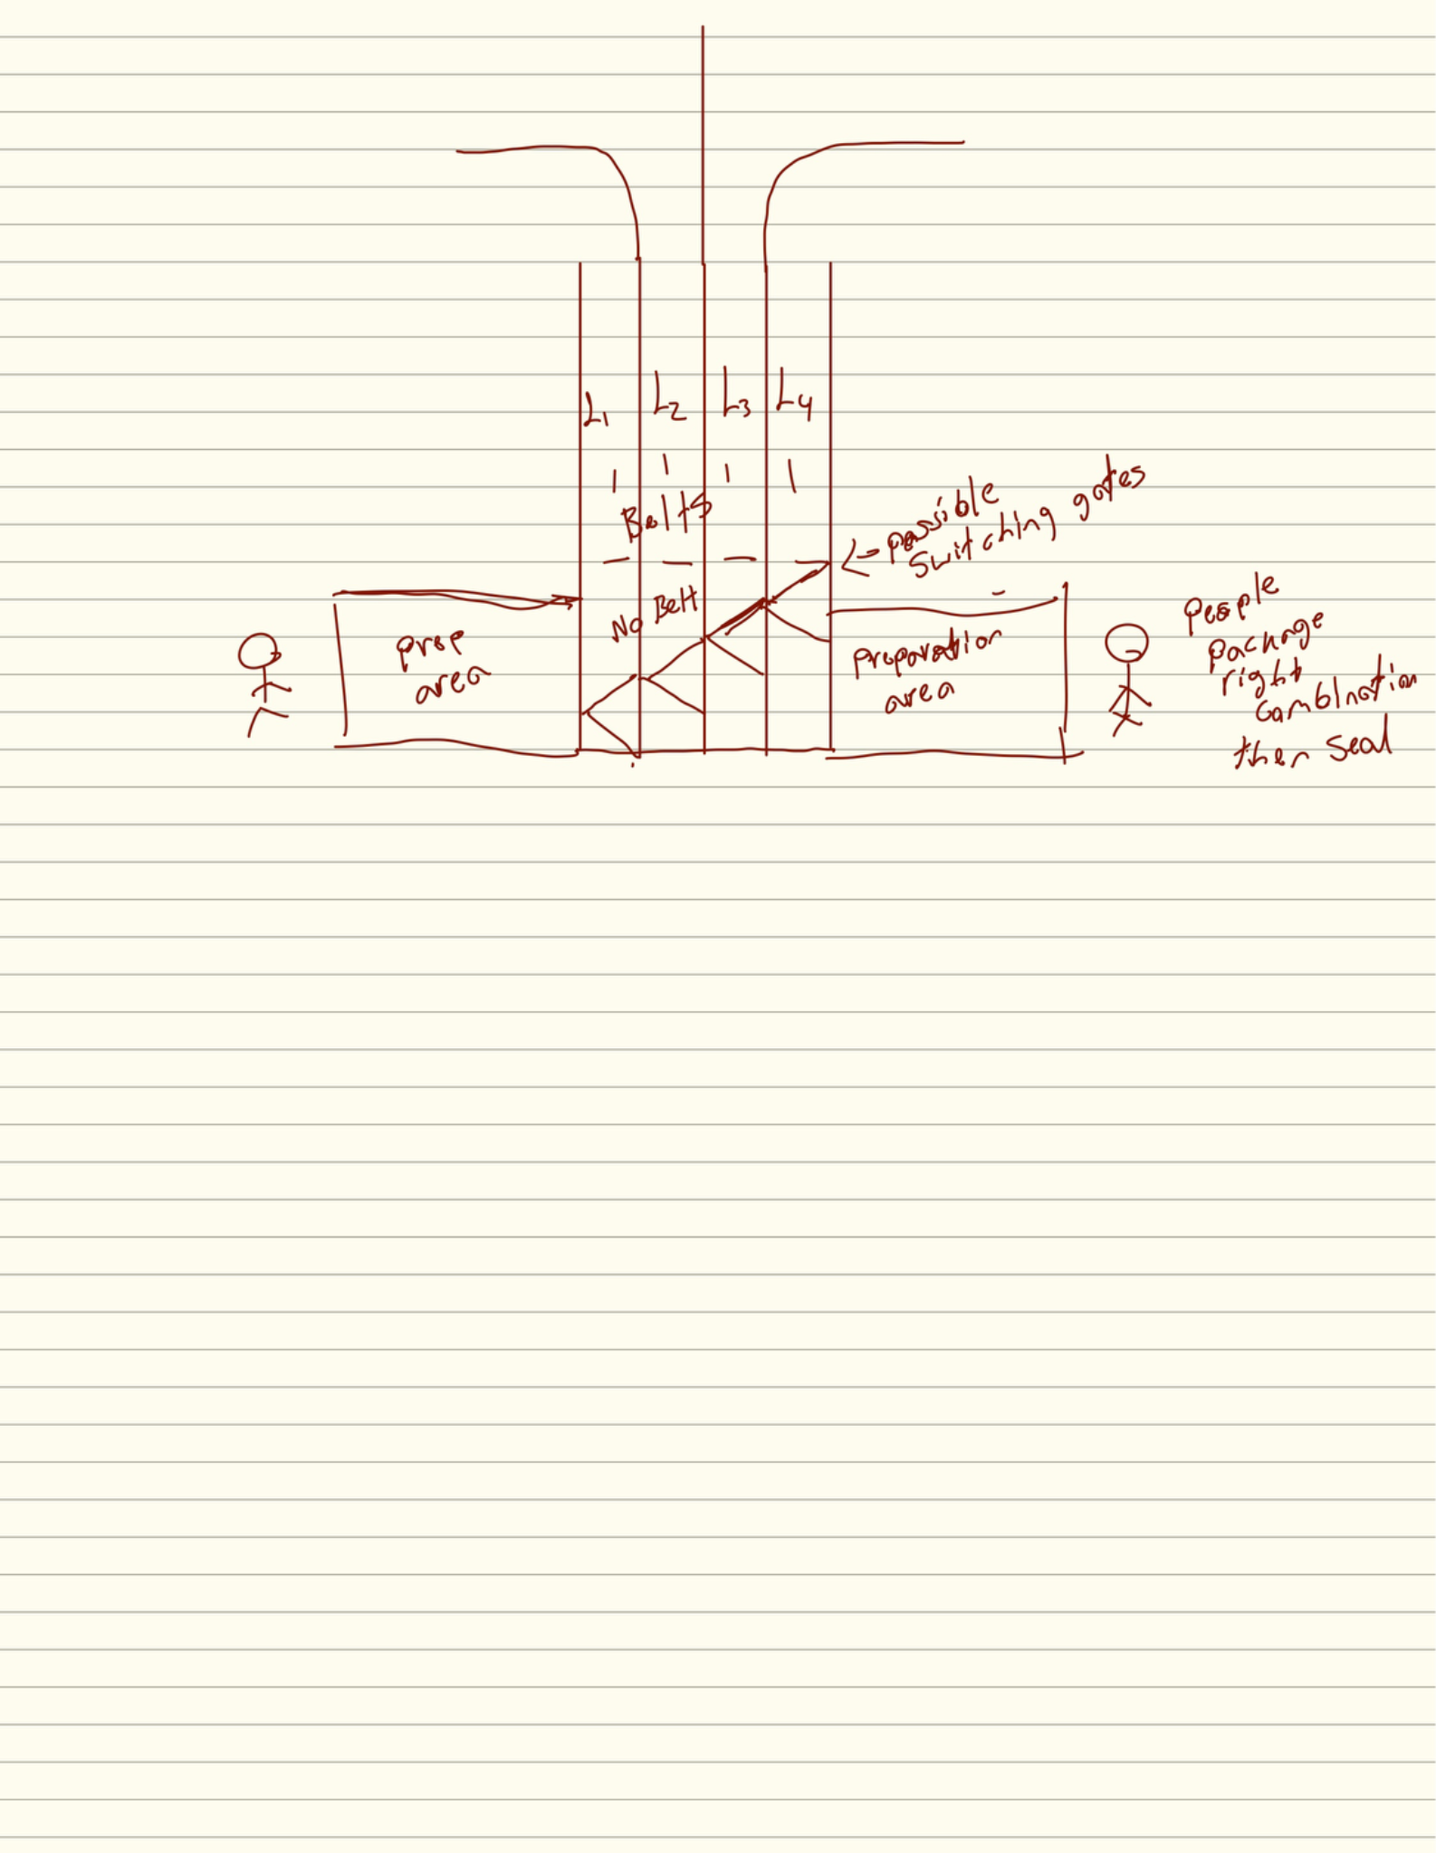
Figure 3. Bird’s-eye sketch produced after the September 4 visit. It captures the shared conveyor, multiple lanes, lane-end passive/backfill region, preparation areas, and the packaging end of the station.

8.1 Current physical station as learned on-site
- The variety station is a movable, manually evolved system rather than a purpose-built high-speed automated line.
- The lane structure evolved over time from a straight conveyor; wings and a gravity carton conveyor were later added.
- Cans are loaded by flavor/SKU into separated lanes. Lane identity provides a strong cue for product identity.
- There is a passive/no-belt area at the lane ends where cans can backfill and remain staged.
- Opened 12-pack cartons are reused and travel down an upper gravity track to the packing operator.
- For Yards-branded cans, the current common mix is three flavors, four cans of each, for a 12-pack.
- Bottle variety work is a different operation and is easier to visually check because the packaging is open/top-loaded; the can variety process side-loads cans into cartons.
- The cans are always packed as 12-packs for this process.

8.2 Why the current process exists
Yards usually runs one to two can SKUs per day for efficiency. The normal packaging machinery can build clean single-SKU cases, so products intended for later variety work are packed or staged individually and then reopened/recombined. The September 4 transcript explicitly confirmed that repacking already-packaged products is the common method when the correct mix carton is not produced inline.
This validated the competitive-research conclusion that an offline variety operation is not an accidental workaround unique to Yards; it is a logical consequence of efficient single-SKU production.

8.3 Validated pain points
Pain point | Evidence from Yards | Project significance
Wrong variety combination | Employees can reach into the wrong lane, double-grab one product, or short another. Yards often cannot detect the mistake until a customer complaint. | Primary target. The system must prevent or detect mix errors.
No closed-loop verification | Current checks are largely balance/eyeball/manual-count based. | Creates opportunity for deterministic count logic plus independent vision/color QC.
Can damage | Cans can be dropped or damaged during lane loading and handling; damaged product is written off. | Guides, gates, and loading mechanisms must avoid denting and unstable impacts.
Manual loading into reused carton | Cans must be side-loaded/stuffed into the reused 12-pack; this is less forgiving than top-loading bottles. | Major mechanical challenge for the capstone.
Mixing + resealing | Site notes identify mixing and resealing as difficult manual portions. | Sealing is relevant but can remain downstream/manual if scope requires.
Variable staffing / intermittent use | Variety work is often done after main work orders, during changeover, or with ancillary labor. | The design should be simple, modular, and useful even when the station is not continuously staffed.

8.4 Throughput information learned on 9/4
Throughput was initially difficult to quantify because the variety station does not always run as a dedicated full-team operation. During the visit, Yards described roughly one pallet every one to two hours in some operating contexts, and confirmed that a can pallet for the discussed 12-pack configuration contains about 100 finished cases. They also described one three-flavor cycle as producing 300 finished cases from three 100-case flavor pallets.
This was a useful baseline but not yet a formal design requirement, because staffing and operating context vary. The September 10 meeting later provided a higher current operating range of roughly 150–200 cases/hour when appropriately staffed, plus a historical/original target of about 1,500 cases/day.

8.5 Site-visit findings that changed the design
Before visit | After visit
Potentially four active flavors for Yards’ own pack. | Current Yards can variety pack is commonly three flavors; another contract variety uses two. Historical capability included more, so modularity still matters.
Camera could identify cans in every lane. | Lane identity already carries SKU meaning; camera does not need to be the primary counter/identifier.
Unclear whether carton order matters. | For the relevant pack, the correct counts matter more than an exact flavor sequence inside the carton.
Unsure where to meter cans. | Existing passive/backfill area provides a natural physical location for gating/escapement concepts.
Automatic loading concept was abstract. | Side-loading geometry and reused one-side-opening cartons became clear enough to begin pusher/funnel concepts.
Throughput unknown. | A rough operational baseline was obtained, though still context dependent.

9. Phase 5 – Design Evolution After the Site Visit (9/4–9/9)
The team iterated rapidly after the visit. Several drawings were useful as thinking tools even when parts were later corrected. This section intentionally preserves those iterations because each exposed a design issue that influenced the current concept.
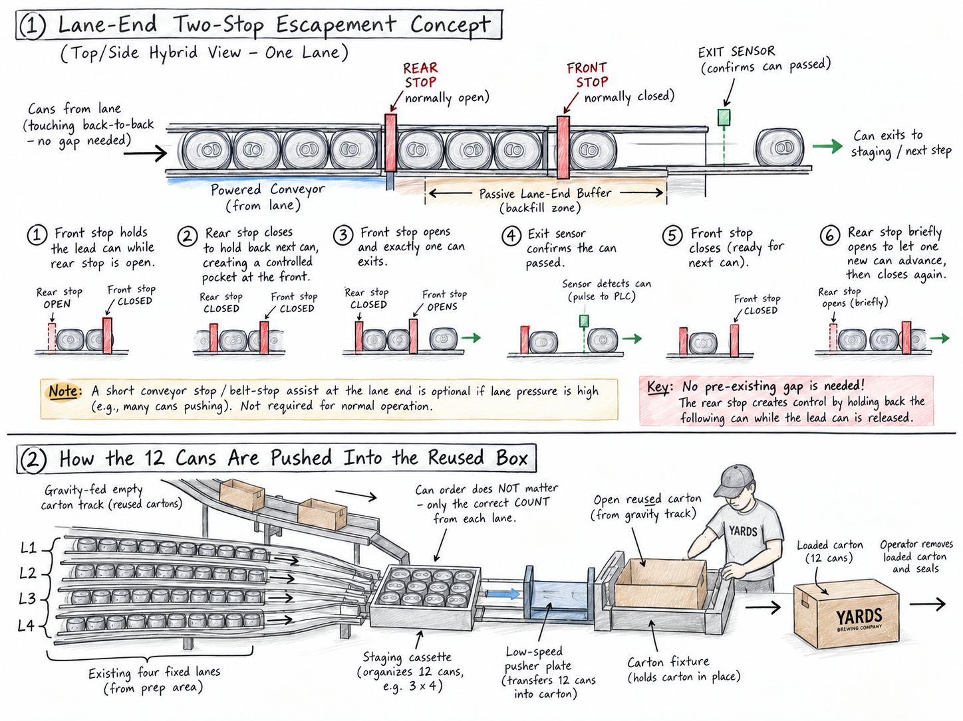
Figure 4. Early post-visit escapement and carton-loading visualization. Useful for introducing the ideas of staged release and a pusher, but later discussion showed that the rear-stop geometry and physical orientation needed refinement.
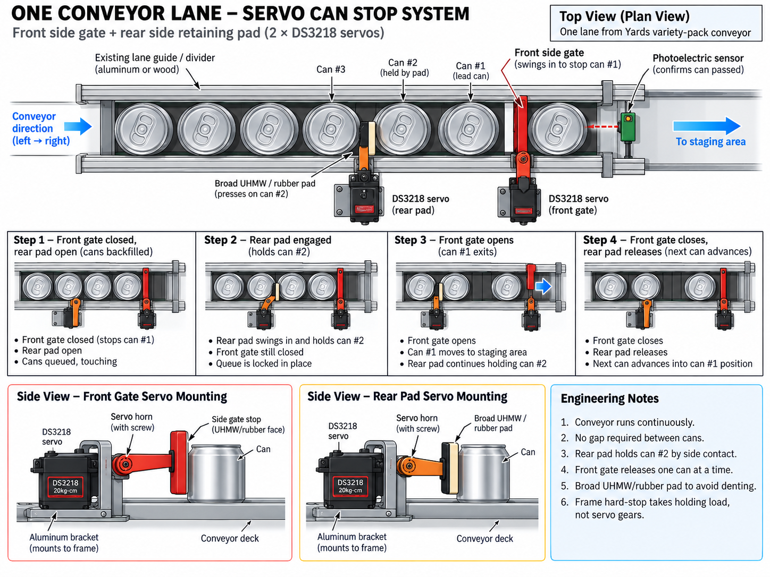
Figure 5. Servo-gate exploration. This image was later treated as a concept rather than a final mechanism because the team clarified that both gates are side-actuated and that a rotary servo cannot simply translate linearly without linkage.
Figure 6. Authoritative team sketch before the 9/10 meeting. It is a bird’s-eye/top-down view: three useful lanes feed forward through a double-gated section, then toward horizontal carton loading. The fourth physical lane is not used in the current concept.
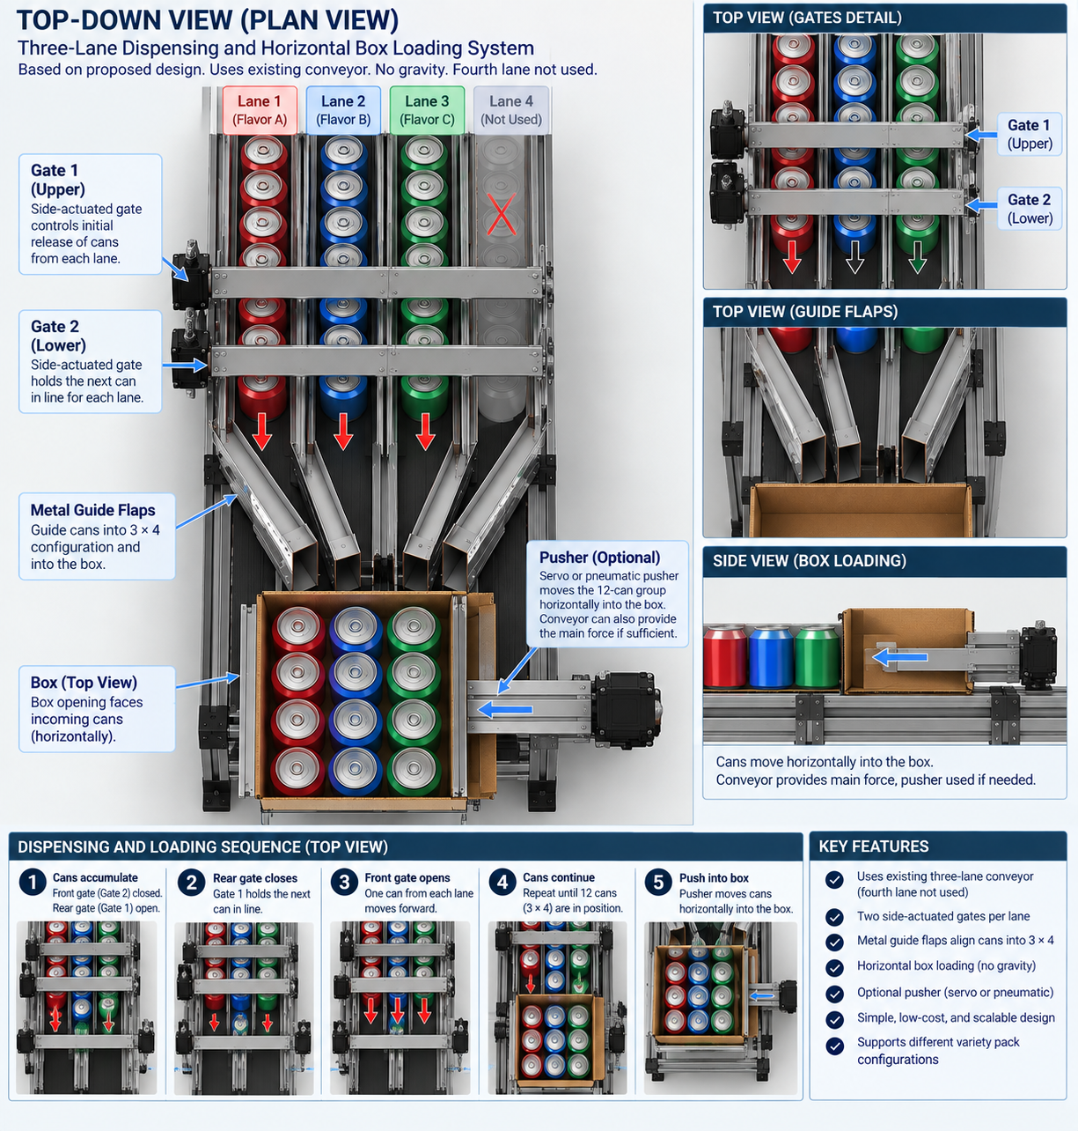
Figure 7. Later concept rendering after the team clarified the top-down orientation: three active lanes, two parallel gate rows in the same horizontal plane, forward flow toward the carton, and horizontal loading with an optional pusher. This remains conceptual, not a final dimensioned engineering drawing.

9.1 Key mechanical question: back-to-back cans
A major design discussion concerned whether a rear gate can reliably close when cans are touching back-to-back. The team correctly identified that a stop cannot assume a pre-existing gap. Several alternatives were discussed, including side squeeze/retaining actions, conveyor stop/jog, and staged escapement geometry. The September 10 meeting significantly reduced this uncertainty because Yards confirmed that a similar double-gate escapement architecture is already used in an existing loader.
The practical next step is therefore not to invent the escapement from first principles. The team should observe and document Yards’ existing double-gate/switchback hardware and adapt the proven spacing, stop geometry, actuation, and timing wherever possible.

9.2 Design direction immediately before 9/10
- Three active can lanes for the current Yards-branded configuration.
- Two side-actuated gate rows / escapement stages across the active lanes.
- Recipe logic to meter the correct number of cans from each lane.
- Thin guide/funnel elements to transition the cans toward the box.
- Horizontal carton insertion; no gravity-drop assumption.
- Optional mechanical/pneumatic pusher if conveyor force is not sufficient.
- Camera considered primarily for validation rather than for the core count logic.

10. Phase 6 – September 10 Yards Admin / Engineering Design Review
The September 10 meeting is the most important design review so far because it brought the concept in front of Yards personnel who understand the existing equipment and can support fabrication. The feedback both validated major parts of the concept and introduced more realistic industrial implementation details.

10.1 Throughput and capacity clarification
- The historical/original system target discussed in the meeting was approximately 1,500 cases/day with a seven-person operating team.
- Current operation can run approximately 150–200 cases/hour depending on staffing and conditions.
- Mark explicitly questioned whether the proposed automation would save time, so speed improvement should be tested rather than assumed.
- Accuracy, quality control, reduced rework, and reduced dependence on human memory remain valid value propositions even if cycle time is similar.
Important reconciliation: the earlier 9/4 one-pallet-per-one-to-two-hours statement described a typical/variable real-world operating context where variety work may be ancillary. The 9/10 150–200 cases/hour figure appears to represent a more fully staffed or production-focused operating condition. Both should be retained until the Kaizen drawings/data establish the formal baseline.

10.2 Double-gate escapement validation
Mark stated that Yards already uses a similar double-gate system with escapements in another loader. This is a major validation. The group aligned on the concept of one gate controlling/releasing product while the other controls the next batch. The design should now reference Yards’ proven implementation wherever possible rather than relying on hobby-servo geometry as the production concept.
This also changes the prototype strategy: a low-cost servo/Arduino test rig may still be useful for software and sequencing experiments, but the production-minded design should be based on the dimensions, stops, brackets, bearings, and actuator principles observed on the existing Yards machinery.

10.3 Carton loading: dead plate + side discharge
Neal and Mark recommended a more industrially realistic loading concept: grouped cans transfer onto a dead plate and are side-discharged/pushed into the carton, likely using an opposing-cylinder arrangement similar to the plant’s case erector. The available extension was discussed as roughly 16 inches to 2 feet, pending confirmation.
This is the clearest current answer to the earlier debate about relying on conveyor force versus adding a pusher. Conveyor force may contribute to presentation/accumulation, but the current preferred concept is a controlled transfer/pusher that is not itself on the moving conveyor.

10.4 Thin stainless-steel guides / prongs
Neal suggested thin stainless-steel plates similar to hardware already used in plant equipment. These plates can function as guides/funnel elements that enter or align with the carton opening, reduce catching on cardboard edges, and help corral the 12 cans during transfer.
The meeting notes refer to a four-prong/finger concept. That should be treated as a loading-guide concept, not as a requirement that every can be individually manipulated. The real engineering objective is to form the correct case pattern and transfer it into the one-side-open carton without denting or losing alignment.

10.5 Vision system returns as an independent QC layer
Earlier site findings reduced the need for vision as the primary can counter because lane identity is known. The 9/10 discussion gave the camera a stronger and more appropriate role: independent validation of color/SKU arrangement before loading, with a fail-safe response if the expected mix is not present.
- Camera/color validation should be independent of gate count logic where possible.
- A failed check should trigger a visible/audible alert and identify the affected row/lane if possible.
- A stronger fail-safe could inhibit the pusher or stop the conveyor until the condition is cleared.
- The camera should not be asked to solve unrelated 360-degree can-defect inspection unless the project scope changes.
- Budget responsibility for camera/electronics sits primarily with the school/Professor Oakes side, while Yards offered support for mechanical hardware.

10.6 Modularity and maintainability
- Build the system modularly so gate, funnel/guide, or pusher assemblies can be removed and serviced independently.
- Keep the main machine architecture stable and make the funnel/guide section the primary configurable component for different pack recipes.
- Design for two-lane versus multi-lane arrangements without requiring a complete rebuild.
- Use hardware Yards can source or fabricate internally where possible.

10.7 Division of responsibilities / available support
Area | Yards support | Team / school responsibility
Mechanical hardware | Basic gates, brackets, bearings, some gearing/fabrication support through suppliers; Neal offered engineering help. | Design integration, dimensions, prototype coordination, documentation.
Electronics / controls | Limited direct supply. | Camera, controller, sensors, software, logic, interfaces, fail-safe implementation.
Existing-machine reference | Observe Switchback/double-gate systems; Mark to provide Kaizen drawings/data where available. | Capture mechanism geometry, timing, and transferable principles.
Prototype / validation | Potential plant visit, staff guidance, hardware collaboration. | Build and test subsystem prototypes; document accuracy, speed, faults, and loading behavior.

11. Current Validated System Architecture (as of 9/10)
Current design thesis: Retrofit the existing variety-pack station with escapement-based metering, independent visual verification, and a controlled dead-plate side-transfer into the reused carton.
- Operators continue to open/prep the source cartons and feed the existing flavor lanes.
- The active lanes accumulate product upstream of the metering area.
- A two-stage/double-gate escapement separates and counts the required quantity for the selected recipe.
- The released cans are organized/corralled into the correct 12-can case pattern using thin stainless guide/funnel elements.
- A camera verifies the visible color/SKU pattern and acts as an independent quality-control check.
- If the pattern is invalid or a lane fault occurs, the system alarms and should inhibit loading; conveyor shutdown is a candidate fail-safe.
- A grouped batch transfers onto/through a dead-plate side-discharge section.
- An opposing cylinder / pneumatic pusher transfers the group horizontally into the one-side-open reused carton.
- The operator removes the loaded carton and performs the remaining sealing/gluing unless that step is later added to scope.

11.1 What is validated vs. still open
Element | Status | Notes
Offline variety-pack station is the correct project boundary | Validated | Yards’ production schedule and external research both support downstream repacking rather than filler integration.
Three active lanes for current Yards can variety | Validated for current product | Future/contract flexibility still matters.
Double-gate/escapement principle | Strongly validated | Yards already uses a comparable mechanism elsewhere.
Exact gate dimensions/actuation | Open | Observe existing loader/switchback; obtain drawings if possible.
Camera as QC fail-safe | Supported | Need camera selection, lighting, field of view, and pass/fail logic.
Thin stainless guide plates | Supported | Yards can help supply material; exact geometry remains open.
Dead plate + side-discharge pusher | Supported direction | Travel ~16–24 in needs confirmation; exact cylinder/fixture geometry open.
Carton handling fixture | Open | Need reliable positioning of one-side-open reused carton.
Automatic gluing/sealing | Not core | Can remain manual unless time/cost/value justify expansion.
Throughput requirement | Partially known | Need Kaizen data to reconcile 150–200 cases/h, 1,500/day, and variable staffing contexts.

12. Controls, Software, and Quality Architecture
The strongest control architecture is layered rather than camera-only. The escapements should deterministically meter the target quantity, while the camera independently checks the resulting visible configuration.

12.1 Core recipe logic
For the current Yards 3-flavor 12-pack, the nominal recipe is 4+4+4. Other contract configurations may include two flavors, and future configurations may change. Recipe logic should therefore map a named pack to target lane counts rather than hard-coding one cycle.
Example logical record: Recipe Yards_3Flavor_12 = {Lane A: 4, Lane B: 4, Lane C: 4}. The controller should count confirmed escapement events per lane, not merely elapsed time.

12.2 Fail-safe hierarchy
- Sensor/gate logic confirms the commanded quantity from each lane.
- Camera validates visible product/color pattern before the pusher is enabled.
- Mismatch or uncertainty triggers a light/alarm and records the affected lane/row where possible.
- The pusher remains inhibited until the issue is cleared.
- A stronger implementation may stop the conveyor on a fallen can, jam, or failed quality check.
- The event should be logged for traceability and later process analysis.

12.3 Data the system could begin collecting
- Recipe selected
- Target and actual lane counts
- Cycle time
- Camera pass/fail result
- Lane/row associated with the fault
- Number of resets or manual interventions
- Pusher cycle count
- Cases completed
- Downtime / jam events
This is valuable because the current variety process has limited instrumentation. Even a simple log would give Yards a much better foundation for measuring true throughput, failure rate, and the operational value of the retrofit.

13. Semester Feasibility and Recommended Scope
The project became more feasible as the team learned that Yards can supply some mechanical components and already has a proven escapement reference. It also became clearer that the full case-loading mechanism is the hardest integration challenge.
Subsystem | Semester feasibility | Recommendation
Recipe/counting control logic | High | Core deliverable.
One-lane escapement prototype | High | Prototype early; then adapt Yards’ existing double-gate geometry.
Three-lane synchronized metering | Medium–High | Core if hardware arrives in time.
Camera color validation + alarm | Medium–High | Core QC layer if camera procurement is timely.
Thin stainless guide/funnel prototype | Medium | Build adjustable and modular.
Dead-plate side-discharge pusher | Medium | High-value mechanical target; use Yards engineering support.
Automatic carton positioning | Medium–Low | Keep simple/manual fixture unless needed.
Automatic glue/seal | Low for this semester | Leave manual unless core system is completed early.
Full industrial install | Low | Aim for validated prototype + engineering package, not production commissioning.

The most defensible success criterion is not “fully automate the entire line.” It is to prove that the proposed retrofit can reliably create the correct mix, detect wrong configurations before loading, and demonstrate a credible controlled loading mechanism without reducing throughput below an operationally useful level.

14. Current Open Engineering Questions
- What are the exact escapement dimensions, stop geometry, actuation method, and timing on the existing Yards double-gate loader?
- What is the formal baseline from the Kaizen event: cases/hour, labor assumptions, cycle time, and expected target throughput?
- What is the confirmed distance available between the gate region and carton-loading region (notes currently cite roughly 16–24 inches / about 2 feet pending verification)?
- What are the exact carton internal dimensions, side-opening geometry, flap behavior, and acceptable insertion clearances?
- What 12-can pattern should be presented to the pusher for each supported recipe?
- How should the thin stainless guide plates be shaped and adjusted for different configurations?
- What cylinder bore/stroke and air pressure are appropriate for the pusher once required force is measured/estimated from real trials?
- What camera, lens, lighting, and mounting position can reliably distinguish the required colors at the variety-line speed?
- Should a failed camera check stop only the pusher, stop the conveyor, or both?
- How should the operator recover from a jam or bad mix without losing count state?
- Which components can Yards provide immediately and which must be budgeted through Penn State?
- What is the minimum useful throughput if the system materially reduces wrong-pack risk?

15. Next Work Plan
- Schedule the follow-up plant visit on a day the variety/switchback system can be observed in operation.
- Document Yards’ existing double-gate escapement: photos/video if permitted, measurements, gate spacing, actuation, sensors, cycle timing, and how back-to-back product is handled.
- Obtain Mark’s original Kaizen drawings/data and reconcile all throughput figures into one baseline model.
- Confirm available Yards-provided mechanical hardware and create a parts-responsibility list.
- Coordinate camera procurement with Professor Oakes; prototype color validation with the actual Yards cans and representative lighting.
- Build the control state machine and fault logic independently of the final mechanical hardware so software can progress in parallel.
- Prototype the guide/funnel geometry using inexpensive mockups first, then move to thin stainless when geometry is proven.
- Prototype the dead-plate + side-discharge pusher using the actual reused cartons and representative filled cans.
- Measure cycle time and accuracy together; do not optimize one while ignoring the other.
- Keep sealing/gluing manual until the metering, validation, and loading subsystems are stable.

16. Design Decision Log
Decision | Reason | Status
Do not redesign the main canning line. | Confirmed by both competitive research and Yards’ single-SKU production practices. | Retained
Focus on the variety-pack station. | This is where mixed-SKU quality risk and manual selection occur. | Retained
Recipe-controlled metering instead of robotic picking as the first solution. | Lower capital and closer to Yards’ existing hardware. | Retained
Camera is not the primary can counter. | Fixed lanes make deterministic gate/sensor counts more reliable. | Retained
Camera used as independent color/QC fail-safe. | 9/10 Yards feedback explicitly supported this. | New/strengthened
Double-gate escapement architecture. | Confirmed as already used elsewhere in Yards. | Strongly retained
Gravity-drop box loading. | Incorrect interpretation of top-down sketches; cans load horizontally. | Rejected
Rely only on conveyor force to fill carton. | Possible assist, but current direction favors controlled pusher. | De-emphasized
Dead plate + side-discharge pneumatic pusher. | Recommended by Yards engineering discussion. | Current preferred direction
Automatic sealing/gluing as core scope. | Not required to solve primary quality problem and adds complexity. | Deferred

17. External Competitive Research References
E1. Packaging World – “Multipacker Helps Historic Brewery Juggle Multiplying SKUs” (Spoetzl Brewery / Shiner). https://www.packworld.com/secondary-packaging/article/21159991/multipacker-helps-historic-brewery-juggle-multiplying-skus
E2. Packaging World – “Maui Brewing Installs New Cartoner and Filler”. https://www.packworld.com/secondary-packaging/cartoning/article/22888598/maui-brewing-installs-new-cartoner-and-filler
E3. KHS – “Always one step ahead” (Mark Anthony Brewing case study). https://competence.khs.com/en/customer-stories/always-one-step-ahead
E4. KHS – “Packing diversity”. https://competence.khs.com/en/technology/packing-diversity
E5. Graphic Packaging International – Fully Enclosed Multipack Machinery / QuikFlex 40. https://www.graphicpkg.com/solutions/machinery-systems/fully-enclosed-multipack-machinery/
E6. Pacteon / Descon – Robotic Variety Pack Uncasing System. https://pacteon.com/news/discover-descons-robotic-variety-pack-uncasing-system
E7. Molson Coors – Topo Chico Hard Seltzer national launch / variety-pack context. https://www.molsoncoorsblog.com/topo-chico-hard-seltzer-national-launch
E8. Molson Coors – Fort Worth automated variety-packer investment. https://www.molsoncoorsblog.com/fort-worth-capabilities

18. Internal Source Inventory
Source | Contribution
Knowledge Domain.pdf | Early brewing/canning knowledge, camera research, variety-pack video notes, company background, initial brainstorm diagrams.
Variety Pack Packaging Automation - Project Discovery & Requirements Document.pdf | Pre-site requirements questions and discovery framing.
Yards 9-4 Major Notes Taken.pdf | Concise site-visit takeaways: damage, 12-pack constraint, quality/count problem, process timing, movable machine, hardware support.
Yards 9-4 Transcript.pdf | Primary detailed source for the September 4 plant walkthrough and staff explanations.
Yards Zoom Meeting (9-10) Notes.pdf | Primary concise notes from the September 10 admin/engineering review.
Zoom Meeting Prep.pdf | Pre-meeting design questions, concept visuals, and the fuller September 10 meeting recap.
Team chat / generated artifacts | Competitive research synthesis, design reasoning, feasibility analysis, diagrams, visual concepts, and iterative corrections.

Appendix A – Historical Visual Artifacts and What They Taught Us
These visuals are retained to preserve the design history. Some are explicitly superseded and should not be interpreted as the current engineering layout.
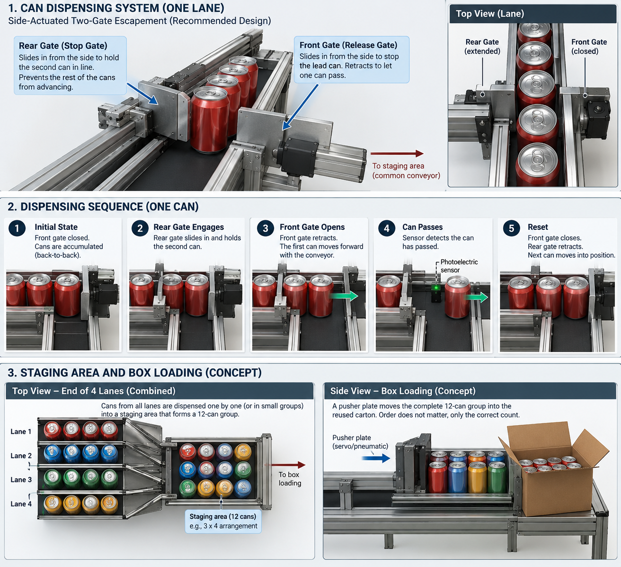
Historical render: early one-lane gate/staging concept. It helped frame sequential release, but the rear-stop geometry and downstream staging arrangement were later reconsidered.
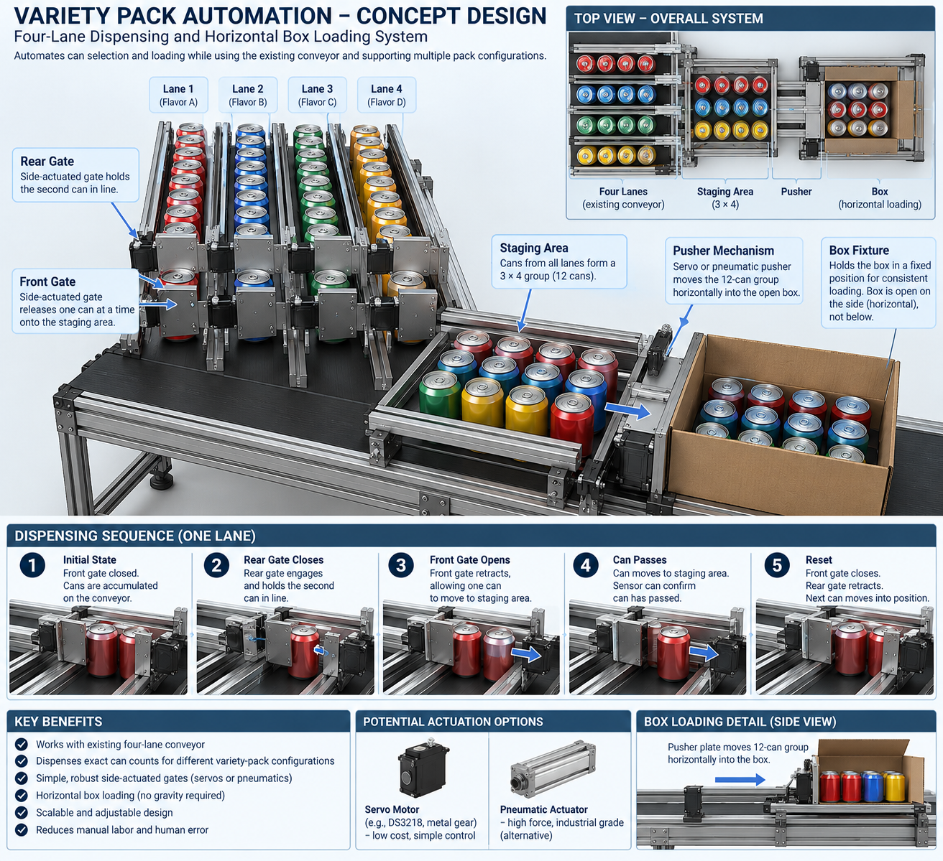
Historical render: four-lane / staging-pusher concept. This over-expanded the system and did not preserve the real current three-lane layout; retained here as evidence of the iteration.
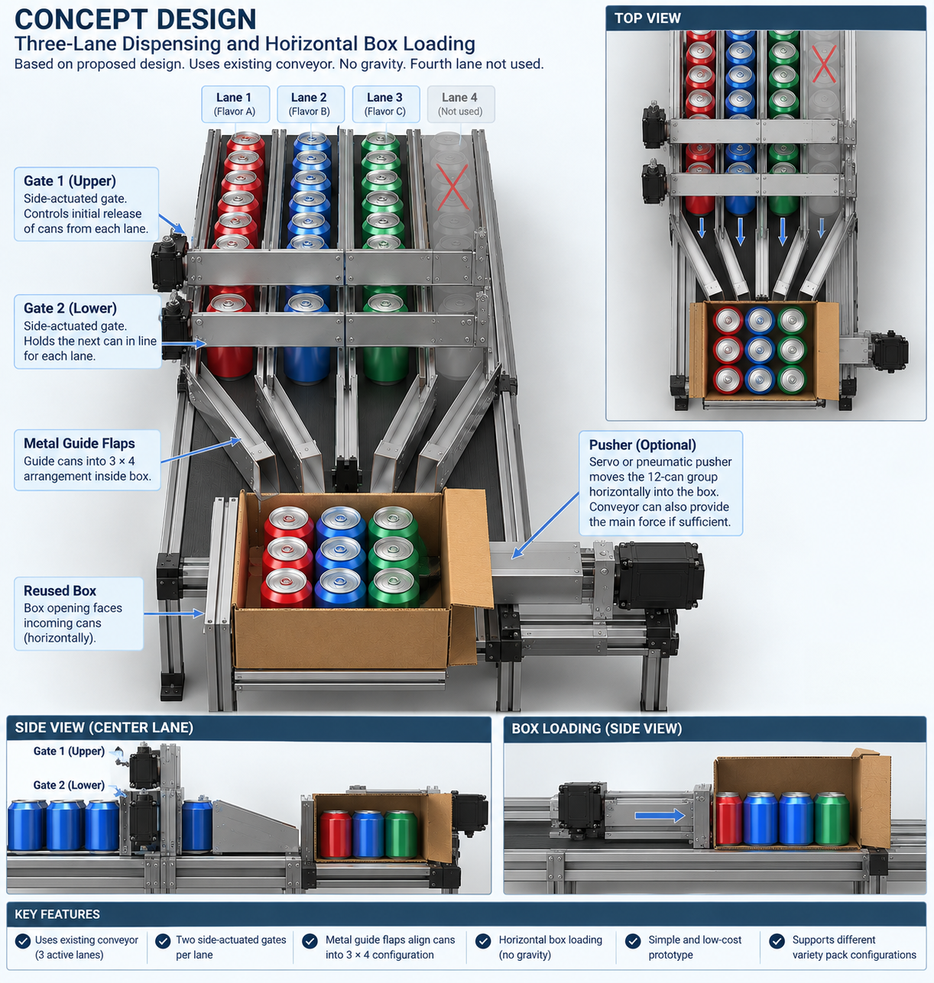
Historical render: three-lane horizontal-loading concept. This was closer to the physical intent but still served mainly as a communication aid rather than a final engineering drawing.

Appendix B – Current Team 1 Working Statement
Team 1 is focused on automating and quality-controlling Yards Brewing’s can variety-pack assembly process, not the general canning line. The working solution is a modular retrofit using Yards-style double-gate escapements to meter the correct SKU counts, camera-based independent color validation with a fail-safe response, thin stainless guides to corral the group, and a dead-plate side-discharge/pneumatic pusher to load the reused carton horizontally.

