Students’ internships & employment tracking process

**Project Idea:**

It is a complement and improvement of the registration site for the Coding Academy by Orange.

These additions will facilitate and simplify the process of the academy’s communication with the trainees and the trainee’s ability to provide his training information and his contacts. The site has also made it easier since its inception. The ease of registering students in the It is a complement and improvement of the registration site for the Coding Academy by Orange and making it an easy and simple process can apply anytime and anywhere.

**Additions:**

* Training Login Page
* Training Home Page
* Training Information Page
* Contact Page
* Admin Dashboard: Training Information Page
* Admin Dashboard: Contact Page

**Requirements:**

* User [Trainee]
* Trainee must be accepted in OCA to be able to login in training website
* Trainee can add training information
* Trainee can edit training information
* Trainee can add his own contact [email, mobile, LinkedIn]
* Trainee can edit his own contact
* Admin:
* Admin can Add, Edit, Remove and View Trainee training information
* Admin can Add, Edit, Remove and View Trainee contact information
* Admin can Add option to allow to trainees to add his training/employment information after specific date
* Admin can see all trainings/employment for the trainee [history]

**Technologies:**

* Front-End:

1. HTML 5.
2. CSS3.
3. JavaScript.
4. Bootstrap.

* Back-End:
  1. Laravel
  2. PHP
  3. MySQL
* Tools:
  + VS Code
  + Git & GitHub
  + Figma
  + Trello
  + Draw SQL

Projects Features:

1. The website implements SEO.

2. The website considers-UX/UI design principles.

3. The website is fully responsive.

4. The website is fully secure

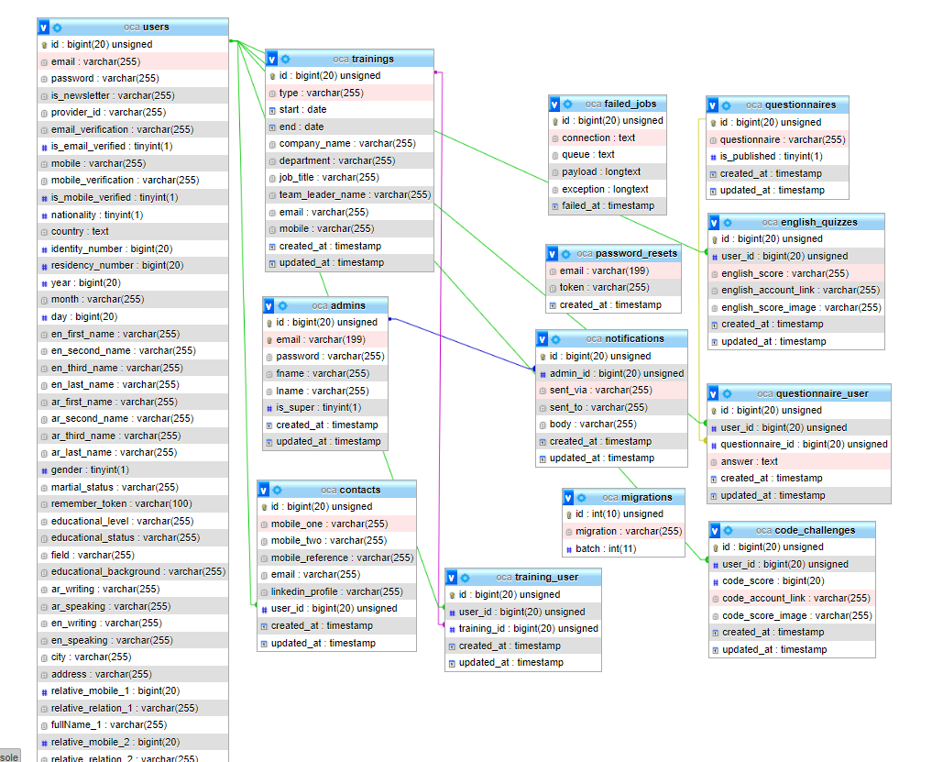**Database Schema:**

**Wireframe & Mockup:**

You can find it as pdf files in this folder

**Business Models:**