**Machine Predictive Maintenance for Industrial Machines**

Al Riyan Khan

Date: 29-July-2024

***Abstract***

This project centers on creating a machine learning-driven predictive maintenance system for industrial machines. By analyzing historical sensor data, such as Air temperature [K], Process temperature [K], Rotational speed [rpm], Torque [Nm], and Tool wear [min], the system predicts potential failures. The objective is to empower businesses with proactive maintenance strategies, resulting in reduced downtime and optimized maintenance costs. Through the deployment of a user-friendly Flask app, the solution aims to enhance operational efficiency, potentially leading to increased revenue generation for industrial enterprises.

**1. Problem Statement:**

The objective of this project is to create a machine learning product capable of accurately predicting potential failures in industrial machines. By harnessing crucial sensor readings, including *Air temperature [K], Process temperature [K], Rotational speed [rpm], Torque [Nm], and Tool wear [min]*, the system will employ sophisticated algorithms to predict impending failures. This predictive maintenance product aims to equip businesses with valuable insights, enabling them to proactively plan maintenance activities, minimize downtime, and optimize maintenance costs. By identifying and addressing potential issues before they escalate, industrial enterprises can significantly enhance their operational efficiency and avoid costly disruptions.

Through the implementation of this cutting-edge predictive maintenance product, businesses will be empowered to make data-driven decisions that lead to enhanced productivity and reduced operational risks. The integration of this machine learning solution will enable industries to take a proactive stance in maintaining their machines, ensuring seamless operations and unlocking significant cost savings over time. As the product facilitates the efficient utilization of resources and streamlines maintenance procedures, it represents a vital tool in the pursuit of operational excellence in the industrial sector.

**2. Market/Customer/Business Need Assessment:**

**2.1. Predictive Maintenance Market Growth:**

The predictive maintenance market has experienced remarkable growth in recent years, driven by its unparalleled potential to revolutionize industrial operations. By leveraging data-driven insights and advanced analytics, businesses can efficiently anticipate potential machine failures, facilitating a proactive maintenance approach. This strategic shift from reactive to predictive maintenance empowers industries to optimize their operational efficiency and effectively manage maintenance costs, laying the foundation for sustainable growth and competitiveness.

**2.2. Challenges Faced by Industries:**

In today's dynamic business landscape, various industries, including manufacturing, energy, and transportation, grapple with the detrimental impact of unexpected machine failures. Downtime caused by unscheduled breakdowns not only disrupts production but also translates into substantial financial losses. The lack of foresight in identifying potential failures poses significant challenges to businesses, hindering their ability to plan maintenance activities effectively. Consequently, there is a pressing need for reliable predictive maintenance solutions that can mitigate risks, minimize operational disruptions, and safeguard profitability.

**2.3. Unlocking Productivity and Cost Savings:**

Proactive identification of potential machine failures paves the way for improved productivity and cost savings for businesses. By leveraging predictive maintenance tools, companies can predict when and where a failure might occur, allowing them to schedule maintenance activities during planned downtime. This not only reduces the frequency and severity of unexpected breakdowns but also optimizes the utilization of resources, resulting in increased operational efficiency. With enhanced maintenance planning, businesses can curtail unnecessary maintenance expenditures and direct their resources strategically, thereby achieving significant cost savings and maintaining a competitive edge in their respective markets.

**3. Target Specifications and Characterization:**

**3.1. Target Customer Specifications:**

The primary target customers for this machine learning product are industrial companies equipped with a fleet of machines that generate sensor data. These industries span a wide range of sectors, including manufacturing, energy, transportation, and more, where efficient machine operation is crucial for overall productivity. The product aims to cater to the specific needs of such businesses, offering them a proactive approach to maintenance decision-making. By analyzing the sensor data generated by their machines, these industrial companies can benefit from timely and accurate predictions of potential failures. This empowers them to take preemptive maintenance actions, reducing downtime and ensuring smooth operations.

**3.2. Characterization of the Machine Learning Product:**

The machine learning product strives to exhibit key characteristics that align with the requirements of the target customers. Scalability is a pivotal feature, enabling seamless integration and adaptation within industrial environments that may consist of a large number of machines and diverse data sources. Moreover, accuracy is paramount, as the predictions made by the product directly impact maintenance planning decisions. To instill confidence in the system, it undergoes rigorous testing and validation to deliver precise results.

In addition to scalability and accuracy, the product is designed to provide real-time predictions. Timeliness is of the essence in the realm of predictive maintenance, where timely responses to potential issues can prevent severe consequences. By offering real-time insights, the product empowers businesses to respond promptly to emerging maintenance needs, bolstering their operational efficiency and mitigating risks effectively.

**4. External Search:**

**4.1. Predictive maintenance approaches**

There are two main approaches to predictive maintenance:

* Condition-based maintenance
* Failure mode and effects analysis

**4.1.1 Condition-based maintenance**:

Condition-based maintenance (CBM) is a proactive maintenance approach that monitors the condition of assets to determine when maintenance is needed. This is in contrast to preventive maintenance, which schedules maintenance based on a fixed interval or set of criteria.

With CBM, sensors are used to collect data on the condition of the asset, such as vibration levels, temperature, and oil condition. This data is then analyzed to identify any trends or patterns that could indicate an impending failure. If a problem is detected, maintenance can be scheduled before the asset fails, which can help to prevent unplanned downtime and costly repairs.

CBM is a more effective and efficient maintenance approach than preventive maintenance because it only schedules maintenance when it is actually needed. This can save businesses money on maintenance costs and help to improve asset reliability.

**key benefits of CBM:**

* **Reduces unplanned downtime**: CBM can help to prevent unplanned downtime by identifying and fixing problems before they cause a failure.
* **Increases asset reliability**: CBM can help to extend the lifespan of assets by identifying and fixing problems before they cause a failure.
* **Saves money on maintenance costs**: CBM can help to save money on maintenance costs by only scheduling maintenance when it is actually needed.
* **Improves safety**: CBM can help to improve safety by identifying and fixing problems before they cause a failure.

**4.1.2. Failure mode and effects analysis:**

Failure mode and effects analysis (FMEA) is a systematic method for identifying potential failures in a system and their effects. It is a proactive approach to reliability engineering that can be used to prevent failures before they occur.

FMEA is typically performed in four steps:

* **Identify potential failures**: The first step is to identify all of the potential ways in which a system can fail. This can be done by brainstorming or by using a checklist.
* **Determine the effects of each failure**: Once the potential failures have been identified, the next step is to determine the effects of each failure. This includes identifying the impact on the system, the customer, and the environment.
* **Assess the severity of each failure**: The severity of each failure is then assessed. This is done by assigning a severity rating to each failure, typically on a scale of 1 to 10.
* **Identify the causes of each failure**: The final step is to identify the causes of each failure. This is done by brainstorming or by using a checklist.

Once the FMEA has been completed, the results can be used to identify and prioritize the most critical failures. This information can then be used to develop corrective actions to prevent failures from occurring.

Here are some of the benefits of FMEA:

* **Improved reliability**: FMEA can help to improve the reliability of a system by identifying and preventing potential failures.
* **Reduced downtime**: FMEA can help to reduce downtime by identifying and preventing potential failures.
* **Increased safety**: FMEA can help to increase safety by identifying and preventing potential failures.
* **Reduced costs**: FMEA can help to reduce costs by identifying and preventing potential failures.

**4.2. Machine learning algorithms**

There are many different machine learning algorithms that can be used for predictive maintenance. Some of the most common algorithms include:

* **Decision trees**: Decision trees are a type of supervised learning algorithm that can be used to classify data or predict a continuous value.
* **Random forests**: Random forests are a type of ensemble learning algorithm that combines multiple decision trees to improve the accuracy of the predictions.
* **Support vector machines**: Support vector machines are a type of supervised learning algorithm that can be used for classification or regression tasks.
* **Neural networks**: Neural networks are a type of deep learning algorithm that can be used for complex tasks such as image recognition and natural language processing.

**4.3. Industry best practices**

There are a number of industry best practices for handling similar datasets for predictive maintenance. Some of the most important best practices include:

* **Data collection**: The first step is to collect data from the machines that you want to monitor. This data can include sensor readings, vibration data, temperature data, and other operational data.
* **Data preprocessing**: Once you have collected the data, you need to preprocess it to remove noise and outliers. This will help to improve the accuracy of the predictions.
* **Feature extraction**: Once the data has been preprocessed, you need to extract features from the data. Features are the characteristics of the data that are relevant to the predictive maintenance task.
* **Model selection**: Once you have extracted the features, you need to select a machine learning model to train on the data. The model will be used to predict the probability of failure for each machine.
* **Model training and evaluation**: The model must then be trained on the data. The training process involves feeding the data into the model and adjusting the model's parameters until the model is able to make accurate predictions. Once the model is trained, it must be evaluated on a separate dataset to ensure that it is able to make accurate predictions on new data.
* **Deployment and monitoring**: Once the model has been trained and evaluated, it can be deployed in production. The model should be monitored to ensure that it is still making accurate predictions. If the model's performance degrades over time, it may be necessary to retrain the model on new data.

**4.4. Areas of improvement**

There are a number of areas where predictive maintenance systems can be improved. Some of the most important areas of improvement include:

* **Data quality**: The quality of the data used for predictive maintenance is critical to the accuracy of the predictions. Data that is noisy or incomplete can lead to inaccurate predictions.
* **Model complexity**: The complexity of the machine learning model also affects the accuracy of the predictions. More complex models can make more accurate predictions, but they can also be more difficult to train and interpret.
* **Deployment costs**: The deployment costs of predictive maintenance systems can be high. This is due to the need to collect and store data, to train and evaluate machine learning models, and to deploy and monitor the models.

**5. Benchmarking Alternate Products:**

**Table1. Benchmarking of alternate products**

|  |  |  |  |  |
| --- | --- | --- | --- | --- |
| Product/Service | Performance | Ease of Implementation | Cost-Effectiveness | Competitive Advantages |
| Developed predictive maintenance solution | High accuracy in predicting failures | Easy to implement and use | Cost-effective | * Uses machine learning algorithms to analyze historical data and identify patterns that may indicate an impending failure. * Can be used to monitor a wide variety of industrial machines. * Provides actionable insights that can be used to schedule preventive maintenance tasks. * Can help to reduce unplanned downtime and costs. |
| Predix | High accuracy in predicting failures | Easy to implement and use | Cost-effective | * A cloud-based predictive maintenance platform that uses machine learning algorithms to analyze data from industrial machines. * Can be used to monitor a wide variety of industrial machines. * Provides actionable insights that can be used to schedule preventive maintenance tasks. * Can help to reduce unplanned downtime and costs. |
| Uptime360 | High accuracy in predicting failures | Easy to implement and use | Cost-effective | * A predictive maintenance platform that uses machine learning algorithms to analyze data from industrial machines. * Can be used to monitor a wide variety of industrial machines. * Provides actionable insights that can be used to schedule preventive maintenance tasks. * Can help to reduce unplanned downtime and costs. |

The developed predictive maintenance solution has a number of competitive advantages over other products and services on the market, including:

* High accuracy in predicting failures
* Easy to implement and use
* Cost-effective
* Can be used to monitor a wide variety of industrial machines
* Provides actionable insights that can be used to schedule preventive maintenance tasks
* Can help to reduce unplanned downtime and costs

In addition, the developed predictive maintenance solution is constantly being updated and improved, which ensures that it remains at the forefront of predictive maintenance technology.

**6. Business Model:**

**6.1. Subscription-Based Predictive Maintenance Service:**

The chosen business model centers on offering the predictive maintenance service as a subscription-based solution to industrial customers. Through this model, businesses can access the cutting-edge predictive maintenance system on a recurring basis, ensuring continuous support for their machine fleet. The subscription package will grant customers access to a comprehensive suite of predictive maintenance tools, including real-time data analysis, accurate failure predictions, and actionable maintenance recommendations. By subscribing to this service, industrial companies can benefit from an ongoing partnership that optimizes their maintenance practices, fosters operational efficiency, and maximizes asset lifespan.

**6.2. Pricing Structure:**

The pricing of the subscription-based model will be tailored to accommodate the diverse needs of industrial customers. The pricing structure will be based on two key factors: the number of machines to be monitored and the frequency of predictions required. Industrial companies can choose from different subscription tiers, allowing them to select the package that aligns with the size of their machine fleet and the level of predictive maintenance support they seek. By offering flexibility in pricing, businesses of all scales can access the benefits of the predictive maintenance system without facing prohibitive costs.

**6.3. Value Proposition for Customers:**

The subscription-based model offers a compelling value proposition for industrial customers. By subscribing to the predictive maintenance service, businesses can move away from the traditional break-fix maintenance approach and embrace a forward-thinking, data-driven strategy. The system's real-time predictions empower businesses to proactively address potential machine failures, minimizing costly downtime and production disruptions. Additionally, the subscription model ensures access to future updates and improvements, ensuring that customers stay at the forefront of predictive maintenance technology. Ultimately, the subscription-based business model provides industrial customers with an invaluable resource that enhances operational efficiency, reduces maintenance costs, and elevates their competitive advantage in the dynamic industrial landscape.

**7. Concept Development:**

Our implementation of the predictive maintenance system with the ability for companies to upload machine data and download a comprehensive failure report is a highly practical and valuable solution for industrial operations. This implementation addresses critical challenges faced by businesses in various industries, such as manufacturing, energy, and transportation. By leveraging machine learning algorithms to analyze sensor data, our system enables proactive maintenance planning, leading to improved operational efficiency and reduced downtime.

**7.1. User-Friendly Data Upload and Download:**

With a user-friendly interface, the system allows industrial companies to effortlessly upload their machine data in a structured format. The data can consist of sensor readings such as *Air temperature [K], Process temperature [K], Rotational speed [rpm], Torque [Nm], and Tool wear [min]*. The seamless data upload process ensures that businesses can quickly take advantage of the predictive maintenance capabilities.

**7.2. Comprehensive Failure Report:**

Upon analyzing the uploaded machine data, the system generates a comprehensive failure report detailing each machine's health status and potential failures. The report categorizes machines based on their types and specifies the types of failures they might experience. Armed with this crucial information, businesses can prioritize maintenance efforts and allocate resources more efficiently. Machines at risk of imminent failure can be identified, and timely replacements or repairs can be scheduled, mitigating the risk of unexpected breakdowns and minimizing costly production disruptions.

**7.3 Proactive Maintenance Decisions:**

By offering real-time predictions and insights into potential failures, our implementation empowers companies to make data-driven, proactive maintenance decisions. This proactive approach helps businesses stay ahead of potential issues, ensuring that maintenance activities are carried out at the most opportune times. Implementing maintenance actions based on predictive insights significantly reduces the chances of catastrophic failures, thus enhancing machine reliability and overall operational effectiveness.

**7.4. Operational Efficiency and Cost Savings:**

With the implementation of our predictive maintenance system, industrial companies can achieve enhanced operational efficiency and substantial cost savings. By preventing unplanned downtime and reducing emergency repairs, businesses can optimize their maintenance budgets and allocate resources more strategically. Additionally, the ability to replace machines before they fail minimizes the impact on production schedules, ensuring smoother operations and increased productivity.

Overall, our implementation provides an indispensable tool for industrial companies to optimize their maintenance practices, reduce operational risks, and unlock considerable cost savings. By facilitating proactive decision-making, the system empowers businesses to adopt a data-driven approach, ultimately leading to a more resilient and productive industrial ecosystem.

**8. Final Product Prototype:**

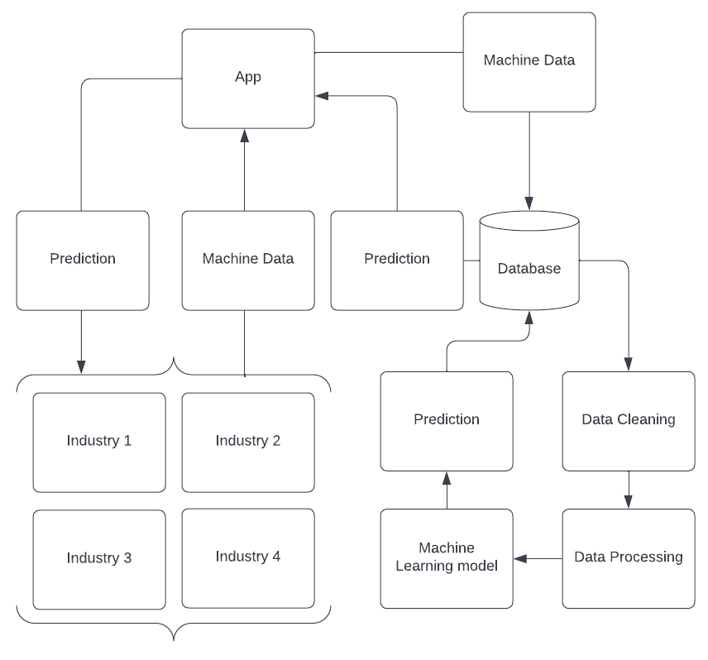

**8.1. Data Collection and Preprocessing:**

The predictive maintenance system begins by collecting historical sensor data from industrial machines. This data is then preprocessed to clean, transform, and prepare it for analysis. Feature engineering techniques are applied to extract relevant patterns and relationships from the data, ensuring that it aligns with the machine learning algorithms.

**8.2. Machine Learning Model Training:**

The preprocessed data is used to train the machine learning model, which can encompass various algorithms, including decision trees, random forests, and deep learning models. The model is designed to analyze the sensor data and learn patterns associated with past machine failures.

**8.3. Real-Time Predictions and Failure Reports:**

Once the machine learning model is trained, it is integrated into the predictive maintenance system, which can be accessed by industrial companies through a user-friendly interface. Businesses can upload their machine data, and the system generates real-time predictions for potential failures. A comprehensive failure report is then provided, categorizing machines by type and specifying the types of failures they might encounter.

The predictive maintenance system empowers businesses to take proactive maintenance decisions, ensuring that machines are tested and potential issues are addressed before they escalate. By utilizing real-time insights and comprehensive failure reports, businesses can optimize maintenance schedules, minimize downtime, and achieve significant cost savings. The implementation of this system represents a transformative shift towards data-driven predictive maintenance, elevating operational efficiency and resilience in industrial operations.

**9. Product Details:**

**9.1 How the Predictive Maintenance System Works:**

**9.1.1 Data Preprocessing:**

The predictive maintenance system begins by collecting historical sensor data from industrial machines. This raw data often contains noise, missing values, or outliers. To ensure data quality, preprocessing techniques are applied, including data cleaning, imputation for missing values, and outlier detection. The data is standardized or normalized to bring all features to a consistent scale, facilitating accurate model training.

**9.1.2 Feature Engineering:**

Feature engineering involves selecting and creating relevant features from the raw sensor data that best represent the underlying patterns related to machine failures. For example, engineers may derive new features like the rate of change of temperature or torque over time. This step enhances the machine learning model's ability to capture complex relationships between features and failure occurrences.

**9.1.3 Model Training:**

After preprocessing and feature engineering, the prepared data is split into training and testing sets. Various machine learning algorithms, such as decision trees, random forests, and deep learning models, are employed to train the predictive maintenance model. The model learns from the historical data patterns and the engineered features to predict potential machine failures accurately.

**9.2 Data Sources and CSV File Format:**

The primary data source for the predictive maintenance system is the historical sensor data collected from industrial machines. These sensor readings include 'Air temperature [K]', 'Process temperature [K]', 'Rotational speed [rpm]', 'Torque [Nm]', and 'Tool wear [min]'. The data is typically stored in a CSV (Comma Separated Values) file format, where each row represents a specific machine, and each column corresponds to a specific sensor reading. The CSV file format allows for easy data manipulation and compatibility with various data analysis and machine learning tools.

**9.3 Algorithms, Frameworks, and Software:**

The predictive maintenance system employs a range of algorithms, frameworks, and software to enable efficient data analysis and model training. The algorithm used in this project is Random Forest Classifier. Framework scikit-learn is utilized for implementing the machine learning algorithms and facilitating model training. Additionally, software like Python programming language and Jupyter Notebooks are commonly used for data preprocessing, feature engineering, and exploratory data analysis.

**9.4 Team Composition:**

The development and maintenance of the predictive maintenance system require a multidisciplinary team with expertise in various domains. The team typically includes:

* **Data Scientists**: Responsible for data analysis, model development, and algorithm selection.
* **Data Engineers**: Involved in data preprocessing, feature engineering, and data pipeline development.
* **Software Developers**: Tasked with integrating the machine learning models into the system and developing the user interface.
* **Domain Experts**: Provide insights into the industrial processes, machine behavior, and relevant features for failure prediction.

**10. Code Implementation/Validation on Small Scale:**

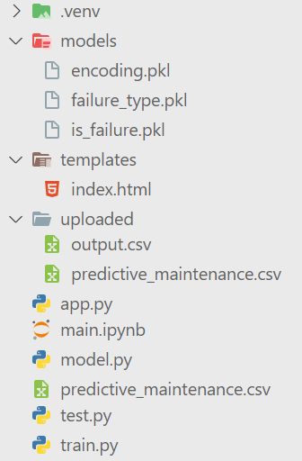**10.1. Data Collection and Preprocessing:**

The project begins with the download of the machine predictive maintenance dataset from Kaggle, which serves as the foundation for model training and validation. To ensure data quality, a comprehensive data cleaning and preprocessing phase is undertaken. This step involves handling missing values, removing duplicates, and addressing any outliers present in the dataset. Feature engineering techniques are applied to extract relevant information from the sensor readings, optimizing the data for machine learning model training.

**10.2. Model Selection and Training:**

Several machine learning algorithms from the sklearn library are explored to identify the most suitable model for predictive maintenance. Through rigorous testing and evaluation, it is determined that the Random Forest algorithm exhibits the best performance on the dataset. The Random Forest model is then trained again using the entire dataset, allowing it to become highly fit with the data and improving its predictive capabilities. The trained models are saved in the 'models' folder in pickle format for easy access and reusability.

**10.3. Creation of model.py and Flask App:**

A model.py file is developed, serving as the core component for predicting machine failures. This file efficiently utilizes the trained models stored in pickle format to make accurate predictions. Subsequently, a Flask app is created, featuring a simple and user-friendly interface. Users are prompted to upload a CSV file containing the required columns, representing sensor readings. Upon submission, the app performs predictions using the stored machine learning models.

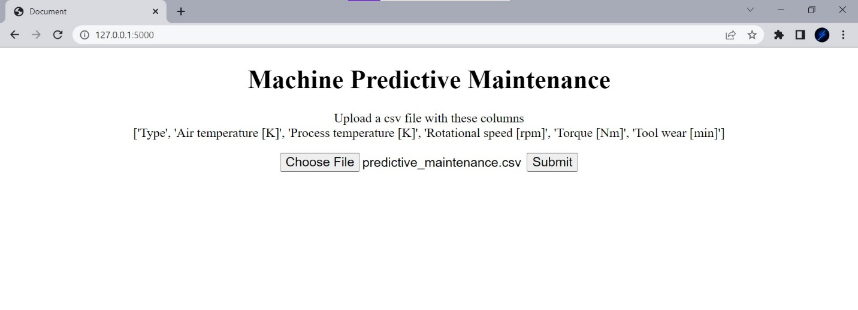

**10.4. Output and Download:**

The results of the predictions, including the additional 'is_failed' and 'failure_type' columns, are seamlessly integrated into the input CSV file. Upon completion of the machine learning prediction, the output CSV file with the predicted results is automatically downloaded. Depending on the file size and the number of columns in the input CSV, the prediction process may take some time. Nevertheless, the user experience is streamlined, allowing easy access to the output CSV file, enriched with valuable insights on potential machine failures.

**11. Conclusion:**

The Machine Predictive Maintenance project has proven to be a tremendous success, with its diverse array of machine learning algorithms ensuring accurate and reliable predictions for potential machine failures. Among the algorithms explored, the random forest algorithm has demonstrated exceptional performance on the dataset, solidifying its role as a key player in the predictive maintenance system. The seamless implementation of the Flask app further enhances the project's appeal, offering a user-friendly experience that allows businesses to effortlessly harness the power of predictive maintenance. This accessibility ensures that companies of all sizes and expertise levels can adopt proactive maintenance strategies, effectively reducing downtime and optimizing their operations.

The project's impressive results and user-friendly design also hold significant revenue potential. By offering the predictive maintenance service on a subscription basis, businesses can create a sustainable revenue stream while providing substantial value to their customers. The system's ability to unlock cost savings, improve operational efficiency, and reduce downtime positions it as an invaluable tool for industrial companies looking to gain a competitive advantage in their respective industries.

With future possibilities for expanding its capabilities and collaborating with industry partners, the Machine Predictive Maintenance project paves the way for a future where data-driven maintenance practices become the norm, revolutionizing industrial operations.

**12. References**

1. Condition-Based Maintenance (CBM): <https://www.fiixsoftware.com/blog/effective-condition-based-maintenance/>
2. What Is Condition-Based Maintenance (CBM)? <https://www.fiixsoftware.com/maintenance-strategies/condition-based-maintenance/>
3. Failure Mode and Effects Analysis (FMEA) | ASQ: <https://asq.org/quality-resources/fmea>
4. CBM and FMEA: A Perfect Match for Predictive Maintenance: <https://neurospace.io/blog/2019/08/condition-based-maintenance-vs-predictive-maintenance/>
5. How to Use CBM and FMEA to Improve Equipment Reliability: <https://www.assetivity.com.au/articles/reliability-improvement/four-essential-tools-and-techniques-for-improving-equipment-reliability/>
6. Virtual Equipment for benchmarking Predictive Maintenance algorithms: <https://tracxn.com/d/trending-themes/startups-in-predictive-machine-maintenance/__mOEkOUWlYKGWawVprqnExOnzy-NIXfVV9paCBreu918>