Andrew Robbertz [alrobbertz@wpi.edu](mailto:alrobbertz@wpi.edu)

CS 4341 A18

09/08/2018

**MINST Data Classification Using**

**Artificial Neural Networks**

**Artificial Neural Network for Classifying Data Without Dropout**

Splitting the dataset with 80% of the data in the training set and saving 20% in the test set, the following results were found. 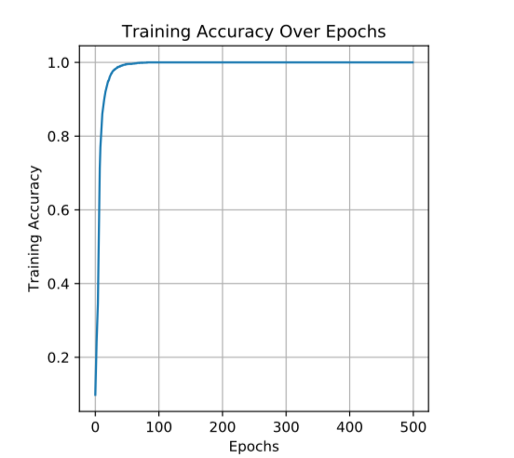

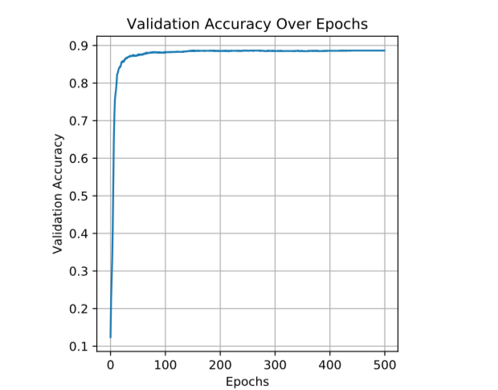

Test Accuracy reaches 100% after the first 100 epochs, while validation accuracy plateaus at just under 90%. This suggests that we are not learning anything

new after the first 100 epochs, and all after are not completely necessary.

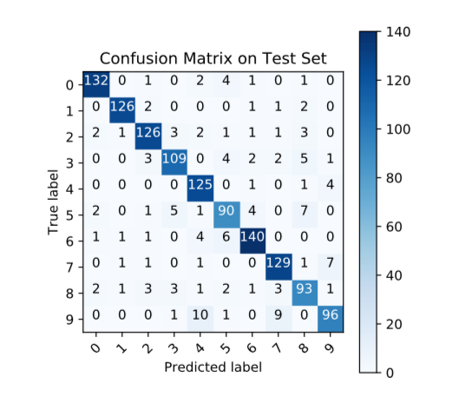

The test set reported 88.3% accuracy, which is sufficiently close to the validation accuracy after it plateaus. The difference may be caused partially by overfitting, as well as any bias in the dataset that emphasizes certain numbers more than others.

**Artificial Neural Network for Classifying Data with Dropout**

Splitting the dataset with 80% of the data in the training set and saving 20% in the test set, the following results were found.

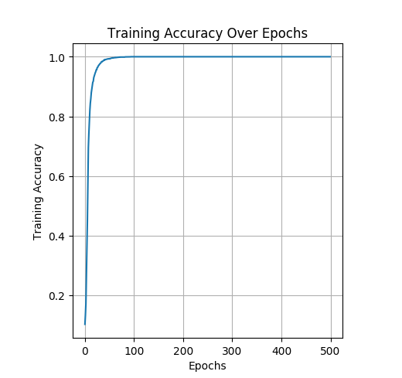

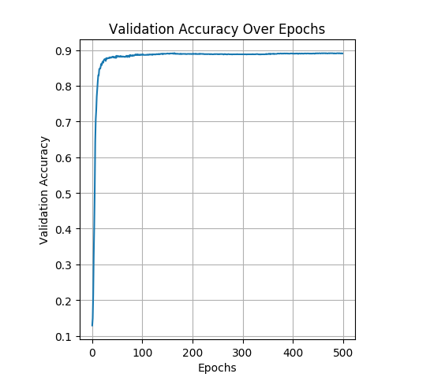

With 20% dropout on the input later, test accuracy still reaches 100% after the first 100 epochs, and validation accuracy still plateaus at just under 90% although it does get slightly closer. Still we are not learning much after the first 100 epochs, and could run significantly fewer. 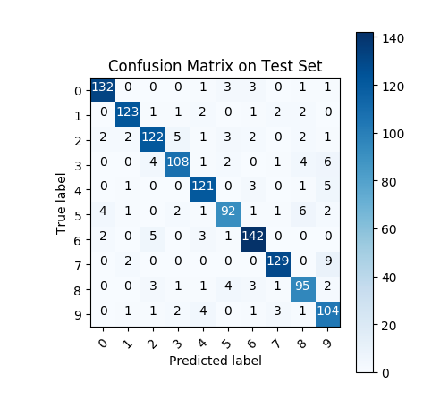

The test set reported 89.4% accuracy, which is slightly better than our test accuracy without dropout. This suggests that the network was likely overfitting data in the training and validation sets to a small degree. The difference is so small though that it may be coincidental. The confusion matrix is noticeably better with dropout than without, also suggesting that we may have been overfitting.