Question Bank:

1. **Explain applications of data streams with examples.**

Certainly! Data streams are continuous flows of data that are generated over time, such as social media posts, sensor data from IoT devices, stock market data, and more. Analyzing data streams has become increasingly important in various applications. Here are some examples of how data streams are used:

Real-time Fraud Detection: Banks and credit card companies use data streams to monitor transactions in real-time. They analyze transaction data as it flows in, looking for patterns of fraudulent activity. For instance, if someone makes an unusually large purchase from a location they've never shopped at before, the system can trigger an alert.

Real-time Fraud Detection

Social Media Sentiment Analysis: Companies use data streams from social media platforms like Twitter to track public sentiment about their products or brands. By analyzing tweets and posts in real-time, they can identify trends and respond to customer feedback promptly.

Social Media Sentiment Analysis

Traffic Monitoring: Cities use data streams from traffic cameras and sensors to monitor traffic conditions in real-time. This data is used to optimize traffic flow, detect accidents, and provide real-time updates to commuters through apps like Google Maps or Waze.

Traffic Monitoring

Industrial IoT (IIoT): In manufacturing and industry, sensors on machines and equipment generate data streams. Analyzing this data in real-time can predict equipment failures, optimize production processes, and reduce downtime.

Industrial IoT

Healthcare: Continuous monitoring of patient data from wearable devices like fitness trackers and smartwatches is another example. Doctors can remotely monitor patients' vital signs and receive alerts in case of any abnormalities.

Healthcare Monitoring

Environmental Monitoring: Environmental agencies collect data streams from sensors placed in various locations to monitor air quality, water quality, and weather conditions. This data helps in early detection of pollution or natural disasters.

Environmental Monitoring

In all these examples, data streams enable real-time decision-making and timely responses to events or trends. Analyzing data streams often involves techniques like stream processing, which can process and analyze data as it's generated, making it a valuable tool in many industries and applications.

1. **Elaborate issues in data stream query processing.**

Data stream query processing poses several unique challenges and issues compared to traditional batch processing of data. Let's elaborate on some of the key issues in data stream query processing:

Limited Memory: Data streams are often unbounded, meaning they continue indefinitely. Processing such data with limited memory resources becomes a challenge. Algorithms and data structures need to be designed to operate efficiently in a space-constrained environment.

Data Arrival Rate Variability: Data streams can experience variations in the rate at which data arrives. Peaks and troughs in data arrival rates make it challenging to design algorithms that can adapt and process data at varying speeds.

Data Skew: Data stream sources can exhibit data skew, where some values or events occur much more frequently than others. Dealing with data skew requires specialized algorithms to ensure fair processing and accurate results.

Out-of-Order Data: Data arriving in a stream may not be ordered sequentially based on timestamps or any other criteria. Handling out-of-order data while maintaining correctness in query results is a significant challenge.

Window Management: In data stream processing, sliding or tumbling windows are often used to limit the amount of data to be processed at any given time. Managing these windows efficiently and ensuring that no data is lost during window updates is a critical issue.

Data Loss Tolerance: Data streams can be so vast that it's impossible to store and process every data point. Stream processing systems must be designed to handle data loss gracefully, especially in situations where real-time decisions are critical.

Scalability: As data volumes increase, the system needs to scale horizontally to accommodate the growing load. This requires distributed processing frameworks and load balancing techniques.

Complex Queries: Some stream processing queries can be highly complex, involving joins, aggregations, and pattern recognition across multiple streams. Optimizing these queries for low latency and high throughput is a significant challenge.

Latency: Many stream processing applications require low-latency results. Achieving low latency while maintaining accuracy and correctness in query results is a trade-off that needs careful consideration.

Fault Tolerance: In a distributed stream processing system, nodes or components can fail. Ensuring fault tolerance and data durability is crucial to maintaining the reliability of the system.

Privacy and Security: Handling sensitive data in data streams requires robust privacy and security measures to protect data from unauthorized access or breaches.

Dynamic Query Updates: In some scenarios, query logic may need to be updated on-the-fly. Managing dynamic query updates without disrupting the stream processing pipeline can be challenging.

To address these issues, stream processing systems often leverage techniques like approximate query processing, window-based aggregation, load shedding, and adaptive algorithms. Additionally, they may use frameworks like Apache Kafka, Apache Flink, or Apache Storm, which are designed to handle the intricacies of data stream processing efficiently.

1. **Explain the sliding window problem with the help of an example.**

The sliding window problem is a common challenge in data stream processing. It involves maintaining a fixed-size "window" over a continuous stream of data and performing computations or analyses within this window as it slides over the data stream. The window moves incrementally, one data point at a time, and its purpose is to capture a recent subset of data for analysis. Let's explain this problem with an example:

Example: Stock Price Analysis

Suppose you are building a real-time stock price monitoring system for a popular tech company, let's call it "TechCo." You want to calculate the rolling average stock price of TechCo's shares over the last 30 minutes. Here's how you can approach this problem using a sliding window:

Initialize the Window: At the start, you have an empty window of size 30 minutes, which represents the time interval for the rolling average.

Data Stream: The stock price data for TechCo is continuously streaming in with timestamps. Let's say the data points look like this:

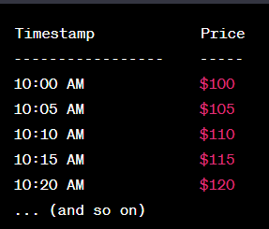

Sliding the Window: As time progresses, you need to slide the 30-minute window over the data stream. Let's say it's currently 10:25 AM.

You remove the data points that are older than 30 minutes (e.g., data points before 10:25 AM - 30 minutes = 9:55 AM).

You add the new data points that fall within the current window (e.g., data points from 10:20 AM onwards).

So, your window now contains data from 10:00 AM, 10:05 AM, 10:10 AM, 10:15 AM, and 10:20 AM.

Calculate the Rolling Average: With the data inside the window, you calculate the rolling average stock price. In this case, it's (100 + 105 + 110 + 115 + 120) / 5 = $110.

Continual Updating: As time progresses, you keep sliding the window, recalculating the rolling average at each step, and updating it with the latest data point. This process repeats as long as you want to monitor the rolling average.

The sliding window problem is important in various real-time analytics scenarios, such as monitoring system performance, tracking website traffic patterns, and analyzing sensor data. It ensures that you're working with a relevant subset of data within a specified time frame, allowing you to make timely decisions and gain insights from the stream of information.

1. **Explain DGIM algorithm for counting ones in stream with given problem N=24 and data set is 10101100010111011001011011**

The DGIM (Data Growth In Mini-batches) algorithm is a method for approximately counting the number of ones in a binary stream, which is especially useful when dealing with large and continuous data streams. It offers an approximate count within a defined error margin. Let's use the DGIM algorithm to count ones in the given binary stream with N=24:

Binary Stream: 10101100010111011001011011

In the DGIM algorithm, we divide the data into "buckets" of varying sizes and keep track of the timestamps (position) of the last one-bit within each bucket. The buckets are organized in a way that they are exponentially increasing in size. Here's how the algorithm works:

Initialize Buckets: Start with a set of buckets, each representing a different time window. The sizes of these buckets are powers of 2 (1, 2, 4, 8, ...), and each bucket stores the timestamp of the last one-bit encountered within that window. You can also keep a count of the number of buckets.

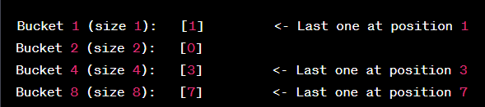

Update Buckets: As you process the data stream from left to right, keep updating the buckets and timestamp positions. When you encounter a one-bit, update the smallest bucket(s) that are affected:

For each one-bit, increment the timestamp of all buckets by 1 (since the stream is moving one position to the right).

If there are more than one bucket with the same size, merge them, keeping only the timestamp of the last one-bit.

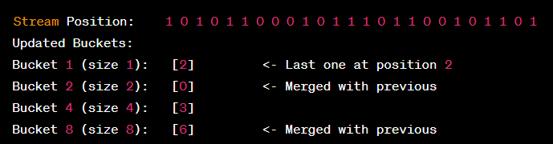

Counting Ones: To estimate the total number of ones in the stream, sum the timestamps in the buckets, but subtract half the timestamp of the largest bucket (to account for the overcounting due to merging).

Estimated Ones = (2 + 3 + 6) - (8 / 2) = 11 - 4 = 7

So, with the DGIM algorithm, for the given binary stream with N=24, we estimate that there are approximately 7 ones in the stream. This is done with a controlled error, which depends on the number of buckets and their sizes. The DGIM algorithm is particularly useful for estimating the number of ones in large data streams efficiently and with a limited error margin.

1. **How bloom filters are useful for big data analytics explain with example.**

Bloom filters are a probabilistic data structure used in big data analytics and various other applications to efficiently test whether an element is a member of a set or not. They are particularly useful for situations where memory and computational resources are limited, and where a small probability of false positives (indicating an element is in the set when it's not) is acceptable. Let's explain how Bloom filters are useful in big data analytics with an example:

Example: Big Data Analytics for Website Traffic

Imagine you are running a big data analytics platform that processes vast amounts of log data from website traffic. You want to track unique IP addresses that have accessed your website. Storing and querying this data efficiently is a challenge because you have a massive number of IP addresses to deal with.

Here's how a Bloom filter can be useful:

Data Ingestion: As you ingest log data from web traffic, you extract and collect IP addresses. Instead of storing each IP address individually, you can use a Bloom filter to store a compact representation of the set of IP addresses you've seen.

Space Efficiency: Bloom filters are memory-efficient. They use a bit array with a fixed size and a set of hash functions. For each IP address, you apply these hash functions to generate multiple indices in the bit array, and you set those bits to 1. This compactly represents the presence of IP addresses.

Bloom Filter

Membership Query: When you want to check whether a new incoming IP address has been seen before, you apply the same hash functions to the address and check the corresponding bits in the Bloom filter. If all of the bits are set to 1, the filter returns "possibly in set." If any of the bits are 0, the filter returns "definitely not in set."

False Positives: It's important to note that Bloom filters can produce false positives, meaning they may indicate an IP address is in the set even if it's not. However, they never produce false negatives. So, you might occasionally have a false positive, but you'll never miss an IP address that was seen before.

Resource Savings: The primary advantage is resource savings. Instead of storing and querying a massive list of IP addresses directly, you can use a much smaller Bloom filter. This is crucial in big data scenarios where memory is at a premium.

Reduced Query Load: By quickly eliminating IP addresses that are definitely not in the set, you can reduce the query load on your more resource-intensive, but accurate, data storage and retrieval mechanisms.

In summary, Bloom filters are useful in big data analytics for reducing memory and computational overhead when dealing with large datasets. While they may occasionally produce false positives, they provide a significant reduction in resource usage and can help streamline data analysis processes, making them particularly valuable for tasks like tracking unique elements in data streams or sets.

1. **With the help of a diagram explain the data stream management system(DSMS).**

A Data Stream Management System (DSMS) is a software system designed for the efficient processing and analysis of continuous data streams. DSMSs are commonly used in applications that involve real-time data processing, such as monitoring IoT devices, analyzing social media streams, or processing financial market data. Let's explain the components and flow of a DSMS using a diagram:

Data Stream Management System (DSMS) Diagram

Components of a DSMS:

Data Sources: These are the external systems or devices that generate continuous data streams. Data sources can be sensors, databases, web services, or any other data-producing entities.

Data Stream: The continuous flow of data generated by data sources. It can be structured (e.g., JSON, XML) or unstructured (e.g., text, logs).

Ingestion Module: This component is responsible for capturing and ingesting data from various sources into the DSMS. It preprocesses and normalizes data before passing it to the processing engine.

Processing Engine: The core of the DSMS, the processing engine performs various operations on the incoming data streams. This includes filtering, aggregation, transformation, and more. It can also apply complex event processing (CEP) techniques to detect patterns or events within the data.

Query Language/Interface: DSMSs often provide a query language or interface that allows users to define real-time queries and analytics tasks. These queries specify how data should be processed and what results should be generated.

Query Optimizer: The query optimizer is responsible for optimizing query execution plans to make the best use of available resources and meet performance requirements. It may involve reordering operations, parallelization, or choosing appropriate processing strategies.

Results/Output: The processed data or results of real-time queries are typically sent to one or more destinations, such as databases, dashboards, or other analytics tools, for further analysis or visualization.

Monitoring and Management: DSMSs often include monitoring and management components to track the health of the system, resource utilization, and query performance. This ensures that the system operates smoothly.

Flow of Data in a DSMS:

Data streams from various sources are ingested into the DSMS through the ingestion module.

The processing engine applies real-time queries and operations defined by users through the query language/interface.

Processed data or query results are sent to output destinations or external systems for further analysis or visualization.

The query optimizer ensures that processing tasks are executed efficiently and in a way that meets performance requirements.

Monitoring and management components keep track of the system's health and performance, allowing administrators to take corrective actions if needed.

In summary, a Data Stream Management System (DSMS) is a vital tool for managing and analyzing continuous data streams in real-time. It consists of several components that work together to ingest, process, and deliver data, and it plays a crucial role in various real-time applications across industries.

1. **What are the challenges of querying on large data stream?**

Querying on large data streams presents several significant challenges due to the continuous and unbounded nature of the data. These challenges make it necessary to design specialized techniques and algorithms for efficient data stream querying. Here are some of the key challenges:

Limited Memory: Data stream processing often takes place in environments with limited memory. Traditional database systems can use disk storage, but in data streams, there may not be enough memory to store all incoming data. This requires the use of algorithms that can summarize and process data in limited memory.

Data Velocity: Data streams can have high data velocity, meaning data arrives rapidly. Querying must keep up with this pace, and real-time processing is often required. This demands highly efficient algorithms and data structures.

Infinite Size: Unlike traditional databases with a finite dataset, data streams are typically unbounded and infinite. Traditional querying methods do not apply, as you cannot load the entire dataset into memory or storage. The challenge is in summarizing and extracting meaningful information from this continuous data flow.

Out-of-Order Data: Data may arrive out of order, which complicates queries that rely on timestamp or sequence information. Handling out-of-order data and maintaining correctness in query results is challenging.

Window Management: In data stream processing, you often work with sliding windows or tumbling windows to limit the data to be processed at any given time. Managing these windows efficiently while ensuring no data is lost during updates is a critical challenge.

Scalability: As the volume of data increases, the system must be able to scale horizontally to accommodate the growing load. Distributed stream processing frameworks are often used to address this challenge.

Complex Queries: Some stream processing queries can be highly complex, involving joins, aggregations, and pattern recognition across multiple streams. Optimizing these queries for low latency and high throughput is a significant challenge.

Latency: Many stream processing applications require low-latency results. Achieving low latency while maintaining accuracy and correctness in query results is a trade-off that needs careful consideration.

Fault Tolerance: In a distributed stream processing system, nodes or components can fail. Ensuring fault tolerance and data durability is crucial to maintaining the reliability of the system.

Privacy and Security: Handling sensitive data in data streams requires robust privacy and security measures to protect data from unauthorized access or breaches.

Dynamic Query Updates: In some scenarios, query logic may need to be updated on-the-fly. Managing dynamic query updates without disrupting the stream processing pipeline can be challenging.

To address these challenges, specialized data stream processing frameworks and algorithms have been developed. These frameworks, like Apache Kafka, Apache Flink, and Apache Storm, provide tools and techniques for efficiently processing and querying large data streams in real-time or near-real-time while considering the unique characteristics of data streams.

1. **Suppose the stream is 1,3,2,1,2,3,4,3,1,2,3,1 let h(x)=6x+1mod 5 show how the Flajolet-Martin algorithm will estimate the number of distinct elements in this stream.**

The Flajolet-Martin algorithm is a probabilistic algorithm used to estimate the number of distinct elements in a data stream. It relies on a hash function to convert elements into binary representations and then analyzes the trailing zeros in these binary representations to make an estimate. Let's apply the Flajolet-Martin algorithm to the given data stream using the hash function h(x) = (6x + 1) mod 5:

Stream: 1, 3, 2, 1, 2, 3, 4, 3, 1, 2, 3, 1

Step 1: Hashing and Binary Representation

Apply the hash function h(x) to each element in the stream, and convert the results into binary representations:

h(1) = (6 * 1 + 1) mod 5 = 0

Binary: 0 (No trailing zeros)

h(3) = (6 * 3 + 1) mod 5 = 4

Binary: 100 (2 trailing zeros)

h(2) = (6 * 2 + 1) mod 5 = 3

Binary: 11 (0 trailing zeros)

h(1) = (6 * 1 + 1) mod 5 = 0

Binary: 0 (No trailing zeros)

h(2) = (6 * 2 + 1) mod 5 = 3

Binary: 11 (0 trailing zeros)

h(3) = (6 * 3 + 1) mod 5 = 4

Binary: 100 (2 trailing zeros)

h(4) = (6 * 4 + 1) mod 5 = 0

Binary: 0 (No trailing zeros)

h(3) = (6 * 3 + 1) mod 5 = 4

Binary: 100 (2 trailing zeros)

h(1) = (6 * 1 + 1) mod 5 = 0

Binary: 0 (No trailing zeros)

h(2) = (6 * 2 + 1) mod 5 = 3

Binary: 11 (0 trailing zeros)

h(3) = (6 * 3 + 1) mod 5 = 4

Binary: 100 (2 trailing zeros)

h(1) = (6 * 1 + 1) mod 5 = 0

Binary: 0 (No trailing zeros)

Step 2: Counting Trailing Zeros

Now, count the maximum number of trailing zeros in the binary representations:

The maximum number of trailing zeros observed is 2.

Step 3: Estimate the Distinct Count

The Flajolet-Martin algorithm estimates the distinct count using the formula:

Estimated Distinct Count = 2^max_trailing_zeros

In this case, max_trailing_zeros = 2, so:

Estimated Distinct Count = 2^2 = 4

So, according to the Flajolet-Martin algorithm with the given hash function, the estimated number of distinct elements in the stream is 4.

1. **How recommendation is done based on properties of the product?Elaborate with a suitable example.**

Recommendation systems, also known as recommender systems, are widely used in e-commerce and other online platforms to suggest products or items to users based on their preferences and the properties of the products. These systems use various algorithms and techniques to provide personalized recommendations. Let's elaborate on how product recommendations are made based on the properties of the product, using an example:

Example: An Online Bookstore

Imagine you are operating an online bookstore, and you want to recommend books to your customers based on the properties of the books and the browsing/purchase history of your users.

Steps for Product Recommendation Based on Properties:

Collect Product Data: Start by collecting data on your books. This data includes properties such as the book's title, author, genre, publication date, and customer reviews/ratings. This information forms the basis for recommendation.

User Profiling: Create user profiles based on their interactions with your platform. This can include browsing history, search queries, previous purchases, ratings, and demographic information. User profiles help you understand their preferences.

Feature Engineering: Convert the properties of books into numerical features that can be used in recommendation algorithms. For example, you can represent book genres as binary indicators (e.g., 1 for "Mystery," 0 for "Romance").

Choose Recommendation Algorithm: Select a recommendation algorithm that is suitable for your dataset and goals. Common algorithms include:

Collaborative Filtering: This approach recommends products based on the behavior and preferences of similar users. For example, if User A and User B have both liked similar books, the system recommends books that User A liked but User B hasn't seen yet.

Content-Based Filtering: This approach recommends products based on the properties of the product itself and the user's historical preferences. For example, if a user has shown a preference for science fiction books, the system recommends books with similar genres.

Hybrid Methods: Combine both collaborative and content-based filtering to improve recommendation accuracy.

Generate Recommendations: For each user, apply the selected recommendation algorithm to generate a list of recommended books. Here's how recommendations can be made based on properties:

Content-Based Recommendation: If a user has shown a preference for science fiction books, recommend books with the "Science Fiction" genre, matching authors, or similar themes. For instance, recommend "Dune" by Frank Herbert based on the user's interest in science fiction.

Collaborative Filtering: Recommend books that users with similar preferences have liked. If users who liked "Dune" also liked "Ender's Game" by Orson Scott Card, recommend "Ender's Game" to the current user.

Personalization: Take into account the user's preferences and history to personalize recommendations further. For example, if a user has previously purchased books by a specific author, prioritize recommendations from the same author.

Feedback Loop: Continuously collect user feedback on the recommendations. If a user rates a recommended book positively or adds it to their cart, consider this feedback for future recommendations to improve accuracy.

Evaluate and Refine: Regularly evaluate the performance of your recommendation system using metrics like click-through rate (CTR) or conversion rate. Refine the algorithms and features based on user feedback and performance data.

By applying these steps, an online bookstore can recommend books to users based on the properties of the books and the user's preferences, enhancing the user experience and potentially increasing sales.

1. **What is jaccard distance and cosine distance in collaborative filtering?**

Jaccard Distance and Cosine Distance are two similarity measures used in collaborative filtering, a technique commonly employed in recommendation systems. Collaborative filtering aims to make recommendations by analyzing user behavior and finding similarities between users or items. These distance metrics help quantify how similar or dissimilar users or items are in collaborative filtering:

Jaccard Distance:

Definition: The Jaccard distance, also known as the Jaccard similarity coefficient, measures the similarity between two sets by comparing the size of their intersection to the size of their union.

Formula:

Jaccard Distance (J) = 1 - (|A ∩ B| / |A ∪ B|)

where:

|A ∩ B| is the size of the intersection of sets A and B.

|A ∪ B| is the size of the union of sets A and B.

Use in Collaborative Filtering: In collaborative filtering, Jaccard distance can be used to measure the similarity between two users or items based on their interaction history. For example, if you're using user-based collaborative filtering, you can calculate the Jaccard distance between two users by considering the sets of items they have interacted with (e.g., liked, purchased).

Interpretation: A Jaccard distance of 0 indicates that the sets are identical, meaning the users/items are perfectly similar. A Jaccard distance of 1 indicates no common elements, meaning the users/items are completely dissimilar.

Cosine Distance:

Definition: Cosine distance measures the cosine of the angle between two vectors in a multidimensional space. In the context of collaborative filtering, each user or item is represented as a vector in a multidimensional space, where each dimension represents a different feature or attribute.

Formula:

Cosine Distance (cos θ) = (A ⋅ B) / (||A|| * ||B||)

where:

A ⋅ B is the dot product of vectors A and B.

||A|| and ||B|| are the magnitudes (Euclidean lengths) of vectors A and B.

Use in Collaborative Filtering: Cosine distance is used to measure the similarity between two users or items based on their feature vectors. For example, in item-based collaborative filtering, items are represented as vectors of user ratings, and the cosine distance measures how similar these rating vectors are.

Interpretation: A cosine distance of 0 indicates that the vectors are orthogonal, meaning they have no similarity. A cosine distance of 1 indicates that the vectors are perfectly aligned, implying perfect similarity.

In collaborative filtering, both Jaccard and Cosine distances are used to quantify the similarity between users or items. The choice between them depends on the specific problem, the type of data available, and the representation of users and items in the recommendation system. These distance metrics play a crucial role in finding users or items that are most similar to the target user or item, enabling the recommendation of relevant items to users based on their preferences or behavior.

1. **A bloom filter with m=1000 cells is used to store information about n=100 items,using k=4 hash functions.Calculate the false positive probability of this instance.will the performance improve by increasing the number of hash function from 4 to 5.Explain your answer.**

To calculate the false positive probability of a Bloom filter, we can use the following formula:

False Positive Probability (P_false) = (1 - e^(-kn/m))^k

In this case, you have:

m = 1000 cells

n = 100 items

k = 4 hash functions

Let's calculate the false positive probability:

P_false = (1 - e^(-4 * 100 / 1000))^4

P_false ≈ (1 - e^(-0.4))^4

P_false ≈ (1 - 0.6703)^4

P_false ≈ 0.0878

So, the false positive probability for this Bloom filter with 4 hash functions is approximately 0.0878 or 8.78%.

Now, let's consider whether increasing the number of hash functions from 4 to 5 will improve the performance:

The false positive probability formula indicates that as you increase the number of hash functions (k), the probability of false positives generally decreases. However, this improvement diminishes as k becomes very large. Additionally, increasing k comes at the cost of increased computational overhead, as each item must be hashed by k functions.

In your case, you can try increasing k to 5, which may reduce the false positive probability further, but the improvement might not be substantial. The trade-off is that you'll need to calculate five hash values for each item instead of four, which can increase processing time and memory usage.

Whether or not it's worth increasing k depends on the specific application and the acceptable false positive rate. If a lower false positive rate is critical and you have the computational resources to handle the additional hashes, increasing k to 5 might be a reasonable choice. However, if the false positive rate is already sufficiently low for your needs, sticking with k = 4 may be more efficient in terms of computation.

1. **Explain Girvan -Newman algorithm with the help of given example.**

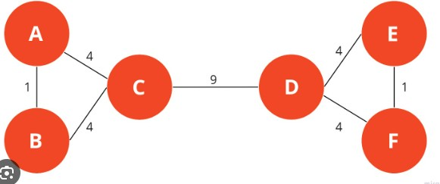

The Girvan-Newman algorithm is a community detection algorithm used to identify communities or clusters within a complex network or graph. It works by iteratively removing edges from the graph and calculating the betweenness centrality of edges to identify communities. Let's explain the Girvan-Newman algorithm using a simple example:

Example: Social Network Graph

Suppose we have a social network graph representing friendships among individuals. The graph consists of nodes (representing people) and edges (representing friendships). We want to use the Girvan-Newman algorithm to identify communities within this social network.

Here's how the algorithm works step by step:

Calculate Betweenness Centrality:

Calculate the betweenness centrality for all edges in the graph. Betweenness centrality measures how often an edge lies on the shortest path between pairs of nodes.

For our example, let's calculate the betweenness centrality for each edge in the graph:

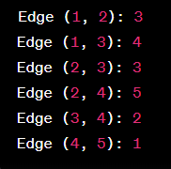

Remove High Betweenness Edges:

Remove the edge(s) with the highest betweenness centrality from the graph. In our case, the edge (2, 4) has the highest betweenness centrality (5), so we remove it from the graph.

The graph now looks like this:

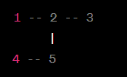

Calculate Betweenness Centrality Again:

Recalculate the betweenness centrality for all edges in the updated graph.

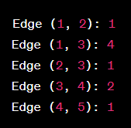

Repeat Edge Removal and Recalculation:

Continue removing edges with the highest betweenness centrality and recalculating betweenness until the graph becomes disconnected (i.e., there are no longer any edges connecting different components of the graph).

In our example, we remove the edge (1, 3) next, which has the highest betweenness centrality of 4.

After the removal, the graph becomes:

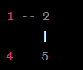

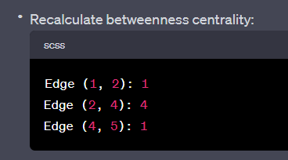

Continue this process until all edges are removed.

Identify Communities:

As edges are removed, the graph will split into disconnected components. Each of these components represents a community or cluster of nodes with strong internal connections.

In our final state, we have two communities:

Community 1: {1, 2}

Community 2: {4, 5}

The Girvan-Newman algorithm has successfully identified the communities within our social network graph. This iterative process of edge removal and betweenness centrality calculation helps uncover the underlying structure of the network and reveals how nodes are grouped together into communities based on their connectivity patterns.

1. **Enlist and explain different functions used for manipulating and processing data in R.**

In R, there are numerous functions and libraries available for manipulating and processing data. Here, I'll enlist and explain some common functions and techniques used for data manipulation and processing in R:

Subsetting Data:

subset(): This function allows you to subset a data frame based on specified conditions. For example, you can extract rows from a data frame where a certain condition is met.

[] (square brackets): You can use square brackets to subset data by specifying row and column indices or conditions.

Filtering Data:

filter() (from the dplyr package): Used to filter rows from a data frame based on specified conditions. It's part of the dplyr package, which is known for its data manipulation capabilities.

Sorting Data:

order(): Sorts a data frame or vector in ascending or descending order based on one or more columns.

arrange() (from dplyr): Sorts data frames by one or more columns. It offers more flexibility than order() and is part of the dplyr package.

Aggregating Data:

aggregate(): Allows you to compute summary statistics (e.g., mean, sum) for different groups within a data frame.

tapply(): Applies a function to subsets of a vector or data frame based on a factor variable.

Reshaping Data:

reshape() and melt() (from the reshape2 package): Used for reshaping data from wide to long format or vice versa.

gather() and spread() (from tidyr): Part of the tidyr package, these functions are used for reshaping data frames to tidy data format.

Data Transformation:

transform() and mutate() (from dplyr): These functions allow you to create new variables or modify existing ones based on specified conditions.

cut(): Divides a continuous variable into discrete bins or intervals.

Joining Data:

merge(): Combines two data frames based on one or more common columns.

join() (from dplyr): Provides various types of joins (inner, left, right, full) between data frames.

Split-Apply-Combine:

split(): Splits a data frame into smaller data frames or lists based on a factor variable.

lapply() and sapply(): Used to apply a function to each element of a list or vector.

aggregate(), by(), and tapply(): Used for aggregating data after splitting it based on a factor variable.

Data Cleaning:

na.omit(): Removes rows with missing values (NA) from a data frame.

complete.cases(): Identifies complete cases (rows with no missing values).

Statistical Functions:

mean(), median(), sum(), min(), max(): Calculate various statistics on data vectors or columns.

quantile(): Compute quantiles of a dataset.

String Manipulation:

paste(): Combines character strings.

strsplit(): Splits character strings based on a delimiter.

grep(), grepl(), sub(), gsub(): Used for searching and replacing text patterns.

Time Series Operations:

as.Date(), as.POSIXct(): Convert character strings to date/time formats.

ts(): Create time series objects.

window(): Subset time series data based on time intervals.

Random Sampling:

sample(): Generates random samples from a vector or data frame.

These are some of the fundamental functions and techniques for manipulating and processing data in R. Depending on your specific data analysis needs, you may need to use a combination of these functions and possibly additional libraries specialized for certain tasks, such as dplyr, tidyr, reshape2, and more.

1. **Write the script to sort the values contained in the following vector in ascending order and descending order(23,45,10,34,89,20,67,99).Demonstrate the output.**

To sort a vector in R in ascending and descending order, you can use the sort() function. Here's a script to sort the given vector both ways and demonstrate the output:

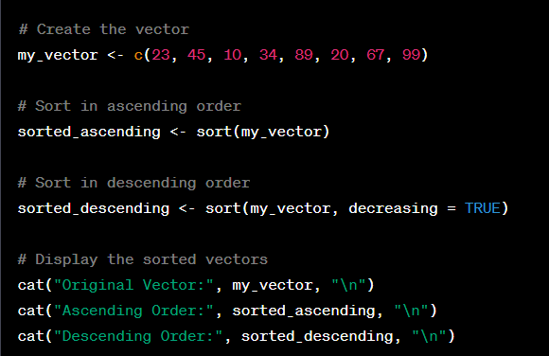

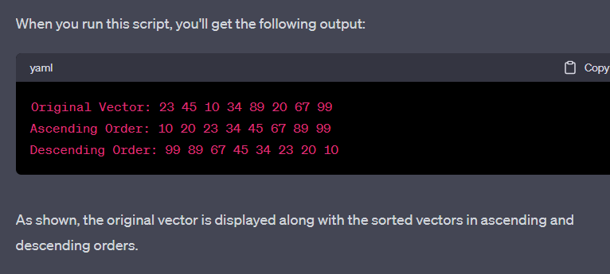

1. **Name and explain the operators used to form data subsets in R.**

Square Brackets []:

The square brackets are used to subset data frames, matrices, or vectors in R. You can specify row and column indices or conditions within the brackets.

Example: my_data[1:5, ] selects the first 5 rows of a data frame.

Dollar Sign $:

The dollar sign operator is used to access specific columns within a data frame or list. It allows you to extract a single column by its name.

Example: my_data$column_name extracts the column named column_name from a data frame.

Double Square Brackets [[]]:

Double square brackets are used to extract a single element from a list or a specific column from a data frame as a vector.

Example: my_list[[1]] extracts the first element from a list.

Subset Function subset():

The subset() function is used to create data subsets based on specified conditions. It allows you to filter rows of a data frame.

Example: subset(my_data, column_name > 5) selects rows where the value in column_name is greater than 5.

Logical Operators (<, >, <=, >=, ==, !=, %in%, &, |)

Logical operators are used to create subsets based on logical conditions. For example, you can use == for equality, != for inequality, and %in% to check if values are in a specified set.

Example: my_data[my_data$column_name > 5, ] selects rows where the value in column_name is greater than 5.

which() Function:

The which() function is used to identify the indices of elements that satisfy a specific condition. It's often used in combination with square brackets to create subsets.

Example: my_data[which(my_data$column_name > 5), ] selects rows where the value in column_name is greater than 5.

%>% (Pipe Operator):

The pipe operator is used to chain together multiple data manipulation functions. It allows you to create complex data subsets and transformations using packages like dplyr.

Example: my_data %>% filter(column_name > 5) %>% select(column_name) filters rows where the value in column_name is greater than 5 and then selects the column_name column.

match() Function:

The match() function is used to find the positions of elements in a target vector that match values in a reference vector. It's commonly used for subsetting.

Example: subset(my_data, column_name %in% match_vector) selects rows where the value in column_name is present in match_vector.

These operators and functions provide flexible ways to create data subsets in R based on specific criteria, conditions, or column names. Depending on your data manipulation needs and coding style, you can choose the most suitable method for forming data subsets.