Interactive data visualization in Processing using the GLGraphics and Proscene libraries
Hugo Camilo Salomón¹, Andrés Colubri^{1,2}, Jean Pierre Charalambos²
¹ Departamento de Ingeniería de Sistemas e Industrial, Universidad Nacional de Colombia, Bogotá Campus.
² College of Life Sciences, Faculty of Biotechnology, Jeju National University, South Korea.

Here we describe a data visualization framework for the Processing programming language and environment, aimed at the real-time representation of large data sets and interactive navigation of three-dimensional data layouts. This framework results from the integration of two Processing libraries developed by the authors: GLGraphics and Proscene. Processing is a programming language and development environment widely used in the digital arts and interactive design communities for teaching, prototyping, and production. GLGraphics and Proscene augment the functionality and performance offered by Processing’s core API in the areas of 3D rendering and camera manipulation. On one hand, GLGraphics encapsulates the Vertex Buffer Object (VBO) extension from OpenGL with a simple class interface. VBOs allow to render large volumes of geometry data very efficiently since their use minimize expensive transfers between main and video memory. Proscene, on the other hand, eases the creation and navigation of 3D scenes by providing several classes for defining cameras, coordinate systems and keyframe-based motions.
In the more specific context of interactive data visualization, GLGraphics and Proscene can be integrated to apply view-frustum-culling and other complexity reduction techniques to large large data layouts in real-time. Camera handling incorporates an adaptive multi-scale attention model to simplify navigation in layouts where the data exhibits several spacial scales. This framework is already in use at places like Google Creative Labs and the New York Times Graphics Department. Several large scale visualizations created with the GLGraphics/Proscene framework are presented and discussed.

Keywords: data visualization, real-time, interactive, processing, framework, glgraphics, proscene, opengl, camera, 3D scenes

The field of data visualization has exhibited a rapid growth in recent years due to the increased availability of data sets from various sources such as the social web [1], automated data mining and sensing [2], genomic and proteomic sequencing projects [3], etc. This data abundance has led to the creation of novel representation techniques and algorithms, most notably in the area of network visualization [4], as well as the implementation of several software applications and toolkits [5, 6] for parsing, analyzing and displaying information originating from large data sources.
There is a also a significant interest within the scientific and visual design communities in creating data visualizations that have an intrinsic aesthetic value. This intersection between infovis and art is usually describe by the new term of “infoaesthetics” [7, 8].
Within this growing field, the Processing language and environment [9], created at the MIT in 2001 by Casey Reas and Ben Fry, is a widely used tool thanks to its simple API and extensible library architecture. Processing has been used in numerous data visualization projects [10, 11], but it presents some performance limitations for generating interactive visualizations from massive data sets. The libraries described in this work, Proscene and GLGraphics, aim at solving these limitations, while keeping Processing’s focus on simplicity.

GLGraphics: GLGraphics is a Processing library that extends the 3D rendering functionality of Processing by adding a number of classes that encapsulate OpenGL textures, GPU-accelerated image filters and shader effects, and VBO-based 3D models for high performance.

Proscene: Proscene is a Processing library which extends its built-in camera functionality by adding support of camera modes, camera profiles, key frames, frames (coordinate systems) and object picking.

GLGraphics and Proscene integration: High performance rendering of large 3D models in GLGraphics is coupled with several culling algorithms implemented in Proscene. In this way, massive geometries can be displayed interactively in real-time. An algorithm for adaptive camera movements allows for easy navigation of data sets where geometric primitives are scattered over large volumes or present a wide range of spatial scales. Both Proscene [12] and GLGraphics [13] are freely available for download and their source code are released under the GPL2 license.

Applications: Some applications of the visualization framework that results of the integration between Proscene and GLGraphics are already available [Figure 1]. As part of our research, we are currently implementing an integrated system for visualization of biological data at the cellular level (protein interaction networks, transduction and regulatory pathways, etc.), where several features of this framework will allow for seamless navigation of complex scenes containing thousands of molecular entities.

Future enhancements: In order to improve the performance and range of applicability of the framework, we plan to implement some of the culling algorithms on the GPU, port the framework to Processing.js so it can be run directly from web browsers, and add support for 3D input devices such as the SpaceNavigator from 3Dconnection.

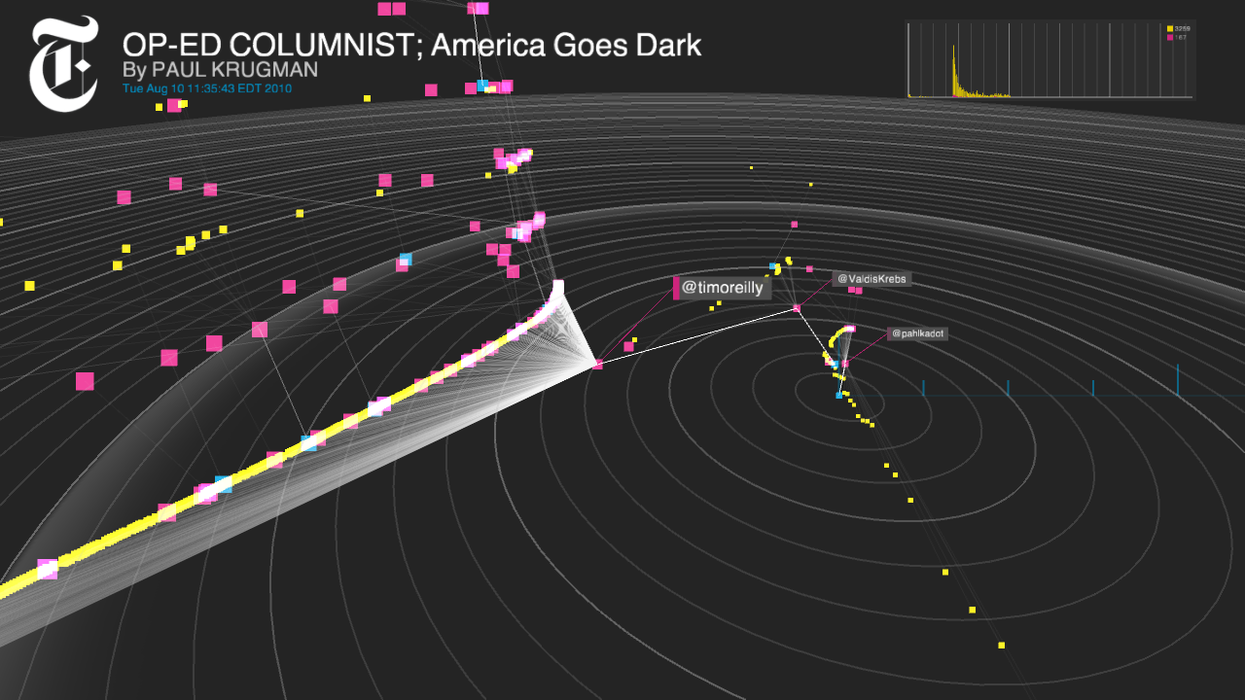
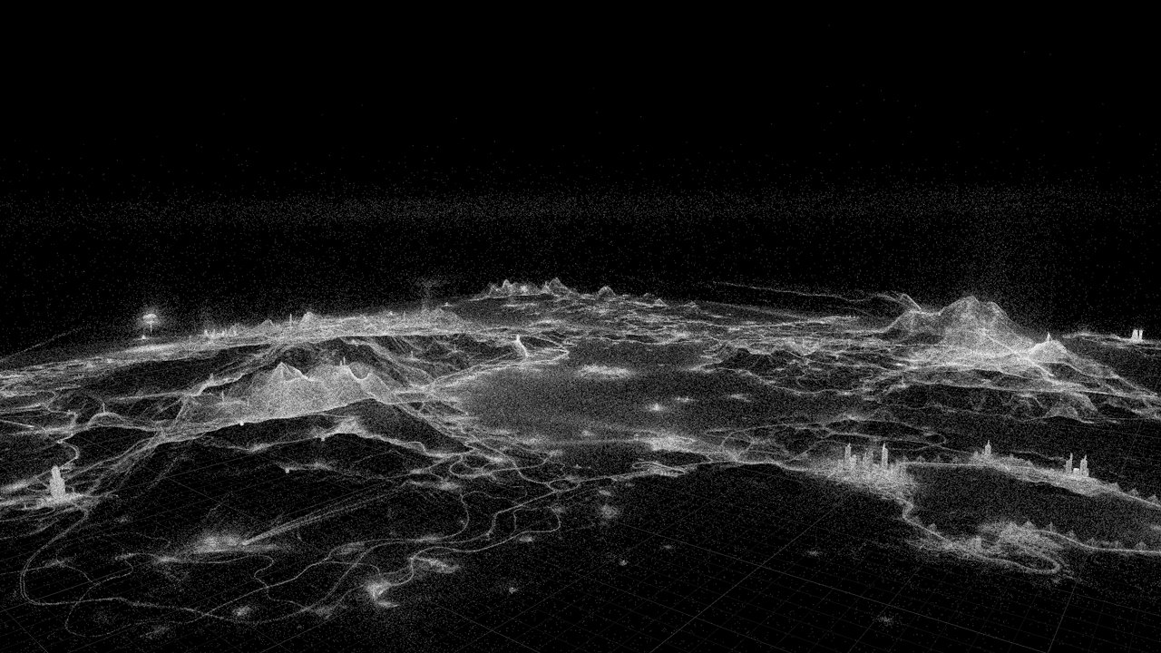
Figure 1:
Interactive visualization of New York Times news headlines, by Jer Thorp (top, courtesy of the author). Realtime visualization of multiplayer data from the online game Just Cause 2, by Jim Blackhurst. (center, courtesy of Square-Enix UK). Geographical mapping of Google search terms, by Aaron Koblin and Michael Chang (bottom, courtesy of Google Creative Labs)

References
[1] Structure and tie strengths in mobile communication networks. Onnela JP, Saramaki, J, Hyvonen J, Szabo G, Lazer D, Kaski K, Kertesz K, Barabasi AL. Proceedings of the National Academy of Sciences. Vol 104, pp 7332–6 (2007).
[2] A Survey of Mobile Phone Sensing. Lane ND, Miluzzo E, Lu H, Peebles D, Choudhury T, Campbell AT. IEEE Communications Magazine Vol. Vol 48 (2010).
[3] The IntAct molecular interaction database in 2010. Aranda B, et al. Nucl. Acids Res. Vol 38 (suppl 1), pp D525-D531 (2010).
[4] Force-Directed Edge Bundling for Graph Visualization
Holten D, van Wijk JJ. Eurographics/ IEEE-VGTC Symposium on Visualization 2009, Vol 28 (2009).
[5] Many Eyes: http://www-958.ibm.com/software/data/cognos/manyeyes/
[6] Visualization Toolkit: http://www.vtk.org/
[7] http://infosthetics.com/
[8] http://www.visualcomplexity.com/
[9] Processing website: http://processing.org/
[10] Flight Patterns by Aaron Koblin: http://www.aaronkoblin.com/work/flightpatterns/
[11] In the Air by Victor Viña, Nerea Calvillo: http://www.intheair.es/
[12] Proscene website: http://code.google.com/p/proscene/
[13] GLGraphics website: http://glgraphics.sourceforge.net/

