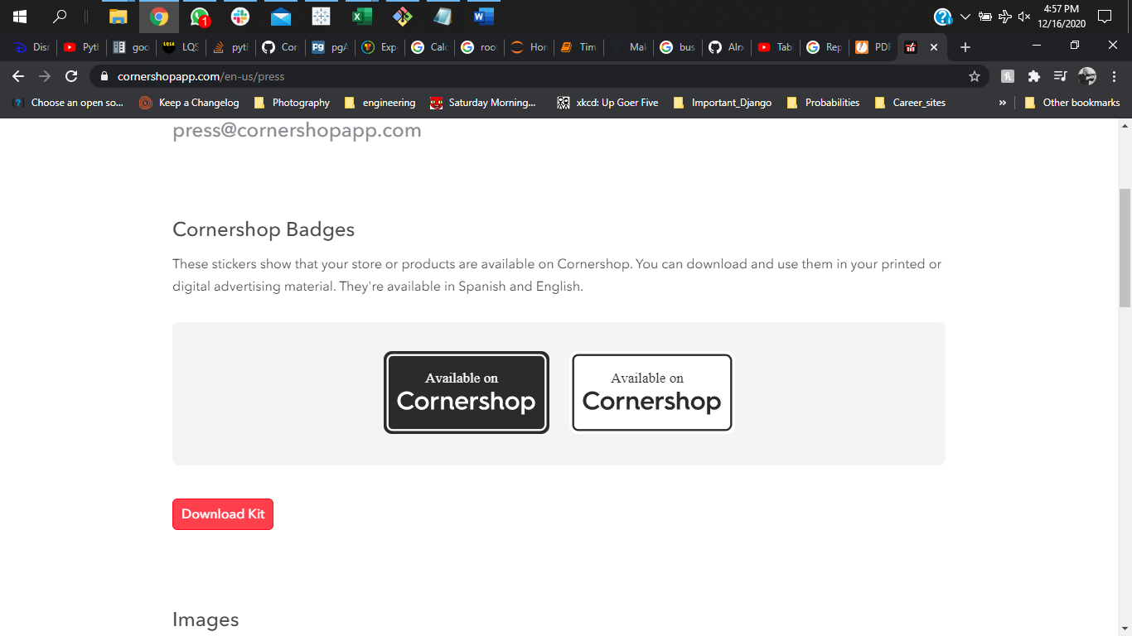

Total time is one of the keys to Cornershop's success. When we analyzed the total time distribution, the higher probability when estimating time falls between 60 to 120 minutes. However, we have seen that the total time goes beyond the expectations during the weekends and late at night.

We can implement incentives to make people want their groceries' deliveries early in the morning, where the average time is ~50 minutes.

**Conclusions**

Cornershop operates in more than 20 cities in 8 countries. However, we will be analyzing the operation of the company in the locality of Guerrero, Mexico.

In Guerrero, Mexico, Cornershop has business in 16 stores. The average quantity in each order ranges from 0.712 to 2.559. This dispersion in the quantity of each order by the store can result from the store's location. Some people might be willing to order more quantity if they live far from supermarkets. Also, purchasing power in the area can affect the quantity. Further analysis has to be conducted to find a strategy to increase each order's amount on those retails.

There is a notable difference in the product format when we calculated the found rate. This rate is the ratio between the quantity of product found vs. the number of products ordered by the customer. Customers order a higher quantity of products with the format in "KG."

People over the weekend generally have more time to do shopping, so there is a smaller incentive to deliver the groceries. We should increase the number of coupons and offer during the week to attract more people to buy on Mon, Tue, and Thu.

The minimum total minute to deliver an order is 49.2, and the maximum is 109 .23. This happens between 7-8 am and 23-24 pm, respectively. The average number of orders is lower in the early morning. However, that can be an excellent opportunity to increase marketing. It can be targeting people who would like to receive their groceries before going to work or someone that forgot to buy something the night before. There is a margin to test some strategies in the early morning.

Rush hours happen between 10 am and 12 pm. However, we have seen that a longer delivery time is close to midnight. During those hours, we might have fewer deliveries and people to fulfill the orders. It might be useful to increase remuneration to decrease total time during those hours.

The number of orders in which the picker and the driver are different is 216.

**Alejandro Alemany**

Data Analyst/Data Scientist

**Contact Info:**

**Tel: 786-314-3562**

**Email:** [**accual1013@gmail.com**](mailto:accual1013@gmail.com)

**Details**

**Cornershop BI Report**