# **Lab1**

1. Create aws account and set billing alarm

* **In Billing Preferences**.

* Create alarm in cloudwatch:

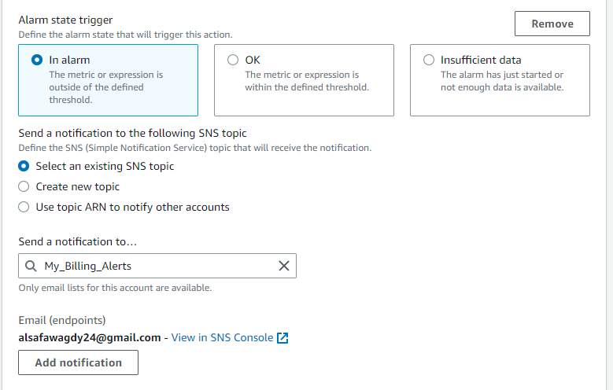

## IAM

* create 2 groups one admin and one for development

* create admin-1 user console access and mfa enabled

* admin2-prog with cli access only and list all users and groups using it commands not console

* in the development group create user with name dev-user with programmatic and. Admin access try to access aws using it (take a screenshot from accessing ec2 and s3)

* Also access cli using it and try to get all users and groups using it

USERS:

Groups:

