# **Lab_2**

1. Graphical user interface, text, application, email

   Description automatically generatedcreating VPC +subnet +route table+IGW  
   Graphical user interface, text, application, email

   Description automatically generated

1. Creating EC2 attached to the vpc

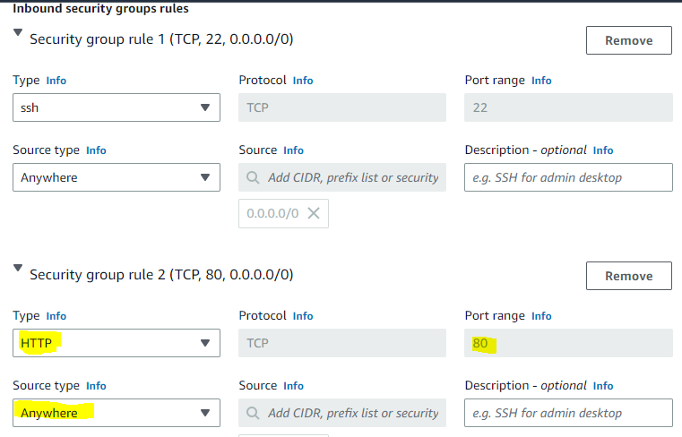

1. To install apachi without while creating Ec2

4)accesing Ec2

Logs:

1. Create vpc , public subnet and private subnet:

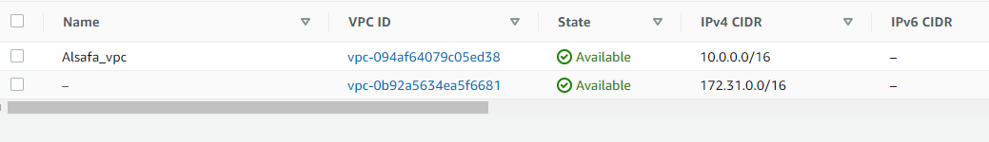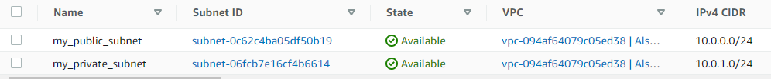

1. Create Internet gateway and attach it to vpc , Route table , and NAT gateway

Puplic subnet route table:

Private subnet route table:

1. Create instance in private subnet

