**Lab_3**

1. Create vpc, Private subnet, public, subnet ,two route table and internet GW

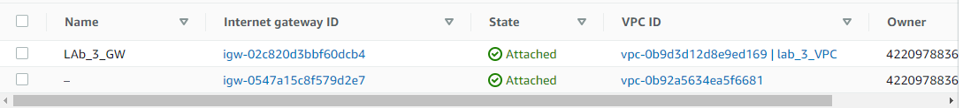

2)create jumb-host instance in public subnet and allow ssh connection only using security group

3)create private instance in the private subnet and allow only ssh from jumb_host 's security group

nce:

