# **Kubernetes**

# **Lab_2**

1. Text

   Description automatically generated with medium confidenceHow many Namespaces exist on the system? *4 namespaces*

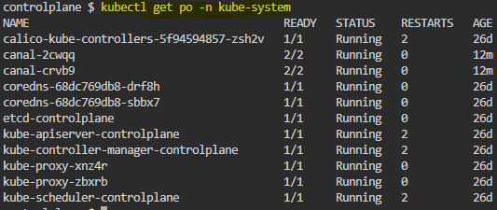2-How many pods exist in the kube-system namespace? *11 pods*

1. create a Deployment with name= deployment-1 image= busybox replicas= 3

1. Graphical user interface, text, application, chat or text message

   Description automatically generatedHow many Deployments and ReplicaSets exist on the system now? *1 deployment & 1 ReplicaSet*
2. Text

   Description automatically generatedHow many pods are ready with the deployment-1?
3. Update deployment-1 image to nginx then check the ready pods again? 3 pods

1. Run kubectl describe deployment deployment-1 and check events. What is the deployment strategy used to upgrade deployment-1?  *Rolling update*

1. Rollback the deployment-1



1. What is the used image with the deployment-1?



1. Create a deployment with

Name: dev-deploy Image: redis Replicas: 2 Namespace: dev

Resources Requests: CPU: .5 vcpu, Mem: 1G

Resources Limits: CPU: 1 vcpu, Mem: 2G

